

**Trainer Manual**

**Strengths-Based Development/Supervision**

**Virtual Course**

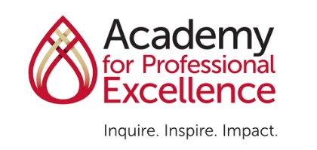

**This training was developed by the Academy for Professional Excellence, with funding from the California Department of Social Services, Adult Programs Division.**



**Curriculum Developer, 2020**

**Joanne Chen, MA, CPC**

© 2021. San Diego State University School of Social Work, Academy for Professional Excellence. Please acknowledge this copyright in all non-commercial uses and attribute credit to the developer and those organizations that sponsored the development of these materials. No commercial reproduction allowed.

**INTRODUCTION**

**THE ACADEMY FOR PROFESSIONAL EXCELLENCE**

We are pleased to welcome you to Strengths-Based Development/Supervision Trainer Manual (Module 1C), developed by Adult Protective Services Workforce Innovations (APSWI), a program of the Academy for Professional Excellence under a grant from the California Department of Social Services, Adult Programs Division.

The Academy for Professional Excellence, a project of San Diego State University School of Social Work, was established in 1996 to provide exceptional workforce development and organizational support to the health and human services community by providing training, technical assistance, organizational development, research, and evaluation. Serving over 20,000 people annually, the Academy continues to grow with new programs and a diversity of training focused on serving the health and human services community in Southern California and beyond.

The Academy is a project of San Diego State University School of Social Work (founded in 1963), which offers both a bachelor’s and master’s degree in Social Work. The School of Social Work at San Diego State University was founded in 1963 and has been continuously accredited by the Council of Social Work Education since 1966.

APSWI is a program of the Academy for Professional Excellence. APSWI is designed to provide competency-based, multidisciplinary training to Adult Protective Services professionals and their partners. APSWI’s overarching goal is the professionalization of Adult Protective Services professionals to ensure that abused and vulnerable older adults and adults with disabilities receive high quality, effective interventions and services.

In partnership with state and national organizations, APSWI is developing a national APS Supervisor Core Competency Training Curriculum. This curriculum is developed, reviewed and approved by experts in the elder and dependent adult abuse fields.

APSWI’s partners include:

• National Adult Protective Services Association (NAPSA) Education Committee

• California Department of Social Services (CDSS), Adult Programs Division

• County Welfare Directors Association of California (CWDA), Protective Services Operations Committee (PSOC)

**PARTNER ORGANIZATIONS**

**Dawn Gibbons-McWayne** **Krista Brown**

Program Manager, APSWI APS Leaders Institute Program Coord., APSWI

Academy for Professional Excellence Academy for Professional Excellence

<https://theacademy.sdsu.edu/programs/> <https://theacademy.sdsu.edu/programs/>

**Lori Delagrammatikas Paul Needham**

Executive Director Chair

National Adult Protective Services NAPSA Education Committee

Association napsa-now.org

(NAPSA)

napsa-now.org

**Kim Rutledge Chris Alire and Francisco Wong**

Adult Protective Services Liaison Co-Chairs

Adult Protective Services Division Protective Services Operations Committee of

California Dept. of Public Social Services the County Welfare Director’s Association

cdss.ca.gov/Adult-Protective-Service cwda.org/about-cwda

**THE ACADEMY FOR PROFESSIONAL EXCELLENCE**

6505 Alvarado Road, Suite 107, San Diego, CA 92120

Tel: (619)594-3546 – Fax: (619)594-1118 – http://theacademy.sdsu.edu/programs/

**ACKNOWLEDGEMENTS**

This training is the result of a collaborative effort between Adult Protective Services administrators, supervisors, staff development officers and workers across the state and the nation; professional educators; and the Academy for Professional Excellence staff members. APSWI would like to thank the following individuals and agencies:

**Agencies**

California Department of Social Services, Adult Programs Division

Arizona Department of Economic Security, DAAS-Adult Protective Services  
National Adult Protective Services Association

**Supervisor Curriculum Advisory Committee**

Kristina Allwood, Program Manager, Institute for Human Services, Inc. (OH)

Nujoud Al-Salem, ACL Grant Program Coord., DAAS-APS, AZ Dept. of Economic Security

Cathy Bahadur, APS Section Manager, GA Department of Human Services

Rosemary Barrington, APS Supervisor, DAAS-APS, AZ Department of Economic Security

Jessica Burke, Staff Development Officer, Riverside County

Kathleen Calderon, Lead Policy Specialist, APS Policy Unit, CO Dept. of Human Services

Kelsey Cato, APS Training Program Manager, WA State Dept. of Social and Health Services

Kama Chase, APS District Program Manager, DAAS-APS, AZ Dept. of Economic Security

Lori Delagrammatikas, Executive Director, NAPSA

Denise Dorsey, Program Manager, Tehama County

Tammy Douglass, APS Social Services Supervisor, Kings County

Esmeralda Garcia, Social Worker Supervisor II, San Luis Obispo County

Markita Grant, Office of Aging, Policy and Training Unit, GA Dept. of Human Services

Michael Hagenlock, Adult Protective Services Bureau Chief (MT)

Liora Levenbach, APS Supervisor II, Humboldt County

Nicole Medina, Program Consultant, APS Division, VA Dept. for Aging

and Rehabilitative Services

Paul Needham, Chair, NAPSA Education Committee

Ashley Shively, Social Worker Supervisor II, Humboldt County

Valerie Smith, Social Services Program Manager, Santa Clara County

Sara Stratton, Consultant, City and County of San Francisco

Erin Van Duzer, Unit Manager, Tulare County

Amy Wasnak, APS Supervisor, San Diego County

Latrice Watson, Social Worker, IV, Humboldt County

**Committees**

National Adult Protective Services Association Education Committee

**Curriculum Developer**

Joanne Chen, MA, CPC

**Table of Contents**

**GENERAL INFORMATION**

Introduction……………………………………………………………………… 3

Partner Organizations………………………………………………………….. 4

Acknowledgements…………………………………………………………….. 5

Table of Contents………………………………………………………………. 6

How to Use this Manual ………………………………………………………. 8

Trainer Guidelines …………………………………………………………….. 9

Tips for Trainers ……………………………………………………………….. 10

Virtual Training Tips …………………………………………………………… 11

Executive Summary …………………………………………………………… 13

Course Outline …………………………………………………………………. 14

**WELCOME AND INTRODUCTIONS**

Display Name Change Instructions …………………………………………. 17

Welcome, Introductions and Housekeeping ……..………………………… 18

Technology Overview ………………………………………………………… 21

Introduction of Trainer ……………………………………………………….. 23

Learning Objectives ………………………………………………………….. 24

Group Agreements …………………………………………………………… 25

**STRENGTHS-BASED APPROACH**

What is Strength? …..….………………………….…………………………… 27

Who Represents Strength? .…………………………………………………… 28

Deficit Model …….………………………………………….…………………… 29

Discover Your Strengths ……….………………………………………………. 30

Benefits of Strengths-Based Approach …………………….………………… 31

Poll #1: Strengths Use Gut Check …………………………………………….. 37

Limitations of Strengths-Based Approach ……………………………………. 38

**STRENGTHS ASSESSMENTS**

Strengths Assessments …………….………………...................................... 42

Your Pre-work …………………………………………………………………… 44

Part 2. Reflection Questions ...………………………………………………… 45

Solo Work – Matching …………………………………………………………. 46

Solo Work – Action Planning …………………………………………………. 47

Small Group Discussion Questions …………………………………………… 48

Large Group Discussion ……………………………………………………….. 49

**STRENGTHS-BASED SUPERVISION**

Strengths-Based Supervision ……………….………………………………… 50

Strengths-Based Supervisor Examples ……………………….………..……. 51

Strengths-Based Supervision ………………….……………..……….……… 52

Poll #2: Strengths-Based Supervision …………………….…………………. 53

Solo Activity – Self-Assessment ………………………….……..……….……. 54

Tools: Strengths-Based Questions …………………………………………… 55

Small Group Work: ASP Scenario ……………………………………………. 56

Large Group Debrief …………………………………………………………… 58

What are you Committed to? …………………………………………………. 59

**CLOSING AND EVALUATION**

Evaluation …………………………………………………………………….…. 60

Thank You ……………………………………………………………………….. 61

References …………………………………………………………………….… 62

Appendix A Handout #1 ………………………………………..…………….… 64

Appendix B Handout #2……………………………………………………….… 67

Moderator/Co-Host Tip Sheet…………………………………….…………….. 68

**How to Use This Manual**

This curriculum was developed as a virtual 120 minute workshop using the Zoom platform, paying close attention to virtual training best practices. It can be tailored to a different virtual platform (WebEx, GoTo Training, etc.), if necessary. It may also be trained in-person by modifying activity and engagement prompts as necessary. When possible, virtual and in-person prompts are given.

The Pre-Training Assignment (*See separate Pre-work Supplemental Manual*) and instructions should be sent via email at least one-week prior to the training date. It will take approximately 60-75 minutes. This must be completed prior to attending the training.

The Participant Manual should also be sent ahead of time as a fillable PDF if using Adobe Acrobat or to allow participants to print a hard copy.

* Actions which the trainer takes during the training are written in **bold**.

**Trainer and Moderator Notes are written entirely in bold in the text box and are provided as helpful hints.**

* When there are both Trainer and Moderator notes on same page, Trainer and Moderator is **underlined**.

**Use of language:** Throughout the manual, staff is used most often to describe supervisees or units/teams. The broader term (APS) worker is also used to denote individual staff who may go by various titles. The term client is used most often to describe the individual at the center of the APS investigation. However, if concept or material was directly quoted from copyrighted material, another term may be used.

He and she have been replaced with the gender-neutral they throughout this manual, unless quoted from copyrighted material. This should not be thought of as plural persons, but rather a gender-neutral term describing all humans.

**Customizing the Power Point:**

This manual is set up so that the trainer script/ background material is on the same page as the accompanying PowerPoint slide.

**Hide a slide instructions**:

1. On the Slides tab in normal view, select the slide you want to hide.

2. On the Slide Show menu, click Hide Slide.

The slide number will have a line through it to show you have hidden it.

NOTE: The slide remains in your file even though it is hidden when you run the presentation.

The course outline, provided in the next section of this manual, is the class schedule used for development of this curriculum. It can be used to help determine how much time is needed to present each section. However, times will vary based on the experience and engagement of the audience.

**Trainer Guidelines**

Trainers will need to familiarize themselves with the Strengths Assessments covered in this training and take at least one themselves. ***Please review carefully “Tips for Trainers on the Strength Assessments” on the next page.*** APS supervisory experience is helpful but not necessary to facilitate this virtual workshop.

Suggestions for virtual training when possible:

* Have a moderator or co-host who can primarily focus on the virtual aspects of this training (e.g., monitoring chat box, launching polls, assigning breakout groups, monitoring participant reactions, etc.).
  + A Moderator/Co-Host Tip sheet is on Page 68
* Test out the use of the breakout room feature prior to conducting this training.
* Log in at least 30 minutes prior to the training to ensure the virtual classroom is fully functioning and that you are comfortable navigating it.
* Your equipment and platform may dictate how you do some activities or discussion. There are times you may not be able to see everyone’s faces, names or reactions (thumbs up, mute/unmute, etc.). There is a need for both verbal discussion and chat discussion. At such times, the moderator will fill a critical role monitoring those features you cannot. Practice during a run through how you will use the various functions for each section.
* The optimal size for this virtual training is 20-25 participants.

|  |  |
| --- | --- |
| **Teaching Strategies** | The following instructional strategies are used:   * Lecture segments * Interactive exercises (e.g., breakout groups, chat box discussion, polling activities) * Question/answer periods * PowerPoint Slides |
| **Materials and Equipment** | **The following materials are provided and/or recommended:**   * Trainer Manual * Participant Manual (fillable PDF) * PowerPoint Slides * Headset with microphone * Computer |

### **TIPS FOR TRAINERS ON THE STRENGTHS ASSESSMENT**

### **CliftonStrengths Assessment**

1. Review sample reports: [Signature Strengths Report](https://josefstepanek.cz/StrengthsFinder_Report.pdf), [Your CliftonStrengths 34 Report](https://www.strengthsquest.com/file/243572/All34Report_DonClifton.pdf).
2. Take the assessment and review your Signature Strengths Report.
3. View [Your Greatest Talents](https://www.youtube.com/watch?v=FQHPSRLt32k&list=PLxDaK7wIyw94F9rI1gV50QNoFr9HCdjnA&index=6&ab_channel=CliftonStrengths) video and [Theme Thursday Season 5: Highlights from Your 34 CliftonStrengths](https://www.gallup.com/cliftonstrengths/en/268829/theme-thursday-season-5-catalog.aspx) videos on at least one of your Top 5 CliftonStrengths.  Bonus: Apply one of the tips given!
4. For your Signature Strengths, review the [Balcony and Basement handout for all 34 CliftonStrengths](https://drive.google.com/file/d/18FObWp6Y5uLakJIA4bye_x8WnHCOVHX_/view?usp=sharing).

### **VIA Character Strengths Survey**

1. Take the assessment and review your results report. If needed, review the [descriptions of your top strengths](https://www.viacharacter.org/character-strengths).
2. Download and review the [summary descriptions of all 24 strengths](https://www.viacharacter.org/downloads/IconsClassifications-2020.zip).
3. Review sample reports: [Sample Total 24 Report (contains sample profile on pg. 2)](https://www.viacharacter.org/pdf/Total24LOOKINSIDE.pdf)
4. Review ["A Character Strengths Revolution" video](https://www.youtube.com/watch?v=fSmbB0Ko2hM&feature=emb_logo&ab_channel=VIAStrengths).

### **Strengths Profile**

1. Review sample reports: [introductory profile](https://files.strengthsprofile.com/Deployable/LocalizableResources/en-US/Profile%20Samples/Strengths_Profile_Introductory_Guide_Sample.pdf?v=20201103.3), [expert profile](https://files.strengthsprofile.com/Deployable/LocalizableResources/en-US/Profile%20Samples/Strengths_Profile_Expert_Guide_Sample.pdf?v=20201103.3).
2. Review [videos](https://www.youtube.com/playlist?list=PL056-pX2LYOl7TMUjKIY2L_PS8rIo-8C2) on using the tool; topics include profile overview, realized strengths, unrealized strengths, learned behaviors, and weaknesses.
3. [“How CliftonStrengths Compares with Strengths Profile” article](https://www.gallup.com/cliftonstrengths/en/249497/compare-strengths-profile-cliftonstrengths.aspx)

### **StandOut Strengths Assessment**

1. Take the free assessment and review your report.
2. Watch [videos of your Top 2 StandOut Roles](https://www.marcusbuckingham.com/standout-learning-journey/).
3. Review sample reports: [Connector-Provider](https://www.slideshare.net/brentdowney/standout-report), [Advisor-Creator](https://ryanrhoten.com/wp-content/uploads/2014/01/StandoutReport.pdf), [Pioneer-Teacher](https://portfolio.du.edu/downloadItem/263135), [Creator-Stimulator](https://itsaboutlearning.files.wordpress.com/2015/03/standoutreport-boadams.pdf)
4. Review [How Do CliftonStrengths and the StandOut Assessment Compare?](https://www.gallup.com/cliftonstrengths/en/249896/compare-standout-assessment-cliftonstrengths.aspx)

Note: Additional resources, including sample reports, technical manuals, and descriptions can be found in [this folder](https://drive.google.com/drive/folders/1ILGOie3D9l9gZWQPbo3Vb10IljCCIbFh?usp=sharing).

**VIRTUAL TRAINING TIPS**

Training and facilitation have always been an art. Virtual training is no exception. Below are some helpful tips to remember and implement when training in a virtual environment.

* Assume nothing.
  + Do not assume everyone has the same knowledge or comfort level with technology or has access to equipment like printers, video camera, headsets or even reliable Wi-Fi.
* Distractions are everywhere.
  + Participants have greater access to distractions (email, phone, others at home) which can take their focus away from the training. Therefore, explain everything and summarize before asking participants to complete an activity and check for clarification.
* Over explain when possible.
  + The virtual room doesn’t allow for participants to see everything you’re doing as they can in-person. Share as you navigate the virtual environment. If you are silent while looking for something or finding a screen, they may think something is frozen.
* Mute with purpose.
  + “Mute all” function can help ensure we don’t hear conversations we’re not supposed to. However, it can also send a message to the participants that they are a passive participant and may not make them feel comfortable taking themselves off mute when you want them to speak.
* Two screens can be a lifesaver.
  + This allows you to move your chat box or participant gallery view away from your presentation so you can see more of what’s going on.
* Rely on practice, not luck.
  + Winging it during an in-person training or facilitation may work from time to time, but doesn’t work in the virtual environment. In addition to covering the content, you have to manage all of the technology issues, learning styles in a virtual room, and it will show if you’re not prepared.
* Bring the energy.
  + As trainers, we are no strangers to being “on,” standing and moving around. However, some of the body language, subtle nonverbal skills we relied on the in-person training room do not translate well in the virtual environment. While this may make you more tired, it’s important to up your enthusiasm, voice, and presence in order to engage with attendees.
* Be mindful of your space.
  + Training virtually brings an entirely new component of what we’re willing to share with others. Learners can get distracted with what’s in your background, whether what is physically there or if you set your video to use a virtual background.
  + It’s important to reflect on questions of privilege, diversity and equity when thinking of your training space.
* Are there objects in your background that can symbolize status, privilege and/or power? If so, consider removing them to dismantle any added power dynamics that already exist with you as the Trainer.
* Unknowingly, objects can come across as offensive or can activate unpleasant or traumatic memories, and can instantly discredit your rapport building. Think of neutral backgrounds that are not distracting and allow you to be the focus of what learners see.

**Executive Summary**

***Strengths-based development/supervision***

Why focus on strengths? The research is clear that the use and development of strengths in the workplace increases work performance, retention, and well-being for staff at all levels. Join us for this interactive, foundational training on strengths-based development and supervision. Identify and explore your strengths and how to apply a strengths-based supervisory approach with your staff. Tips, tools and best practices will be shared for use on the job and in supervision.

**Virtual Training**:

* The following virtual instructional strategies are used throughout the course: short lectures (lecturettes), interactive activities/exercises including breakout groups, chat box discussions, large group discussions, self-reflection, poll options, and individual practice. PowerPoint slides and role-playing/demonstrations are used to stimulate discussion and skill development.
* Participants will need access to a computer with video conferencing capability and be able to connect to the virtual platform being used to deliver this training. A headset or earbuds with microphone and a video camera are highly encouraged. Participant Manual is a fillable PDF if using Adobe Acrobat. Participants are encouraged to either print a hard copy or ensure access to Adobe Acrobat to allow for highlighting, typing in comments and filling out worksheets.

**Course Requirements:**

* Pre-Training Assignment:Prior to the training, participants will be sent a Prework Supplemental Manual. They will complete a strengths assessment and the Your Top Strengths Handout (parts as indicated in directions). It will take approximately 60-75 minutes. This must be completed prior to attending the training. This will be included as a major processing activity and needs to be readily available for the training.
* Completion of the entire module is required to receive course completion credit.

**Target Audience**: This workshop is intended for new supervisors or experienced staff who may require a refresher.

**Outcome Objectives for Participants:**

By the end of this training participants will be able to:

* Compare and contrast the benefits and limitations of the strengths-based approach.
* Identify how each of your top strengths/talents (as described in your strengths assessment report) have contributed to your role/career.
* Discuss how you might approach supervising staff in an APS case study using the strengths-based approach and your top strengths/talents.

**Course Outline**

|  |  |  |
| --- | --- | --- |
| **CONTENT** | **MATERIALS** | **TIME** |
| **Welcome, Housekeeping and Introductions** |  | 10 minutes |
| Display Name Change Instructions | Slide 1 |  |
| Welcome, Housekeeping and Introductions | Slides 2-4 |  |
| Technology Overview | Slide 5-6 |  |
| Introduction of Trainer | Slide 7 |  |
| Learning Objectives | Slide 8 |  |
| Group Agreements | Slides 9-10 |  |
| **Strengths-Based Approach** |  | 20 minutes |
| What Is Strength? | Slide 11  Chat Box Activity |  |
| Who Represents Strength? | Slide 12  Chat Box Activity |  |
| Deficit Model | Slides 13-14 |  |
| Benefits of Strengths-Based Approach | Slides 15-20 |  |
| Poll: Strengths Use Gut Check | Slide 21 |  |
| Limitations of Strengths-Based Approach | Slides 22-25 |  |
| **Strengths Assessments** |  | 40 minutes |
| Strengths Assessments | Slide 26-27 |  |
| Your Top Strengths | Slides 28-33  Your Pre-work  Solo Work: Matching and Action Planning  Small Group Discussion  Large Group Debrief  *Pre-work* Handout: “Your Top Strengths” |  |
| **Strengths-Based Supervision** |  | 40 minutes |
| Strengths-Based Supervision | Slides 34-36 |  |
| Poll: Strengths-Based Supervision | Slide 37 |  |
| Strengths-Based Supervision Self-Assessment | Slides 38  Solo Activity  Handout #1: “Strengths-Based Supervision  Self-Assessment” |  |
| Tool: Strengths-Based Questions | Slide 39  Handout #2: Strengths-Based Coaching Questions for Supervisors |  |
| APS Scenario | Slides 40-42  Small Group Work  Large Group Debrief |  |
| What Are You Committed To? | Slide 43  Chat Box Activity |  |
| **Closing and Evaluation** |  | 5 minutes |
| Evaluation |  |  |
| Thank You |  |  |
| References |  |  |
| Pre-Work: Your Signature (Top) Strengths or Strengths Roles |  |  |
| **TOTAL TIME** |  | **120 MINUTES** |

**Module 1C**

**WELCOME AND INTRODUCTIONS with Time Allotted (10 minutes)**

**Slide #1: Changing Your Display Name in the Platform**

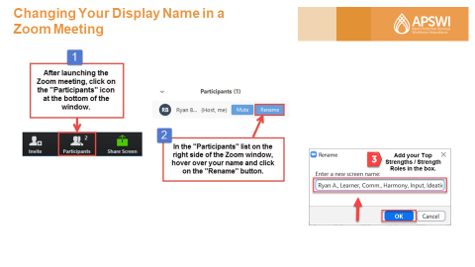

**Moderator:** As participants are logging in and getting settled, please have them add their Signature (Top 5) Strengths to their name on the Zoom window.

For those of who took the StandOut Strengths Assessment, please enter your Top 2 StandOut Roles.

Here are the steps to add them:

1. Click on the "Participants" icon at the bottom of the Zoom window.
2. Find your name on the Participants list.  Hover your mouse over your name and click on the "Rename" button.
3. Type your Signature Strengths or Strength Roles next to your name in the field and click "OK" when you are finished.

Feel free to abbreviate in order to squeeze all in the field.

**Slide #2: Welcome**

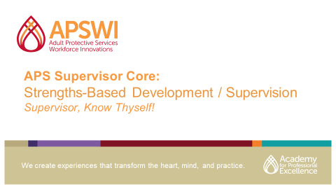

**Moderator:** Welcome everyone and introduce yourself. Explain you will be going over some housekeeping before introducing and handing it over to our trainer.

If virtual, have participants introduce themselves in the chat box by typing their Name, Title, County/Jurisdiction as introduction and for attendance.

1. Today’s training will take place from XX:XX to XX:XX

2. Please stay for the entire duration of the training to receive full credit

3. Introduce/orient participants to participant manual/materials

4. We will be taking some time at the end of training for your evaluation feedback – both verbal and an end-of-training evaluation.

**Slide #3: SDSU School of Social Work**

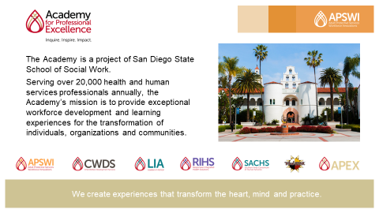

**Moderator: Explain** that the Academy for Professional Excellence is a project of San Diego State School of Social Work. Its mission is to provide exceptional workforce development and learning experiences for the transformation of individuals, organizations and communities.

**Slide #4: About APSWI and the Academy**

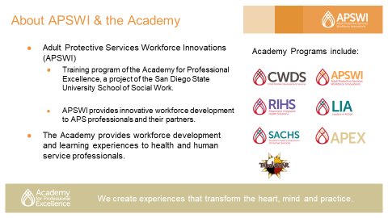

**Moderator: Explain** that Adult Protective Services Workforce Innovations (APSWI) provides innovative workforce development to APS professionals and their partners. APSWI is a program of the Academy for Professional Excellence along with others listed on the slide.

**Slide #5: Technology Overview**

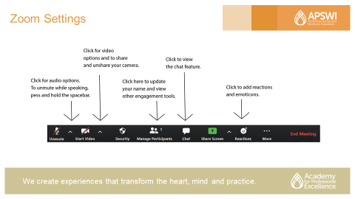

**Trainer/Moderator Note: If participants are equally comfortable with the virtual platform you are using, this slide might not be needed. However, it provides participants an opportunity to get involved right away and establishes that the Moderator is a key partner in this training (if available).**

**Moderator: Introduce participants to the virtual platform functionality**

1. Please click the mic for audio services and to unmute and mute yourself.
2. Next to that is the Video option where you can share and unshare your camera and also click on the arrow above to utilize virtual backgrounds, if you want.
3. Next is the manage participants tab where you can update your name and utilize other engagement tools such as raising your hand.
4. Please click the chat box to view all chats.
   1. You can receive help by private messaging the tech support.
   2. If you need to step away, please type BRB (be right back) into chat, it helps with breakout room assignment.
5. Lastly, you can add reactions during the training by utilizing the reactions tab.

**Slide #6: Changing Your Display Name in a Zoom Meeting**

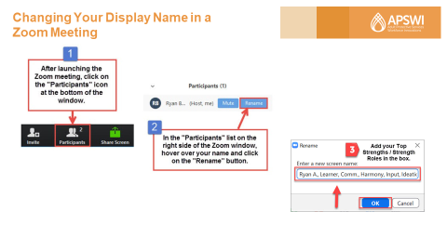

**Moderator:** Review again, for any latecomers. Reminder, please add your Signature (Top 5) Strengths to your name on the Zoom window.

For those who took the StandOut Strengths Assessment, please enter your Top 2 StandOut Roles.

Here are the steps to add them:

1. Click on the "Participants" icon at the bottom of the Zoom window.
2. Find your name on the Participants list. Hover your mouse over your name and click on the "Rename" button.
3. Type your Signature Strengths or Strength Roles next to your name in the field and click "OK" when you are finished.

Feel free to abbreviate in order to squeeze it all in the field.

**Slide #7: Introduction of Trainer**

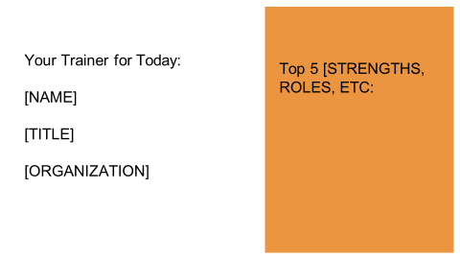

**Trainer Note: Prior to training this course, please add your name, title and your Top 5 strengths, themes, values, roles from the assessment you completed (the exact wording depends on the assessment).**

**Moderator: Introduce** the trainer and hand it over to them.

**Trainer:** As you can see on the slide, my Top 5….

**Slide #8: Learning Objectives**

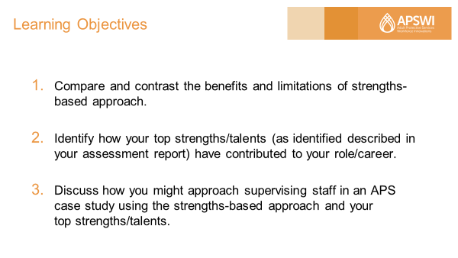

**Trainer**: Briefly review learning objectives.

By the end of this training, you will be able to:

1. Compare and contrast the benefits and limitations of the strengths-based approach.

2. Identify how your top strengths/talents (as described in your strengths assessment report) have contributed to your role/career.

3. Discuss how you might approach supervising staff in an APS case study using the strengths-based approach and your top strengths/talents.

**Slide #9: Group Agreements**

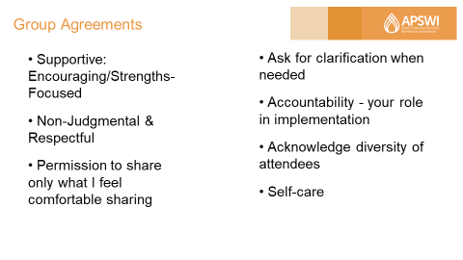

**Trainer Note: Read the agreements aloud from the slide.**

**Trainer:** To help create an online environment where everyone here feels comfortable and safe to share, I'd like to introduce a couple of group agreements.  See if they resonate with you.

**Slide #10: Group Agreements**

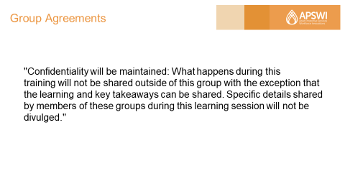

**Trainer Note: Read the Academy's Confidentiality Statement**

"Confidentiality will be maintained: What happens during this trainingwill not be shared outside of this group with the exception that the learning and key takeaways can be shared. Specific details shared by members of these groups during this learning session will not be divulged."

**Trainer: Ask** learners for any additional group agreements to add to the list. *Do a final check with all learners.*

**Trainer: Ask** "Does anyone have any questions about these agreements?" "Is everyone comfortable with all these?"

Thank everyone for upholding these agreements.

**Strengths-Based Approach with Time Allotted (20 minutes)**

**Slide #11: What is Strength?**

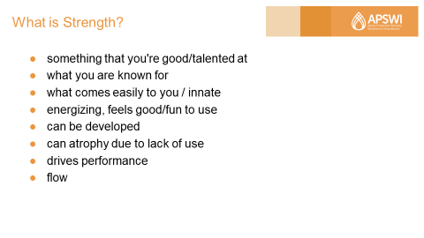

**Trainer Note: Bullet points are animated.**

**Read the answers in the chat box aloud, noting any common answers and affirming learners. Then click on the slide to share your answers.**

**Trainer:** To start, let's see where we are currently as a group in terms of our understanding of what strengths are. What comes to mind when you think of the word “Strength”? It could be a word or phrase.

Go ahead and type your answer into the chat box, but don't press "Enter" yet. We will have everyone press "Enter" together. Okay everyone, go ahead and press "Enter" now.

***Read*** *the answers in the chat box.*

***Click*** *to reveal answers on the slide*

**Trainer:** Here's what I've come up with based on what I see in the literature.  ​

​

*Read these out loud and make connections with the answers shared by learners.*

**Slide #12: Who Represents Strength?**



**Trainer Note: Images are animated.**

**First, ask who comes to mind, read answers and then click 3 times on the slide to share the people graphics.**

**Trainer: Ask:** "**Who** comes to mind when you think of the word 'Strength'?" Go ahead and share in the chat box and press "Enter."

***Read*** *the answers in the chat box aloud.  Then* ***click*** *3 times on the slide to share the people graphics.*

**Trainer:** Notice that there's diversity in our answers. There is no ONE prototype for being strong. Everyone that we mentioned has their unique mix of strengths and talents, which are celebrated. So when we're talking about strengths, let's keep in mind that there are different pathways to success and that we can be successful by leveraging our top strengths and those of our employees.

**Slide #13: Deficit Model**

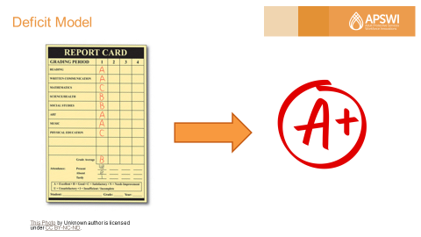

**Trainer Note: The images are animated. Start with the report card, discuss example then click on the screen twice to reveal the arrow and the A+**.

**Trainer:** Unfortunately, this strengths-based approach/perspective did not come about until the latter half of the 1900s from fields, including psychology, therapy, and social work. Historically, the emphasis has been more on the *deficit model,* which focuses onfixing/improving weaknesses.  We see this focus starting in school.

Let's say that in school, you get A's, B's, and C's on your report card. Would your parents or counselor likely say: "Wow, now we know what you're really good at, we will help you get into a career that will leverage your strengths!"

Noooo. Instead, most likely they tell you, "You're in big trouble, young man/young lady!  You're going to buckle down and get these grades up or you're grounded for life."

Does anyone here actually have parents who practiced strengths-based parenting?  Really? Can I join your family?

***Click*** *on the screen twice to reveal the arrow and the A+.*

What went wrong? In this case, grades, became the focus versus what went well/right.

In the workplace, we hire for strengths. Ironically, once people are onboard, traditionally we tend to focus on fixing weaknesses instead of allocating time to cultivate their strengths.  Let's change this.

**Slide 14: Discover Your Strengths**

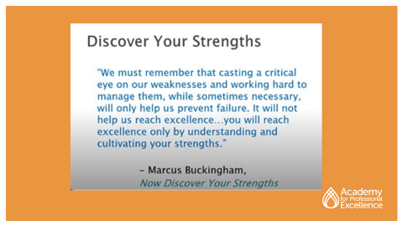

**Trainer:** According to Marcus Buckingham and other experts in the strengths field:

“We must remember that casting a critical eye on our weaknesses and working hard to manage them, while sometimes necessary, will only help us prevent failure. It will not help us reach excellence…you will reach excellence only by understanding and cultivating your strengths.”

**Slide #15: Benefits of Strengths-Based Approach**

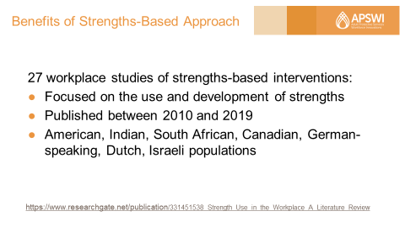

**Trainer:** What could happen if we shift the focus to cultivating strengths at work?

According to a literature review of 27 workplace studies across different populations (including American, Indian, South African, Canadian, German, Dutch, Israeli) published between 2010 and 2019, these were the results of strengths-based interventions.

(Source: Miglianico, Marine & Dubreuil, Philippe & Miquelon, Paule & Bakker, Arnold & Martin-Krumm, Charles. (2020). “Strength Use in the Workplace: A Literature Review.” *Journal of Happiness Studies*. 21. 10.1007/s10902-019-00095-w.)

**Slide #16: Benefits of Strengths-Based Approach**

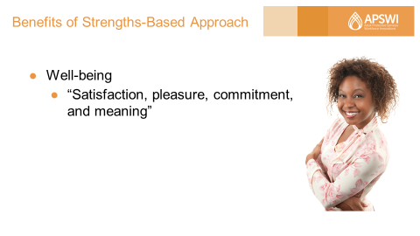

**Trainer:** Benefits of the strengths-based approach include: Positive impact on well-being, including "Satisfaction, pleasure, commitment, and [sense of] meaning.”

**Slide #17: Benefits of Strengths-Based Approach**

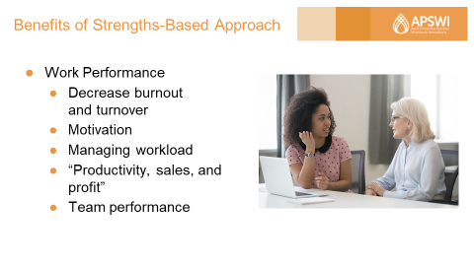

**Trainer:** Developing and using strengths also positively impacts work performance. These interventions decreased employee burnout and turnover, increased employee motivation and ability to manage workload, and overall increased productivity, sales, profit, and team performance.

Gallup researchers have found that the strengths-based approach "… affects key performance outcomes, regardless of the organization's industry or country."

(Source: Gallup. “2015 Strengths Meta-Analysis Report.” <https://www.gallup.com/cliftonstrengths/en/269615/strengths-meta-analysis-2015.aspx>)

**Slide #18: Benefits of Strengths-Based Approach**

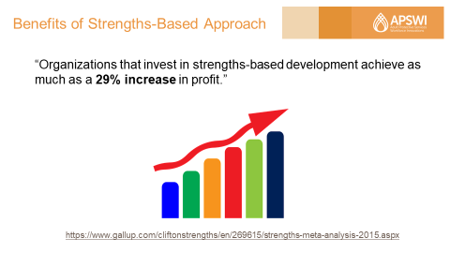

**Trainer:** Gallup researchers also found that "Organizations that invest in strengths-based development achieve as much as a 29% increase in profit.”

(Source: Gallup. “2015 Strengths Meta-Analysis Report.” <https://www.gallup.com/cliftonstrengths/en/269615/strengths-meta-analysis-2015.aspx>)

**Slide #19: Benefits of Strengths-Based Approach**

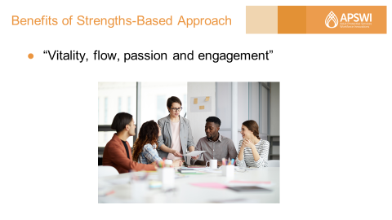

**Trainer:** “Vitality, flow, passion and engagement” are also benefits, according to the literature.

In fact, Don Clifton, of Gallup, found that employees who focus on their strengths at work are **“*six times as likely to be engaged in their jobs* and more than *three times as likely to report having an excellent quality of life in general*.”**

(Source: Rath, T. (2007). StrengthsFinder 2.0. New York: Gallup Press.)

**Slide #20: Benefits of Strengths-Based Approach**

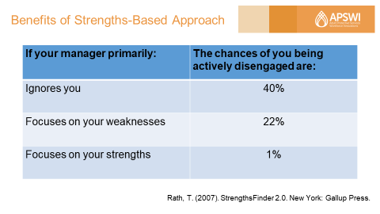

**Trainer:** According to a 2005 Gallup study:

- If your manager primarily ignores you, the chances of you being actively disengaged are 40%

- If your manager primarily focuses on your weaknesses, the chances of you being activity disengaged are 22%

- If your manager primarily focuses on your strengths, the chances of you being activity disengaged are only 1%

(Source: Rath, T. (2007). StrengthsFinder 2.0. New York: Gallup Press.)

**Slide #21: Poll: Strengths Use Gut Check**

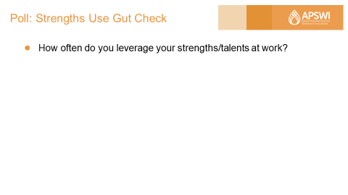

**Trainer:** Let's do a quick gut check here of your use of your strengths at work. We're going to conduct a totally anonymous poll. The question is: "How often do you leverage your strengths at work?" I'm going to give everyone about 15 seconds to pick your best answer. Try not to overthink it.

**Trainer:**Okay, I'm going to close the poll.  Let's see where everyone is at this time.  ​

*Read the results out loud.*​

​

**Trainer:**Wherever you are, I would like everyone to set a goal of moving from where you are to the next level.  For example, if you selected "Sometimes," focus on increasing your use of strengths to "Frequently."  If you selected "Frequently," congratulations!  Look for ways to keep developing and using your strengths.​

​

To help you upgrade your use of strengths, later in this training I will be asking everyone to create 30-day action items related to the strengths-based approach and your top strengths.​

**Note to Moderator:** You will need to program the poll in Zoom with the following question and answers:

How often do you leverage your strengths/talents at work?

* Frequently. My work allows me to exercise my strengths every day/almost every day.
* Sometimes. My role gives me opportunities to exercise my strengths about half the time.
* Rarely.  I don't really get to use my strengths in my role. Work is a constant struggle.

**Slide #22: Limitations of Strengths-Based Approach**

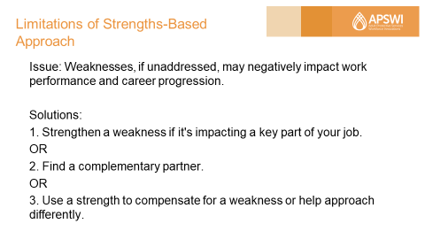

**Trainer Note: Consider using yourself as an example to make it relatable and understandable.**

**Trainer:** Before we dive into your strengths, let's take a look at some cautionary notes that critics of the strengths-based approach have that we should keep in mind for ourselves and our employees:

First, some say that it's not a good idea to ignore weaknesses (or non-strengths) and other performance issues (e.g., low self-esteem) completely because weaknesses, if not addressed, may negatively impact work performance and career progression.

It's suggested to try to strengthen a weakness if it's impacting a key component of your job or seek partnership with someone who can support you in that area.

Actually, another benefit of the strengths-based approach is that it makes it more palatable to talk about weaknesses because we know that everyone has unique strengths, and this approach encourages people to partner with others who have complementary strengths. The efforts to collaborate ultimately support a robust team culture.

Additionally, see whether one of your strengths can help compensate for a weakness or help you look at things or approach the situation in a different way.

(Sources: <https://drjasonjones.com/characterstrengthsapproach/>

<https://www.strengthscope.com/strengths-based-programs-cant-ignore-weaknesses/>)

**Slide #23: Limitations of Strengths-Based Approach**

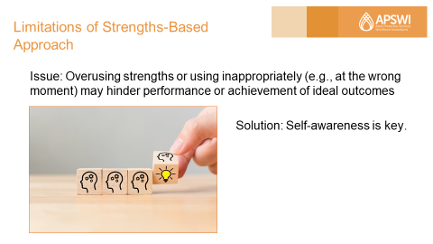

**Trainer:** Another cautionary note is:

Overusing strengths or using them inappropriately (e.g., at the wrong moment) may hinder performance or achievement of ideal outcomes. What counts as “strength” in one context/culture may be seen as weakness in another.

I am going to give you a couple of examples.  See if any of them apply to you:

* + - Being creative when there are existing, effective or “common sense” solutions
    - Being compassionate when being direct is actually called for in the situation
    - Going overboard with details leads to perfectionism and being stuck

**Trainer Note: Engage the learners now by asking them to click on "Raise your hand" or type in the chat box for the following:**

**- Which one of you has gotten into trouble with being overly creative, being compassionate when you should be direct, and being a perfectionistic? Raise your hand.**

Self-awareness is key here. The assessment reports talk about hindering behaviors, or blind spots, when you are overusing strengths or using them inappropriately. You can create an action item to watch yourself for one of these hindering behaviors and use tips provided by the reports.

(Source: [Zhang, Liguo](https://www.grin.com/user/1199071). 2014. “Reflections on the strength based perspective of a social worker.” Munich, GRIN Verlag, <https://www.grin.com/document/341879>)

**Slide #24: Limitations of Strengths-Based Approach**

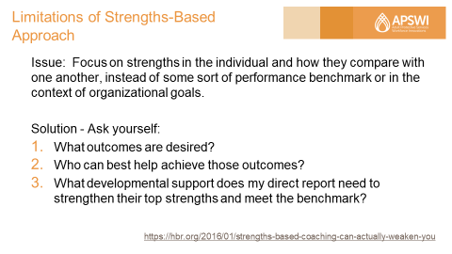

**Trainer:** Another limitation is that the strengths-based approach focuses on individual strengths (the idea that “everyone is talented in their own way”) and how these strengths compare with one another within the individual, as opposed to measuring individual strengths against some sort of performance benchmark (I.e., how does that person's strength compare to that same strength in others? Do they truly have the ability we need to achieve the desired outcomes?) or in the context of organizational goals.

I have a couple of suggestions to help alleviate these concerns. I would like to invite you to go beyond the assessment reports and ask the following questions when considering employees for assignments. Ask yourself:

* What outcomes are desired? (this question will help you set a performance benchmark)
* Among those who have the desired strengths, who can best help achieve those outcomes?
* What developmental support does a particular direct report need to further strengthen their top strengths and meet the performance benchmark? You can identify promising candidates and help them close the gap with custom-tailored developmental plans.

It is suggested by a writer of a Harvard Business Review article that “individual qualities should be considered strengths if they align not only with the individual’s role or job, but also with the organization’s goals or competency framework.”

(Source: <https://hbr.org/2016/01/strengths-based-coaching-can-actually-weaken-you>)

**Slide #25: Limitations of Strengths-Based Approach**

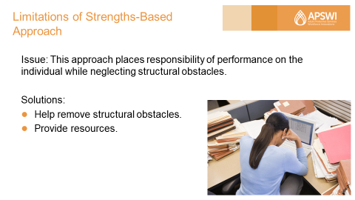

**Trainer:** One other critique is that this approach does not take into account the impact of the social structure, but places responsibility on the person for performance.

We need to recognize what’s within our employees' control/sphere of influence and help remove structural obstacles (e.g., structural inequities that hinder development, inequitable policies, processes, environmental factors), and provide them with the resources that they need.

(Sources: [Zhang, Liguo](https://www.grin.com/user/1199071). 2014. “Reflections on the strength based perspective of a social worker.” Munich, GRIN Verlag, <https://www.grin.com/document/341879>

<https://www.researchgate.net/publication/274821656_Back_to_Basics_A_Critique_of_the_Strengths_Perspective_in_Social_Work>)

**Strengths Assessments with Time Allotted (40 minutes)**

**Slide #26: Strengths Assessments**

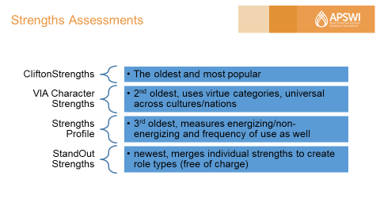

**Trainer:** During the first part of this training, we spent time looking at what a strength is, looked at the difference between the deficit model and the strengths-based approach, and discussed the benefits and limitations of the latter approach.

Now we're going to talk about the four research-based strengths assessments, which you took for pre-work.

On the spreadsheet you received for pre-work, the assessments were listed according to popularity and years in existence.  Let’s quickly review:

* Gallup, publisher of the CliftonStrengths Assessment, offers the most resources. It is also the oldest and most popular assessment here, started in 1949.

The publishers of other assessments also offer a combination of free resources (such as YouTube videos, blog posts, podcasts) and paid resources (e.g., book, courses, certification)

- VIA Character Strengths is second oldest and uses virtue categories, universal across cultures/nations.

- Strengths Profile is third oldest and measures whether a strength is energizing/non-energizing and frequency of use as well.

- StandOut Strengths is the newest and merges individual strengths to create role types, it’s free of charge.

**Slide #27: Strengths Assessment**

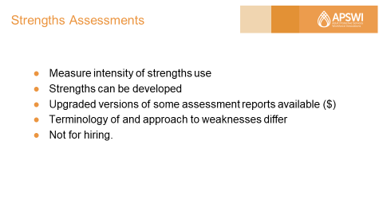

**Trainer:** These assessments measure how intensely you lean into different strengths in everyday life and/or at work.  The developers of these assessments advocate that strengths can be developed further, although their recommendation of which ones to focus on differ. Reports from all assessments include tips to exercise and develop your Top Strengths, although they differ in the number of Top Strengths or Roles that you can focus on.

All assessments, except the StandOut Strengths Assessment, are paid and have upgraded versions of reports that you can purchase to unlock all strengths measured.

The treatment of "weaknesses" differs among the assessments. Some of the assessments call them "lesser strengths" instead of "weaknesses."

One common caution raised with the creators of these assessments is: Don't use these reports/assessments for hiring purposes since people bring different strengths to different roles. Whatever strengths our staff bring, we should help them develop and use their strengths more.

**Slide #28: Your Pre-work**

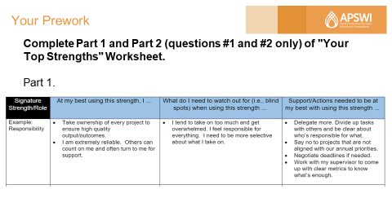

**Trainer Note: Prior to training, review *Pre-work Supplemental Manual* and have available.**

**Refer Participants to Pre-work – Your Top Strengths Worksheet. You don't need to review the example because they are supposed have already read it while completing pre-work. A copy has been included in the Participant Manual in case pre-work was not received/completed.**

**Trainer:** Now we're going to give everyone some time to delve into the impact of their strengths.

For pre-work, you were asked to complete Part 1 and Part 2 (Questions #1 and #2 only) of "Your Top Strengths" Worksheet.  Part 1 consisted of completing this table with your Top 5 Strengths or Top 2 StandOut Roles from the assessment you took and insights from the assessment report and your own reflection. ("At my best using this strength, I …" "What do I need to watch out for (i.e., blind spots) when using this strength …" and ideas on "Support/Actions needed to be at my best with using this strength").

**Slide #29: Your Pre-work**

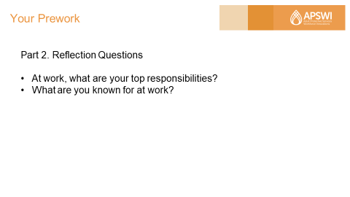

**Trainer:** For Part 2, you completed the first two reflection questions, which are:

1. At work, what are your top responsibilities?

2. What are you known for at work?

You may notice that parts of the answers to these two questions overlap.

**Slide #30: Solo Work: Matching**

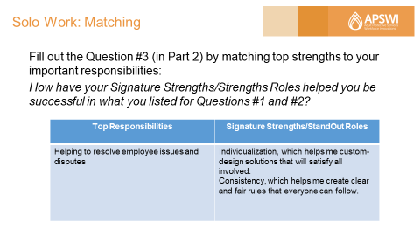

**Trainer:** Now we're going to have you take a look at what strengths you bring to help you be successful in your role. I'm going to give everyone time to fill out Question #3 (in Part 2 of the worksheet), which will match your top strengths to your top responsibilities.

The question is: "How have your Signature Strengths/Strengths Roles helped you be successful in what you listed for Questions #1 and #2?"

Here is an example.

***Trainer Note: Read aloud the example in the table.***

Does anyone have any questions about this example or what they're supposed to do?

**Slide #31: Solo Work: Action Planning**

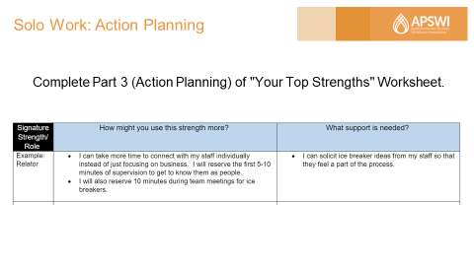

**Trainer:** I'm also going ask everyone to complete Part 3 (Action Planning) of the worksheet. Be as specific as possible.

We will give you 6 minutes to complete these exercises. We will then put everyone in small groups with people who took the same assessment as you so that you can discuss your answers.

**Trainer Note: Ask people if they have any questions about tying their top responsibilities with their Signature Strengths or StandOut Roles. Go over implications whether they are using a lot or a few of their Top Strengths/Strength Roles, including: They may find that tasks that involve lesser strengths or learned behaviors are more taxing to do.**

**Slide #32: Small Group Discussion Questions**

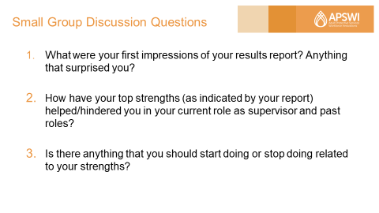

**Moderator Note: You will need to create break out groups of 3-4 people, preferably people who took the same assessment**. **Copy and paste questions into the chat box. They have about 15 minutes total.**

**Trainer:** Welcome back! We're now going to put you all in small groups. Designate a spokesperson in your group to share any a-ha's and patterns in your responses when we come back to the large group.

Here are the discussion questions (most of which were given to you as pre-work):

1. First, introduce yourself and mention your Top 5 Strengths or Top 2 StandOut Roles.
2. What were your first impressions of your results report? Anything that surprised you?
3. How have your top strengths (as indicated by your report) helped or hindered you in your current role as supervisor and past roles? Consider: When you use your top strengths, what kind(s) of feedback have you received from your supervisor and direct reports?
4. Is there anything that you should start doing or stop doing related to your strengths?

**Slide #33: Large Group Discussion**

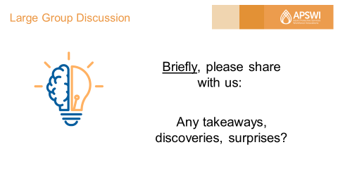

**Trainer Note: Encourage group spokesperson to share. Allot about 5-8 minutes for discussion, more or less depending on time. Turn off screen sharing once everyone is back from breakout rooms.**

**Trainer: Ask** near the end of the debrief: Would you use this assessment with your employees - whether individually or on your team?  Why or why not?

**Strengths-Based Supervision with Time Allotted (40 minutes)**

**Slide #34: Strengths-Based Supervision**

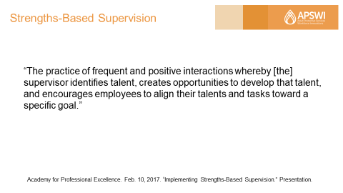

**Trainer:** Now that we've spent time looking at how you can develop your own strengths so that you can be more impactful in your roles, let's turn our attention to how we can apply strengths principles to one of your key responsibilities, which is the supervision of your staff.

Here we have a definition of Strengths-Based Supervision: “The practice of frequent and positive interactions whereby [the] supervisor identifies talent, creates opportunities to develop that talent, and encourages employees to align their talents and tasks toward a specific goal.”

**Slide #35: Strengths-Based Supervision Examples**

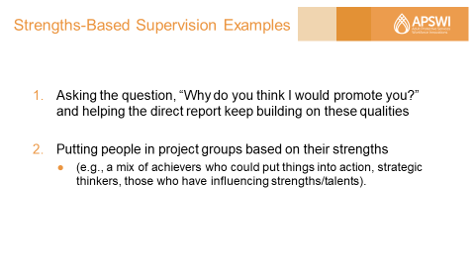

**Trainer:** Here are two examples of Strengths-Based Supervision by an actual APS supervisor:

* In one case, these questions were asked by an APS supervisor of a direct report:

“Why do you think I would promote you?” and “Why wouldn’t I promote you?” The supervisor then focused on helping the direct report keep building on qualities that came up for question #1 with the belief that strengths will squash out weaknesses.

* In another case, an APS supervisor put people in project groups based on their strengths (e.g., a mix of achievers who could put things into action, strategic thinkers, those who have influencing strengths). This supervisor noted that there was a tendency for people to concentrate on what was wrong. By focusing on what they could do and their strengths, the supervisor engaged these social workers, some of whom had experienced secondary trauma on the job, and helped them manage work pressure, perform at their best, and have a common language to speak intelligently and constructively with their supervisor.

**Slide #36: Strengths-Based Supervision**

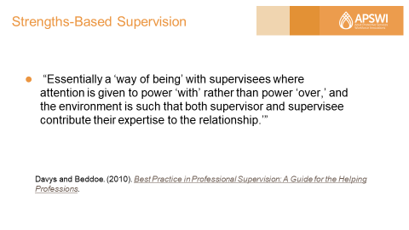

**Trainer:** Another way to look at strengths-based supervision is the following:

* “Essentially [it is] a ‘way of being’ with supervisees where attention is given to power ‘with’ rather than power ‘over,’ and the environment is such that both supervisor and supervisee contribute their expertise to the relationship’” (p.38).

What are called out in this description are the principles of:

* shared responsibility
* shared learning
* shared leadership

The case study in the exercise that we will be looking at and discussing later in this training is an example of these principles.

(Source: Davys and Beddoe. (2010). *Best Practice in Professional Supervision: A Guide for the Helping Professions*.)

**Slide #37: Poll – Strengths-Based Supervision**

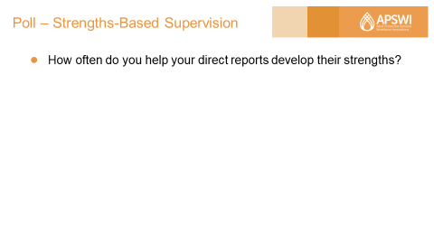

**Trainer:** We're going to do another gut check, this time of your practice of Strengths-Based Supervision. Here's another totally anonymous poll and the question is: "How often do you help your direct reports develop their strengths?"

**Note to Moderator:**You will need to program the poll in Zoom with the question and the following answers:

How often do you help your direct reports develop their strengths?

* Always/Almost Always.  I integrate Strengths-Based Supervision in every/almost all my individual meetings with staff.
* Frequently. I practice Strengths-Based Supervision often/consistently (at least weekly), but I know that I can do better.
* Sometimes. I practice Strengths-Based Supervision about maybe half the time or less, or not consistently.
* Rarely.  I rarely or don't practice Strengths-Based Supervision in my role.

**Trainer:** I'm going to give everyone about 15 sec to pick your best answer.  Again, try not to overthink it. Okay, I'm going to close the poll. Let's see where everyone is at this time.

*Read the results out loud.*

**Trainer:** Of course, there's always room for improvement, right?

**Slide #38: Solo Activity – Self-Assessment**

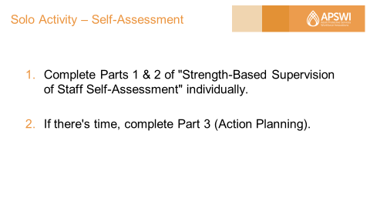

**Trainer Note: You will find Handout #1 in Appendix A.**

**Refer Participants to Handout #1 Strength-Based Supervision of Staff Self-Assessment. This exercise will take them about 8 minutes to do (3 minutes just to fill out the table).**

**Trainer:** Our next activity will give you an opportunity to evaluate and remind yourself of specific strengths-based supervision practices. This activity will also prepare us to evaluate the case study exercise later in this training.

Complete Parts 1 and 2 of the "Strength-Based Supervision of Staff Self-Assessment" tool individually. If there's time, complete Part 3 (Action Planning). I will give everyone a couple of minutes to do this activity.

**Trainer: Ask** people if they have any questions. You have about 8 minutes to complete it.

After the time is up, **Ask** people to share any major takeaways. **Ask** them whether their own gut check aligns with the results of the self-assessment.​

Let them know that subsequent modules will go into depth with cultivating the strengths of your employees using feedback, coaching, and other developmental opportunities.

**Slide #39: Tools: Strengths-Based Questions**

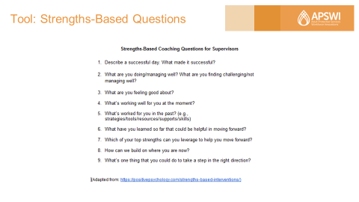

**Trainer Note: You will find Handout #2 in Appendix B.**

**Refer to Handout #2 – Strengths-Based Coaching for Supervisors.**

**Trainer:** This handout contains 9 powerful coaching questions that you can use with their staff. These questions will draw out their staff members' resourcefulness, as well as help them feel a sense of accomplishment.

**Slide #40: Small Group Work: APS Scenario**

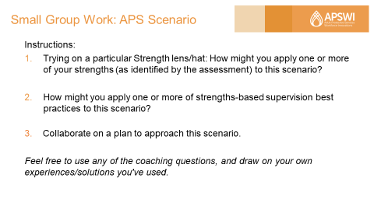

**Moderator Note: Copy and paste questions into the chat box.**

**Trainer:** We're now going to help you integrate what we've learned about strengths-based development and supervision and about your own strengths in this case study activity where you will work together in small groups. I will share the actual resolution of the case study after we come back into the large group.

In consideration of your Signature/Top Strengths and the "Strength-Based Supervision of Staff Self-Assessment" that you completed:

* Try on a particular Strength lens/hat: How might you apply one or more of your strengths (as identified by the assessment) to this scenario?
* How might you apply one or more of the strengths-based supervision best practices that you read in the self-assessment to this scenario?
* With your group members, come up with a plan to approach this scenario and be prepared to share in the large group.

Also, feel free to use any of the nine coaching questions, and draw on your own experiences and solutions that you’ve used.

**Slide #41: Small Group Work: APS Scenario**

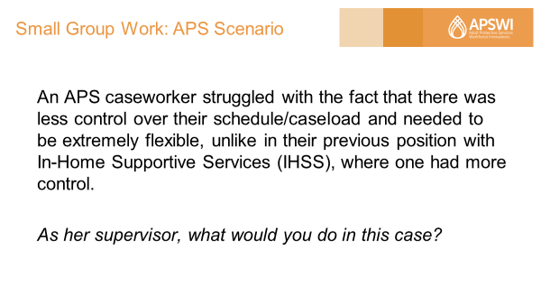

**Moderator Note: Copy and paste the case study into the chat box. Put everyone in the same groups that they were in earlier. There is 15 minutes for discussion.**

Scenario: An APS caseworker struggled with the fact that there was less control over their schedule/caseload and needed to be extremely flexible, unlike in their previous position with In-Home Supportive Services (IHSS), where one had more control.

Question: As her supervisor, what would you do in this case?

**Slide #42: Large Group Debrief**

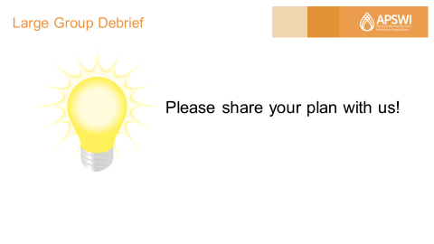

**Trainer Note:  Turn off screen sharing once everyone is back from breakout rooms. Ask for volunteers to share. Plan on no more than 5-8 minutes for this portion of the training. Then take 1 min. to share the resolution.**

**Trainer:** Resolution – This caseworker has taken the CliftonStrengths Assessment and discovered that she had Discipline and Focus as her Top Strengths. This worker’s supervisor assigned the exercise of researching and understanding the basement behaviors of these two CliftonStrengths. The worker soon realized that there is a tendency for someone with Discipline as a top CliftonStrength to be too rigid and controlling. The supervisor and the employee discussed and looked at balcony behaviors for these two talent themes (i.e., what does it look like to engage in these behaviors in productive ways) so that the caseworker was able to catch herself before slipping into rigidity and get support. The supervisor also provided the following tips, including:

* Acknowledge the frustration. Things get messed up.
* It’s okay to be vulnerable.
* Allow yourself to re-group and restructure the plan to get a new plan.
* Leave more room in your schedule for the unexpected.
* Ask yourself: How do I bring myself back to working with my talents/strengths in order to help my families and my organization? [this is a strengths-based question]

**Slide #43: What Are You Committed to?**

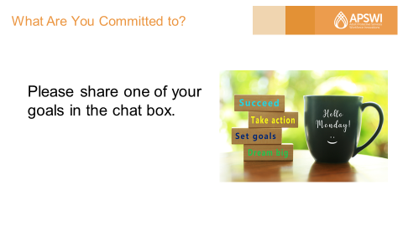

**Trainer:** Thank you all for your participation.  Hope these activities have helped formulate some aha's on your understanding of where you are at in terms of using your Top Strengths and strengths-based supervision best practices in your work.

We're going to end by having everyone share one goal specific to using one of your top strengths or a best practice more intentionally for the next 30 days.

**Ask**people to enter one goal that they're committing to into the chat box and ask them to wait to press "Enter" until your prompt.  Read the goal statements out loud.

**Closing and Evaluation with Time Allotted (5 minutes)**

**Slide #44: Evaluation**

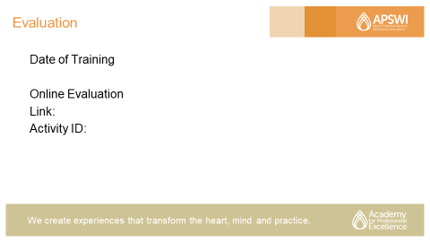

**Moderator:** Provide any instructions concerning the course evaluation for this training or any activities you generally use to close out a session of this type.

**Slide #45: Thank You**

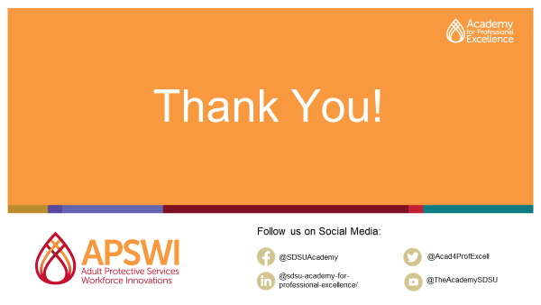

**Moderator: Thank** participants for their time today and active participation.

**References**

Academy for Professional Excellence. Feb. 10, 2017. “Implementing Strengths-Based Supervision.” Presentation.

Chamorro-Premuzic, T. (2016, January 4). “Strengths-Based Coaching Can Actually Weaken You.” *Harvard Business Review*.<https://hbr.org/2016/01/strengths-based-coaching-can-actually-weaken-you>

CliftonStrengths Assessment. <https://www.gallup.com/cliftonstrengths/en/252137/home.aspx>

Davys, Allyson & Beddoe, Liz. (2010). *Best Practice in Supervision: A Guide for the Helping Professions.* <https://www.researchgate.net/publication/235961794_Best_Practice_in_Supervision_A_Guide_for_the_Helping_Professions>

Gallup. “2015 Strengths Meta-Analysis Report.”

<https://www.gallup.com/cliftonstrengths/en/269615/strengths-meta-analysis-2015.aspx>

Gallup. “2018 CliftonStrengths Meta-Analysis Report.”

<https://www.gallup.com/cliftonstrengths/en/270350/2018-cliftonstrengths-meta-analysis-report.aspx>

Gray, Mel. (2011). “Back to Basics: A Critique of the Strengths Perspective in Social Work.” *Families in Society: The Journal of Contemporary Social Services*. 92: 5-11. 10.1606/1044-3894.4054.

“How is Strengths-based Supervision Different?” St Luke’s Innovative Resources. (2019). Retrieved February 5, 2021, from<https://innovativeresources.org/how-is-strengths-based-supervision-different/>

Jones, J. (n.d.). “The Two Problems with the Strengths-Based Approach.” Retrieved February 5, 2021, from<https://drjasonjones.com/characterstrengthsapproach/>

Jones-Smith, E. (2014). *Strengths-Based Therapy*. Thousand Oaks, CA: Sage.

Miglianico, Marine & Dubreuil, Philippe & Miquelon, Paule & Bakker, Arnold & Martin-Krumm, Charles. (2020). “Strength Use in the Workplace: A Literature Review.” *Journal of Happiness Studies*. 21. 10.1007/s10902-019-00095-w.

Miller, D. (2016, October 19). “Which Strengths Tool Should I Use? The Case for Strengths Profile. Langley Group.”<https://langleygroup.com.au/which-strengths-tool-should-i-use-the-case-for-strengths-profile-formerly-r2-strengths-profile/>

Passions, Erin. “Discover Your Strengths: An Introduction to Strengths-Based Development.” Webinar. <https://register.gotowebinar.com/recording/2636832690786419201>

Rath, Tom. *Strengths Finder 2.0: Discover Your Strengths*. New York: Gallup Press, 2007.

[StandOut Strengths Assessment](https://www.marcusbuckingham.com/). <https://www.marcusbuckingham.com/>

Strengths Profile. <https://www.strengthsprofile.com/en-us/who/individuals>

VIA Character Strengths Survey. <https://www.viacharacter.org/survey/account/register>

“Why Strengths Based Programs Can’t Ignore Weaknesses.” (2018, April 13). Strengthscope.<https://www.strengthscope.com/strengths-based-programs-cant-ignore-weaknesses/>

[Zhang, Liguo](https://www.grin.com/user/1199071). 2014. “Reflections on the strength based perspective of a social worker.” Munich, GRIN Verlag, <https://www.grin.com/document/341879>

# **Appendix A**

# **Handout #1**

**Strengths-Based Development/Supervision of Staff Self-Assessment**

# Part 1: Self Evaluation

Instructions: In the table below, indicate with an “X” how often you practice each of the following strength-based behaviors in supervision.[1]

|  |  |  |  |  |
| --- | --- | --- | --- | --- |
| **Best Practice Behaviors** | **Always/** **Almost Always** | **Sometimes** | **Rarely** | **Never** |
| 1. I spend at least one hour a month with my staff on identifying their strengths and weaknesses in performance. |  |  |  |  |
| 1. I give my staff specific, strength-based feedback. |  |  |  |  |
| 1. I make expectations and outcomes clear with my staff, and expectations and outcomes are stated in strength-based language. |  |  |  |  |
| 1. I ask my staff for feedback on my supervision to learn about my strengths and areas for improvement. |  |  |  |  |
| 1. I celebrate with my staff when they meet professional goals. |  |  |  |  |
| 1. I take time to learn about my staff members’ lives to better understand their unique cultural values and strengths. |  |  |  |  |
| 1. I acknowledge - verbally and in writing - my staff members who are doing good work. I try to notice those who are doing the right things. |  |  |  |  |
| 1. I regularly ask my staff members for ideas on how to improve the operations of the agency, perform follow-up, and advocate for ideas that might work. |  |  |  |  |
| 1. I write employee performance reports that are strength-based; each item reflects a positive outcome (change) that is expected/desired. |  |  |  |  |
| 1. I work to create a positive environment for my unit. |  |  |  |  |
| 1. I demonstrate confidence in the ability of my staff to make good decisions and let them do the job in a way they think it should be done. |  |  |  |  |
| 1. When mistakes occur, I avoid blame and, instead, work with the staff member to find ways to prevent similar problems in the future. |  |  |  |  |

# Part 2. Summary

Instructions: In the text boxes below, summarize your strengths as a supervisor (i.e., behaviors indicated with an “Always/Almost Always” rating) and identify 3 areas for improvement.

|  |
| --- |
| My Strengths as a Supervisor:  *Example: I make expectations and outcomes clear with my staff. I take time to learn about my staff members’ lives to better understand their unique cultural values and strengths.* |

|  |
| --- |
| Potential Areas for Improvement:  *Example: I need to celebrate with my staff more when they meet professional goals.* |

Part 3. Action Planning

Instructions: Create a developmental plan for yourself in the form of goal statements (specifying when, where, and what) to strengthen those areas needing improvement.

|  |
| --- |
| Action Plan for Improvement:  *Example: Starting in April, I will set aside 10 minutes at the beginning of every team meeting for reviewing and celebrating milestones and successes achieved by my staff during the previous month.* |

**Appendix B**

**Handout #2**

**Strength-Based Coaching Questions for Supervisors**

1. Describe a successful day. What made it successful?
2. What are you doing/managing well? What are you finding challenging/not managing well?
3. What are you feeling good about?
4. What’s working well for you at the moment?
5. What’s worked for you in the past? (e.g., strategies/tools/resources/supports/skills)
6. What have you learned so far that could be helpful in moving forward?
7. Which of your top strengths can you leverage to help you move forward?
8. How can we build on where you are now?
9. What’s one thing that you could do to take a step in the right direction?

(Adapted from: [https://positivepsychology.com/strengths-based-interventions/)](https://positivepsychology.com/strengths-based-interventions/)

**Moderator/Co-Host Tip Sheet**

Slide #2 Welcome, page 18

* Type in Chat Box “Please enter name, county, and role for attendance records”.

Slides #3-7, pages 19-23 – follow script in trainer manual

Slide #21: Poll Strengths Use Gut Check, page 37

* You will need to program the poll in Zoom with the following question and answers:

*Poll Question: How often do you leverage your strengths/talents at work?*

* *Frequently. My work allows me to exercise my strengths every day/almost everyday.*
* *Sometimes. My role gives me opportunities to exercise my strengths about half the time.*
* *Rarely.  I don't really get to use my strengths in my role. Work is a constant struggle.*

Slide 32: Small Group Discussion Questions, page 48

* For virtual delivery, you will need to create small groups of 3-4 participants, preferably people who completed the same assessment, via your platform and list the instructions in the chat box prior to sending them to breakout groups. They have approx. 15 minutes.
* Activity Instructions: Please designate a spokesperson in your group to share any a-ha's and patterns when we come back to the large group. You have approx. 15 minutes.

Here are the discussion questions (most of which were given to you as pre-work):

1. First, introduce yourself and mention your Top 5 Strengths or Top 2 StandOut Roles.
2. What were your first impressions of your results report? Anything that surprised you?
3. How have your top strengths (as indicated by your report) helped or hindered you in your current role as supervisor and past roles? Consider: When you use your top strengths, what kind(s) of feedback have you received from your supervisor and direct reports?
4. Is there anything that you should start doing or stop doing related to your strengths?

Slide 37: Poll – Strengths-Based Supervision, page 53

* You will need to program the poll in Zoom with the following question and answers:

*Poll Question: How often do you help your direct reports develop their strengths?*

* *Always/Almost Always.  I integrate Strengths-Based Supervision in every/almost all my individual meetings with staff.*
* *Frequently. I practice Strengths-Based Supervision often/consistently (at least weekly), but I know that I can do better.*
* *Sometimes. I practice Strengths-Based Supervision about maybe half the time or less, or not consistently.*
* *Rarely.  I rarely or don't practice Strengths-Based Supervision in my role.*

Slide #40/41: Small Group Work: APS Scenarios, Page 56-57

* For virtual delivery, put people into the same small groups of 3-4 participants. Copy and paste questions and scenario into the chat box. They have 15 minutes for discussion.
* Activity Instructions: Please designate a spokesperson in your group to share when we come back to the large group. You have approx. 15 minutes.  
  + Try on a particular Strength lens/hat: How might you apply one or more of your strengths (as identified by the assessment) to this scenario?
  + How might you apply one or more of the strengths-based supervision best practices that you read in the self-assessment to this scenario?
  + With your group members, come up with a plan to approach this scenario and be prepared to share in the large group.

Scenario: An APS caseworker struggled with the fact that there was less control over their schedule/caseload and needed to be extremely flexible, unlike in IHSS where one had more control.

Question: As her supervisor, what would you do in this case?

Slide #44: Evaluations, page 60

* Provide any instructions concerning the course evaluation for this training or any activities you generally use to close out a session of this type.

Slide #45: Thank you, page 61

* Thank participants for their time today and active participation.

This page is intentionally left blank.



1. Adapted from the work of Nora Gerber and Gil De Gibaja in *“Assessing My Own Strength Based Work,”* Strength-Based Family Centered Practice for CSWs. Training curriculum, Los Angeles County Department of Children and Family Services, 2004.