Trainer Manual
The Unique Role of the APS Supervisor
Virtual Course

This training was developed by the Academy for Professional Excellence, with funding from the California Department of Social Services, Adult Programs Division.

Curriculum Developer, 2020
Amy Waszak, LMFT

© 2021. San Diego State University School of Social Work, Academy for Professional Excellence. Please acknowledge this copyright in all non-commercial uses and attribute credit to the developer and those organizations that sponsored the development of these materials. No commercial reproduction allowed.
INTRODUCTION
THE ACADEMY FOR PROFESSIONAL EXCELLENCE

We are pleased to welcome you to The Unique Role of the APS Supervisor Trainer Manual (Module 1B), developed by Adult Protective Services Workforce Innovations (APSWI), a program of the Academy for Professional Excellence under a grant from the California Department of Social Services, Adult Programs Division.

The Academy for Professional Excellence, a project of San Diego State University School of Social Work, was established in 1996 to provide exceptional workforce development and organizational support to the health and human services community by providing training, technical assistance, organizational development, research, and evaluation. Serving over 20,000 people annually, the Academy continues to grow with new programs and a diversity of training focused on serving the health and human services community in Southern California and beyond.

The Academy is a project of San Diego State University School of Social Work (founded in 1963), which offers both a bachelor’s and master’s degree in Social Work. The School of Social Work at San Diego State University was founded in 1963 and has been continuously accredited by the Council of Social Work Education since 1966.

APSWI is a program of the Academy for Professional Excellence. APSWI is designed to provide competency-based, multidisciplinary training to Adult Protective Services professionals and their partners. APSWI’s overarching goal is the professionalization of Adult Protective Services professionals to ensure that abused and vulnerable older adults and adults with disabilities receive high quality, effective interventions and services.

In partnership with state and national organizations, APSWI is developing a national APS Supervisor Core Competency Training Curriculum. This curriculum is developed, reviewed and approved by experts in the elder and dependent adult abuse fields.

APSWI’s partners include:
• National Adult Protective Services Association (NAPSA) Education Committee
• California Department of Social Services (CDSS), Adult Programs Division
• County Welfare Directors Association of California (CWDA), Protective Services Operations Committee (PSOC)

PARTNER ORGANIZATIONS

Dawn Gibbons-McWayne Krista Brown
Program Manager, APSWI APS Leaders Institute Program Coord, APSWI
Academy for Professional Excellence Academy for Professional Excellence
https://theacademy.sdsu.edu/programs/ https://theacademy.sdsu.edu/programs/

Lori Delagrammatikas Paul Needham
Executive Director Chair
National Adult Protective Services Association NAPSA Education Committee
(NAPSA) napsa-now.org
napsa-now.org

Kim Rutledge Chris Alire and Francisco Wong
Adult Protective Services Liaison Co-Chairs
Adult Protective Services Division Protective Services Operations Committee of
California Dept. of Public Social Services the County Welfare Director’s Association
cdss.ca.gov/Adult-Protective-Services cwda.org/about-cwda

THE ACADEMY FOR PROFESSIONAL EXCELLENCE
6505 Alvarado Road, Suite 107, San Diego, CA 92120
Tel: (619)594-3546 – Fax: (619)594-1118 – http://theacademy.sdsu.edu/programs/

ACKNOWLEDGEMENTS

This training is the result of a collaborative effort between Adult Protective Services administrators, supervisors, staff development officers and workers across the state and the nation; professional educators; and the Academy for Professional Excellence staff members. APSWI would like to thank the following individuals and agencies:

Agencies
California Department of Social Services, Adult Programs Division
Arizona Department of Economic Security, DAAS-Adult Protective Services
National Adult Protective Services Association

Supervisor Curriculum Advisory Committee
Kristina Allwood, Program Manager, Institute for Human Services, Inc. (OH)
Nujoud Al-Salem, ACL Grant Program Coord, DAAS-APS, AZ Dept. of Economic Security
Cathy Bahadur, APS Section Manager, GA Department of Human Services
Rosemary Barrington, APS Supervisor, DAAS-APS, AZ Department of Economic Security
Jessica Burke, Staff Development Officer, Riverside County
Kathleen Calderon, Lead Policy Specialist, APS Policy Unit, CO Dept. of Human Services
Kelsey Cato, APS Training Program Manager, WA State Dept. of Social and Health Services
Kama Chase, APS District Program Manager, DAAS-APS, AZ Dept. of Economic Security
Lori Delagrammatikas, Executive Director, NAPSA
Denise Dorsey, Program Manager, Tehama County
Tammy Douglass, APS Social Services Supervisor, Kings County
Esmeralda Garcia, Social Worker Supervisor II, San Luis Obispo County
Markita Grant, Office of Aging, Policy and Training Unit, GA Dept. of Human Services
Michael Hagenlock, Adult Protective Services Bureau Chief (MT)
Liora Levenbach, APS Supervisor II, Humboldt County
Nicole Medina, Program Consultant, APS Division, VA Dept. for Aging and Rehabilitative Services
Paul Needham, Chair, NAPSA Education Committee
Ashley Shively, Social Worker Supervisor II, Humboldt County
Valerie Smith, Social Services Program Manager, Santa Clara County
Sara Stratton, Consultant, City and County of San Francisco
Erin Van Duzer, Unit Manager, Tulare County
Amy Wasnak, APS Supervisor, San Diego County
Latrice Watson, Social Worker, IV, Humboldt County

Committees
National Adult Protective Services Association Education Committee

Curriculum Developer
Amy Waszak, LMFT
TABLE OF CONTENTS
GENERAL INFORMATION
Introduction……………………………………………………………………… 3
Partner Organizations………………………………………………………….. 4
Acknowledgements…………………………………………………………….. 5
Table of Contents………………………………………………………………. 6
How to Use this Manual ………………………………………………………. 7
Trainer Guidelines …………………………………………………………….. 8
Virtual Training Tips …………………………………………………………… 9
Executive Summary …………………………………………………………… 11
Course Outline …………………………………………………………………. 12

WELCOME AND INTRODUCTIONS
Welcome, Introductions and Housekeeping ……..………………………… 14
Technology Overview ………………………………………………………… 17
Meet and Greet ……………………………………………………………….. 18
Course Goals and Objectives ……………………………………………….. 19

SUPERVISORY ROLES – EDUCATIONAL, SUPPORTIVE AND
ADMINISTRATIVE
APS Cultural Framework .….………………………………………………… 20
APS Supervisory Roles …….………………………………………………… 22
Educational Role ……………………………………………………………… 23
Supportive Role ……………….………………………………………………. 26
Administrative Role …………………………………………………………… 28
HR Best Practice Tips ………….…………………………………………….. 30

APS SUPERVISOR COMPETENCIES
APS Supervisor Competencies ….………………...................................... 31

TRANSITIONING INTO THE SUPERVISOR ROLE
Transitioning in the Supervisor Role ……………………………………… 32
Transitioning: Peer to Supervisor ……………………………………..……. 33
Transitioning from Outside APS ………………….………………….……… 35
Professional Boundaries for Supervisors – Case Scenarios ……….……. 37

CLOSING AND EVALUATION
Closing Thoughts …………………………………………………………….. 39
Evaluation ………………………………………………………………….…. 40
Thank You …………………………………………………………………….. 41
References ………………………………………………………………….… 42
Appendix A – Pre-Work ……………………………………………………… 43
Appendix B – Handout 1 …………………………………………………….. 44
Appendix C – Handout 2 …………………………………………………….. 46
Moderator/Co-Host Tip Sheet……………………………………………….. 47
HOW TO USE THIS MANUAL

This curriculum was developed as a virtual 120 min workshop using the Zoom platform, paying close attention to virtual training best practices. It can be tailored to a different virtual platform (WebEx, GoTo Training, etc.), if necessary. It may also be trained in-person by modifying activity and engagement prompts as necessary. When possible, virtual and in-person prompts are given.

The Pre-Training Assignment (See Appendix A) and instructions should be sent via email one-week prior to the training date. The Participant Manual should also be sent ahead of time as a fillable PDF if using Adobe Acrobat or to allow participants to print a hard copy.
- Actions which the trainer takes during the training are written in bold.
Trainer Notes are written entirely in bold text box and are provided as helpful hints.

Moderator Notes are written entirely in bold text box and are provided as helpful hints.
- When there are Trainer and Moderator notes both on same page, Trainer and Moderator is underlined.

Use of language: Throughout the manual, staff is used most often to describe supervisees or units/teams. The broader term (APS) worker is also used to denote individual staff who may go by various titles. The term client is used most often to describe the individual at the center of the APS investigation. However, if concept or material was directly quoted from copyrighted material, another term may be used.

He and she have been replaced with the gender-neutral they throughout this manual, unless quoted from copyrighted material. This should not be thought of as plural persons, but rather a gender-neutral term describing all humans.

Customizing the Power Point:

This manual is set up so that the trainer script/ background material is on the same page as the accompanying PowerPoint slide.
Hide a slide instructions:
1. On the Slides tab in normal view, select the slide you want to hide.
2. On the Slide Show menu, click Hide Slide.
The slide number will have a line through it to show you have hidden it.
NOTE: The slide remains in your file even though it is hidden when you run the presentation.

The course outline, provided in the next section of this manual, is the class schedule used for development of this curriculum. It can be used to help determine how much time is needed to present each section. However, times will vary based on the experience and engagement of the audience.
TRAINER GUIDELINES
It is recommended that someone with APS supervisory experience facilitate this virtual workshop.
Suggestions for virtual training when possible:
- Have a moderator or co-host who can primarily focus on the virtual aspects of this training (e.g., monitoring chat box, launching polls, assigning breakout groups, monitoring participant reactions, etc.).
  - A Moderator/Co-Host Tip sheet is on Pages 47-48
- Test out the use of the breakout room feature prior to conducting this training.
- Log in at least 30 minutes prior to the training to ensure the virtual classroom is fully functioning and that you are comfortable navigating it.
- Your equipment and platform may dictate how you do some activities or discussion. There are times you may not be able to see everyone’s faces, names or reactions (thumbs up, mute/unmute, etc.). There is a need for both verbal discussion and chat discussion. At such times, the moderator will fill a critical role monitoring those features you cannot. Practice during a run through how you will use the various functions for each section.
- The optimal size for this virtual training is 20-25 participants.

Teaching Strategies | The following instructional strategies are used:  - Lecture segments  - Interactive exercises (e.g., breakout groups, chat box discussion, polling activities)  - Question/answer periods  - PowerPoint Slides
Materials and Equipment | The following materials are provided and/or recommended:  - Trainer Manual  - Participant Manual (fillable PDF)  - PowerPoint Slides  - Headset with microphone  - Computer

VIRTUAL TRAINING TIPS
Training and facilitation have always been an art. Virtual training is no exception. Below are some helpful tips to remember and implement when training in a virtual environment.
- Assume nothing.
  - Do not assume everyone has the same knowledge or comfort level with technology or has access to equipment like printers, video camera, headsets or even reliable Wi-Fi.
- Distractions are everywhere.
  - Participants have greater access to distractions (email, phone, others at home) which can take their focus away from the training. Therefore, explain everything and summarize before asking participants to complete an activity and check for clarification.
- Over explain when possible.
  - The virtual room doesn’t allow for participants to see everything you’re doing as they can in-person. Share as you navigate the virtual environment. If you are silent while looking for something or finding a screen, they may think something is frozen.
- Mute with purpose.
  - “Mute all” function can help ensure we don’t hear conversations we’re not supposed to. However, it can also send a message to the participants that they are a passive participant and may not make them feel comfortable taking themselves off mute when you want them to speak.
- Two screens can be a lifesaver.
  - This allows you to move your chat box or participant gallery view away from your presentation so you can see more of what’s going on.
- Rely on practice, not luck.
  - Winging it during an in-person training or facilitation may work from time to time, but doesn’t work in the virtual environment. In addition to covering the content, you have to manage all of the technology issues, learning styles in a virtual room, and it will show if you’re not prepared.
- Bring the energy.
  - As trainers, we are no strangers to being “on,” standing and moving around. However, some of the body language, subtle nonverbal skills we relied on the in-person training room do not translate well in the virtual environment. While this may make you more tired, it’s important to up your enthusiasm, voice, and presence in order to engage with attendees.
- Be mindful of your space.
  - Training virtually brings an entirely new component of what we’re willing to share with others. Learners can get distracted with what’s in your background, whether what is physically there or if you set your video to use a virtual background.
  - It’s important to reflect on questions of privilege, diversity and equity when thinking of your training space.
Continued
    - Are there objects in your background that can symbolize status, privilege and/or power? If so, consider removing them to dismantle any added power dynamics that already exist with you as the Trainer.
    - Unknowingly, objects can come across as offensive or can activate unpleasant or traumatic memories, and can instantly discredit your rapport building. Think of neutral backgrounds that are not distracting and allow you to be the focus of what learners see.

EXECUTIVE SUMMARY - THE UNIQUE ROLE OF THE APS SUPERVISOR
Without a doubt, supervisors have one of the most multifaceted and difficult roles within APS programs. A clear understanding of key roles and responsibilities is instrumental for job success and satisfaction. Join us for this interactive, foundational training outlining the educational, supportive and administrative roles of APS supervision. Explore APS supervisor competencies, best practice tips around transitioning from peer to supervisor, and the importance of professional boundaries for supervisors.

Virtual Training:
- The following virtual instructional strategies are used throughout the course: short lectures (lecturettes), interactive activities/exercises including breakout groups, chat box discussions, large group discussions, self-reflection, poll options, and individual practice. PowerPoint slides and role playing/demonstrations are used to stimulate discussion and skill development.

- Participants will need access to a computer with video conferencing capability and be able to connect to the virtual platform being used to deliver this training. A headset or earbuds with microphone and a video camera are highly encouraged. Participant Manual is a fillable PDF if using Adobe Acrobat. Participants are encouraged to either print a hard copy or ensure access to Adobe Acrobat to allow for highlighting, typing in comments and filling out worksheets.

Course Requirements:
- Pre-Training Assignment: Prior to the training, participants will be asked to complete the APS Supervisory Task Self-Analysis; it will take approximately 15 minutes. Note strength areas and areas that need improvement. This must be completed prior to attending the training. This self-analysis will be included in a processing activity and needs to be readily available for the training.
- Completion of the entire module is required to receive course completion credit.
Target Audience: This workshop is intended for new supervisors or experienced staff who may require a refresher.

Outcome Objectives for Participants:
By the end of this training participants will be able to:
- Identify the three key roles of an APS supervisor and practice at least one element from these roles.
- Discuss the six APS Supervisor Competencies and identify areas for individual growth and development.
- Use case scenarios to discuss the issues that may arise around professional boundaries for supervisors and possible solutions.

COURSE OUTLINE
CONTENT | MATERIALS | TIME
WELCOME, HOUSEKEEPING AND INTRODUCTIONS |  | 15 minutes
Welcome, Housekeeping and Introductions
Technology Overview
Meet and Greet
Course Goals and Objectives
SUPERVISORY ROLES – EDUCATIONAL, SUPPORTIVE AND ADMINISTRATIVE |  | 35 minutes
Supervisory Roles – Educational, Supportive and Administrative
APS Cultural Framework
APS Supervisory Roles
Educational Role
Supportive Role
Administrative Role
HR Best Practice Tips
APS SUPERVISOR COMPETENCIES |  | 30 minutes
APS Supervisor Competencies | Slide 15  Handout #1  Small Group Activity
TRANSITIONING INTO THE SUPERVISOR ROLE |  | 30 minutes
Transitioning into the Supervisor Role | Slides 16 – 19  Handout #2  Case Scenario Activity
Transitioning: Peer to Supervisor
Transitioning from Outside APS
Professional Boundaries for Supervisors – Case Scenarios
CLOSING AND EVALUATION |  | 10 minutes
Closing Thoughts
Evaluation
Thank You
TOTAL TIME (INCLUDING BREAKS) |  | 120 MINUTES

MODULE 1B

WELCOME AND INTRODUCTIONS
Time Allotted: 15 minutes

Slide #1: Welcome, Housekeeping, Introductions

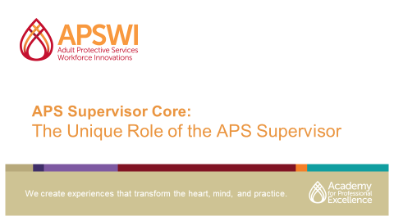

Moderator: Welcome everyone and introduce yourself and trainer. Explain you will be going over some housekeeping before handing it over to our trainer.
If virtual, have participants introduce themselves in the chat box by typing their Name, Title, County/Jurisdiction as introduction and for attendance.
- Today’s training will take place from XX:XX to XX:XX
- Please stay for the entire duration of the training to receive full credit
- Introduce/orient participants to participant manual/materials
- We will be taking some time at the end of training for your evaluation feedback – both verbal and an end-of-training evaluation.

Slide #2: SDSU School of Social Work
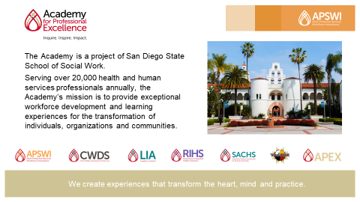

Moderator: Explain that the Academy for Professional Excellence is a project of San Diego State School of Social Work. Its mission is to provide exceptional workforce development and learning experiences for the transformation of individuals, organizations and communities.

Slide #3: About APSWI and the Academy
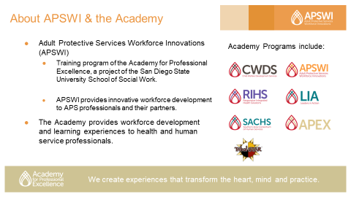

Moderator: Explain that Adult Protective Services Workforce Innovations (APSWI) provides innovative workforce development to APS professionals and their partners. APSWI is a program of the Academy for Professional Excellence along with others listed on the slide.

Slide #4: Welcome to Your Platform – Zoom Settings
Trainer/Moderator Note: Please modify this slide and instructions for your virtual platform

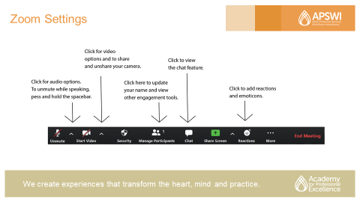

Moderator: Introduce participants to the virtual platform functionality
- Please click the mic for audio services and to unmute and mute yourself.
- Next to that is the Video option where you can share and unshare your camera and also click on the arrow above to utilize virtual backgrounds, if you want
- Next is the manage participants tab where you can update your name.
- Please click the chat box to view all chats.
  - You can receive help by private messaging the Moderator.
  - Please type BRB (Be Right Back) if you need to step away, it helps with breakout group assignment.
- Lastly, you can add reactions during the training by utilizing the reactions tab.

Slide #5: Meet and Greet
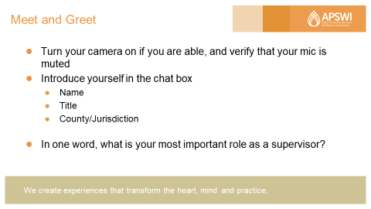

Moderator: Now I will hand it over to TRAINER NAME, but before I do, I would like to remind you to:
- Turn your camera on if you are able and verify that your mic is muted
- Introduce yourself in the chat box
  - Name
  - Title
  - County/Jurisdiction
Ask: In one word, what is your most important role as a supervisor? Please type your answer in the chat box.
Trainer/Moderator: Read aloud some of the answers. You may want to revisit/incorporate these during the next section on Supervisory Roles.

Slide #6: Course Goals and Objectives (2-3 minutes)
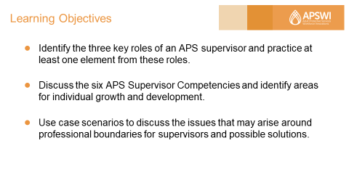

Trainer Note: Quickly review learning objectives.
Identify the three key roles of an APS supervisor and practice at least one element from these roles.
Discuss the six APS Supervisor Competencies and identify areas for individual growth and development.
Use case scenarios to discuss the issues that may arise around professional boundaries for supervisors and possible solutions.

Supervisory Roles – Educational, Supportive, and Administrative
Time Allotted: 35 minutes

Slide #7 – APS Cultural Framework
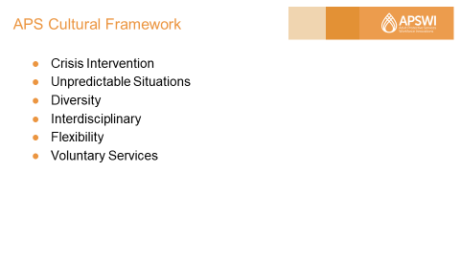
Trainer Note: This section is a high-level overview many of the concepts and focus areas will be covered in-depth in further training modules. Specifics are noted below with “Trainer Note” indication.

Trainer: We know that culture influences all aspects of life and there are some unique aspects of APS work which affect your staff and can impact your supervisory role. Some things to consider:
- APS becomes involved when the client is experiencing some problem that the client/family is apparently unable to handle on their own.
- APS initial involvement/visit is not always welcomed by the client/family, especially when we make unannounced visits.
- APS workers walk into completely unexpected situations, as the information in the report is often sketchy or biased by the reporting party. They visit every type of culture/ethnic group and socioeconomic class. They see ages 18 through 100 + years old.
- They also perform visits in homes, health care centers, hospitals, coffee shops, Regional Center facilities, etc. and must necessarily be able to communicate effectively with both the client/family and the professionals who support the client in these settings.
Continued
- APS workers need to be flexible with their time and resources, to meet immediate/emergency response times and know how to prioritize to meet all mandated timeframes for all their cases.
- Last, but not least, APS is a voluntary service - and often the APS worker must close a case when the worker remains concerned about the client’s welfare.

Reference: Academy for Professional Excellence. (2013). Foundations of Effective Supervision, Trainer Manual, Module 2, Version 2.2. Pages 26-27.

Slide #8 – APS Supervisory Roles
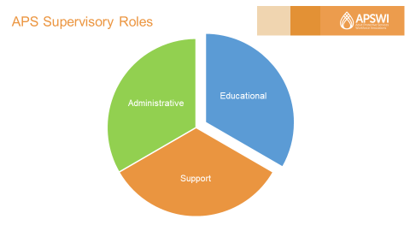

Trainer Read Quote: The APS Supervisor provides both clinical and administrative oversight, approves key casework decisions, and guides the caseworker in overall case planning and management.
This quote from the Updated National Voluntary Consensus Guidelines for State Adult Protective Services Systems sums up the multi-faceted role of the APS supervisor and provides a great launch point to discuss what Kadushin & Harkness (2002) identify as the three primary supervisory roles – Educational, Supportive & Administrative. Each role requires different skills, knowledge and attributes.
References:
ACL Updated National Voluntary Consensus Guidelines for State APS Systems, 2020. Pg 21.
Kadushin, A., & Harkness, D. (2002). Supervision in social work. (4th ed.). New York, NY: Columbia University Press.
National Association of Social Workers. (2012). Best Practice Standards in Social Work Supervision: Taskforce on Supervision Standards – Draft.

Slide #9 - Educational Role
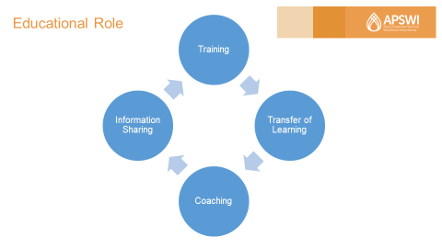

Trainer: This part of your job is important and extensive. You probably have heard the term “Supervisor as Trainer” and thought, okay, what does that mean? Let’s break it down.
As an APS supervisor, you need to:
- Keep staff informed of program updates, resources, and best practices.
- Ensure staff are adequately trained and able to perform their work with confidence. This includes onboarding new staff.
- Ensure staff meet training requirements required by your agency and/or by the profession, such as the National Adult Protective Services Association (NAPSA) National APS Certificate Program (www.napsa-now.org/the-napsa-certificate-program/)
- Share training opportunities with staff and/or recommend trainings for identified learning and/or performance improvement needs.
- Support Transfer of Learning (TOL). Utilize transfer of learning materials such as the Field Guide for APS (https://theacademy.sdsu.edu/programs/apswi/field-guide-for-aps/) one-on-one with staff or in a unit meeting. Or when your worker attends a training, follow up with the worker to discuss what was learned and have the person share the learning at a unit meeting.

- Case consultations are another opportunity for transfer learning to actual casework and a time to teach APS principles, such as the concept of self-determination, trauma-informed service, etc.

Continued
- Coach - Coaching is the process by which the supervisor creates enabling relationships with the worker that makes it easier for the worker to learn. Together, the coach (supervisor) and learner (staff member) set performance goals that are higher than the worker's current performance. The learning process increases the worker's self-awareness and confidence that they have the ability to achieve their goals. As a result of the learning relationship and the learning that happens, stronger workers are created. Note: Coaching can also be in the Supportive role.

Reference: Academy for Professional Excellence. (2012). Understanding Self as Supervisor, Trainer Manual, Module 1, Version 1.4. Pages 70-71.

Slide #10 - Discussion Questions:
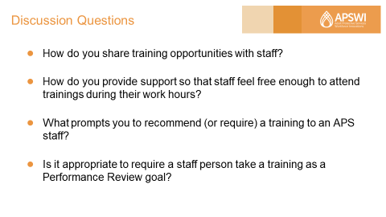
Trainer Note: Questions programmed with animations so that each question will appear separately on the slide.

Using the chat box or unmute/shout out:
- How do you share training opportunities with staff?

- How do you provide support so that staff feel free enough to attend trainings during their work hours?

- What prompts you to recommend (or require) a training to an APS staff?

- Is it appropriate to require a staff person take a training as a Performance Review goal?

Trainer/Moderator: Process responses as they come in.
Trainer Note: Competency 3 – Supporting Team Building and Individual Development has modules that cover the educational role topics shared today in depth.

Slide #11 - Supportive Role
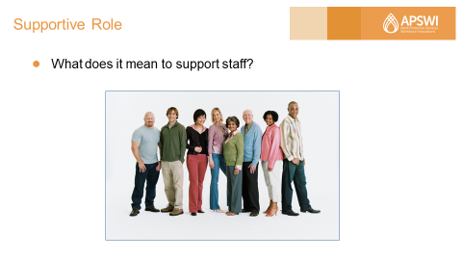

Trainer: Let’s move onto the Supportive Supervisory Role. You could say that the supportive role creates the working “culture” for the APS unit. The supportive role of supervision draws from and expands the scope of strength-based social work practice and trauma-informed approach The relationship the supervisor creates with staff models the relationship characteristics that the worker ideally would like to create with clients and colleagues.
Trainer Note: There are separate training modules on each of these topics – Trauma Informed Supervision in APS (Module 1A) and Strengths-Based Supervision (Module 1C).

Ask: What does it mean to support staff? Please provide some examples using the chat box or unmute/shout out.
Trainer Note: This activity can be processed using a white board with Moderator charting answers.

Moderator: Chart or share responses as they come in.

Slide #12 – Supportive Role
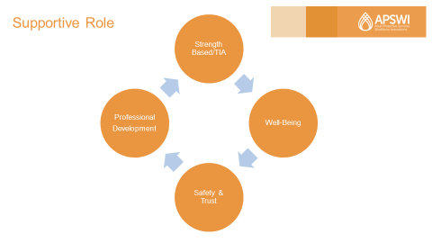

Trainer: Process responses and add from below as needed:
- Promoting staff physical and emotional well-being: Including review of agency policies, worker safety in the field, encouraging and modeling self-care, and valuing the worker as a person.

- Creating an environment of safety and trust: Communication is collaborative, encourage your workers to provide feedback about their work culture and about your performance. However, remember to avoid getting defensive of yourself, or of your managers, when workers are honest with you! Also, be trustworthy with communication. Avoid gossiping and hold confidences unless to do so violates agency policy/professional ethics. We will touch more on this later in the training when we discuss professional boundaries.

- Supporting Professional Growth & Development
  - Allowing time for 1:1 meetings for structured case consultation and/or clinical supervision
  - Coaching
  - Employee skills, certifications, professional licenses, supporting promotion of employees.
Ask (as time allows): Share in the chat box or unmute/shout out – Think of a supervisor who supported you and what did that look like? How can you do this in the future with you staff?
Reference: Academy for Professional Excellence. (2013). Foundations of Effective Supervision, Trainer Manual, Module 2, Version 2.2. Pages 61-64.

Slide #13 - Administrative Role

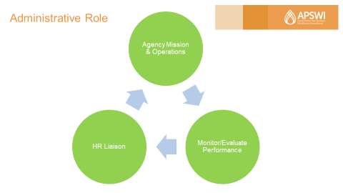

Trainer: Let’s move into our third and final role, the Administrative Role. Tasks within this role are often the hardest for new supervisors. It’s a great idea to lean into your training and find your supports as you are learning.

Here is a high-level overview of three areas within this role:

- Support/Facilitate Agency Mission and Operations – Some examples include: Fulfilling the mission of increasing safety and supporting independence for dependent adult and aging clients, reduction of maltreatment, meeting state guidelines for case management standards and APS operations, etc.

The administrative role for the supervisor supports the achievement of these objectives. Ultimately, they reflect the best interest of the community/clients served by the agency.

- Monitoring and Evaluating Staff Performance – Some ways of monitoring and evaluating the worker performance:

  - The first and most frequently used are case reviews. Supervisors must sign off on worker’s cases, so they are already reviewing the documentation of cases.
  - Direct observation of the worker’s interaction with clients/co-workers/other professionals is crucial for evaluating the quality of social work practice. No one can objectively assess his/her own performance and even the best documentation of case interaction cannot substitute for what can be
Continued
  - observed and experienced. Supervisors should make at least two home visits with each worker per evaluation period. In addition to home visits, the supervisor can observe the worker’s interactions in meetings, in work groups, etc.
  - Feedback from clients and from other professionals often reflects the satisfaction others have with the worker’s interpersonal and team skills.
  - Additionally, involvement in work groups/committees reflects the worker’s initiative, creativity, commitment-traits that generally exceed the minimum performance standards.

- Supervisor as liaison between Human Resources (HR) and staff – Though HR rules and requirements vary from state to state and/or jurisdiction to jurisdiction, it is important for new supervisors to understand their role with HR including the agency’s HR policies, general guidelines including the gray areas.

Slide #14 – HR Best Practice Tips

Trainer: Here are some HR best practice tips:

  - Study up on your agency’s HR policies, including general guidelines and the gray areas.
  - Introduce yourself to your HR contact and establish a relationship with them.

  - Know what documentation and/or tracking is required for monitoring/evaluating staff performance. Important for both positive evaluations and progressive discipline.
  - Know when to involve HR – some examples include:
    - Workers Compensation/Family Medical Leave (FML)/Disability/Workplace Injury/Maternity Leave
    - Performance Improvement/Disciplinary Issues
    - When Hiring: Checking candidate personnel file for employment record, history of performance, flagging any disciplinary issues
    - Public health
    - Unions
Trainer note: Competency 5 - Supervising for Accountability and Retention has modules that cover data informed supervision, case review and personnel issues in depth.

Reference: Academy for Professional Excellence. (2013). Foundations of Effective Supervision, Trainer Manual, Module 2, Version 2.2. Pages 72-75.
APS Supervisor Competencies
Time Allotted: 30 minutes

Slide #15 – APS Supervisor Competencies
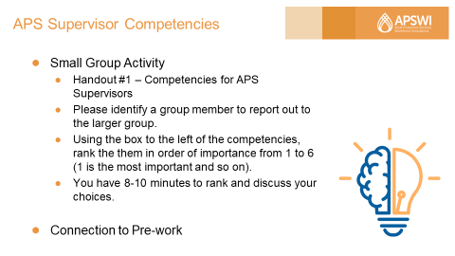
Trainer Note: Please ask participants to have their pre-work – APS Supervisory Task Self-Analysis available for this portion of the training. For your reference, both the pre-work and Handout #1 can be found in the appendices.

Moderator: For virtual delivery, you will need to create small groups of 4-5 participants via your platform and list the instructions in the chat box prior to sending them to breakout groups.
Trainer: Direct participants to Handout #1 – Competencies for APS Supervisors in their participant manuals. Let them know you will be breaking them into small groups shortly.
Activity Instructions: Please identify a group member to report out to the larger group. Using the box to the left of the competencies, rank them in order of importance from 1 to 6 (1 is the most important and so on). You will have 10 minutes to rank and discuss your choices.
Trainer: Bring the groups back and ask groups to share their rankings (more if time allows). Process discussion. Is there a highest-ranking competency? Themes?
Summarize by asking: Are there any of these that are not important?
The answer should be NO.
Connection with Pre-Work Assignment - Have participants look at their self-analysis pre-work, focusing on the “like to grow” responses. Have them choose one. Which supervisor competency does it fall under? Can you develop an action item(s) to implement once back in the office? What resources do you need to succeed? Who do you need to connect with for support?
Reference: Academy for Professional Excellence. (2018). Supervisor as Trainer, Trainer Manual, Version 2. Pages 21-25.
Transitioning into the Supervisor Role
Time Allotted: 30 minutes

Slide #16 – Transitioning into the Supervisor Role
Trainer note: Depending on your audience (new vs. seasoned). Plan to spend less time on slides 17, 18, 19 and the rest of the time on professional boundaries/case scenarios.

Trainer: The transition into frontline supervisor is not always an easy one. This is especially true for supervisors that may have been workers and then promoted to supervisor within the same unit. The change in the nature of the relationship with your colleagues can be stressful and challenging.
In addition, for those frontline supervisors promoted from outside APS, understanding APS work and culture may present its own set of challenges.
It’s fair to say, there are advantages and challenges for both. So, let’s quickly explore.

Slide #17 – Transitioning: Peer to Supervisor (Promote from within APS)
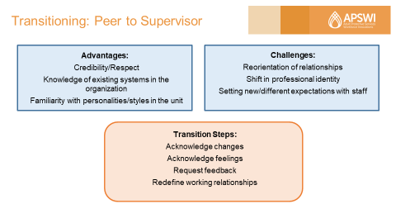

For the supervisor who promoted from within APS, advantages may include:
- You have credibility and respect, since you were a good APS worker.
- You have an intimate knowledge of the actual work of investigating and managing a caseload, which makes you well suited to helping new staff learn the ropes and guiding experienced staff.
- You also already know the personalities and strengths of many, if not all, of the workers in APS. This will allow you to be flexible in your communication with them and help with assigning cases.

On the flip side, the challenges may include:
- You will need to reorient your relationships with your former co-workers.
- You are now the “boss” and your responsibilities require that you have a different type of interaction with staff.
- Lastly, just because you were an exceptional APS worker does not necessarily mean you will be an excellent supervisor because the skill sets are different. Give yourself time to learn and adjust to this new role and recognize when you are placing unrealistic expectations on yourself.

We will have an example of this “buddy to boss” dynamic in a scenario activity to come on professional boundaries.
Continued
Transition Steps:
By virtue of your position, you now model leadership and are consequently held to a higher standard of conduct. You are same person you were, but the responsibilities you now have require you to behave differently.
- Acknowledge changes - APS workers, in many ways, are like first-responders. They share a common, sometimes cynical sense of humor and often bond very closely with their coworkers as a result. When one promotes, the relationship with former co-workers will/must change. The newly promoted supervisor will need to establish new professional boundaries which we will discuss in scenarios below.

- Acknowledge feelings - Change is uncomfortable for most of us. Both you and your workers will lose a certain amount of intimacy once you promote-and there may be grief/irritation/hurt associated with that loss. It is common for new supervisors to doubt their abilities as supervisors, because this emotional passage is not always addressed openly. Assure your staff that you will do what you can to make the transition as smooth as possible for all. Also, it is important that you convey that you are learning how to function as a supervisor, and that you will need your workers help in this process.
- Request feedback on how you can best support your workers - You probably know the kind of supervisor you would like to be - open, honest, fair, respected, a person of integrity, a leader who people want to follow. Your workers, those independent thinkers/advocates will likely give you feedback if you are sincere about requesting it and consider applying/actually apply their suggestions.
- Redefine working relationships - It may be, as a worker, you had difficult relationships with co-workers/other professionals. If you have had some difficult relationship with others, now is the time to work on redefining those relationships.

Reference: Academy for Professional Excellence. (2013). Foundations of Effective Supervision, Trainer Manual, Module 2, Version 2.2. Pages 28-30.

Slide #18 – Transitioning From Outside APS

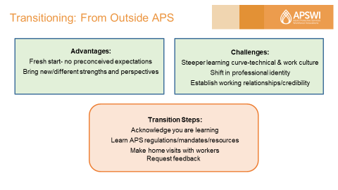

Trainer: The APS Supervisor from outside APS: is like a “tabula rasa”- one is able to create the image one always wanted to have. This supervisor also has a fresh perspective on problem solving and sees APS culture with unbiased eyes; consequently can offer insight for resolving systems issues and may address personnel issues differently.
The challenges for this supervisor include not only learning a new job, but a new culture. The time it will take for this supervisor to feel competent/comfortable in the job will be longer - so it’s important that this supervisor have patience with himself/herself. It is said that it takes 18-24 months to feel competent in a job, but it may be longer for a supervisor coming from outside APS.
- Acknowledge that you are learning: You don’t need to know all the answers, just know to ask the questions. This is humility; humility is knowing and accepting your place in the world. APS workers like to empower people, so if you ask them to teach you about the job, they will.

- Make a point to read the laws/mandates of APS and to learn about the agencies that work collaboratively with APS - including Regional Center, law enforcement, geriatric resources, area agencies on aging, and local senior centers.

- Make home visits with all your workers: this allows you to learn not only about how APS work is done, but to actually learn the different styles/strengths and values of your individual workers. This is a time to develop trust and establish positive working relationship. “I’m here to learn from you.”
- As mentioned above - Request feedback on how you can best support your workers
Continued
Ask (as time allows) - Share in the chat box or unmute/shout out if they were promoted from inside or outside of APS and if any of the advantages or challenges listed are relatable to them.

Reference: Academy for Professional Excellence. (2013). Foundations of Effective Supervision, Trainer Manual, Module 2, Version 2.2. Pages 31-32.

Slide #19 - Professional Boundaries for Supervisors – Case Scenarios
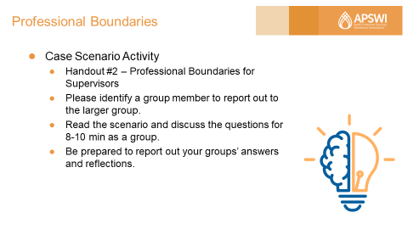

Trainer/Moderator Note: Put participants back into break out groups and assign a scenario/discussion question to each group to discuss for 8-10 min. For virtual delivery, you will need to list the instructions in the chat box prior to sending them to breakout groups. Bring groups back to report out to the large group for about 10-12 min.
Alternatively, if you have less time, you could process scenarios and discussion in a large group using chat and shout out.
For your reference, Handout #2 is located in Appendix C.

Trainer: As supervisor, you are a leader with more power and authority and a different set of responsibilities than your staff. Ultimately, you are striving for transparency, trust and consistency.
It’s also important to understand that some situations are not black and white and there may be gray areas. In these situations, it’s important to be able to think critically about the situation at hand and make informed decisions with guidance from HR and/or management as needed.
Let’s review and discuss the scenarios below. Please turn to Handout #2 - Professional Boundaries for Supervisors – Case Scenarios.
Activity Instructions: Please turn to Handout #2 - Professional Boundaries for Supervisors – Case Scenarios. Please identify a group member to report out to the larger group. Each group is assigned a case scenario/discussion questions. Read the scenario and discuss the questions for 8-10 min as a group. Be prepared to report out your groups’ answers and reflections.
Continued

Professional Boundaries
*Scenario 1: Sue and Bill are APS workers in the same unit, both are in the same position level. Sue and Bill become friends and socialize outside of work, becoming close friends and even taking care of each other’s children. Sue gets promoted to Unit Supervisor. When the time comes for Sue to hire/promote a worker to Assistant Supervisor, Bill is one of the people who interviews for the position, but is not necessarily the best choice/fit to promote.
Discussion: What issues can be identified in this scenario? What are the pitfalls of becoming friends with co-workers? If Bill is not chosen for the position, can this relationship be salvaged? If so, how?
Potential answer: Understand if you are friends and socialize outside of work it may be awkward if the relationship changes. There could be real or perceived favoritism, ethics, etc.
Conflict of Interest - Ethics and Transparency
*Scenario 2: Aziza is an APS Supervisor who manages Sara, an APS worker, who has a side gig (part-time, seasonal employment) as a tax preparer. The Sara has been having some performance issues on the job, especially during tax season. As tax season approaches, Sara mentions that she could do Aziza’s taxes.
Discussion: Since taxes have nothing to do with APS work, would it be okay for Aziza to let Sara do her taxes? Would the answer to this be different if Sara was not having performance issues? What issues could arise from this situation?
Potential answer: No, it is not appropriate. It could be considered a dual relationship, stay away from dual relationships!
Confidentiality - Keeping employee’s personal business and information private.
*Scenario 3: A spouse of one of the workers in your unit, Jose, has been diagnosed with a terminal illness. The situation with Jose’s spouse will greatly impact the their ability to work full time and fulfill the complete range of responsibilities associated with the position, and may eventually require this Jose to take Family Medical Leave.
Discussion: How and when should this situation be communicated to the rest of the unit? Should you, the Supervisor share this information with the unit? What kind of consent/permission should be obtained to share such personal information? Does the rest of the unit need to know this information?
Potential answer: Do not disclose a staff member’s personal health information. If a person wants to share information about themselves with the group, let it come from their own mouth. As supervisor, you can speak generally about related changes and potential effect on the unit.

Closing and Evaluation
Time Allotted: 10 minutes

Slide #20 – Closing Thoughts
Trainer Note: As time allows, ask if there are any questions, reflections, takeaways, etc. that anyone wants to share.

Trainer: This brings us to the end of our time together today. Would anyone like to ask any further questions? Does anyone have reflections on what we discussed today? Any takeaways?
I want to thank you for your time, attention and energy today.

Slide #21 – Evaluation
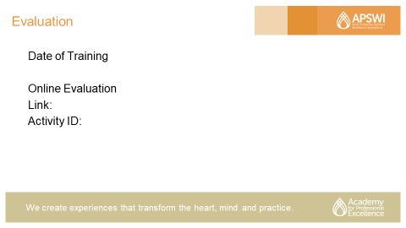

Moderator: Provide any instructions concerning the course evaluation for this training or any activities you generally use to close out a session of this type.

Slide #22 – Thank you
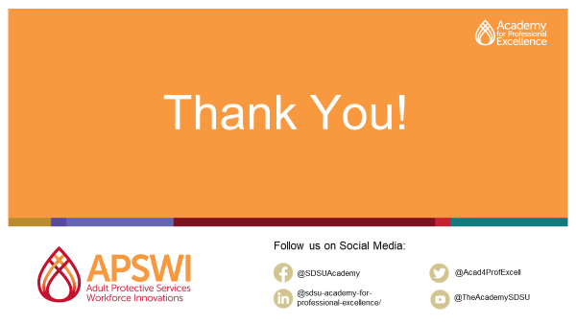

Thank participants for their time today and active participation.

REFERENCES

Academy for Professional Excellence. (2013). Foundations of Effective Supervision, Trainer Manual, Module 2, Version 2.2.
Academy for Professional Excellence. (2018). Supervisor as Trainer, Trainer Manual, Version 2.
Academy for Professional Excellence. (2012). Understanding Self as Supervisor, Trainer Manual, Module 1, Version 1.4.
Administration for Community Living (ACL) Updated National Voluntary Consensus Guidelines for State APS Systems, 2020.
Kadushin, A., & Harkness, D. (2002). Supervision in social work. (4th ed.). New York, NY: Columbia University Press.
National Association of Social Workers. (2012). Best Practice Standards in Social Work Supervision: Taskforce on Supervision Standards – Draft.

APPENDIX A
PRE-WORK ASSIGNMENT - APS SUPERVISORY TASK SELF-ANALYSIS
(ADAPTED FROM THE APS SUPERVISOR AS TRAINER, TRAINER MANUAL, V2, MAY 2018)
This pre-training assignment it will take approximately 15 minutes to complete. Note your strength areas and areas that need improvement. This must be completed prior to attending the training. This self-analysis will be included in a processing activity, please have it easily accessible.
 | Competent & Confident | Adequate & Skilled | Learning to do Better | Like to Grow
Understand and Relate Policy and Procedures
Case Assignments
Facilitate Training
Evaluate Performance
Give Feedback
Model Self-Care
Motivate Staff
Set Goals
Enforce Limits
Documentation
Seek Professional Development
Teambuilding
Meet Deadlines
Handle Personnel Issues
Foster Dynamic Relationships
APPENDIX B
HANDOUT #1- COMPETENCIES FOR APS SUPERVISORS
(FROM THE APS SUPERVISOR AS TRAINER, TRAINER MANUAL, VERSION 2, MAY 2018)
- Professional Use of Self
  - Interpersonal Relationships
  - Communication and Interviewing
  - Self-Management
  - Work Management

- Foundation of APS Work: Common Knowledge and Skills
  - Adult Development, Disabilities, and Aging
  - Policy, Procedures, and Laws
  - Medical and Psychological Issues

- APS Casework Methods and Practice
  - Protective Services Casework Methods
  - Service Planning
  - Knowledge of and Linkage with Resources and Programs
  - Guardianship
  - Facility Investigation

- Supervisor as Manager
  - Techniques of Effective Supervision and Management
  - Staff and Volunteer Selection and Retention
  - Managing Change and Conflict
  - Crisis and Stress Management
  - Decision Making and Problem Solving

- Supervisor as Leader
  - Styles of Leadership
  - Use of Authority
  - Group Dynamics and Team Building
  - Advocacy for Program and Staff
  - Relationships with Other Professionals

Continued
- Supervision and Development of Staff
  - Administrative Supervision
  - Supportive Supervision
  - Educational Supervision and Training
  - Monitoring Performance and Conducting Performance Evaluations
  - Working Effectively with Challenging Staff

APPENDIX C
Handout #2 - Professional Boundaries for Supervisors – Case Scenarios
Professional Boundaries
*Scenario 1: APS worker A works with APS worker B in a unit, both in the same position level. APS worker A and APS worker B become friends and socialize outside of work, becoming close friends and even taking care of each other’s children. APS worker A gets promoted to Unit Supervisor, becoming Supervisor A. The time comes for Supervisor A to hire/promote one of the workers to Assistant Supervisor. APS worker B is one of the people who interviews for the position, but is not necessarily the best choice/fit to promote.
Discussion: What issues can be identified in this scenario? What are the pitfalls of becoming friends with co-workers? If APS worker B is not chosen for the position, can this relationship be salvaged? If so, how?

Conflict of Interest - Ethics and Transparency
*Scenario 2: APS Supervisor manages an APS worker who has a side gig (part-time seasonal employment) as a tax preparer. The APS worker has been having some performance issues on the job especially during tax season. As tax season approaches, the worker mentions that she could do the supervisors’ taxes.
Discussion: Since taxes have nothing to do with APS work, would it be okay for the supervisor to let the worker do her taxes? Would the answer to this be different if the worker were not having performance issues? What issues could arise from this situation?

Confidentiality - Keeping employee’s personal business and information private.
*Scenario 3: A spouse of one of the workers in your unit has been diagnosed with a terminal illness. The situation with the ill spouse will greatly impact the worker’s ability to work full time and fulfill the complete range of responsibilities associated with the position, and may eventually require this worker to take Family Medical Leave.
Discussion: How and when should this situation be communicated to the rest of the unit? Should the Supervisor share this information with the unit? What kind of consent/permission should be obtained to share such personal information? Does the rest of the unit need to know this information?

Moderator/Co-Host Tip Sheet

Slide #1: Welcome, Page: 14
- Type in Chat Box “Please enter name, county, and role for attendance records”.

Slide #4: Zoom Settings, Page: 17
- Please modify this slide and instructions for your virtual platform.
Slide #5 – Meet and Greet, Page: 18
- Type in the Chat Box “In one word, what is your most important role as a supervisor?”.
- Trainer/Moderator: Read aloud some of the answers. You may want to revisit/incorporate these during the next section on Supervisory Roles.
Slide #10 – Discussion Questions, Page 25
- Trainer/Moderator: Process responses as they come in.
Slide #11 – Supportive Role, Page 26
- Type in Chat Box “What does it mean to support staff?”
- Chart or share responses as they come in.
Slide #12 – Supportive Role, Page 27
- (AS TIME ALLOWS) Type in the Chat Box
- “In what ways have you supported a staff person’s professional development? Or how could you do this in the future?
Slide #15 – APS Supervisor Competencies, Page 31
- For virtual delivery, you will need to create small groups of 4-5 participants via your platform and list the instructions in the chat box prior to sending them to breakout groups.
- Activity Instructions: Please identify a group member to report out to the larger group. Using the box to the left of the competencies, rank them in order of importance from 1 to 6 (1 is the most important and so on). You will have 10 minutes to rank and discuss your choices.
Continued

Slide #18 – Transitioning From Outside APS, Page 36-37
- (AS TIME ALLOWS) Type in the Chat Box “Were you promoted from inside or outside of APS? Are any of the advantages or challenges listed are relatable to you?”
Slide #19 - Professional Boundaries for Supervisors – Case Scenarios, Page 37
- Trainer/Moderator Note: Put participants back into break out groups and assign a scenario/discussion question to each group to discuss for 8-10 min. For virtual delivery, you will need to list the instructions in the chat box prior to sending them to breakout groups. Bring groups back to report out to the large group for about 10-12 min. Alternatively, if you have less time, you could process scenarios and discussion in a large group using chat and shout out.
- Activity Instructions: Please turn to Handout #2 - Professional Boundaries for Supervisors – Case Scenarios. Please identify a group member to report out to the larger group. Each group is assigned a case scenario/discussion questions. Read the scenario and discuss the questions for 8-10 min as a group. Be prepared to report out your groups’ answers and reflections.
Slide #21 – Evaluation
- Provide any instructions concerning the course evaluation for this training or any activities you generally use to close out a session of this type.
Slide #22 – Thank you, Page 42
- Thank participants for their time today and active participation.

This page is intentionally left blank.

