Introduction to this Skill Based Training Manual
This Skill Based Training is designed to follow completion of the Voluntary Case Planning in Adult Protective Services/Elder Abuse eLearning (Voluntary Case Planning). Without having completed the Voluntary Case Planning eLearning, participants will find this skill based training and its activities confusing. Prior to beginning the Skill Based Training, please ensure that all participants have completed the Voluntary case planning eLearning.
Once the APS Worker has completed their initial assessment, a case plan must be developed with the client. Although in some cases an Involuntary intervention must be considered, in most situations where the client has capacity and is able to consent to services, a voluntary Case Plan needs to be developed with the client. In this Skill Based Training, we will review the concepts learned by the participants during the Voluntary Case Planning eLearning, and will provide participants with opportunities to practice voluntary planning skills, to learn more about Voluntary Case Planning, and to refresh their memories of the concepts transferred to them during the eLearning.
You may want to schedule a coaching call for approximately 2 weeks after the completion of this in-person course.
Before the Training:
- Room set-up: The room should be set-up with round tables with 6-8 chairs each, making up table groups. There should be sufficient space between tables that groups don’t have to talk over each other.

- Preparations for the ‘Eva’s Story’ activity: One of the best ways to add interest to these team based activities is to create your own ‘scratch off’ answer cards. This is a relatively simple process. For information, please see the video at: https://www.youtube.com/watch?v=P0xDwDYC4Hw or google “scratch off cards”.
A major principle of team based learning is that participants get to experience the following:
- They get to know which the ‘best’ answer is immediately, and at the same time as the other ‘teams’ in the training.
- Each team is responsible for picking their 1st, 2nd, 3rd, and last choice. As you will note in some exercises, different point values are assigned depending on whether the ‘best answer’ when revealed, was their 1st, 2nd, 3rd, or last choice.
If participants can scratch off the answers in the order of their choice this adds to the team experience and to the spontaneity of the activity.
Alternate Option: If you elect not to use the scratch off option, then you can make cards with the letters A-E on them and ask teams to arrange the cards in the order of preference 1st choice on top, 2nd choice next, etc.

Training Goals and Objectives:
- Identify the factors that influence intervention needs
- Discuss strategies to engage the victim in developing mutual goals to decrease risk of abuse
- Determine appropriate interventions that would decrease risk of abuse
- Explain when and how to use a Domestic Violence Safety Planning tool

Skill Based Training Timeline
Timeline | Activity | Duration
8:00-8:30 | Introductions | 30 minutes
8:30-8:40 | Explanation of Team-based Learning/dividing into teams | 10 minutes
8:40-9:20 | Eva exercise | 40 minutes
9:20-10:00 | Case Pre-planning | 40 minutes
10:00-10:15 | BREAK | 15 minutes
10:15-10:30 | Reframing Activity | 15 minutes
10:30-10:45 | What’s Out There Activity | 15 minutes
10:45- 11:10 | Evaluating the Case Plan | 25 minutes
11:10-12:00 | Safety Planning | 50 minutes

Slide #1
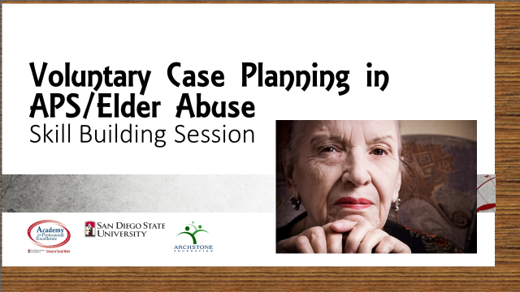

Trainer: Introduce yourself, provide any relevant information about your position, work history, or other relevant information. Tell participants that this skill based training is intended to follow completion of the Voluntary Case Planning in APS/Elder Abuse, and that this training and its activities will be difficult and probably ineffective for anyone who has not completed the eLearning. Ask if any participants have not completed the eLearning, and advise as appropriate (i.e. not to take this training, to speak with their supervisor or training coordinator about how to access the eLearning).

Slide #2
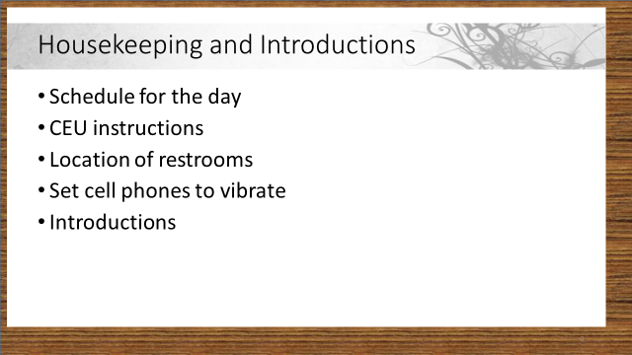

Trainer: (Review housekeeping information)

- There will be one 15-minute break
- The restrooms are located at….
- Please set your cell phones to vibrate for the duration of the training. If you must make or receive a call, please leave the training room and return as quickly as possible. Check the course outline to see what you have missed.
- In the event of an emergency, all participants will exit the room through…and gather at …
- Ask participants to: introduce themselves, tell their position and where they work and how long they have worked in this field.

Slide #3
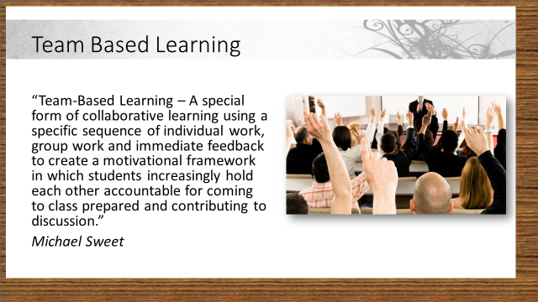

Trainer: Explain to participants that during this Skill Based training they will be taking part in a training utilizing the concept of Team based Learning: (Paraphrase, in your own words) This concept encourages participants to work together to find the best answer available utilizing each group member’s individual skills in collaboration to identify the group’s choice for the best answer to the question or situation presented.
Using Team Based Learning concepts, teams will work together to review and assess the questions or situations presented, and participants, acting within their groups, may utilize additional resources such as the use of Smart Phone (please use only for the activities). Team members must assess one another to determine if one or more of their group members may have additional knowledge, experience, or information that may enhance the team’s performance during exercises.

Slide #4
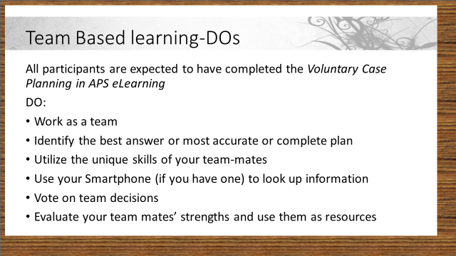
Trainer: (Paraphrase for participants)
Trainer: Here are some Do’s, things that we expect you to do and encourage you to do to get the greatest benefit from today’s skill based training.
- Work as a team- we want you to work together, and this skill based training is designed to encourage team members to work together in order to discover and utilize all the skills of all group members to collaborate on the best possible answer as determined by a given team or group.
- Identify the best answer or most accurate or complete plan-as in real life situations, there may be several correct answers, but Team Based Learning asks that participants work together and share knowledge to find the best answer that their team can identify.
- Utilize the unique skills of your team-mates-most trainings encourage participants to act only as individuals, only gathering in groups to take a group vote on the correct answer. In Team Based Learning participants are asked to share knowledge, often times their unique knowledge, to enhance the group’s decision making.
- Use your Smartphone (if you have one) to look up information-While we request that Smartphones be used for activities only during this training (rather than for social purposes) we are encouraging you to use actual resources that you might use in the field to benefit your group in its deciding the ‘best’ answer to the question or problem.
- Vote on team decisions-this doesn’t sound like anything new for training, however, we are asking you to make use of your skills and experience to help persuade your team members of your position or opinion. Ultimately groups will have to arrive at a group decision, and we encourage you to ‘make your case’ for what you believe to be the best answer.
- Evaluate your team mates’ strengths and use them as resources-We are not encouraging you to judge one another or to rate each other’s skills, we are all unique individuals and should be so. We are, instead, encouraging you to listen to, and factor in the unique opinions, experiences and knowledge of all of your team mates.

Slide #5
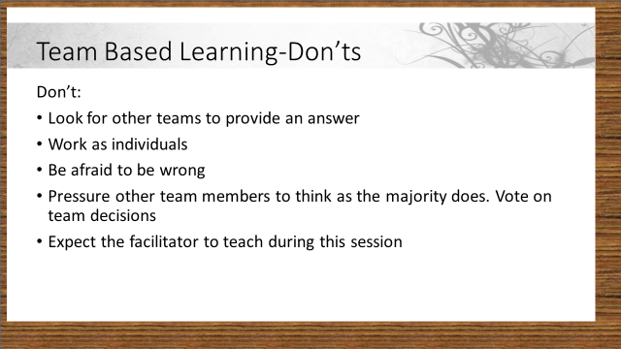
Trainer: (paraphrase)
Don’t look for other teams to provide an answer- It’s not just that we don’t want you to cheat…we want your team to work collaboratively and cohesively together. In the field you will need to build networks of people that you work with regularly, we want you to do the same here in the classroom. You may not always agree with what some members of the network you have built think, but you can still have a constructive relationship through sharing and mutual respect.
Don’t work as individuals- in this training we want you to get practice working together as a group. You might like it better working alone, it might even be easier working alone; but in real life there are few situations where you will have this option, especially in a complex case that may involve several agencies and/or organizations.
Don’t be afraid to be wrong-everyone is wrong sometimes! We won’t ask you and your team to have the perfect answer or solution, just to come up with what you believe to be the best answer or solution. If you find out later that there was a better answer, that’s not a failure, IT’S A LEARNING EXPERIENCE!
Don’t pressure other team members to think as the majority does. Vote on team decisions-A part of Team-based Learning is learning to work together and to benefit from your other team members’ unique skills and knowledge. You are encouraged to listen to everyone, even if you disagree. If it comes time to pick a ‘best’ answer you may all still not agree, that’s okay. Then it will be time to take a vote on what answer the majority of your team feels is the best answer. But in addition, if you find that the answer you picked was not the ‘best’ then for the next question or activity, think about whether you need to consider other team members’ suggestions.
Don’t expect the facilitator to teach during this session-Team-learning uses a facilitator to move the team-based learning process forward to but not to “teach” the material from the eLearning. Experience is the teacher here. You learn through applying what you learned during the eLearning module and working together to process that information to come to a conclusion or plan. This doesn’t mean that you can’t ask questions but, they may be redirected to the class for answers.

Slide #6
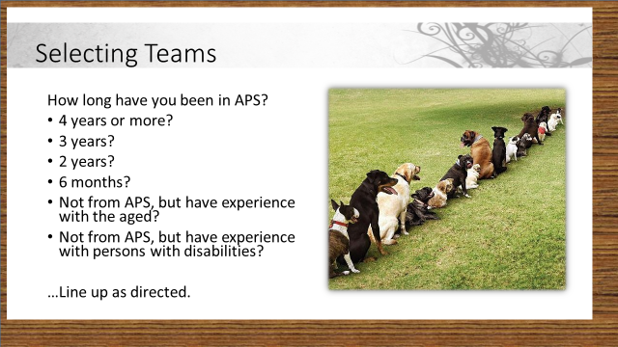
Now it is time to divide up into teams. We want to attempt to have various experience levels and types in each team, and to avoid having groups of friends or co-workers who work with each other all of the time sit together again. In order to attempt this goal, we will sort people by experience, job type, etc as follows:
Ask participants to line up along one wall of the training area with their belongings when you direct them to do so. Ask participants to respond to the following questions by a show of hands:
- How many of you have been working in Adult protective Services for 4 or more years? Once these persons identify themselves, ask them to line up on the side of the room in order of experience, from the most experience to the least.
- Next: How many of you have worked in APS for 3 years? Once these persons have identified themselves, have them line up behind the last group.
- Next: How many of you have worked in APS for 2 years? Ask these persons to line up behind the last group identified.
- Next: How many of you have worked for APS for 6 months or less? Ask these persons to line up behind the last group identified.
- Next: How many of you do not work in APS, but have experience with the aged? Ask these persons to line up behind the last identified group.
- Last: How many of you do not work in APS, but have experience with persons with disabilities? (You guessed it!) Ask these persons to line up behind the last group identified.
Now you should have a line of participants with the APS staff with the most experiences on the job at the head of the line and descending in length of experience, with non-APS persons with experience with the aged or with persons with disabilities at the end of the line.
Now have the lined up participants count off 1 to 5 (or 1 to 4 depending on how many groups you need. You should have 6 to 8 persons in each group.) Adjust the numbers you count off to fit with the number of groups you have. Next ask participants to be seated together in groups as far apart as the training space will allow.

Slide #7
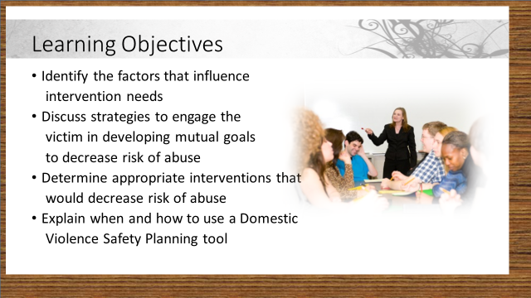
Now that you have your ‘teams’, it’s time to review the objectives for today’s skill based training.
Presenter: (paraphrase) These are the overarching objectives we will be working towards through our skill based activities today:
(Read through the objectives paraphrasing as needed, and answering questions as they may come up)
Do you have any questions or comments about today’s objectives?

Slide #8
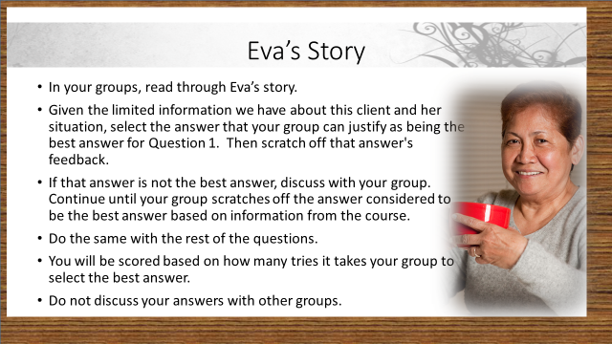
Trainer: Direct the participants to read the instructions on the slide. Tell them that they will have 10 minutes to complete this exercise.
Handout #1
The Story of Eva
Eva is a 74 year old widow who lives in a small 2 bedroom mobile home in a senior mobile home park. Eva uses a walker to ambulate and is currently receiving help from a home care agency with bathing, housework and grocery shopping. She has one good friend, Myrtle, who lives nearby but is otherwise isolated. She has one child and no living siblings. She called APS to ask for help dealing with her 52 year old son, Gene, who is pressuring Eva to let him move in with her. Here is what she tells you:
“Thank you so much for coming. I am just beside myself. I don’t know what to do. I love my son and I want him to be in my life but I am also afraid of him.
Gene (my son) has lived with me his whole life and, until his father died 4 years ago, things were ok. I mean, Gene got into his fair share of trouble. He never could hold a job for very long because he tends to talk back to anyone giving him orders. He really doesn’t like people telling him what to do. And, he has always drunk too much. But, his father kept him in line at home.
After Gene’s father died, Gene decided that he was the man-of-the-house and that he should be in charge of everything, including me. He felt that my money was his money since he paid all the bills (something his father did before he died). We had lots of arguments about how money should be spent. For example, he thought beer was a necessity but my blood pressure medication wasn’t important. He’d get really mad when we argued, he’d slam out of the house and go drinking.
Three years ago, he used all of my savings to buy a new car and then he totaled it one month later when he was drinking. In the accident, he hit another car and the woman in that car was badly hurt. Gene was hurt too. He was arrested and put in the jail ward of the hospital. He spent nearly a month in the hospital and he now walks with a cane. He spent a year in jail for driving under the influence and then moved back home with me. He is disabled and can’t work. And, he has chronic pain.
If I thought things were bad before, back when we argued about money all the time, things got really bad when he came back home from jail. He developed an addiction to pain pills and getting pills was the most important thing in his life. He didn’t care whether there was food in the house or whether bills got paid. He only cared about his drugs. And, if I said anything… complained about anything… he would fly into a rage. He would throw things at me. He punched holes in the walls. Once he pulled a knife on me and told me that he wouldn’t have to listen to me complain if he cut my throat. I was terrified. I felt like a prisoner in my own home, afraid to ask for a decent meal or a moment of peace. It was very hard on my nerves. And, I never got much sleep because he would have friends in and run the TV all hours of the night. Some nights I almost wished he would cut my throat so I could have some peace.
A couple of times you folks (APS) came to the house but I always turned the social worker away. It is so embarrassing to have to admit that your own child would treat you so horribly. Or that your parenting was so bad that you raised a child who could be so mean. I felt like a failure as a mother and a human being. I didn’t tell anyone about the terror I was experiencing in my own home.
One night, about 6 months ago, Gene wanted me to give him all my jewelry to sell. I would have let him have most of it. But, he even wanted the engagement ring that his father gave me. I refused and he threw me against the wall. I hit my head and was unconscious for a time. A neighbor had heard the fight and called the police. When I came to, the police and paramedics were here. Gene was gone and so was my engagement ring. The police had a victim advocate help me to get a restraining order so Gene couldn’t come back.
The restraining order is still in place but Gene has been calling the house asking to come home. I have been trying to stay strong since my life is so much more peaceful these days. There is food in the refrigerator and my bills are paid on time. But, Gene has been living on the streets and he sounds awful. He was in the hospital last month with an infection in his bad leg and a social worker called me to see if he could be released to my house. I felt terrible saying no. I felt like such a bad mother. I mean, who turns away their sick child? Gene is back on the streets now. He promises that he isn’t using drugs anymore. He keeps calling and begging to come home. What should I do? I really want to help him but I am afraid to have him come home. Should I give him another chance?

Slide #9
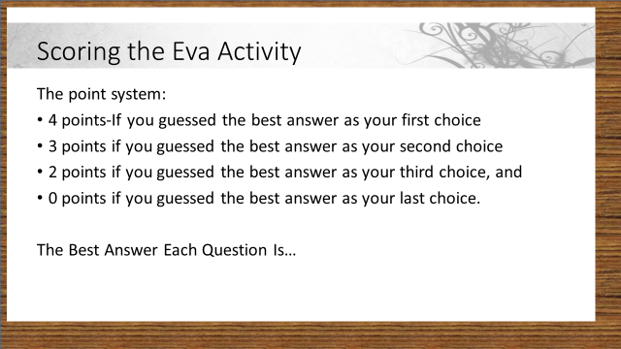
Trainer: Ask each team count up their points using the scoring system on the slide. Then ask each group to state how many points they scored (keeping score throughout the training is optional). After any remaining discussion about points is concluded, move on to the next slide.

Slide #10
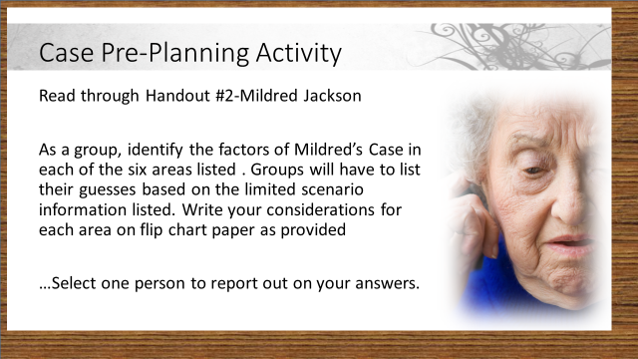
Trainer: Now we’re moving on to another activity to test your voluntary case planning skills. Remaining in your groups, read through the Case Pre-Planning Activity-Handout #3-Read through the scenario for Mildred Jackson. Each group will receive a sheet of flip chart paper and a marker to record their group’s answers (more sheets may be given out if needed). Identify your group’s reporter. You have 10 minutes.
Trainer: put the next slide (#11) on the screen while groups are working. Observe the groups as they are working to make sure that they are not ‘stuck’ on any on question or instruction. After 10 minutes ask the groups to come back together. Have each group in turn present their considerations for each area

Handout #2
Mildred Jackson
Mildred Jackson, age 92, lives in a small bungalow in a rural area. She has lived there for 60 years and she owns it. Ms. Jackson is frail and has some periods of confusion. The home has been in disrepair for many years. Housekeeping standards and hygiene have never been very high. She does not like to go to the doctor, but does see a woman who mixes herbs for her. Ms. Jackson has 6 children who live within an hour drive from her. She also has an “adopted” daughter Emma (someone she raised), age 65, who lives with her. Emma has mental health problems and hears voices. She has had frequent hospitalizations but does not consistently follow through with treatment or medication. Ms. Jackson’s other children are concerned that Ms. Jackson is more vulnerable and cannot protect herself from Emma’s outbursts.
In preparing for your visit, based on the limited information you have been given, what would you need to find out about in order to do an effective assessment of Eva’s needs, desires, and risk factors? What steps would you take to determine the following issues?
Victim Wishes

Alleged Abuser Issues

Urgency of Situation

Ethical Considerations

Cultural Considerations

Other Considerations

Slide #11
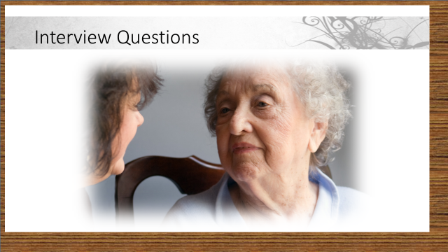
Trainer: Now we will put your interviewing and assessment skills to the test. We have discussed the considerations for each of the areas of concern related to Mildred’s case. After making these choices, how will you frame the questions for each area? On the next slide, read the question. Given the limited information we have about this client and her situation, select the answer that your group can justify as being the best answer for Question 1. Do not discuss your answers with other groups.
After one minute, I will ask you to raise the Letter Card (show cards) that corresponds with your choice.

Slide #12-16 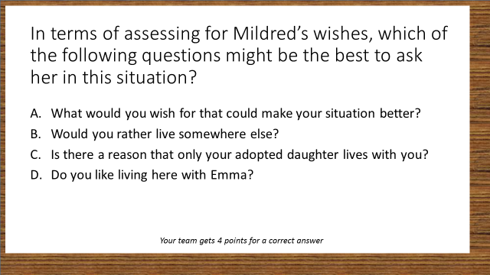
Trainer: Let’s see which question you selected. Raise your cards.
Now that you see the ‘best’ answer identified, what was your group’s rationale for selecting the answer that you chose as best? (discuss briefly). Ask any groups that did not select the identified ‘best’ answer what their rationale was in making the selection that they did. If there are disagreements as to the identified ‘best’ answer, guide the discussion toward: “what would you do if you disagreed with a decision that a peer or your supervisor recommended?” The important concept is that there is never only one best answer, and that as APS Workers we all have to decide and reevaluate the decisions that we and others make; however, in some instances we may disagree and will have to find an appropriate, professional way to raise our ideas with supervisors and peers.
As before, trainers may help groups keep score throughout the training, or leave the score keeping to the groups. The best course of action with regard to scoring may come from the competitiveness of each individual training groups. Some groups may be uninterested in keeping scores, while others may insist on it! Each group gets 4 points for correct answers.
Continue in this manner through all five questions slides. (Note: the questions are on Handout 4 on page 23) Correct questions are indicated in bold font.

Handout #3
Mildred Jackson Activity-Questions
- In terms of assessing for Mildred’s wishes, which of the following questions might be the best to ask her in this situation?
- What would you wish for that could make your situation better?
- Would you rather live somewhere else?
- Is there a reason that only your adopted daughter lives with you?
- Do you like living here with Emma?

- In assessing for alleged abuser issues, which question might be the best to use when assessing for any abuser issues regarding Mildred’s case?
- Is there anything or anyone that makes you afraid or uncomfortable?
- Does Emma behave differently than your other children toward you?
- Is Emma having mental health problems?
- Has anyone been threatening you?

- In assessing for any urgency related to risk factors what might be the best question to ask Mildred when you first meet her?
- Are you scared when Emma comes home?
- If you are feeling anxious or afraid, are there any reasons that you are more afraid now?
- If I told you that physical abuse and financial abuse are very common in our society, would you be surprised?
- Has Emma been violent?

- In terms of ethical considerations, what might be the best question to ask Mildred when you first speak to her?
- Do you think you might be happier living somewhere else?
- Do you know that your children are worried about you?
- Are you happy with your living situation?
- Are you taking care of Emma or is she taking care of you?

- What would the best question be to begin assessing Mildred’s cultural considerations?
- When you grew up, was family life very different than your life with your family is now?
- In the family you grew up in, were family members who were physically or mentally ill cared for at home?
- What kind of food and drink did you grow up with?
- Were your parents immigrants?

Slide #17 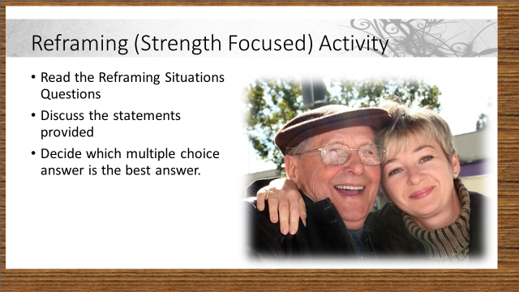
When developing Voluntary Case Plans, you need to focus on the strengths of the client, as well as their potential weaknesses and risk areas. These strength areas will be the areas that voluntary case planning needs to build upon. We must assess risk and take any immediate actions to protect clients from imminent threats, however, in building a service plan, our focus needs to be on strengths.
Strengths, and how we perceive them, often has to do with how we interpret or ‘frame’ given circumstances. Attempts to view the client’s situations objectively will be more successful if we are aware that the way we look at given situations and how we talk about them may impact our view of the clients’ world, and their strengths available to cope with problems. We are going to look at some examples that illustrate how common it is to frame situations negatively, along with 4 possible alternate framings that describe the same situation. At least one of the options uses strength-based phraseology rather than focusing on the negative perceptions of clients’ behavior.
As we did in the last exercise, you will have one minute for your group to decide which statement is the strength-based statement. When asked, please hold up the letter card that corresponds to your choice.
Trainer:
For each slide, read the original statement and then ask the groups to respond with their choices for the ‘best’ reframing for that statement and why they thought it to be the best. Beneath each statement is the rational you can provide to the groups if (and only if) they are struggling with these concepts.

- “She knows how to work the system. She manipulates one agency against the other.”

Trainer: Many individuals do understand and utilize the system… but is that necessarily a bad thing? If workers can reframe what they see as manipulation, to the client’s ability to obtain what she or he needs, to her/his resourcefulness, there is a better chance of mutually deciding a case plan. Congratulating the client on knowing who to call, on understanding the function of different agencies, on being an effective self-advocate… those reframe the behavior in a positive light and may help build a trusting relationship.

- “She needs so much care but is so resistant to anything I offer. She doesn’t want a home health aide. She doesn’t want a nursing home. She just wants to be left alone.”
Trainer: Sometimes resistance is the struggle for the client to remain independent. This desire for independence is a positive thing and, if acknowledged instead of fought, can bring worker and client together with the mutual goal of empowerment.

- “She and that no good son of hers can’t survive without each other. Their codependency is so destructive.”
Trainer: We have discussed earlier the mutual dependency between victims and abusers. When we frame the situation as codependent, we may not see the underlying issues such as loyalty, forgiveness, kindness and compassion. When we acknowledge those feelings, the victim may not feel so threatened and the relationship between worker and client may be enhanced. Terms such as “codependent” or “enabling” may also lead to blaming the victim, so refrain from using these labels.
- “I just can’t get her to move on any suggestion. She is so passive about the horrible situation she is in. It is so frustrating.”
Trainer: Rather than defining the victim as passive, workers must understand how trauma and domestic violence affects individuals’ mental state, causing feelings of helplessness and hopelessness. Trying to instill hope by offering options and alternatives may set the stage for some positive work with the victim, as well as give the worker some hope that change may come… but in small baby steps.

- “Anyone who chooses to stay in such an abusive situation is using poor judgment. It is time to determine if he can make these decisions for himself.”
Trainer: Choosing to stay in an abusive situation may be the result years of strong adaptive skills and survival instincts rather than poor judgment. It may be a normal reaction or a strategic decision for coping with a dangerous situation. Workers must be careful not to jump to the conclusion that the victim who refuses to leave an abusive situation is impaired to the point of needing a conservator/guardian. It is more important to understand how the victim has coped so far and what skills she has to continue to cope.

Handout #4
Reframing Situations
Below are some words we use frequently when discussing clients and their situations. The negative connotations may get in the way of our success in the mutual development of a case plan that empowers the client and improves the safety conditions. Consider how your own personal values/biases may come into play in these scenarios.
Read the following worker statements and try to find the strengths rather than the weaknesses. Review the reframed statements describing the same situation and select the ‘best’ seeming answer from the options listed below each example.
- “She knows how to work the system. She manipulates one agency against the other.”
- She is a long-term client and has learned to ‘play the game’ effectively.
- She is a system and agency abuser
- She has a long history of working with various agencies and interacts with each in a way that best suits her needs.
- She may have Multiple Personality Disorder and becomes different people when she contacts different agencies.

- “She needs so much care but is so resistant to anything I offer. She doesn’t want a home health aide. She doesn’t want a nursing home. She just wants to be left alone.”
- She is very independent and wants to live on her own in her own home.
- She is incapable of understanding her own needs and in denial about her need for help.
- She is an anti-social type of person who always pushes people away.
- She is just looking for sympathy, but then won’t let anyone help her.

- “She and that no good son of hers can’t survive without each other. Their codependency is so destructive.”
- She loves her son and takes care of him like a good mother should.
- She has made her son very dependent on her.
- She and her son would be better off if they each lived separately
- She and her son are very close and are hesitant to make decisions without consulting one another.

- “I just can’t get her to move on any suggestion. She is so passive about the horrible situation she is in. It is so frustrating.”
- She is highly ambivalent about making any changes to her situation and is resolved to deflect my suggestions until she is ready to change.
- She is socially isolated and unmotivated to take care of herself.
- She is defiant in the face of authority, but won’t take actions on her own.
- Eventually her environment will get worse and she will need conservatorship.

- “Anyone who chooses to stay in such an abusive situation is using poor judgment. It is time to determine if he can make these decisions for himself.”
- He must like the abuse to stay in that situation
- He seems reluctant to leave the situation although it places him at risk of abuse.
- Due to undue influence, he is unable to choose to leave the situation.
- He comes from a family history of abuse so his script is already written and he must be abused or be an abuser.

Slide #23
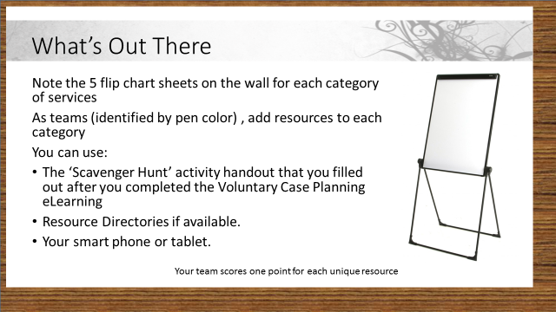
Trainer: Post 5 flip chart sheets on the wall, labeled with the following categories: aging services, mental health/substance abuse system, health care system, legal system, victim services (includes domestic violence/sexual assault services).
Trainer: Now we’re going to look at the homework assignment you had from the Voluntary Case Planning eLearning. You were all asked to complete the Scavenger Hunt activity and identify different types of resources in your area and to bring this completed assignment to this training. Continuing to work in your groups, and, using your scavenger hunt records, available resource directories and your smart phones, walk around the room and add resources to each of the flip charts. You will have 10 minutes (Move to slide #24).
Trainer: Give the groups 10 minutes to work on this and add their resources to the sheets, then bring the group back together and review each of the sheets briefly.

Slide #24 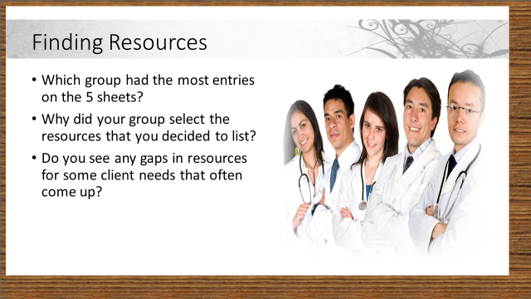
Trainer: Participants may want to copy down some of the resources that are listed or take pictures with their Smart Phones to preserve new resources they may not have been aware of. If possible, leave these sheet posted where group members can see them and record them after the training ends.
Review the questions listed on this slide with the groups briefly, then move on to the next activity.

Slide #25 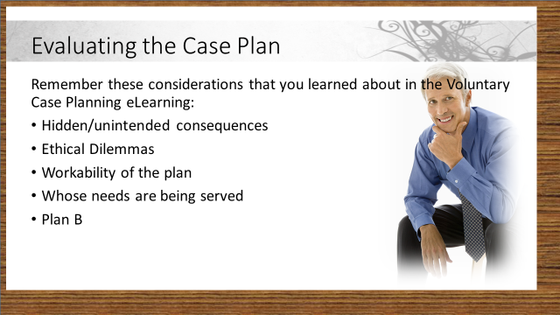
Trainer (read or paraphrase): Each of the areas of consideration listed on the slide were discussed in the Voluntary Case Planning eLearning. You will be using these in the next activity. Does anyone have any questions about any of these areas of consideration?
In case participants should have questions, listed here are possible responses pertaining to each of the consideration areas listed on the slide:
• Hidden/ unintended consequences: Will the intervention put the client at more risk? Will the client be able to follow through when the worker is not available?
• Ethical dilemmas: If the client has capacity, are we respecting the right to self-determination?
• Workability: Are the services we propose available when we need them? How do we know if the perpetrator will follow through on promises?
• Whose needs are being served: Are we responding to community pressure (“How can you let a person live like that?) or to our own value system (“I would never treat my mother that way.” “That son is a scum-bag and shouldn’t be allowed anywhere in the house.”)
• Plan B: Do we have another plan in case Plan A falls short? How do we plan to follow up?

Slide #19
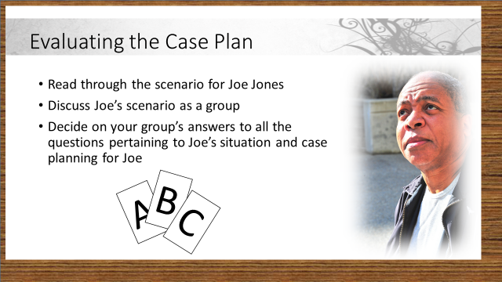
Trainer: Read through the instructions on the slide, then direct participants to handout #6 in their participant manuals.
For this activity, the groups will determine their answers to ALL the questions before you call for a vote AND they have the opportunity to try and convince the class to give them a point for “wrong” answers if they can make a strong case for that answer. Correct answers are noted on page 33 in bold.

Handout #5
The Case Plan

Joe Jones resides in an apartment in an unsafe neighborhood. He has a heart condition and diabetes. He has had 4 toes amputated, uses a wheelchair, and is housebound. His unemployed son, George, lives with him. It was reported by client’s daughter that her brother is a drug addict, takes her father’s money and threatens him. The daughter tells the APS worker that her brother is known to the police and asks the APS worker to have George removed from the home. When the APS worker meets with Joe Jones, he says that he understands his son and doesn’t wish to take an action against Jesus since the son helps him out. The APS worker says that there are many agencies that can provide the services he needs and convinces client to file a restraining order.

Questions:
- Based on the limited information that you have, which of the following motivations is most likely to play a significant role in this case?
- The client’s daughter may be trying to take control of Joe’s money
- George may only be staying with his father because he is dependent on Dad
- The daughter’s accusations about George may be partly based on sibling rivalry
- Despite George’s bad behavior, Dad may like the fact that he is still needed

- Again, based on the limited information we have so far, what may realistically happen as a direct result of filing a restraining order to keep George out of his father’s home?
- Joe may be left without a caregiver unless the daughter steps in
- The daughter may move in with Joe and she may become an abuser.
- George may be arrested and/or become homeless
- Joe may seem to comply initially, but later may allow George back into his home in spite of the restraining order

- Should the APS Worker be ‘convincing’ the client to get a restraining order?
- No. The client’s wishes should always come first and fostering independent decision making on the part of the client is strength based planning
- Yes. APS has an obligation to protect their clients, even if they don’t want protecting
- APS workers must strike a delicate balance between protecting Joe and recognizing his right to make decisions about his life.
- The police should be called and they will decide.

- What might a good ‘Plan B’ be in this case if the initial intervention fails or cannot be accomplished?
- Encourage Joe to connect with community or senior organizations who make regular contact with their clients so that someone from outside the home will be seeing Joe.
- Encourage the daughter to file for conservatorship so that she can take control and keep George away from Joe.
- Find out if George is on probation, if so talk to his probation officer and see if George can be put back in jail.
- Encourage the daughter to move in with Joe and George so that she can help keep Joe safe.

Slide #20 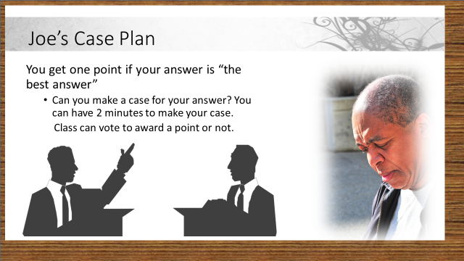
Trainer: Have participants raise their letter cards for each question after you read it, After all the questions have been answered, any group that thinks that their answer is better than the “best answer” is allowed two minutes to make their case. (Limit this to challenging one answer per team). The entire class can vote whether or not to award that team a point for a disputed answer.

Slide #28
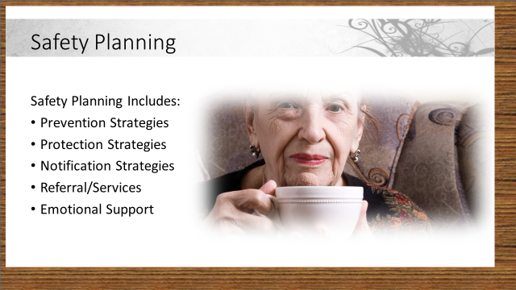
Trainer: Have a brief discussion with all participants to remind them about the Safety Planning elements that were covered in the eLearning. Refer the participants to handout #7 on safety planning. Paraphrase this content from the eLearning:
PREVENTION STRATEGIES: Preventing future incidents of abuse (e.g., going to shelter or moving to another residence, obtaining a restraining/ protective order, hiding/disarming weapons, changing schedules and routes to avoid being found).

PROTECTION STRATEGIES: Discussing methods victims can use to protect themselves during an abusive or violent incident (e.g., having an escape route, or having victim seek shelter in a room where a door can be locked, with a working phone available or where weapons are not present).

NOTIFICATION STRATEGIES: Developing methods for seeking help in a crisis situation (e.g., cell phones, emergency numbers readily available, life lines, security systems, towel in the window, code words with friends/family/neighbors).

REFERRAL/SERVICES: Recognizing and utilizing services that can offer assistance (e.g., domestic violence, sexual assault, adult protective services, criminal justice, aging and disability network, faith and community organizations, etc.).

EMOTIONAL SUPPORT: Considering methods of emotional support and ways to become less isolated (e.g., music, exercise, yoga, reading positive or spiritual materials, hobbies, art, friends, support groups, and other community activities).
CONTINUE
Recognize that the victim may want to stay with the abuser, or may be in the process of leaving or returning to the abuser, or may have left and ended the relationship. In each of these situations, the five components of safety planning listed above are crucial.

Trainer: If participants have specific input on elements of safety planning that are not listed in their handout, you may want to capture some of the participants input for each area on a flip chart to help participants retain or take notes on the individual components.

HANDOUT 6
Safety plans include:

PREVENTION STRATEGIES: Preventing future incidents of abuse (e.g., going to shelter or moving to another residence, obtaining a restraining/ protective order, hiding/disarming weapons, changing schedules and routes to avoid being found).

PROTECTION STRATEGIES: Discussing methods victims can use to protect themselves during an abusive or violent incident (e.g., having an escape route, or having victim seek shelter in a room where a door can be locked, with a working phone available or where weapons are not present).

NOTIFICATION STRATEGIES: Developing methods for seeking help in a crisis situation (e.g., cell phones, emergency numbers readily available, life lines, security systems, towel in the window, code words with friends/family/neighbors).

REFERRAL/SERVICES: Recognizing and utilizing services that can offer assistance (e.g., domestic violence, sexual assault, adult protective services, criminal justice, aging and disability network, faith and community organizations, etc.).

EMOTIONAL SUPPORT: Considering methods of emotional support and ways to become less isolated (e.g., music, exercise, yoga, reading positive or spiritual materials, hobbies, art, friends, support groups, and other community activities).

Safety planning is NOT:
- Telling the victim what to do. (e.g., “I think you should go to a shelter.”)
- Helping a victim accomplish your goals for his or her safety. (e.g. "Let's call the police and make a report.")
- Simply referring the victim to local agencies. (e.g., "Here's a list of agencies you can call. Let me know if you need other help.")
- Ignoring cultural, spiritual or generational values that influence the options the victim sees as available. (e.g., “I think your only choice here is to divorce him.”)
- Recommending strategies that could increase the risk for the victim. (e.g., purchasing a gun or weapon, attending couples counseling, “just standing up to him.”)
- Blaming the victim if he or she does not follow the safety plan and experiences further abuse.

Slide # 29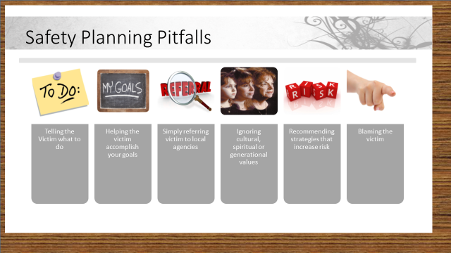
Trainer-Refer participants to Handout #7 again and lead a discussion on what safety planning is NOT. Paraphrase the elements below and discuss with participants:
NCALL provides the following guidance about what safety planning is NOT:
- Telling the victim what to do. (e.g., “I think you should go to a shelter.”)
- Helping a victim accomplish your goals for his or her safety. (e.g. "Let's call the police and make a report.")
- Simply referring the victim to local agencies. (e.g., "Here's a list of agencies you can call. Let me know if you need other help.")
- Ignoring cultural, spiritual or generational values that influence the options the victim sees as available. (e.g., “I think your only choice here is to divorce him.”)
- Recommending strategies that could increase the risk for the victim. (e.g., purchasing a gun or weapon, attending couples counseling, “just standing up to him.”)
- Blaming the victim if he or she does not follow the safety plan and experiences further abuse.

Slide #30
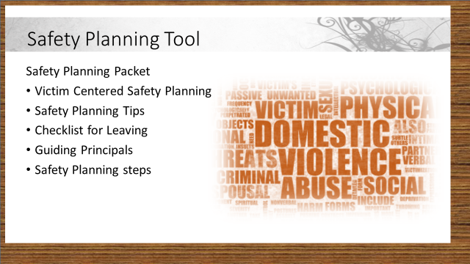
Trainer: Direct participants to handout #8-Safety Planning Packet in their participant manuals. Briefly review some of the highlights of the packet. This brief review will help participants to refresh their memories before the need to use the packet for the next activity.
You should all remember this Safety Planning Tool from the Voluntary Case Planning eLearning. Let’s discuss a few of the planning areas in preparation for the next activity.
Quickly walk the participants through each document.

HANDOUT 7 Safety Planning Packet

This packet was designed to assist adult protective services (APS)/elder abuse workers safety plan with victims of abuse. These materials provide a philosophical framework and cover many “nuts and bolts” of safety planning. The packet contains three documents:
- Victim Centered Safety Planning
This handout briefly describes the guiding principles and safety planning process. Additional considerations including victim mobility, victim capacity, and worker safety issues are also covered briefly.
- Safety Planning Tips
This Safety Planning Tips document can be used to guide an interview with a victim of abuse. The document can also be given to the victim if it is safe. The categories of tips covered in this handout include: 1) During a Violent or Dangerous Incident; 2) Preparing to Leave; 3) After you have Left or Separated; 4) Improving Your Living Space; and 5) Protecting Your Emotional Health.
- Checklist for Leaving – Temporarily or Permanently
This tool is designed for APS workers to use with a victim who may need to leave quickly or wants to leave permanently. The tool may be used to guide a discussion or given to a victim if it is safe.

Key Considerations for Adult Protective Services (APS)/Elder Abuse Workers
WHAT IS SAFETY PLANNING?
Safety planning is a process where a worker and a victim jointly create a plan to enhance the individual’s personal safety. The safety plan is victim driven and centered. It is based on the victim’s goals, not the professional’s opinions and recommendations.
WhO Can BENEFIT FROM Safety PLANNING?
Safety planning can benefit a victim who is living in fear or being physically or sexually abused. Some victims who are being financially exploited or neglected may find safety planning useful while others may need other case management remedies to address their situation. The process can provide useful strategies for victims who choose to maintain relationships with abusers; those who leave and return to abusers; or those who end the relationship permanently.
GUIDING PRINCIPLES
- Respect the integrity and authority of victims to make their own life choices.
- Hold perpetrators, not victims, accountable for the abuse and for stopping their behavior. Avoid victim blaming questions and statements.
- Take into consideration victims concepts of what safety and quality of life mean.
- Recognize resilience and honor the strategies that victims have used in the past to protect themselves.
- Redefine success – success is defined by the victim, not what professionals think is right or safe.

INCREASED DANGER FOR VICTIMS WHO END RELATIONSHIPS
Key Messages for Victims
- No one deserves to be abused.
- I am concerned about you.
- You’re not alone
- Help is available.

Ending a relationship or leaving an abuser can increase the possibility of serious injury due to retaliation or death. Indicators of potential danger may include weapons in the home, a history of or escalation of violence, or suicidal comments by abuser. Offenders who fear they are losing control over their victims lives and resources may become more dangerous.
Assistance must not, and cannot be forced upon an individual

SAFETY PLANNING Steps
- Be sure to speak to the victim alone - not in the presence or earshot of the abuser.
- Ask about the situation and current safety.
- Listen to the fear experienced and voiced by the victim.
- Ask what changes the victim would like to see to improve safety and quality of life.
- Reinforce the victim’s strength and resilience. Offer kudos on current strategies.
- Learn about the victim’s existing natural support system and possible allies. friends and family who may be able to offer support and assistance.
- Listen - a victim who feels heard is more likely to trust and continue to work with you.
- Plan specific steps with a victim to enhance safety or to get away if the older adult is fearful or in danger by reviewing safety planning tips and safety planning checklist documents. (Tools of various lengths have been created that can be used to ask questions of victims or to give victims (if safe) to complete on their own. See www.ncall.us) Ensure that tools in your office are in various formats such as audio and large print so they are accessible. Have a list of interpreters ready to work with Deaf and non-English speaking victims.
- Offer options, support and resources without judgment.
- Remind the victim that safety comes first – before belongings, pets and other plans.
- Update the plan. A safety plan is not a finished document, but a work in progress that will have to be revisited regularly as circumstances change.

ADDITIONAL ConsidERATIONS
General Issues
- Ask if the victim has any need of or responsibility for caretaking.
- Determine if culture, language, religion, sexual orientation or legal status is preventing the victim from accepting help or accessing resources.
- Ask if the individual resides in congregate living. If yes, are staff a resource or source of potential retaliation?
- Is the victim willing to consider staying at a domestic violence shelter? Are the domestic violence shelters accessible? Are they willing to accept victims who do not have children, or may be parenting grandchildren rather than birth children? Can they accommodate persons with medical needs or with a caregiver?

Victim Mobility
Victims with mobility issues may need to discuss additional accommodations when safety planning. Some issues to consider:
- Consider how the abuser may use a person’s physical limitations against him or her as an abusive tactic.
- Can the victim carry a cell phone at all times to call 911 in an emergency?
- What accommodations and medical/assistive equipment will the victim need if not living at home?
- Consider adaptations to the individual’s home that might make it safer and easier to escape from in a dangerous incident.
- Keep in mind issues such as spare batteries and backup assistive devices and food for services animals will need to be considered for some victims.

For more information, see “Safety Planning: A Guide for Individuals with Physical Disabilities” at www.ncall.us. And “Model Protocol on Safety Planning for Domestic Violence Victims with Disabilities” at www.wscadv.org.

Victim Capacity
During the intake and safety planning process, consider the victim’s capacity to create and follow the steps of a safety plan. The worker should presume capacity, but if seems possible that the older adult may not be able to track information, contact health care providers who may be able to assist with a capacity assessment. When working with persons who have capacity limitations to create a safety plan, consider the following:
- Follow the victim’s wishes as much as possible.
- Consider if the victim can follow a simplified plan with one or two steps such as “If I am afraid, I will call my sister Sara at______________________”
- Consider whether the victim has a support network of family, friends, or paid staff who can assist with developing and implementing the safety plan.
- Consider whether a written plan or one with pictures is more effective.
- If offering a cell phone, be sure the person knows how to charge and use the phone. Consider having the phone programmed to 911.
- Safety planning may take more time with a person with cognitive limitations. A person’s ability to track the plan may change over time and may need frequent updating.
For more information, see “Safety Planning: How You Can Help” at www.ncall.us.
Worker Issues
- Be aware, alert, and wary. Plan for your own safety when you enter someone’s home.
- Be sure other staff knows your location. Keep your cell phone handy.
- If you are concerned about your personal safety, contact law enforcement to accompany you on the home visit.
- Avoid colluding with charming or sympathetic abusers. Focus on victim safety.
Success is
….listening and having the speaker feel heard
….offering non-judgmental support and information
….providing resources to enhance a sustainable safety net
….seeing victims find their way so they trust and use their abilities to
build peaceful lives
peaceful lives

Safety Planning Tips
During an Violent or Dangerous Incident
- Plan a safe place to go if you have to leave suddenly.
- Plan a primary and backup escape route out of your home.
- Practice getting out of your home safely.
- Try to avoid rooms that have only one exit like bathrooms, or that have no phone or cell phone to call for help.
- Be aware of items in your home that could be used as weapons, such as guns, knives, even cords used for strangulation.
- If you are being attacked, curl up and protect your head and heart.
- Arrange a signal with a trusted friend or neighbor for when you need help.
- If you have a disability that impacts your mobility, plan how best to escape or who to call for help.
- Keep your purse or wallet ready to leave suddenly.

Preparing to Leave (temporarily or permanently)
- Hide an overnight bag packed with your identification, important documents, medication and a change of clothes. Be sure to include things like glasses, hearing aids, dentures or canes.
- Make copies of all your important documents and hide them in a safe place. Tell someone you trust the location of the hiding place.
- If you have a car, back into your driveway so you can quickly drive away. Keep the gas tank full. Hide a spare set of keys.
- Open your own checking and/or savings account. Have a credit card in your name only. Be sure to use a password your abuser will not guess.
- Contact Social Security or pension programs if you need to change how you currently receive payments. If you have representative payee, be sure this person is aware of your situation. If the representative payee is someone you no longer trust, change representative payees.
- Get a Post Office Box so your abuser cannot track you by where you have your personal mail forwarded.
- If you are 60 years of age or older, contact your local aging or tribal program about assistance with emergency housing, health care benefits, or financial assistance you might need or want.
- Call your local domestic violence program for assistance with safety planning and information about counseling and legal services. You can also call the National Domestic Violence Hotline at 1-800-799-7233 (SAFE) or 1-800-787-3224 (TTY).
- Be aware that your abuser can discover your plans or location by monitoring your phone, cell phone, TTY, your email or computer searches, and your car. Your abuser can place a locator device in your personal belongings or your car. Also, many cell phones have a GPS device inside. Ask for help if you need assistance if any of these actions have been taken.
- Consider getting a domestic violence stay away or restraining order. If you are a person over 60 years of age you may qualify for additional protections in some states. Your local domestic violence program or APS worker can assist you with these orders.
- If you are concerned about your immigration status, speak with an immigration expert. You may qualify for special consideration under the Violence Against Women Act.

After You have Left or Separated from a Former Spouse, Partner, Family Member, or Caregiver
- If you are still in the family home, change the lock. Add security devices such as motion activated exterior lights, a metal security door or gate, or an alarm system.
- If you haven’t already done so, get Post Office Box for forwarding your mail and for deliveries. Open your new bank accounts and be sure to use a password no one will guess.
- Consider getting caller ID and an unlisted phone number. Many domestic violence programs can assist you with obtaining cell phone to call 911.
- Keep your Restraining Order with you. Make several copies. Keep one on your person, one in your car, and give a copy to a trusted friend or family member. If you haven’t already gotten a restraining order, consider getting one now. Your local domestic violence program or adult protective services can often help you to obtain the court order.
- Let your neighbors or facility staff know about anyone who is no longer welcome on the premises. Ask them to call you and the police if they see that person(s) entering or loitering around your property.
- Let your co-workers or persons you volunteer with know about your situation. Ask them to screen your calls, walk you to and from your car, and keep a copy of your restraining order in your desk. Your employer may want to obtain a workplace restraining order.
- Avoid the stores, banks, and pharmacies you used previously. Establish new services or tell your previously used services who you are avoiding. They may be willing to help you avoid a situation that could become dangerous.

Improving your current living space
- Phones: Have a phone in every room of the house or have a charged cell phone that you carry everywhere with you.
- Handrails: Have grab bars and handrails installed (e.g., bath tub, stairs) so you have something to hold on to if you lose your balance.
- Lighting: Increase the wattage of light bulbs and ensure that closets, stairs, entrances and walkways are well lit. Add motion lights outside your home so you will know if someone is outside.
- Hearing: If needed, increase the volume on the phones. If needed, use a smoke detector with strobe lights.
- Mobility: Keep floors clutter free and electric cords out of the way. Use slip resistant area rugs.

Protecting your emotional health and safety
- Get counseling, attend workshops or support groups. Do whatever you can to build a supportive network that will be there for you.
- If you are thinking of returning to your abuser have a friend, family member, or counselor you can call to support you.
- If you must communicate with your abuser, consider ways to so safely. Meet in a public place, take a friend for support, or call the abuser from a phone other than your own.
- Leaving an abusive situation is a process; it does not happen in one day. There may be many times when you are tempted to contact your abuser ‘just to talk’, to handle unfinished business, or to discuss how hurt or angry you are. Call a trusted friend or counselor first. Once you have aired your thoughts with a trusted friend or counselor, you may be able to eliminate your need to call your abuser all together.

IF YOU NEED TO LEAVE
This checklist will help you make plans for what to do if you are afraid or being hurt. If you don’t have some of the information, you can begin to gather some documents and items to pack now. You may also want to identify trusted family, friends or others who can help.
Keep this information in a safe and private place where your abuser cannot find it.

Important Phone Numbers
Police: 911 or _____________________________________________
My doctor __________________________________________________
My attorney_________________________________________________
My safe friend_______________________________________________
Other______________________________________________________

I can tell these friends and neighbors about the abuse. I can call them in an emergency. I can ask them to call the police if they hear suspicious sounds coming from my house or if they cannot contact me and think I am in danger. (Think about if they can be trusted before talking to them. )
Name phone number
______________________________________________________________________

Name phone number

I can go to these places if I have to leave my home in an emergency

________________________________________________________

________________________________________________________

The following are hidden in a safe place (these are only suggestions, hide the items that you think you must have to survive.)
I have told ______________________ where they are.

(____) An extra set of car and house keys
(____) Some extra money
(____) A pre-paid cell phone
(____) An overnight bag packed with medication and
a change of clothes
(____) A spare assistive device

I can leave my pet(s) with or have livestock/other animals feed by:

___________________________________________________
Name phone number

Items to copy and hide or give to a safe friend

- My birth certificate
- My Social Security card
- My health insurance card and records
- My driver’s license
- My passport
- Banking information (check book, statements etc.)
- Welfare identification papers
- Children or grandchildren’s birth certificates and passports if you are their guardian
- Lease agreements or mortgage payment book
- Home, car or other insurance documents
- Divorce documents
- Other important documents such as immigration papers

A friend who can help me copy and hide these documents

___________________________________________________
Name phone number

Items to take when it is safe to pack or if you have a pre-packed overnight bag

- Medical or assistive devices such as glasses, hearing aids, canes etc.
- Medication
- Originals of all the above documents
- Keys
- Money
- Address book
- Change of clothes
- Comfortable shoes
- Toiletries
- Pictures, jewelry, items of sentimental or monetary value
- Documents and favorite toys of children or grandchildren if you are their guardian

A friend who can help me pack and hide an overnight bag

______________________________________________________________________
Name phone number

This information must be updated regularly. A safety plan is only as safe as it is current.

While it is helpful to have a completed list and all your belongings packed or hidden, it is always more important to escape a violent situation than to stop and gather lists or possessions.

Slide #31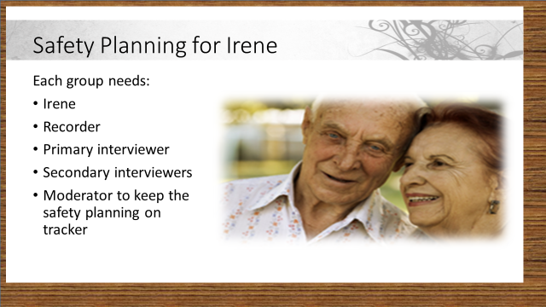
Trainer: Read the following case study to the class:
HANDOUT 8 Safety Planning for Irene

You have received a report from a neighbor stating that Mrs. Irene Newman (age 74) has a black eye. The reporter believes that Irene’s son Jack hit her when he was drunk.

Irene lives with her husband, Arthur (age 77), who is paralyzed from the neck down following a very serious stroke. Arthur is now cognitively impaired and needs care 24/7. Irene and Arthur’s son, Jack (age 50) lives with them. Jack normally works construction but he is currently unemployed. He lives with his mom and dad in order to “help out”, mainly by running errands for this mother and doing yard and maintenance work. If your agency requires you to interview the suspected abuser, you get the following information: Jack states that he enjoys a couple of beers in the evening and during football games. He denies having a drinking problem and says that his mother is just too straight laced. He denies hitting his mother and states that she fell and hit her head.

Trainer: Working in their established groups, ask participants to do the following:

Have each group select:
- A person to play Irene
- A person to be the moderator and help keep the safety planning on track. They are to listen for and correct safety planning that:

  - Tells the victim what to do.
  - Accomplishes your own goals
  - Makes a referral.
  - Ignores cultural, spiritual or generational values
  - Recommends strategies that could increase the risk for the victim. (e.g., purchasing a gun or weapon, attending couples counseling, “just standing up to him.”)
  - Blames the victim if he or she does not follow the safety plan.
(Note: this information is NOT to be reported out to the rest of the class, it is to help keep the group on task)
- A person to be the recorder
- A person to be the primary interviewer
- People to be the secondary interviewers

Give each “Irene” a situation card marked #1. This card gives “Irene” her expectation about the outcome of her Safety Plan. Give the group 10 minutes to develop a safety plan. The groups may want to consider information from the “Factors that Influence the Service Plan” Handout as they safety plan with “Irene”.

As the trainer, you should also monitor the discussions and listen for (and correct) any discussions that blame the victim, recommending strategies that are not helpful and may prove dangerous, or plans that focus almost exclusively on case management and referral rather than safety planning and empowerment.

After 10 minutes, debrief the groups.
Ask:
- What was your situation and what was your case plan?
- Does your safety plan address Irene’s concerns? Are Irene’s desires responsible? What compromises did you need to make?

Trainer: Show slide #32 on the screen as groups work.

Safety Plan for Irene Cards-Template

Slide #32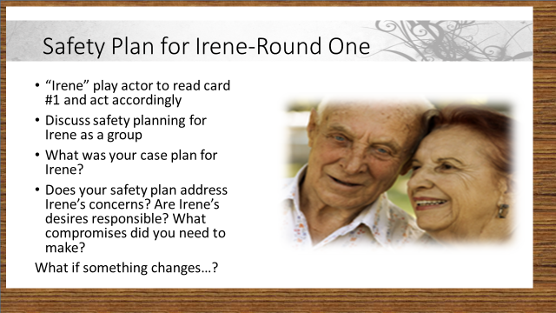
Trainer: After participants have had a chance to discuss their groups’ safety planning for the 1st scenario card, move on to slide #33

Slide #33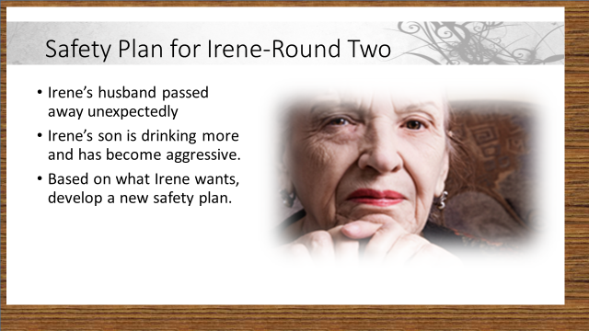Trainer: Explain to the class that safety plans often have to be changed to reflect changes in the victim’s life. Read the changes to Irene’s case from the slide. In this case, Irene is now a widow and her son has become more aggressive.
Give each “Irene” a new card marked #2. Ask the groups to spend 5 minutes discussing how the safety plan would need to change given the new information. Again, ask the moderator to monitor the discussions and listen for (and correct) any discussions that blame the victim, recommending strategies that are not helpful and may prove dangerous, or plans that focus almost exclusively on case management and referral rather than safety planning and empowerment. After 5 minutes, debrief the groups.
Show slide #34 on the screen while groups process the changes necessary for Irene after they receive card #2

Slide #34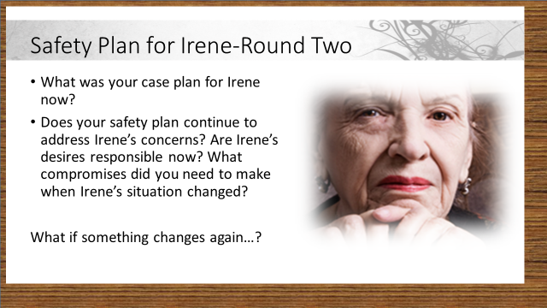
Trainer: After groups have been debriefed, move on to slide #29.

Slide #35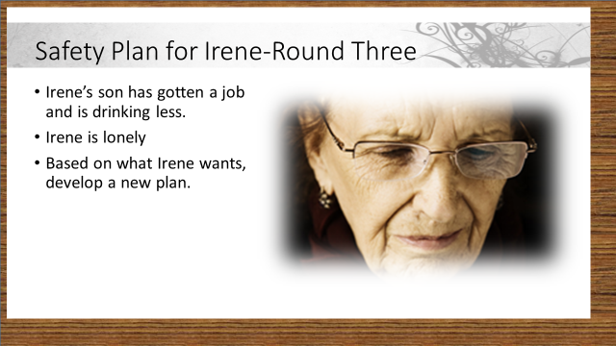
If time allows:
Trainer: Keeping the groups together and ask the groups to spend 5 minutes discussing how the safety plan would need to change given the new information. After 5 minutes, debrief the groups. Show slide #30 on screen while groups work on their latest plan modifications.
This third change can be skipped if there is less than 20 minutes left at this point.

Slide #36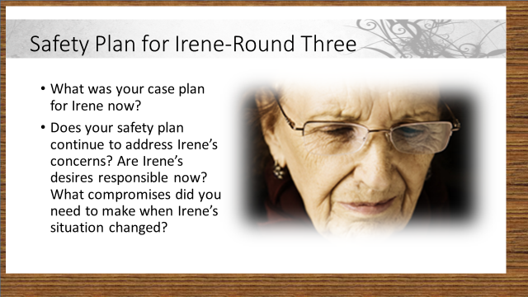
Trainer: Once participants have completed their planning for the 3rd new situation for Irene, and have reported out on their plans, move to slide #37.

Slide #37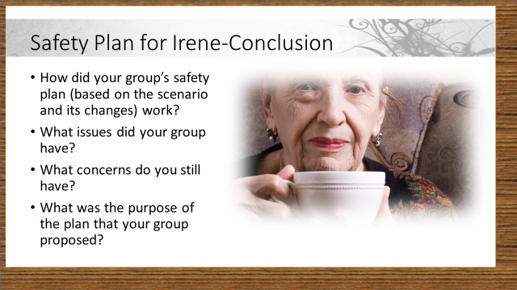
Trainer: Lead a discussion with all participants about how they felt that their safety plans worked. Encourage participants to talk about what issues they had as a group while they were problem=solving for each of the three changes to Irene’s situation. Ask groups: what concerns do you still have? What was the purpose of the plan that your group proposed?

Slide #38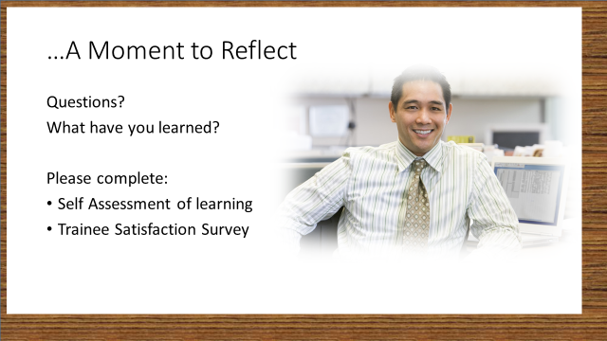
As the skill based training draws to a close, encourage participants to ask any questions that have not been answered or explained for them. Also encourage participants to discuss what they have learned. This may provide valuable feedback for you as a trainer, about the training in general, and provide hints for possible training modifications in the future if you again give this skill based training. Teams may want to point out who has “bragging rights” for the highest scores!
Ask participants to complete the self-assessment of learning and the trainee satisfaction survey.
If you have scheduled in a coaching conference call, remind the class of the date, time and call in information for that call.
Thank participants for their participation and for the important work that they do in protecting these segments of their community.

