**PIECES OF THE PUZZLE:  
COLLABORATION IN APS WORK**

**TRAINER’S GUIDE**



**MODULE 21 **TRAINER MANUAL

Pieces of the Puzzle: Collaboration in APS Work

 

This training was produced by the Academy for Professional Excellence under 2009-SZ-B9-K008, awarded by the Office for Victims of Crime, Office of Justice Programs, U.S. Department of Justice. The opinions, findings, and conclusions or recommendations expressed in this training are those of the contributors and do not necessarily represent the official position or policies of the U.S. Department of Justice. The National APS Training Project is a project of the Academy for Professional Excellence, San Diego State University School of Social Work

**Curriculum Developer**

Miriam Wolf MS, LCSW

© 2013. San Diego State University School of Social Work, Academy for Professional Excellence. Please acknowledge this copyright in all non-commercial uses and attribute credit to the developer and those organizations that sponsored the development of these materials. No commercial reproduction allowed.

**INTRODUCTION**

**THE ACADEMY FOR PROFESSIONAL EXCELLENCE**

We are pleased to welcome you to the Pieces of the Puzzle: Collaboration in APS Work Training developed by Project MASTER, a program of the Academy for Professional Excellence.

The Academy for Professional Excellence was established in 1996 and provides training, technical assistance, organizational development, research, and evaluation to public and private health and human service agencies and professionals.

The Academy is a project of San Diego State University School of Social Work (founded in 1963), which offers both a bachelor’s and master’s degree in Social Work. The School of Social Work at San Diego State University was founded in 1963 and has been continuously accredited by the Council of Social Work Education since 1966.

The Academy has extensive experience in providing specialized services, including:

* multidisciplinary competency-based trainings
* curriculum development
* needs assessment
* research
* evaluation
* meeting facilitation
* organizational development consultation services

MASTER has received Office of Victims of Crime funds for this project and is a program of the Academy for Professional Excellence which has the overarching goal to develop standardized core curricula for new APS social workers and to share these trainings on a national scale. Professional training opportunities are a critical step toward ensuring APS social workers have the appropriate tools to serve their clients/victims. MASTER has worked extensively with state and national partner agencies in the development of this curriculum.

Our partners include:

* National Adult Protective Services Association Education Committee (NAPSA)
* The Statewide APS Training Project
* California Department of Social Services, Adult Services Branch
* California State University Sacramento IHSS Training Project
* Protective Services Operations Committee of the California Welfare Director's Association (PSOC)

**PARTNER ORGANIZATIONS**

|  |  |
| --- | --- |
| **Lori Delagrammatikas**,  Program Coordinator for MASTER  The Academy for Professional Excellence  6505 Alvarado Road, Suite 107  San Diego, California 92120  (909) 213-6059  [ldelagra@projects.sdsu.edu](mailto:ldelagra@projects.sdsu.edu)  <http://theacademy.sdsu.edu/programs/> | **Krista Brown**,  APS Project Coordinator The Academy for Professional Excellence  6505 Alvarado Road, Suite 107  San Diego, California 92120  (510) 459-0731  [krbrown@projects.sdsu.edu](mailto:krbrown@projects.sdsu.edu)  <http://theacademy.sdsu.edu/programs/> |
| **Kathleen Quinn**, Executive Director  National Adult Protective Services Association  920 South Spring Street, Suite 1200  Springfield, IL 62704  (217) 523-4431 / (271) 522-6650  [Kathleen.quinn@apsnetwork.org](mailto:Kathleen.quinn@apsnetwork.org) | **Paul Needham**, Chair  NAPSA Education Committee  Oklahoma Dept of Human Services  PO Box 25352,  Oklahoma City, OK  405-521-3660  [paul.needham@okdhs.org](mailto:paul.needham@okdhs.org) |
| **Bethany Berube**, Chair  Protective Services Operations Committee of the County Welfare Director’s Association  5957 S. Mooney Blvd  Visalia, CA 93277  BBerube@tularehhsa.org |  |

**Academy for Professional Excellence**- 6505 Alvarado Road, Suite 107

Tel. (619) 594-3546 – Fax: (619) 594-1118 – <http://theacademy.sdsu.edu/programs/>

**ACKNOWLEDGMENTS**

This training is the result of a collaborative effort between Adult Protective Services administrators, supervisors, staff development officers and workers across the state and the nation; professional educators; and the Academy for Professional Excellence staff members. Project MASTER would like to thank the following individuals and agencies:

**Agencies**

California Department of Social Services, Adult Services Branch

California Social Work Education Center Aging Initiative

Los Angeles County Adult Protective Services Agency

Orange County Social Services Agency

Riverside County Department of Public Social Services

San Bernardino County Department of Aging and Adult Services

San Diego County Aging and Independence Services

**Regional Curriculum Advisory Committee**

Carol Mitchel, APS Manager and PSOC Representative, Orange County

Beverly Johnson, LCSW, Staff Development Officer, Riverside County

Carol Castillon, APS Supervisor, San Bernardino County

Carol Kubota, LCSW, Staff Development Officer, Orange County

LaTanya Baylis, Staff Development Officer, San Bernardino County

Ralph Pascual, Staff Development Officer, Los Angeles County

**Committees**

Project MASTER Steering Committee

APS Core Curriculum Committee

National Adult Protective Services Association Education Committee

Protective Services Operations Committee of the California Welfare Directors’

Association

**Evaluation Consultants**

Jane Birdie, Evaluation Consultant

**TABLE OF CONTENTS**

|  |  |
| --- | --- |
| **General Information** |  |
| **Introduction**……………………………………………………………………………………. | 3 |
| **Partner Agencies**……………………………………………………………………………… | 4 |
| **Acknowledgements**…………………………………………………………………………... | 5 |
| **Table of Contents**……………………………………………………………………………... | 6 |
| **Course Outline**………………………………………………………………………………… | 8 |
| **Training Goal and Objectives**………………………………………………………………. | 9 |
| **Trainer Guidelines**…………………………………………………………………………….. | 11 |
| **Course Timeline**……………………………………………………………………………….. | 14 |
| **Executive Summary: Handout 1**…………………………………………………………… | 15 |
| **Presentation** |  |
| **Welcome and Introductions**………………………………………………………………… | 18 |
| Handout 2: Letter to Participants………………………………………………………….. | 21 |
| Handout 3: ID Code…………………………………………………………………………. | 25 |
| **Introduction to Collaboration**………………………………………………………………. | 27 |
| **Why Collaborate?**........................................................................................................... | 30 |
| **Collaborating with Partner Agencies/Disciplines**……………………………………….. | 38 |
| Handout 4: MDT Partners………………………………………………………………….. | 42 |
| Handout 5: Case Example…………………………………………………………………. | 51 |
| Handout 6: Approaching an MDT Member About Collaboration……………………… | 54 |
| **Skills for Collaboration**……………………………………………………………………… | 57 |
| Handout 7: Principles of Conflict Resolution……………………………………………. | 65 |
| Handout 8: Collaboration Learning Inventory…………………………………………… | 74 |
| **Confidentiality and Information Sharing**…………………………………………………. | 77 |
| **Multidisciplinary Teaming in Elder Abuse**……………………………………………….. | 80 |
| Handout 9: MDT Team Exercise Instruction Packet……………………………………. | 83 |
| **Q and A and Evaluations**…………………………………………………………………. | 92 |
| **References** |  |
| **References**…………...…………………………………………………………………….... | 93 |
| **Appendix** |  |
| **Appendix**……………………………………………………………………………………… | 95 |

COURSE OUTLINE

|  |  |  |  |
| --- | --- | --- | --- |
| **Content** | **Total Time** | **Activities** | **Slides/pages** |
| **Welcome & Introductions: Objectives, Overview of Project, Housekeeping** | 30 minutes | Lecture, Participant introductions | Slides 1-6  **Handout 2 and 3** |
| **Introduction to Collaboration** | 30 minutes | Activity: Puzzle Exercise -- provides an opportunity to see team dynamics in action, to identify behaviors that support and challenge successful collaboration | Slide 7 |
| **Why Collaborate?** | 30 minutes | Lecture  Mini-exercise: Identifying which benefits/barriers to collaboration are related to competencies required for cross-discipline work | Slides 8-12 |
| **Collaborating with Partner Agencies/Disciplines** | 75 minutes | Lecture  MDT Partners Activity – Trainees identify and define roles of critical collaborative partners and potential areas of conflict  Case Discussion | Slides 13-22  **Handout 4, 5 and 6** |
| **Skills for Collaboration** | 60 minutes | Lecture on guidelines for developing cross-discipline relationships  Collaboration Learning Self-Inventory | Slides 23-37  **Handout 7 and 8** |
| **Confidentiality and Information Sharing** | 30 minutes | Distribution of handouts & information re: local statutes and laws governing information sharing and confidentiality | Slides 38-40 |
| **Multidisciplinary Teaming in Elder Abuse** | 60 minutes | MDT Exercise that demonstrates the skills needed for and the benefits of collaboration | Slides 41-42 **Handout 9** |
| **Q and A and Evaluations** | 15 minutes |  | Slide 43 |

TRAINING GOALS AND OBJECTIVES

|  |
| --- |
|  |



**LEARNING OBJECTIVES**

Knowledge:

The trainee:

* Can define collaboration as it applies to work across professional disciplines.
* Can articulate the benefits, challenges and barriers to successful collaboration.
* Will be able to describe the roles and functions of the other professional disciplines that are involved in elder/dependent adult abuse prevention, investigation and remediation, and how they work together to produce a safety net for victims of elder abuse.
* Understands the fundamental elements critical to effective team building within a collaborative partnership or relationship.
* Can list at least two strategies for effective interpersonal communication.
* Can list at least two strategies for conflict resolution.
* Understands legal and ethical issues related to confidentiality.

Skills:

The trainee:

* Can identify his/her own interaction style and skills which contribute to or detract from successful collaboration.
* Can identify examples of successful professional collaboration, using case scenarios and anecdotal, personal experiences.
* Can demonstrate beginning skills in communication and networking with other disciplines routinely involved in adult protective service cases, using a case scenario.

Attitudes:

The trainee:

* Values multidisciplinary collaboration in achieving optimal outcomes in adult protective service cases.
* Appreciates the roles and functions of non-investigative personnel on multidisciplinary teams.
* Is motivated to improve his/her own skills to enhance collaboration with professionals from other disciplines.

TRAINER GUIDELINES

This training was developed to be delivered as an in-person, interactive training for APS workers and their multidisciplinary partners. As such, class size should be limited to 30 people or less. Participants can belong to any agency which would normally participate on an elder abuse team. This includes APS, law enforcement, aging services, public health, mental health, conservators or public guardians, code enforcement, and a variety of other agencies. Seating should be in small table groups of six or less to facilitate small group work.

In preparing for this class, you will need to purchase four picture puzzles of 24 pieces. Children’s 24 piece puzzles can be purchased in many “dollar” stores at a minimal cost.

You will also need to research laws/statutes relating to confidentiality, formal MOUs or MDT protocols, agency-specific releases/authorizations and information on local MDTs. It is recommended that you provide participants with the following:

* Copies of laws/statutes relating to confidentiality/ information sharing
* Copies of formal MOUs or MDT protocols, if they exist for the jurisdiction in which this training is being presented
* Copies of agency-specific releases/authorizations, if training staff of only one agency
* Copies of materials from local, formal MDTs, if in existence

You will also need to print out copies of the four fact sheets (found in the Appendix, pages 98-101) for the MDT exercise as they are **NOT** in the participant manuals. This is because it is important that each “discipline” only have access to their own agency’s information.

An executive summary is provided on page 15 to inform supervisors about what their staff will learn in the training and how they might increase the transfer of learning from the training to their workers’ practice. Please provide the executive summary to supervisors in advance of the class.

**Customizing the PowerPoint:**

Although we recommend presenting the material as written, you may need to make changes in order to allow extra time to cover your local laws and statutes or to train on your local MOUs. If this is the case, you may need to customize your PowerPoint. The Microsoft Office PowerPoint software allows you to hide any slides you don’t want to use.

|  |
| --- |
| Hide a slide instructions   1. On the **Slides** tab in normal [view (view: A way of displaying the contents of a presentation and providing the user with the means to interact with it.)](javascript:AppendPopup(this,'ppdefView_1')), select the slide you want to hide. 2. On the **Slide Show** menu, click **Hide Slide**.   The hidden slide icon Icon imageappears with the slide number inside, next to the slide you have hidden.  **Note**: The slide remains in your file, even though it is hidden when you run the presentation. |

Please note that this manual is set up so that the trainer script/ background material is on the same page as the accompanying PowerPoint slide making it easy to also customize your manual to match the slides you have decided to use, just remove the unneeded pages.

|  |  |
| --- | --- |
| **Teaching Strategies** | **The following instructional strategies are used:**   * Lecture segments * Interactive exercises (e.g. Table Top Activities, experiential exercises, role plays ) * Question/answer periods * Slides * Participant guide (encourages self-questioning and interaction with the content information) * Embedded evaluation to assess training process. |
| **Materials and Equipment** | **The following materials are provided and/or recommended:**   * Computer with LCD (digital projector) * CD-ROM or other storage device with the slide presentation * Easel/paper/markers * **Four different 24 piece puzzles and four large envelopes with each puzzle picture (can be cut from the puzzle box) on the outside** * **Masking Tape** * **Handouts for MDT exercise (They are NOT in the participant manual- they are in the appendix, pages 98-101)** * Trainer’s Guide: This guide includes the course overview, introductory and instructional activities, and an appendix with reference materials. * Participant Guides: This guide includes a table of contents, course introduction, and all training activities/handouts. Name tags/name tents. * Water access/snacks/restroom access/lunch plans |
| **NOTE:** This training covers the basic theories, techniques and skills needed to develop basic collaboration skills, but it does not answer agency specific questions. Y**o**u will need to collect agency specific information before delivering this training. Trainer’s notes indicate where you must collect agency specific information. | |

**Course Timeline**

9:00 – 9:30 Introductions, Overview, Learning Objectives

9:30 – 10:00 Introduction to Collaboration

* Puzzle Activity

10:00-10:30 Why Collaboration

* Definitions and Terms
* Benefits and Barriers
* Competencies needed for effective collaboration

10:30 – 10:45 Break

10:45 – 12:00 Collaborating with Partner Agencies/Disciplines

* Identifying partner agencies and their roles/missions
* Case scenario #1

12:00 – 1:00 Lunch

1:00 – 2:00 Skills for Effective Collaboration

* Interpersonal
* Communication
* Conflict Resolution

2:00 – 2:30 Confidentiality and information sharing

* Legal and other mandates that govern information sharing and confidentiality
* Ways information can be shared

2:30- 2:45 Break

2:45 – 3:45 Multidisciplinary Teaming in Elder Abuse

* MDT exercise

3:45 – 4:00 Evaluations and Wrap-up

**EXECUTIVE SUMMARY HANDOUT 1**

**Course Title:** *Pieces of the Puzzle: Collaboration in APS Work*

**Outline of Training:**

In this interactive and thought provoking introductory training, participants learn the benefits, challenges and barriers to successful collaboration, the fundamental elements critical to effective team building within a collaborative partnership or relationship, and can demonstrate beginning skills in communication and networking with other disciplines routinely involved in adult protective service cases. Participants should walk away from this training motivated to improve their own collaborative skills.

The following instructional strategies are used: lecture segments; interactive activities/exercises (e.g. small group discussion, case studies); question/answer periods; PowerPoint slides; participant guide (encourages self-questioning and interaction with the content information); and embedded evaluation to assess training content and process.

**Course Requirements:**

Please note that training participants are expected to participate in a variety of in-class and post-training evaluation activities. These activities are designed to enhance the learning experience and reinforce the skill acquisition of training participants as well as determine the overall effectiveness of the trainings.

An executive summary of each training and directions for post-training evaluation activities will be provided to training participants and their supervisors.

**Target Audience:**

This course is designed for new APS social workers as well as Vulnerable Adult Abuse partners (e.g. conservatorship investigators, workers in the aging and disability networks, law enforcement). This training is also appropriate for senior staff that require knowledge and/or skills review.

**Outcome Objectives for Participants:**

Knowledge:

The trainee:

* Can define collaboration as it applies to work across professional disciplines.
* Can articulate the benefits, challenges and barriers to successful collaboration.
* Will be able to describe the roles and functions of the other professional disciplines that are involved in elder/dependent adult abuse prevention, investigation and remediation, and how they work together to produce a safety net for victims of elder abuse.
* Understands the fundamental elements critical to effective team building within a collaborative partnership or relationship.
* Can list at least two strategies for effective interpersonal communication.
* Can list at least two strategies for conflict resolution.
* Understands legal and ethical issues related to confidentiality.

Skills:

The trainee:

* Can identify his/her own interaction style and skills which contribute to or detract from successful collaboration.
* Can identify examples of successful professional collaboration, using case scenarios and anecdotal, personal experiences.
* Can demonstrate beginning skills in communication and networking with other disciplines routinely involved in adult protective service cases, using a case scenario.

Attitudes:

The trainee:

* Values multidisciplinary collaboration in achieving optimal outcomes in adult protective service cases.
* Appreciates the roles and functions of non-investigative personnel on multidisciplinary teams.
* Is motivated to improve his/her own skills to enhance collaboration with professionals from other disciplines.

**Transfer of Learning:** *Ways supervisors can support the transfer of learning from the training room to on the job.*

**BEFORE the training**

Supervisors can encourage line staff to attend the training and help them identify particular situations where collaboration would be beneficial in their work. Training participants can share these experiences during training.

**AFTER the training**

Supervisors can read the training executive summary. Supervisor and training participant will then schedule a time to share what specific skills they obtained from the training. If further staff involvement is available, trainees may present an overview of what was learned to other staff members to encourage collaboration and a culture of learning.

**PRESENTATION**

**WELCOME AND INTRODUCTIONS**

**TIME ALLOTTED: 30 minutes**



**_______________________________________________________**

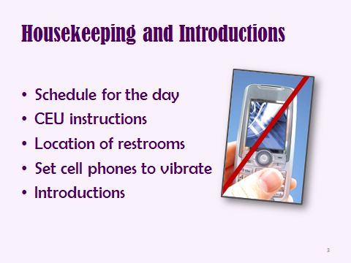

**Slide #3:**

**WELCOME** the participants and introduce yourself by name, job title, organization, and qualifications as Trainer.

**Review Housekeeping Items**

* There will be two 15-minute breaks and an hour for lunch today: 12-1 pm in…
* The restrooms are located at….
* Please turn your cell phones to vibrate for the duration of the training. If you must make or receive a call, please leave the training room and return as quickly as possible. Check the course outline to see what you have missed.

**Participant Introductions**

j0363168*Ask participants to*: make a brief self-introduction including name, job title, and organization to the entire group.

**Slide #4**

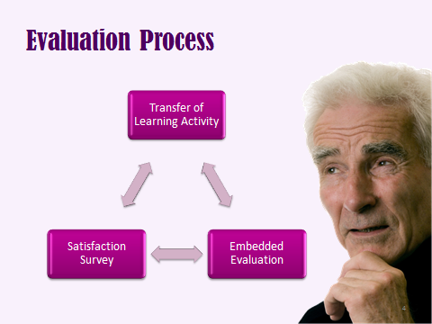

**TOPIC: Introducing participants to the evaluation process**

**Draw attention to the Letter to Participants and the ID Assignment Handouts from the Evaluation materials on pages 14 and 17 in the Participant Manual**

For this training, you will be completing a training satisfaction survey, an embedded evaluation regarding question typology (completed in class) and a post training transfer of learning exercise (to be turned in next week). All of these measures are intended to allow you to practice what you have learned and measure whether the training was effective. We want APS training to become an evidenced based practice that truly provides the knowledge and skills we believe it provides. The purpose of the evaluation process is more fully explained in your “Letter to Participants”, see page 14 of the participant manual.

**HANDOUT #2: Participant Letter of Consent**

* Academy for Professional Excellence at San Diego State University School of Social Work, MASTER (Multi-disciplinary Adult Services Training & Evaluation

for Results) begun a process of evaluating training delivered to Adult Protective Service workers

* At certain points during this training series, in addition to the usual workshop evaluation forms, you will be asked to complete various training evaluation activities
* These training evaluation activities aim to: (1) improve trainings’ effectiveness and relevance to your needs, and help you better serve adults and their families; and (2) see if the training has been effective in getting its points across.
* If you agree to participate, you will fill out a questionnaire administered before and after the training.
* The questionnaires will be coded with a unique identifier system and all responses will be confidential



**HANDOUT 2**

Dear Training Participant,

As a training program for the Academy for Professional Excellence at San Diego State University School of Social Work, MASTER (*Multi-disciplinary Adult Services Training & Evaluation for Results*) has begun a process of evaluating training delivered to Adult Protective Service workers. As part of this evaluation, we need your help.

At certain points during this training series, in addition to the usual workshop evaluation forms, you will be asked to complete various training evaluation activities.

These training evaluation activities have two main purposes:

1. To improve trainings’ effectiveness and relevance to your needs, and help you better serve adults and their families; and
2. To see if the training has been effective in getting its points across.

**Our goal is to evaluate training, NOT the individuals participating in the training.**

In order to evaluate how well the training is working, we need to link each person’s assessment data using a code. You will generate the code number using the first three letters of your mother’s maiden name, the first three letters of your mother’s first name, and the numerals for the day you were born. **Please put this 8-digit ID code on each of your assessment forms, exactly the same way each time**. ID code information will only be used to link demographic data to test data to ensure that the training is working equally well for all participants. Once this linking is done, we will only be looking at class aggregate scores, rather than individual scores.

Only you will know your ID code refers to you. All individual responses to evaluation exercises are confidential and will only be seen by the Academy’s training program and evaluation staff. Only group averages and percentages will be reported. Individual results will not be reported to your employer. Aggregate data may be used for future research to improve training for Adult Protective Service workers.

If you agree to participate, you will fill out a questionnaires administered before and after the training. The questionnaire will be coded with a unique identifier system and all responses will be confidential.

There are no foreseeable risks to you from participating. There is also no direct benefit to you. Your responses will contribute to the development of a series of evaluation tools that will be able to accurately assess the effectiveness of adult protective service training. It is hoped that these tools will assist the Academy for Professional Excellence in improving training for adult protective service workers and therefore improve services to adults and families.

Your participation is voluntary and you may withdraw your consent and participation at any time. Participation or non-participation will have no effect on your completion of this training series.

By completing and submitting the questionnaire, you agree to participate. You further agree to permit us to use your anonymous responses in written reports about the questionnaires.

Your help with this evaluation process is greatly appreciated. Your feedback will be instrumental in helping to improve adult protective service training for future participants. If you have any questions about the evaluation or how the data you provide will be used, please contact:

James Coloma, MSW

Training & Evaluation Specialist

Academy for Professional Excellence

San Diego State University – School of Social Work

6505 Alvarado Road, Suite 107

San Diego, CA 92120

(619) 594-3219

[jcoloma@projects.sdsu.edu](mailto:jcoloma@projects.sdsu.edu)

**Slide# 5**

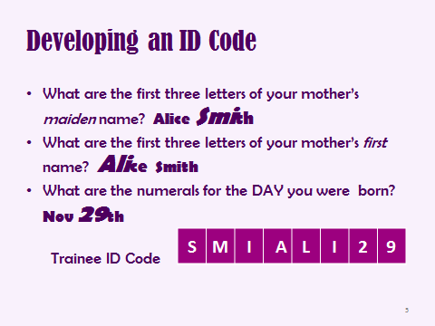

**TOPIC: Developing an ID code**

We are NOT evaluating you and no one from your agency will see your individual responses. To keep your responses confidential, we are going to develop your personal ID code. Use of the code on all your evaluation documents will allow us to link your information while maintaining your anonymity. Follow along with your ID Assignment Handout and write in your ID code on the Handout, found on page 17 in your participant manual:

**Your Identification Code:**

In order for us to track your evaluation responses while maintaining your anonymity, we need to assign you an *identification code*. We would like you to create your own *identification code* by answering the following questions:

1. What are the first three letters of your mother’s *maiden* name?

Example: If your mother’s maiden name was Alice Smith, the first three letters would be: **S** **M** **I**. If the name has less than three letters, fill in the letters from the left and add 0 (zero) in the remaining space(s) on the right.

1. What are the first three letters of your mother’s *First* name? Example:

Example: If your mother’s maiden name was Alice Smith, the first three letters would be: **A** **L** **I**. If the name has less than three letters, fill in the letters from the left and add 0 (zero) in the remaining space(s) on the right.

1. What are the numerals for the DAY you were born?

**HANDOUT #3: MASTER Identification Code Assignment**

* In order to track each of your evaluation responses while maintaining your anonymity, we need to assign you an identification code.
* You will generate the code number using the first three letters of your mother’s maiden name, the first three letters of your mother’s first name, and the numerals for the day you were born.
* Please put this 8-digit ID code on each of your assessment forms, exactly the same way each time. ID code information will only be used to link demographic data to test data to ensure that the training is working equally well for all participants.
* The questionnaires will be coded with a unique identifier system and all responses will be confidential. Only you will know your ID code refers to you.
* Aggregate data may be used for future research to improve training for Adult Protective Service workers.

**HANDOUT #3**

|  |  |  |  |  |  |  |  |  |
| --- | --- | --- | --- | --- | --- | --- | --- | --- |
| Trainee ID Code |  |  |  |  |  |  |  |  |
|  |  |  |  |  |  |  |  |  |
| Date |  |  | / |  |  | / |  |  |
|  | M | M |  | D | D |  | Y | Y |

**Your Identification Code:**

In order for us to track your evaluation responses while maintaining your anonymity, we need to assign you an *identification code*. We would like you to create your own *identification code* by answering the following questions:

1. What are the first three letters of your mother’s *maiden* name?

Example: If your mother’s maiden name was Alice Smith, the first three letters would be: **S** **M** **I**. If the name has less than three letters, fill in the letters from the left and add 0 (zero) in the remaining space(s) on the right.

___ ___ ___

1. What are the first three letters of your mother’s *First* name?

Example: If your mother’s maiden name was Alice Smith, the first three letters would be: **A** **L** **I**. If the name has less than three letters, fill in the letters from the left and add 0 (zero) in the remaining space(s) on the right.

___ ___ ___

1. What are the numerals for the DAY you were born?

Example: If you were born on November 29, 1970, the numerals would be **2** **9**. If your birth date is the 1st through the 9th, please put 0 (zero) in front of the numeral (example **0** **9**).

___ ___

Combine these parts to create your own identification code (example: **S** **M** **I** **A** **L** **I** **2** **9**). Please write your identification code in the space at the top right corner of all evaluation materials you receive.

***Remember your identification code and write it at the top of every evaluation form provided to you throughout this training*.**

**Slide #6:**

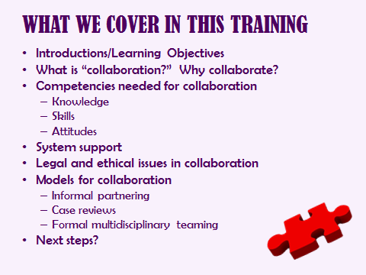

**TOPIC: What We Cover In This Training**

Give the class a quick overview of what will be covered during the training day. Give trainees a minute or two to review the learning objectives in their handout, and then ask them to choose two or three that they feel will be most relevant to them personally.

Explain to participants that this training is meant to help them develop their collaborative skills so they can more effectively work with their community partners. Although we will touch on working within a multidisciplinary team (MDT), this is not a training on how to form an MDT.

**INTRODUCTION TO COLLABORATION**

**TIME ALLOTTED: 30 minutes**



**_______________________________________________________**

**Slide #7**

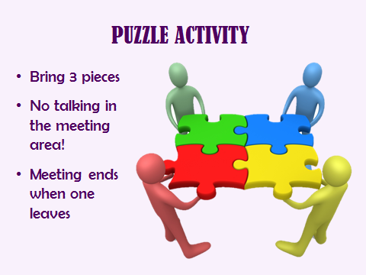

**TOPIC: Puzzle Activity**

The objectives of this learning activity are:

* Provide participants with opportunity to see group dynamics in action.
* Provide opportunity for small teams to work together collaboratively to accomplish task.
* Identify group behaviors that support and challenge successful teamwork.
* Recognize and discuss how decision making occurs when a group is faced with a complex task.

PRIOR TO THE TRAINING:  
Purchase four 24 piece puzzles. Next, divide the puzzle pieces equally into four envelopes, so that each envelope has approximately the same number of pieces from each puzzle. On each envelope, attach a picture of the completed puzzle. (In other words, every “team” will get an envelope with a picture of the puzzle they’re expected to put together, but inside each envelope are six pieces from each of the four puzzles.) It is imperative that you are sure that all of the puzzle pieces are in the envelopes so that the task can be successfully completed. The trainees have a copy of the rules in their participant manual. Finally, use the masking tape to make a 4’ x 4’ square on the floor in the middle of the room. This will serve as the meeting space. Make sure that there are tables in each corner of the room at which each team can work.

IMPLEMENTING THE ACTIVITY:

Divide the group into four teams of equal size and assign each to one of the tables in the corners of the room. Provide the following directions:

* All teams work for the same system, but are located in four different locations.
* The goal is to find all your puzzle pieces and complete your puzzle as quickly as possible, but there will be a time limit of 15 minutes.
* Review the rules (which should be posted on the slide):
* The teams cannot communicate with each other in any way and must stay at their table.
* Each team can send a representative to the meeting area at one time. (Point out the meeting area marked on the floor in the middle of the room.)
* Each representative can bring **up to three pieces** during each visit.
* A meeting can only happen when representatives are present from each of the teams. (When one leaves, the meeting is over.)
* A different representative must come to the meeting area each time. (After each member has gone to the meeting area, they can rotate through again.)
* All communication in the meeting area is **nonverbal**.

After stating the rules and clarifying any questions, pass out an envelope to each team and tell them to begin.

TRAINER ROLE DURING THE ACTIVITY:

Monitor the behavior of the teams carefully, especially at the meeting space, so that you can gently enforce the rules. Pay careful attention to when a meeting can begin as well as when it ends, so that no trading of pieces occurs in violation of the rules. You can expect most teams to catch on to the idea fairly quickly. Most often it will take more than one rotation of team members to the meeting space to complete the task. Pay careful attention to whether teams are competitive or collaborative, and use your observations when you process the activity. Make sure your process comments are descriptive rather than evaluative or judgmental.

AFTER THE ACTIVITY IS COMPLETED:

When all four puzzles are successfully put together or teams stop sending members to the meeting area (preventing a team from completing their puzzle), invite participants to process their experience of the activity using the following questions:

* 1. What happened in your small teams? What was your goal, and how did you decide to accomplish that goal?
  2. What happened in the meeting area? How did that affect your strategy?

How did you decide to change your strategy?

* 1. When were you most excited and hopeful? Most frustrated?
  2. How is this activity like your work? How is this activity like your work when you need to work across disciplines? (e.g. with law enforcement, Ombudsman, medical, prosecution, etc.)?
  3. What are the lessons you can take away about decision making and working together?

If the teams become so competitive that they prevent others from completing their puzzles, stop the activity, debrief what has been happening, and then ask the groups to go back to the activity and work towards the goal of completing ALL the puzzles as quickly as possible. Once all puzzles have been completed, debrief the differences between the first and second parts of the activity.

**WHY COLLABORATE?**

**TIME ALLOTTED: 30 minutes**



**_______________________________________________________**

**Slide #8**

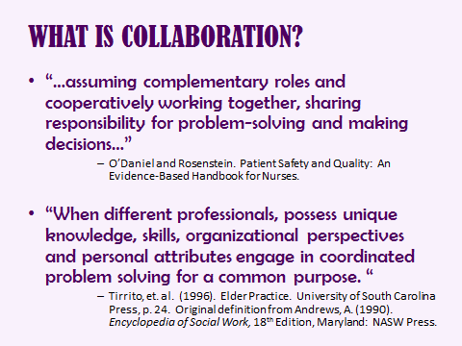

**TOPIC: What is Collaboration?**

Collaborative, multidisciplinary work in the field of aging is not new. The field of gerontology – and elder abuse – includes researchers and practitioners from diverse fields. In the last several decades, increased specialization has led to a deep knowledge base, but also, to overlap in professional roles with, at times, accompanying services, inappropriate or inadequate referrals, lack of accountability and fragmentation, or redundancy of services. The shared desire for optimal service provision to clients is what motivates professionals from different disciplines to COLLABORATE.

Collaboration implies a process of shared planning, decision-making, responsibility, and accountability in the care of the client. Ideally, in collaborative practice, providers work well together through effective communication, trust, mutual respect, and understanding of each other’s skills. While some skills and services appear to overlap, most skills and services are complementary and reinforce each other.

**Slide #9**

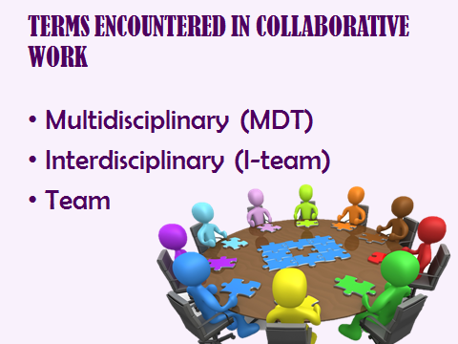

**TOPIC: Terms encountered in collaborative work**

Often, the terms multidisciplinary and interdisciplinary are used interchangeably, as we will do in this training. A general definition of multidisciplinary is “*members of different professions working together.”*

A team is defined as, *“a group of people with complementary skills who are committed to a common purpose, performance goals, and approach, for which they hold themselves mutually accountable.”* Teams need to have shared goals and values, and effective teams have members who understand and respect the competencies of other team members. An elder care/elder abuse interdisciplinary team is generally made up of representatives from several different disciplines who each interface with elderly/dependent clients. A common goal is established and each discipline works to achieve that goal, assigning tasks to members based on their particular specialties and expertise.

In this training, we will use the terms “collaborator” and “team member” interchangeably.

In some communities, the MDT is referred to as an “I-Team” (Interdisciplinary Team).

**Slide #10**

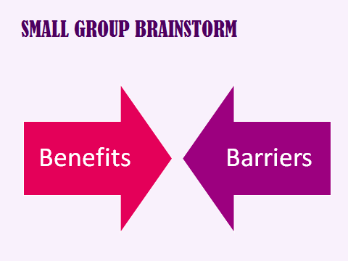

C:\Users\HP Compaq\AppData\Local\Microsoft\Windows\Temporary Internet Files\Content.IE5\8SZ7433L\MC900030042[1].wmf

**TOPIC: Small Group Brainstorm**

Divide the group into two groups of up to eight people each. Assign one group BENEFITS and one group BARRIERS. (If you have a large group, divide into four groups and have two groups working on the same assignment.) Ask groups to write their brainstorms on flip chart paper. Allow 5-10 minutes for brainstorms and then do report-backs to the larger group. If you have four groups, round-robin the two groups on Benefits and the two groups on Barriers during the report-back.

In the BARRIERS report-backs, look for answers such as:

* Lack of knowledge about other professions’ roles, cultures and systems
* Confusion about goals/lack of consensus regarding the reasons for the collaboration
* Lack of a common stake/common mission that binds the different professions together in their task
* Territorialism or historical suspicion of other disciplines (e.g. social work and law enforcement)
* Desire to protect own professional domain
* Apathy/lack of participation by needed disciplines
* Individuals involved are not team players
* Time
* Confidentiality concerns
* Funding
* Lack of direction/focus of individuals or teams
* Historical conflict between disciplines (for example, between APS and law enforcement)
* Individual professionals who need to collaborate don’t have the skills to do so

In the BENEFITS report-backs, look for answers such as:

* Shared expertise and cross-training/education
* Builds trust between agencies and individuals engaged in similar work
* Builds relationships
* Promotes networking
* More effective outcomes/action taken on behalf of clients
* Larger power base/advocacy efforts
* Feeling of larger support system for achieving goals
* Improved outcomes for clients through coordinated investigations and interventions
* Able to identify community’s service gaps and system problems
* No one program or agency can meet complex needs
* Reduced duplication of efforts/improve efficiency in service delivery
* Resources are shared during hard economic times
* More holistic approach to problem-solving/case management/services
* Ensuring that all members of the multidisciplinary team are used in a way that is maximally effective
* Cross-fertilization of knowledge and skills between professions
* Supervisors become invested and continue staffing MDTs
* Administration will be less suspicious as their line workers pass on their comfort level after collaboration
* All disciplines come in on the ground floor and don’t need to be convinced later of the relevance of collaboration

**Slide #11**

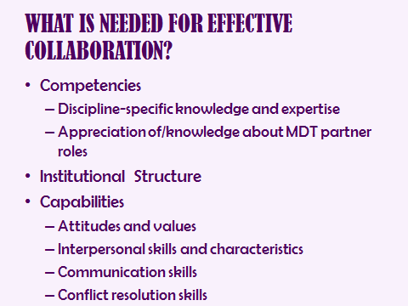

C:\Users\HP Compaq\AppData\Local\Microsoft\Windows\Temporary Internet Files\Content.IE5\0JLGXZ1M\MC900030041[1].wmf

Review previous sheets

**TOPIC: What is Needed for Effective Collaboration?**

Competencies:

Capabilities - Practitioners require more than a prescribed set of competencies to perform their role.

Looking at the flip charts that were completed by the small groups in the previous exercise, identify which of the benefits/barriers are related to knowledge, skills, attitudes and/or institutional structure.

While we will not touch on discipline-specific knowledge, this training will address all three arenas – competencies, capabilities, and structure – which are all needed for effective collaboration. After the break, we will start by discussing the roles of MDT partners.

**Slide #12**

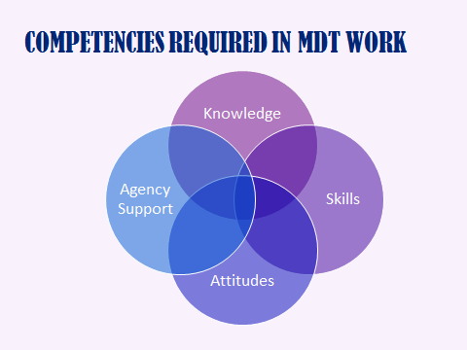

**TOPIC: Competencies required in MDT Work**

Knowledge - Each individual on a multidisciplinary team brings to their work particular skills associated with their specific profession or discipline. In APS work, discipline-specific knowledge and expertise means: Are you knowledgeable about your role and the function of APS? Do you have content knowledge about the aging process, assessment and interviewing skills, family and abuse dynamics, resources/referrals, etc.?

Skills – Each team member is a unique individual with their own interpersonal style/characteristics. Working on a team requires being able to communicate your knowledge and ideas to others in ways that can be “heard” by others in a variety of dynamic situations. It is these elements which may, in fact have the greatest influence on how people function as team members and collaborators.

Attitudes – One’s attitudes and values have a significant bearing on behavior when working in a group. Attitudes and values means that the individual holds a belief that collaboration with other disciplines/MDT partners maximizes outcomes for clients. This was covered in our “benefits to collaboration” exercise; it does minimize the challenge to collaboration, but fundamental to effective collaboration is a belief that overcoming obstacles in order to work together maximizes outcomes for clients.

Structural –Each team member is also required to work within the framework provided by their agency. They have to follow that organization’s policies and procedures which may act as either a barrier or a support to their collaborative efforts. Possible sources of support may include MOUs with other agencies, legal stattutes that address cross discipline collaboration, written policies that outline specific methods of making referrals and working joint cases, etc.).

The remainder of the training is designed to aid in the development of these competencies (though we do not address the discipline-specific knowledge and expertise, which is obviously covered in many other APS worker trainings).

The following outline is on page 23 of the participant manual.

Knowledge

* Discipline-specific knowledge and expertise
* Understanding of MDT partner roles

Skills

* Interpersonal skills
* Communication skills
* Conflict resolution skills

Attitudes/Values

* Belief that multidisciplinary work creates optimal results for clients
* Willingness to accept feedback

Agency/institutional support for collaboration

**COLLABORATING WITH PARTNER AGENCIES/DISCIPLINES**

**TIME ALLOTTED: 75 minutes**



**_______________________________________________________**

**Slide #13**

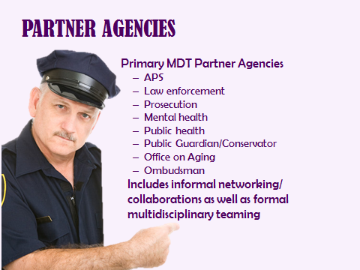

**TOPIC: Partner Agencies**

As APS workers, you will be partnering with employees from all of the agencies listed here at one time or another. You may be working with them individually, within informal partnerships, or within the structure of a more formal committee made up of various disciplines who meet under the auspices of a formal MOU.

Note that the term MDTs includes formal and informal partnerships. An example of a formal partnership is a formalized case review process or “i-Team” (interdisciplinary team), which will be discussed later in the training. Informal partnerships are seen daily in cross-disciplinary conversations and activities that occur whenever you consult, coordinate or collaborate with individuals or agencies from other disciplines. As new workers, you will be dealing mostly with informal partners.

This list is far from exhaustive.

Ask for examples of other organizations/agencies with whom trainees have collaborated as needed, on a case-by-case basis. Some additions include:

* Public Health
* Victim-Witness/Crime Victim Assistance
* Rape Crisis
* Code Enforcement
* Animal Control
* Cultural/Ethnic/Faith Community Organizations

This slide provides a good opportunity to incorporate a discussion about the importance of providing culturally relevant services and using collaboration as a mechanism to improve cultural competence as a worker and as a member of a team. Solicit examples of cultural, ethnic and community organizations with whom trainees have collaborated, emphasizing that collaborations with such organizations should reflect the communities’ demographics where APS clients reside. Examples include: Tribal members; Latino, African-American, Asian community-based organizations; LGBT seniors, veterans, and clergy from religious constituencies.

.

**Slide #14**

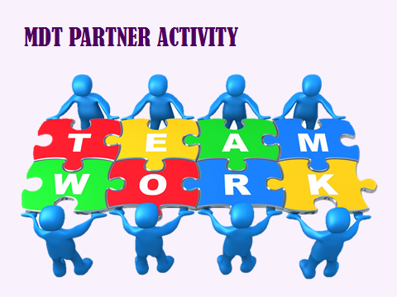

**TOPIC: MDT Partner Activity**

Point out the *MDT Partners Handout* in the participant manual on page 25. Assign each table 4-6 (depending on the number of tables) sections to complete on the chart. Allow 20 minutes for each table to complete their section of the chart, and 30 minutes for report-backs to the larger group. Instruct trainees that each person should make their own notes, with the goal of each person being able to leave the training with a completed chart for primary partners.

Directions:

* Working at your table, complete your assigned sections in the chart in your trainee handout #4. This table will do numbers1-6, this table will do 7-12 ….
* Identify how each MDT partner might help/why collaboration is valuable
* Identify potential areas of conflict/barriers to collaboration

Ask for report-backs to large group

Use the trainer version of the handout to assist you in the report-backs; be sure the debriefing covers the main points about why collaboration with specific agencies is valuable, and identifies potential barriers/areas of conflict. Also be sure that the debriefing notes that, for some disciplines, the “line” between the role of an APS worker and the partner’s role is more blurred. Example: A mental health worker with a biopsychosocial perspective may implement case management and resource/referral strategies typically assumed by APS.

During the debriefs, note that it is important for workers to be able to explain APS’ role and its regulations; in fact, we will discuss later that the ability to describe one’s role and organizational mission to others, and being able to communicate your expertise in identifying and responding to elder abuse, is an essential skill in collaboration.

Note that the afternoon modules will provide information and skill-building activities to begin to address the potential conflicts/barriers.

HANDOUT 4 – MDT PARTNERS

|  |  |  |  |
| --- | --- | --- | --- |
|  | Agency | How they help | Potential Areas of conflict |
| 1. | Adult Protective Services |  |  |
| 2. | Home Delivered Meals |  |  |
| 3. | Code Enforcement |  |  |
| 4. | Animal Control |  |  |
| 5. | Public Guardian/  Conservator |  |  |
| 6. | Adult Day Health Centers/Adult Day Social Centers |  |  |
|  | Agency | How they help | Potential Areas of conflict |
| 7. | Caregiver Agency |  |  |
| 8. | Utility Companies |  |  |
| 9. | Law Enforcement |  |  |
| 10. | Social Security |  |  |
| 11. | Representative Payee Program |  |  |
| 12. | Private Doctors/  Hospitals |  |  |
|  | Agency | How they help | Potential Areas of conflict |
| 13. | Long-Term Care Ombudsman |  |  |
| 14. | Community Care Licensing |  |  |
| 15. | State Contractor’s Licensing Board |  |  |
| 16. | Medicaid |  |  |
| 17. | Mental Health |  |  |
| 18. | Veterans Administration |  |  |
|  | Agency | How they help | Potential Areas of conflict |
| 19. | Office on Aging |  |  |
| 20. | Disability Resource Center/ Disability Advocates |  |  |
| 21. | Public Health |  |  |
| 22. | Rape Crisis Program |  |  |
| 23. | Welfare Fraud Investigations |  |  |
| 24. | Domestic Violence Program/Shelter |  |  |

TRAINER COPY (for trainer use; not to be distributed)

|  |  |  |  |
| --- | --- | --- | --- |
|  | Agency | How they help | Potential Areas of conflict |
| 1. | Adult Protective Services | *(If all participants are APS workers, this refers to working with other APS offices and programs.)*   * Provide history on some victims and perpetrators * Back-up for large projects (like emergency placements during a disaster) * Source of resources/ information | * Jurisdictional issues (is it my case or yours?) * Struggle for limited resources/ funding * There may be philosophical differences in how to handle cases |
| 2. | Home Delivered Meals | * Provide meals either free or at low cost * Can be an extra set of eyes in the home * May provide assistance referrals | * May not deliver to some areas (especially rural areas) * May not provide meals on weekends * May not have special diet available |
| 3. | Code Enforcement | * Can be the “bad guy” in hoarding cases, putting pressure on the client to clean things up. * Will often work with APS to give the client time to clean-up a situation. | * Often require clients to clean-up too fast (hoarders will revert later). * May require clients to pay large fines or clean-up fees. * The client’s mental health is not their priority. |
| 4. | Animal Control | * Can be the “bad guy” in animal hoarding cases, putting pressure on the client to give up animals/ provide care * Will often work with APS to help the client improve their situation | * May require client to give up all animals * May push for a quicker resolution than the client can handle. * The client’s mental health is not their priority. |
| 5. | Public Guardian/  Conservator | * Can freeze bank accounts * Can conserve a person or estate to safeguard them * Can ask the court to require a client to be medicated if necessary. * Can make medical decisions * Can make placement decisions | * Higher level of proof required than the general public’s idea of incapacitated * Often overworked/overwhelmed * Disposition may not match expectations if client does not meet eligibility criteria (varies by agency) * Takes a long time to conserve a client * Can’t cross state lines |
| 6. | Adult Day Health Centers/Adult Day Social Centers | * Can provide a safety net for clients for part of the day. * Can provide respite to caregivers | * Participant on participant abuse can happen * More caregivers can mean more chance of abuse * Service areas can be limited |
| 7. | Caregiver Agency | * Can provide hired caregivers for clients either free (if it’s a government or insurance based service) or for a fee. * Can be a source of respite or emergency care * May fingerprint/background checked caregivers * Can provide an “extra set of eyes” on the client’s situation | * May refuse to believe/investigate claims that their caregivers have acted wrongly * May refuse to serve difficult/demanding clients * May not be able to provide caregivers as timely as they claim * May fail to send caregivers for a shift (and not let anyone know) * May not do background checks |
| 8. | Utility Companies | * Can work out payment options for clients * May have low-income programs * May have programs for people with disabilities | * Need to get paid by *someone*  (They are a business, not a charity) * May not be willing to cut a deal in every case. |
| 9. | Law Enforcement | * Welfare Checks on clients * “Back-up” for workers in dangerous situations * Enforce “Stay Away” orders * Keep the peace * Arrest perpetrators * Can fingerprint/ID lost/demented clients | * Not all abuse is criminal * Have a different standard of proof * Need different level of evidence * Have different confidentiality rules * See some situations as civil * Focus is on the perpetrator, not the client * May lack knowledge about APS |
| 10. | Social Security | * Can assign a Representative Payee to clients that need help managing their money. * Can provide background information about a client (address, name of rep payee, previous occupations, Medicare eligibility, etc.) * Can put a hold on a check in order to protect the client or his money | * Can be very difficult to get in touch with staff to confirm information about the client’s SSA benefits |
| 11. | Representative Payee Program | * Can help client manage their money * Usually charge the client a fee * Some provide case management | * May be a source of financial abuse * May have high fees |
| 12. | Private Doctors/  Hospitals | * Can provide consultation on care needs * Clients are often more willing to talk to their doctor than others * Can determine whether a client needs a conservator | * Doctors often do not want to complete conservatorship paperwork. They don’t want to upset their patient or testify in court. |
| 13. | Long Term Care Ombudsman | * Investigate complaints of residents of long term care facilities and act as their advocates | * Must have the consent of the client to report to law enforcement or other agencies. * Often use volunteers who may not have the skills to deal with specialized types of abuse (undue influence for example) |
| 14. | Care Licensing Agency | * Investigate and cite facility violations | * They handle the issues with the facility but are not responsible for providing services to individual victims. * Often have a very limited staff to facility ratio so may only check on a facility once every 2-3 years. |
| 15. | State Contractor’s Licensing Board | * Can go after contractors who rip off clients | * Not always able to do much (if anything) against unlicensed contractors |
| 16. | Medicaid | * Provides medical care for low income seniors | * May not pay for specialized care or procedures or equipment |
| 17. | Mental Health | * Can hospitalize individuals who are a danger to themselves or others * Can deal with suicidal clients * Can provide treatment for mentally ill clients/perpetrators | * Dementia is organic and not a mental health problem (they won’t do a mental health hold or treat dementia) * Generally don’t bring treatment to the home * Generally won’t do an assessment in the home * Generally can’t provide transportation * Have different (stricter) rules about confidentiality |
| 18. | Veterans Administration | * May provide medical care, trauma services, medical transportation, etc. | * May not pay for specialized care or procedures or equipment |
| 19. | Office on Aging  (Services are variable) | * May offer case management services * May have a caregiver registry * May offer help with home repairs * May help clients complete forms, etc. * May offer free legal services | * Focus is on “healthy aging” rather than on vulnerability * May have looser confidentiality rules |
| 20. | Disability Resource Center/ Disability Advocates | * Depending on eligibility, may provide training to deal with disability, help with housing, caregivers, respite care, sheltered workshop activities, social and recreational activities, etc. | * There may be philosophical differences with APS- may want to promote client independence at the expense of safety. |
| 21. | Public Health | * Can check on clients who refuse to go to doctor * Can provide consultation on care needs * Clients are often more willing to talk to a nurse than anyone else | * May not be available for every case |
| 22. | Rape Crisis Program | * Have expertise in sexual assault. * Can arrange a forensic exam * Can provide specialized counseling | * May not have experience with older or disabled victims * Counseling groups for younger people may not be appropriate |
| 23. | Welfare Fraud Investigations | * Investigates situations where the client or other (e.g. caregiver) is defrauding the welfare system | * APS may have a conflict if the client is the one being fraudulent |
| 24. | Domestic Violence Program/Shelter | * Provide emergency shelter to victims of DV * Provide counseling to victims * Provide help obtaining services * Help with restraining orders, stay away orders, etc. * May provide services not limited to intimate partner | * Services may not be set-up to handle elderly/disabled clients * Support groups may be made up of younger women with different needs * There is a philosophical difference between APS and DV that seems to cause friction. (DV sees abuse as caused by power and control issues, APS sees additional causes such as ageism, responsibility for perp/child and caregiver burn out) |

**Slide #15**

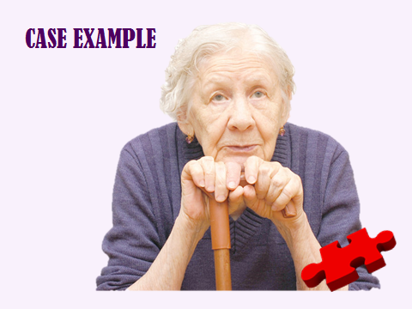

**TOPIC: CASE EXAMPLE[1]**

Point out the Case Example in the Participant Manual on page 29 and discuss out loud with large group.

Read (or ask a volunteer to read) aloud the “Case Example”, then summarize the case discussion: Professionals may view goals for their clients differently, depending on their role and primary mission.

A key principle of collaboration is not to ignore conflicts or differences in interpretations among MDT members, but to identify these differences, discuss, and identify points of compromise or agreement. In fact, effective collaboration requires that as much consideration be given to the nature of the collaboration as to the independent tasks MDT members perform.

Handout 5 CASE EXAMPLE

L is a frail, 83 year old widow whose only son is deceased. L’s only living relatives are an adult grandson, granddaughter and ex-daughter-in-law. The grandson moved in with L after L’s husband’s death, but she later asked him to leave because he contributed nothing to the household, was allegedly abusing drugs, and wrecked a car she bought for him. He had also become verbally and physically abusive. The grandson refused to move out.

The first report of the grandson’s abusive behavior came to APS from the ex-daughter-in-law (i.e. the grandson’s mother); the second, from the domestic violence specialist referred by APS after the first report. APS confirmed physical and verbal abuse. As a result of the investigation, the APS worker advised L to take out restraining orders on all three of her relatives because of concerns about possible financial abuse. L refused to request a restraining order against the grandson, and a temporary restraining order against the two women (the granddaughter and the ex-daughter-in-law) was withdrawn after L hired an attorney to defend them. L sought support through her church. Her minister did a home visit. Since L had last attended church, the minister noted that she had lost weight, wasn’t eating, and was recovering from pneumonia. He also noted that her arthritis was making it more difficult to ambulate and to complete routine household chores such as shopping, cleaning and cooking. He spoke to the grandson. The visit from her minister triggered another argument with her grandson. After the minister left, the grandson slapped L so forcefully that she fell to the ground. L was taken to the hospital and treated for her injuries. L’s former daughter-in-law reported the abuse, and all three women cooperated with the law enforcement investigation. The suspect claimed that his grandmother was demented and had attacked him.

Discussion questions:

1. What are L’s strengths?
2. What are your hypotheses about what might be happening with L/what she might need?
3. Name some of the stakeholders/MDT partners who might become involved in this case, and benefits of involving those agencies/partners.
4. What might be sources of conflict in the ways that various MDT members might view this case?
5. What might be some areas of assessment/need that MDT members might agree on?
6. What can each agency bring to the table?

**Slide #16**

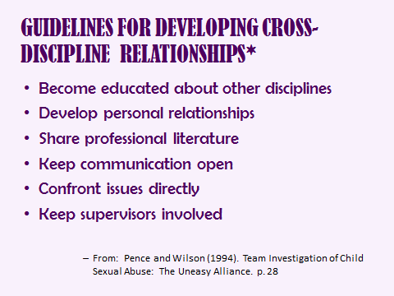

**TOPIC: Guidelines for Developing Cross-Discipline Relationships**

Become educated – It is imperative to learn as much as possible about the culture of the other organizations with whom you work, how they operate and what they value. Often friction between professions is a result of misunderstandings about what one professional can and cannot do within the regulations and culture of their agency. For example, you may think someone has an ethical requirement to report a type of abuse when, in fact, there are legal and ethical reasons why they cannot report without the victim’s consent.

Personal relationships – While it is important to demonstrate good professional relationships, it is also important to get to know other professionals as individuals. Many successful professional collaborations were born over a shared love of a good cup of coffee!

Share professional literature – This educates other team members on common issues, but also communicates that you view them as colleagues.

Keeping communication open and confronting issues directly – these issues will be discussed in more depth later in the training. Disagreements are to be expected in collaborative work, even in the most successful of partnerships and teams. Be respectful but don’t let disagreements fester. Speak to your supervisor about it.

Keep supervisors involved – Communication at a system level is also critical to making partnerships work.

**Slides #17-21**

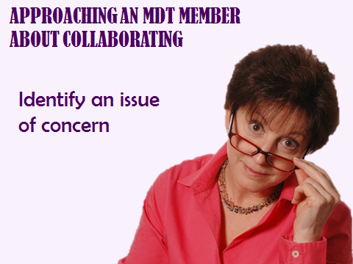 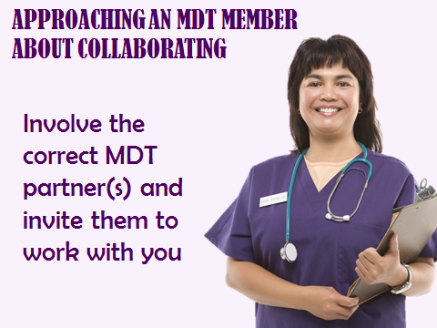

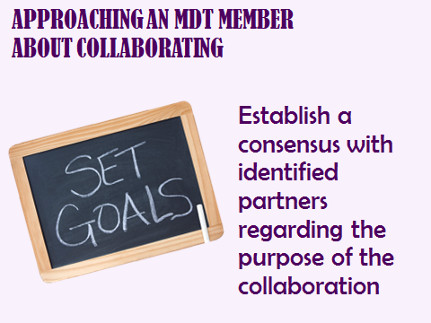 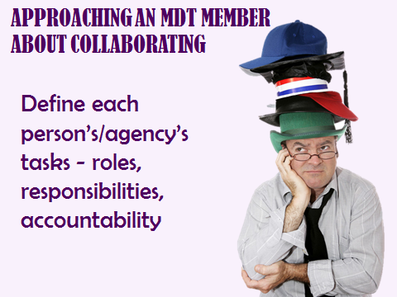

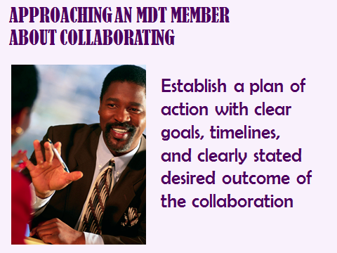

**TOPIC: Approaching an MDT Member about Collaborating on a Case**

Point out Handout #6 in the participant manual on page 32.

“What are we doing together?” – The answer should be coming to a consensus regarding what is best for the client.

* Define nature of your relationship– Especially if there is an overlap in your job descriptions, this is important.
* Establish agreement – MDT partners should be able to come to agreement about the desired outcomes for the collaboration.
* Define tasks – this is especially important if the completion of a task is dependent on completion of tasks by another team member. Conflicts arise if this is not anticipated and planned for.
* Plan of action – Individual ownership and accountability is crucial in successful collaboration. It also helps define “success” for the collaboration so that when the goal is achieved, everyone “wins.”

Handout 6:

APPROACHING AN MDT MEMBER ABOUT COLLABORATING

* Identify an issue of concern
* Involve the correct MDT partner(s) and invite them to work with you
* Establish a consensus with identified partners regarding the purpose of the collaboration
* Define each person’s/agency’s tasks - roles, responsibilities, accountability
* Establish a plan of action with clear goals, timelines, and clearly stated desired outcome(s) of the collaboration

Adapted from: Kathryn Hyer, DrPA, Author. Editor: Conchita Rader, MA, RN. Staff Development Partners Edition

Instructor Guide. The John Hartford Foundation, Institute for Geriatric Nursing. Module 20. Retrieved on 11/1/11 from: http://www.evidence2practice.org/topics/Hartford/data/guides/Module20InterdisciplinaryCollaboration.doc

Walk through the following example included on page 32 of the participant manual:

* There is a concern that abuse complaints about private conservators are getting lost because friends and family don’t know where to report. You decided to “fix” the problem. After identifying this issue…
* Decide who to invite to the meeting: Who should get the reports? Who is currently getting reports? Who has the authority to respond effectively to these reports? All of these players should be at the table. Next…
* Brainstorm the best way to respond to this issue with the team. Should there be a policy put in place? If so, at which agency? Should there be a training to let all the professionals know where to report? Or should there be an awareness campaign for the public?
* Then decide who will take on which tasks. Let’s say you decide to develop an informational pamphlet to be given to families when a conservator is appointed. Who is going to write the pamphlet? Who is going to pay for it? Who should approve the wording? How will the pamphlet be distributed?
* Then, develop a clear action plan. The plan should include timelines and goals. It should also include check-in meetings/calls. And, it should include a way to figure out whether the plan is working.
* Check back: How is your plan going to be evaluated to ensure accountability?

**Slide #22**

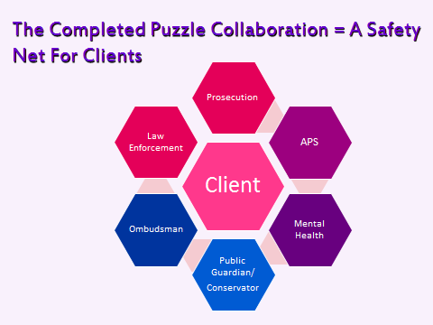

**TOPIC: The Completed Puzzle Collaboration**

To conclude this section, summarize by saying that many disciples work together as an MDT to create a safety net of services as a wraparound service approach for victims of elder/dependent abuse. Older adults, particularly victims of abuse, confront biopsychosocial problems that are often too complex for one discipline (APS) to handle alone. Working with other professionals/disciplines is often needed in order to develop a comprehensive and integrated care and protection plan.

**SKILLS FOR COLLABORATION**

**TIME ALLOTTED: 60 minutes**



**_______________________________________________________**

**Slide #23**

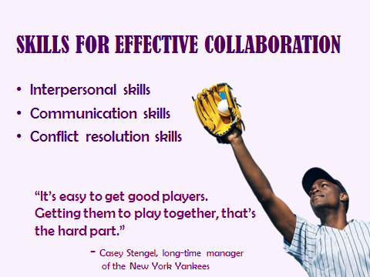

**TOPIC: Skills for Effective Collaboration**

In this section of the training we will review interpersonal, communication and conflict resolution skills. Depending on the skill level of the group, this can be done as a very quick review or a more in-depth lecture.

**Slide #24**

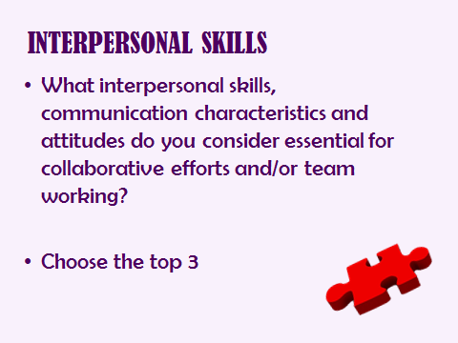

C:\Users\HP Compaq\AppData\Local\Microsoft\Windows\Temporary Internet Files\Content.IE5\0JLGXZ1M\MC900030041[2].wmf

**TOPIC: Interpersonal Skills**

Interpersonal skills, and certain style characteristics and attitudes are essential to effective collaboration. While practitioners may have well-developed clinical skills, not everyone has the SKILLS needed to collaborate effectively with others, nor do they always think to employ their clinical skills with their partners. All team members need the opportunity for self-reflection and to learn effective communication, collaborative decision making and conflict resolution skills that will enable them to function effectively as part of a team/collaborative effort.

Allow five minutes for small group discussion/brainstorm, have each group report on their top three essential skills. Record them on a flip chart.

If these do not appear in the lists, make sure you add:

* Respect
* Humility
* Sense of humor
* Commitment to MDT work
* Genuine care and interest in protecting elder adults/adults at risk
* Active listener
* Respect for diversity/cultural awareness/cultural competency

Re: cultural competency - be certain this is on the list! Just like cultural competency is an essential competency in client-based work, it is critical in cross-discipline collaboration. In addition to the individual having cultural uniqueness – ethnicity, race, religion, age, physical abilities, gender, socioeconomic differences - agencies/disciplines have their own unique cultures as well.

It should be noted that not everyone comes to the table with the same level of sophistication in their interpersonal skill sets and additional training or coaching may be necessary in some cases.

**Slide #25**

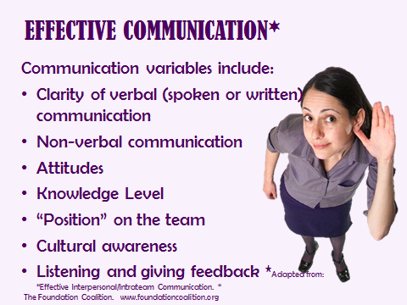

**TOPIC: Effective Communication**

We have to be aware of several variables in communication, both when we are sending as well as receiving communications. (Trainer should ask for examples of these from trainees).

* Clarity of our verbal communication: Are we abundantly clear in what we are saying/writing? Is there any way for what we said to be misinterpreted?
* Non-verbal communication: Some studies show that 90+% of communication is non-verbal! (Mehrabian, A. (1972). Nonverbal communication. Aldine-Atherton, Chicago, Illinois.)
* Attitudes: One’s generalized tendencies/feelings which get applied to the collaborative communication. For example, do I often wonder, “Is this person judging me?” “Does this person even want to know what I think?” If this unconscious inner dialogue is not addressed, it can impede communication.
* Knowledge level: If we are knowledgeable and confident in our knowledge, then we convey our message differently than if we don’t know or don’t feel confident.
* Position: Does my collaborative partner/team value my role? If the listener views the sender as a valuable partner, then he/she will listen more earnestly.
* Culture: Different cultures foster different communication styles. Culture also informs non-verbal communication factors such as making eye contact, sitting vs. standing, as well as cultural norms such as deference based on age, gender, etc. There is no “right” or “wrong” re: cultural communication styles, but we must recognize there are differences. We also have to acknowledge professional cultures which differ; law enforcement personnel have different communication norms/language, etc. than APS, etc. Developing group agreements about the rules for communication within the group can helpful.
* Feedback: Finally, we must be open to feedback, both as the speaker and as the listener.

**Slide #28**

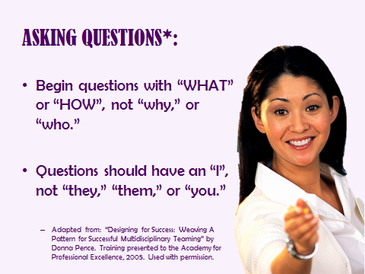

**TOPIC: Asking Questions**

“Why” questions – no matter how nicely phrased – are almost always blaming. When we ask “who” questions, what we’re often really doing is looking for scapegoats (i.e. someone else to blame). Asking questions that focus our efforts and energy on what we can do makes us significantly more effective, happier, and less frustrated.

Provide some examples of “why” and “they” questions, and ask how they can be rephrased.

“Why don’t they just do (fill in the blank)?”

“How can I do my job better?” “What can I do to help?”

“Why would they do that?

“I would like to understand more about X (fill in the blank).” “What can I do to improve/change the situation?”

“Who made the mistake?”

“What can I do to solve the problem?”

“Who dropped the ball?”

“What action can I take to “own” the situation?”

**Slide #29**

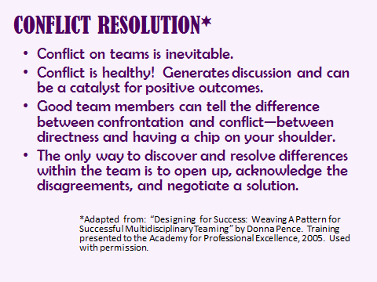

**TOPIC: Conflict Resolution**

Conflict on teams is inevitable. Team members need to be able to express opinions and disagree with each other. It is important to recognize that most people would rather avoid conflict but healthy partnering and teaming encourage open discussion of differing views.

Mini-exercise:

 Ask for examples from trainees about a time when a “healthy” conflict or disagreement with a co-worker resulted in a good outcome for a client.

Example of what can happen when steps are **NOT** followed ( on page 36 of participant manual):

A social worker on a MDT was increasingly frustrated with a team member from a partner agency due to of lack of collaboration. She felt the other team member was essentially not interested in collaboration but in doing things her way and not receiving input. The social worker discussed the issue in supervision, and possible strategies were addressed. Among the issues the supervisor pointed out was that, while you can coach, discuss, share observations, etc., you cannot change people, and some people have less than optimal team-oriented styles. Supervision focused on ways to make requests such as “I need…” rather than “You’re not….”

Despite this coaching during supervision, the social worker decided to “let loose” and confront the other team member in front of the rest of the MDT during a team building retreat self-reflection exercise (similar to the one we did earlier). The social worker attacked the person, not on a case-specific problem. She chose an inappropriate time and place for the discussion. She did not take any responsibility for her part in the communications. Rather than building the relationship up, she tore it down.

Quickly review Handout #7, also found on page 36 of the participant manual. Ask that participants return to the handout in the future when they are dealing with problems between themselves and other agencies.

Handout 7 PRINCIPLES OF CONFLICT RESOLUTION

* Identify issues causing a conflict before there is an explosion.
* Attack the problem; do not blame the person.
* Choose an appropriate time and place for the discussion.
* Leave “old stuff” behind.
* Focus on what can be done, not on what can't be done.
* Encourage differing points of view and honest dialogue.
* Accept ownership for your part of the problem.
* Demonstrate understanding of the other person's point of view before giving your own.
* Keep the focus on how resolution of the issue will advance your shared mission!

**Slide #30**

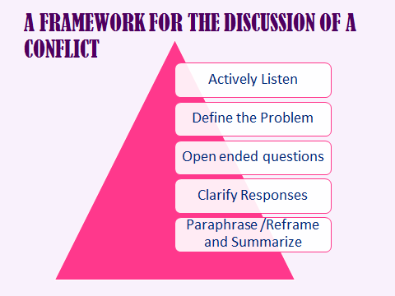

**TOPIC: A Framework for the Discussion of a Conflict**

Remind participants of the social work principles of active listening and questioning.

* Actively Listen: Rephrase the issue and repeat the statement.
* Define the Problem: Emphasize the areas of agreement and frame the area of disagreement.
* Open-ended questions: Ask questions that encourage discussion and permit disagreement. “Tell me more about that…” “What else do we need to consider?”
* Clarify Responses: Help others recognize members’ attitudes and feelings.
* Paraphrase and Reframe: Summarize discussion to ensure that the disagreement is understood. Explore group problem solving and encourage solutions that have not been considered before.

**Slide #31**

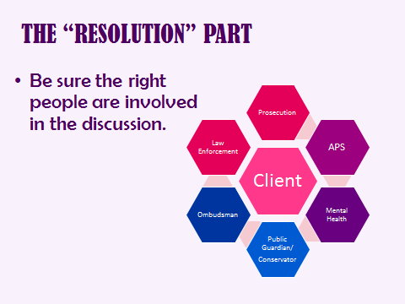

**TOPIC: The Resolution Part**

The first requirement of conflict resolution is to make sure you have the right people at the table. For example: If a team member says that he can’t do X because of an agency policy, you will need to get that agency’s decision maker at the table if you feel that X is something that the agency can or should do or that an exception can be made.

 Ask participants if anyone has an example of this happening.

Trainer note: You should be prepared with an example from your own experience if no one in the classroom has an example.

**Slide # 32**

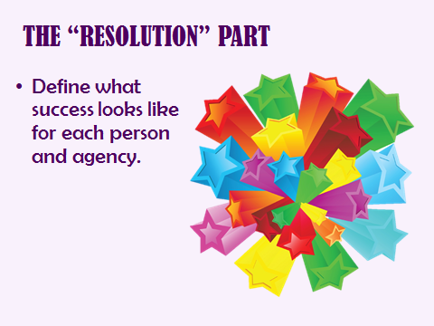

**TOPIC: The Resolution Part**

This step is important because there may be an assumption that everyone is working towards the same goal when, in fact, they are working towards opposing goals. For example, APS may be working with a son to help him quit misusing mom’s money and become a better care provider for his mother while law enforcement may be working to arrest him. Because their goals are in conflict, the two agencies may actually undermine each other’s attempts to be successful.

 Ask participants if they have ever experienced this in their work.

**Slide #33**

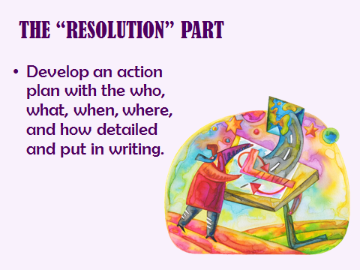

**TOPIC: The Resolution Part**

Has anyone ever gotten upset with you because you didn’t do X but the reason you didn’t do it was because you didn’t know they were expecting you to do it? In any kind of group work, it is important to clearly delineate who will do what (in detail) and when they are expected to do it. And, putting it in writing makes it clear to everyone on the team what is expected.

 Ask whether anyone in the group has experienced a conflict that was based on confused expectations.

**Slide #34**

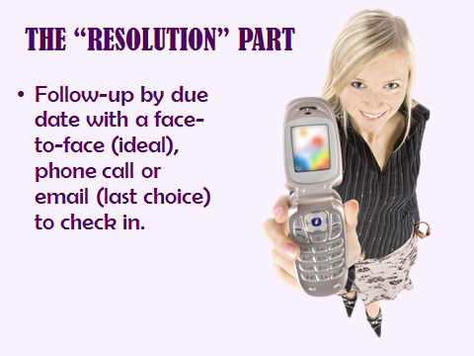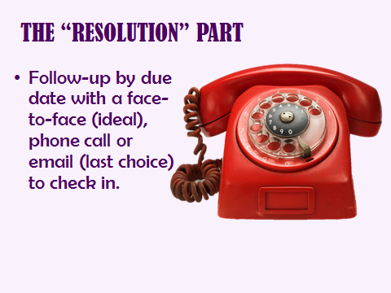

**TOPIC: The Resolution Part**

Checking in with partners at the agreed upon times also helps reduce confusion and keeps everyone on the same page as to what is happening on the case/project. If there has been any confusion, the sooner you are aware of it, the sooner you can resolve it.

**Slide # 35**

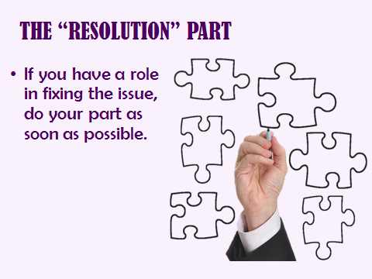

**TOPIC: The Resolution Part**

Obviously, if you want to fix a situation, you have to set an example and do your part. Partnerships are based on trust and you will lose much of that trust if you don’t either complete your part or, at the very least, communicate why you can’t complete your part in a timely manner.

Trainer note: You should be prepared with an example from your own experience to illustrate how you were part of the problem, took responsibility and help resolve the problem. Role modeling the ability to admit mistakes in public is an especially powerful teaching tool.

**Slide # 36**

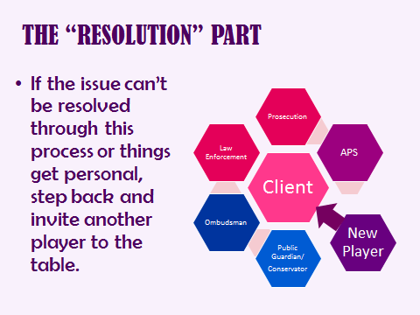

**TOPIC: The Resolution Part**

You may need to bring in a mediator, another agency or an agency decision maker.

Trainer note: If you are able, provide a personal example of a situation where you had to invite another player to the table to help mediate an issue and how that worked out for all the parties.

*Adapted from: “Designing for Success: Weaving A Pattern for Successful Multidisciplinary Teaming” by Donna Pence. Training presented to the Academy for Professional Excellence, 2005. Used with permission.

**Slide #37**

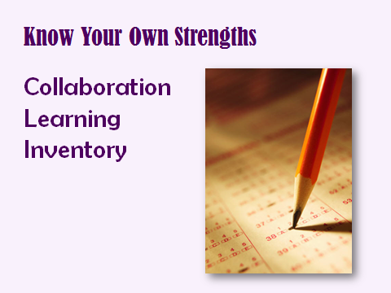

**TOPIC: Collaboration Learning Inventory- homework assignment**

Point out the Collaboration Learning Inventory in the participant manual on page 40. Ask participants to complete the inventory individually after class as a follow-up exercise. This is not a shared activity. They will not be required to reveal their answers or score to anyone.

Let the participants know that the ratings are NOT whether someone thinks the item is important or not; it asks the respondent to rate whether this is a still developing skill for them, or whether they feel confident about this skill and able to teach/model for others. The exercise is intended to make the participant more aware of his/her strengths and areas needing improvement. There is no composite score.

# Handout 8 COLLABORATION LEARNING INVENTORY[2]

The following is to be used as a guide for your own self-awareness. By completing the following inventory, you will have an opportunity to identify your own strengths and learning areas as a collaborator. The behavior, trait or knowledge associated with each item is what our best thinking shows for successful collaboration. This guide is based on research on collaboration and from successful collaboration efforts. You have an opportunity to gain awareness of how you help or prevent collaboration. Awareness is the first step in learning. You will find this activity the most useful when you can be your most honest. **You will not be required to share your responses.**

Please rate yourself on a scale of 1 to 5.

1 = This is a great opportunity for me to LEARN/DEVELOP MY SKILLS

5 = This is a great opportunity for me to TEACH/MODEL for others

## KNOWLEDGE and ATTITUDES

|  |  |  |  |  |  |
| --- | --- | --- | --- | --- | --- |
| I can articulate the mission, and services of APS. | 1 | 2 | 3 | 4 | 5 |
| I can articulate the mission, services and role of partner organizations. | 1 | 2 | 3 | 4 | 5 |
| I practice and value good communication strategies. | 1 | 2 | 3 | 4 | 5 |
| I find common elements and shared mission as the focus of my communications with partners. | 1 | 2 | 3 | 4 | 5 |
| I believe collaborative efforts are an effective way to deliver optimal services to my clients. | 1 | 2 | 3 | 4 | 5 |
| I am perceived by others as having expertise in my field. | 1 | 2 | 3 | 4 | 5 |
| I can describe how collaborative group process differs from other group processes. | 1 | 2 | 3 | 4 | 5 |
| I can identify specific barriers to collaboration and common methods to overcome them. | 1 | 2 | 3 | 4 | 5 |

**SKILLS: Personal traits/characteristics and communication style**

|  |  |  |  |  |  |
| --- | --- | --- | --- | --- | --- |
| I am perceived as a positive person. | 1 | 2 | 3 | 4 | 5 |
| I use humor effectively. | 1 | 2 | 3 | 4 | 5 |
| I am flexible in communication and making decisions. | 1 | 2 | 3 | 4 | 5 |
| Others describe me as fair and tolerant. | 1 | 2 | 3 | 4 | 5 |
| I encourage direct, honest communication. | 1 | 2 | 3 | 4 | 5 |
| I know my strengths and weaknesses. | 1 | 2 | 3 | 4 | 5 |
| I am flexible. | 1 | 2 | 3 | 4 | 5 |
| I make a conscious effort to improve my skills through training and sharing of information/research. | 1 | 2 | 3 | 4 | 5 |
| I am not ego or turf centered, but known as a doer and collaborator | 1 | 2 | 3 | 4 | 5 |

**SKILLS: Nurturing and sustaining effective relationships with partners**

|  |  |  |  |  |  |
| --- | --- | --- | --- | --- | --- |
| I make active efforts to build relationships with people who are my collaborative partners. | 1 | 2 | 3 | 4 | 5 |
| I provide a safe environment for others to express their feelings and concerns. | 1 | 2 | 3 | 4 | 5 |
| I can initiate and maintain effective collaborations. | 1 | 2 | 3 | 4 | 5 |
| I can access and utilize the skills and knowledge of others. | 1 | 2 | 3 | 4 | 5 |
| I can identify the principles of conflict resolution. | 1 | 2 | 3 | 4 | 5 |
| I employ principles of conflict resolution to address issues, when needed. | 1 | 2 | 3 | 4 | 5 |
| I regularly employ active listening techniques to avoid or address conflicts/communication challenges. | 1 | 2 | 3 | 4 | 5 |
| I identify and contact a variety of community resources | 1 | 2 | 3 | 4 | 5 |

Star the items that indicate additional learning needs for you. It may be where you scored a 1 or a 2, or ones that you identify as high priority for your work role or personal development.

Answer the following question, using this tool as a guide. What are my top five areas of strength as a collaborator?

1)

2)

3)

4)

5)

**CONFIDENTIALITY AND INFORMATION SHARING**

**TIME ALLOTTED: 30 minutes**



**Slide #38**

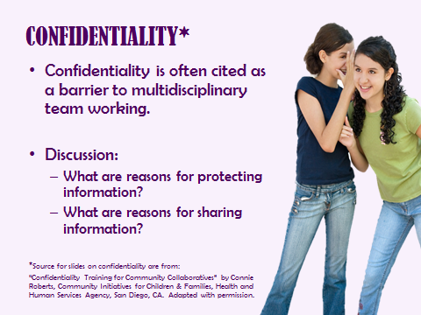

**TOPIC: Confidentiality**

The need to maintain confidentiality is often cited as a barrier to multidisciplinary team working. Mechanisms of maintaining confidentiality must be in place and a formal policy prepared.

 Ask these two questions on the slide as a shout-out:

-What are reasons for protecting information?

- What are the reasons for sharing information?

Make a point of explaining that, while APS has confidentiality requirements, other agencies also have confidentiality requirements. Those requirements may be even more restrictive than the ones that APS must follow.

**Slide #39**



**TOPIC: Laws and Rules Governing Confidentiality**

NOTE TO TRAINER: Prior to the training, review the state laws pertaining to confidentiality and information sharing in the jurisdiction in which you are presenting. You may wish to create a handout specific to your jurisdiction.

How much information can be shared with you will vary according to discipline and their specific legal and ethical standards. For example, mental health treatment professionals have professional privilege, as do medical providers. Medical/hospital based personnel are bound by HIPAA rules. And, federal regulations dictate that the ombudsman cannot share anything without client consent, even if a law has been broken!

**Slide #40**

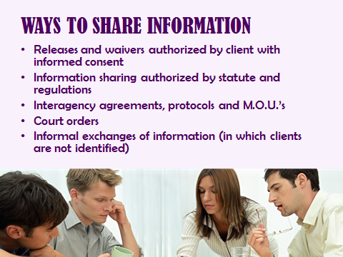

**TOPIC: Ways to Share Information**

NOTE TO TRAINER: As with previous slide(s), the trainer should be knowledgeable about the statutes that authorize information sharing in your state/jurisdiction, as well as the existence of interagency agreements/MOUs which exist, e.g. formal MDT protocols. If these exist, you may choose to distribute these at this time. Similarly, if your training is for personnel from one specific agency which has standardized releases/confidentiality forms, etc., you may choose to distribute these.

Sharing information is critical to APS work. So, while there are many conflicting laws and regulations, such as HIPPA, restricting what information may be shared, there are always ways to share enough information to get clients the help they need. At a minimum, cases can be discussed as hypothetical situations without names or identifying facts.

**Multidisciplinary Teaming in Elder Abuse**

**TIME ALLOTTED: 60 minutes**



**_______________________________________________________**

**Slide #41**

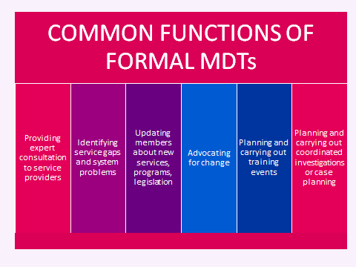

**TOPIC: Common Functions of Formal MDTs**

Review each of these functions with the participants and provide examples of each.

Note to trainer: Prior to the training, gather information about any formal elder abuse MDTs in the local jurisdiction(s). If there is written material about the MDT (brochures, flyers, website information, protocols, case review referral guidelines etc.), distribute at this time. Encourage APS workers or their agencies to become involved in their local Elder Abuse MDT.

**SLIDE #42**

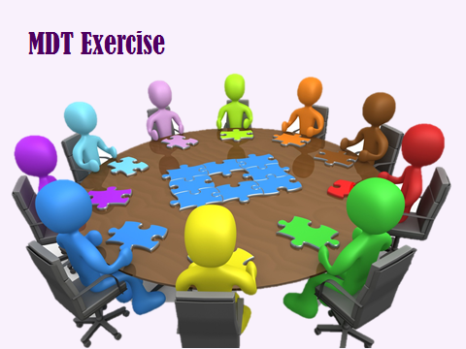

**TOPIC: MDT Exercise**

Read the MDT Team Exercise Instructions to the class. Divide the class into small groups of four participants. Give each member of the small group a single Fact Sheet (one for APS, one for Law Enforcement, one for Ombudsman, and one for Licensing) **without making it obvious that the sheets are different**. The fact sheets are in the Appendix, on pages 95-99.

NOTE: The Fact Sheets in this section of the manual have the specific facts unique to each agency written in red to help the trainer quickly identify those unique facts. The Fact Sheets for the participants are NOT in the participant manual and must be printed separately. They are in the appendix, pages 95-99.

Point out the directions and the Suspect list in the participant manual on page 46. Monitor the groups’ progress, watching for signs of conflict, collaboration and “ah ha” moments. Give the groups 30 minutes to complete the tasks. Then ask them the following questions:

1. What did you learn from this exercise?
2. Was there consensus that a crime was committed?
3. How long did it take for your group to realize that you had different facts?
4. What would have happened if one of the agencies was not present at this “meeting”?
5. How would this incident be communicated internally? Would they report it as a crime? Does the incident raise additional issues for an agency (Adult Protective Services, Law Enforcement, Licensing, and Ombudsman)? What would the agency investigators focus on?
6. What evidence would law enforcement focus on? What witnesses would they want to interview? What should they do before interviewing the victim? What other materials would they seek to obtain?
7. Are there any other service providers or assistance agencies/programs that could provide assistance to the client-victim or the mentioned responders? How could they be brought into the multidisciplinary response in this situation?

NOTE: If the participants are from a variety of agencies, ask each agency’s personnel how their agency would handle this victim/perpetrator.

Handout 9 **MDT TEAM EXERCISE**

Instructions

1. You are a member of the MDT Team.
2. You are attending a meeting of the team to discuss a specific case.
3. You are to select the most promising suspect who will become the subject of a search warrant that law enforcement member(s) will serve.
4. You are also required to determine what type of short and long term supports and protective services are needed for the victim and determine who will provide what services.
5. You have been provided with a statement of facts and a list of potential suspects.
6. Your task is to select the most likely perpetrator and to eliminate the other six suspects for a specific reason. Reasons for disqualification must be recorded by the group.
7. Assume that there is one correct suspect.
8. Assume that all data is correct and complete.
9. You have approximately 30 minutes to choose the suspect.
10. There must be substantial agreement in your group that the problem has been solved.
11. You must solve the problem as a group.
12. You may organize your work in any way that you please.

**Who Did It?**

You are a member of the Multi-disciplinary Team. A recent sexual assault has led to this meeting. The initial investigation has yielded a list of possible suspects. As there is considerable physical evidence in this case, the team is discussing the possibility of obtaining a search warrant for comparison purposes. Your assignment is to determine which suspect should be the subject of a search warrant.

## The Facts Uncovered by APS

Karen McHann, an eighty three year old female, was examined at the Emergency Room two weeks ago, on a Wednesday evening. During the examination, the doctor noticed a rash on her genital area. Further testing confirmed Syphilis. The alleged molestation was reported and a rape kit was completed.

Karen was interviewed by Adult Protective Services and Law Enforcement but did not disclose any information concerning the incident. Karen has aphasia post-stroke with limited verbal skills. The lab report disclosed the following: Karen has been sexually assaulted, most likely within twenty-four hours of her examination. Photographs were taken of a large human bite mark, located on her left buttock.

The investigation retraced Karen’s activities for the twenty-four hour period preceding her examination. According to the reports, Karen lives with her daughter, Linda Newton. She also has on son who she sees regularly, Bill McHann. When advised of the molestation, Linda Newton immediately accused her brother. When Bill McHann was interviewed, he immediately accused Paul Strong, Linda Newton’s boyfriend.

Karen attends Fairview adult day care program which is located across town. The program provides services to twenty-five elders with a variety of disabilities. Karen’s supervision is provided by Jeff Green and Jennifer Singleton. Karen is dropped off at 8:00 a.m. and picked up by a neighbor, Mike Eagleheart, at 3:30 p.m. Eagleheart has a grandfather in the day program. This procedure was followed on both Tuesday and Wednesday of the week in question.

Karen arrived home at 4:00 p.m. on Tuesday and was met by her daughter. She was picked up by her son at 6:00 p.m. and returned home at 9:00 p.m. Bill McHann lives with his oldest son, Rex McHann. Rex is Karen’s grandson. When Karen arrived home at 9:00 p.m., present in the home were her daughter, Linda Newton, her daughter’s boyfriend, Paul Strong, and her nephew Pete Podgerski. Linda reluctantly admitted that they all had been drinking heavily. Both Strong and Podgerski spent the night. Strong spent the night in Linda’s room and only left the room when he got up in the morning to go to work.

On Wednesday morning, Linda helped dress Karen and took her to the day program as usual. Everything was normal. Karen remained there until picked up by Eagleheart.

**Who Did It?**

You are a member of the Multi-disciplinary Team. A recent sexual assault has led to this meeting. The initial investigation has yielded a list of possible suspects. As there is considerable physical evidence in this case, the team is discussing the possibility of obtaining a search warrant for comparison purposes. Your assignment is to determine which suspect should be the subject of a search warrant.

## The Facts uncovered by Law Enforcement

Karen McHann, an eighty three year old female, was examined at the Emergency Room two weeks ago, on a Wednesday evening. During the examination, the doctor noticed a rash on her genital area. Further testing confirmed Syphilis. The alleged molestation was reported and a rape kit was completed.

Karen was interviewed by Adult Protective Services and Law Enforcement but did not disclose any information concerning the incident. Karen has aphasia post-stroke with limited verbal skills. The lab report disclosed the following: Karen has been sexually assaulted, most likely within twenty-four hours of her examination. Her assailant has type B+ blood. A brown pubic hair, as well as an unidentified animal hair, were recovered from her clothing. Photographs were taken of a large human bite mark, located on her left buttock.

The investigation retraced Karen’s activities for the twenty-four hour period preceding her examination. According to the reports, Karen lives with her daughter, Linda Newton. She also has on son who she sees regularly, Bill McHann. When advised of the molestation, Linda Newton immediately accused her brother. When Bill McHann was interviewed, he immediately accused Paul Strong, Linda Newton’s boyfriend.

Karen attends Fairview adult day care program which is located across town. The program provides services to twenty-five individuals with disabilities. Karen’s supervision is provided by Jeff Green and Jennifer Singleton. Karen is dropped off at 8:00 a.m. and picked up by a neighbor, Mike Eagleheart, at 3:30 p.m. Eagleheart has a grandfather in the day program. This procedure was followed on both Tuesday and Wednesday of the week in question.

Karen arrived home at 4:00 p.m. on Tuesday and was met by her daughter. She was picked up by her son at 6:00 p.m. and returned home at 9:00 p.m. Bill McHann lives with his oldest son, Rex McHann. Rex is Karen’s grandson. When Karen arrived home at 9:00 p.m., present in the home were her daughter, Linda Newton, her daughter’s boyfriend, Paul Strong, and her nephew Pete Podgerski. Linda reluctantly admitted that they all had been drinking heavily. Both Strong and Podgerski spent the night.

On Wednesday morning, Linda helped dress Karen and took her to the day program as usual. Everything was normal. Karen remained there until picked up by Eagleheart.

**Who Did It?**

You are a member of the Multi-disciplinary Team. A recent sexual assault has led to this meeting. The initial investigation has yielded a list of possible suspects. As there is considerable physical evidence in this case, the team is discussing the possibility of obtaining a search warrant for comparison purposes. Your assignment is to determine which suspect should be the subject of a search warrant.

## The Facts uncovered by Licensing

Karen McHann, an eighty three year old female, was examined at the Emergency Room two weeks ago, on a Wednesday evening. During the examination, the doctor noticed a rash on her genital area. Further testing confirmed Syphilis. The alleged molestation was reported and a rape kit was completed.

Karen was interviewed by Adult Protective Services and Law Enforcement but did not disclose any information concerning the incident. Karen has aphasia post-stroke with limited verbal skills. The lab report disclosed the following: Karen has been sexually assaulted, most likely within twenty-four hours of her examination. Photographs were taken of a large human bite mark, located on her left buttock.

The investigation retraced Karen’s activities for the twenty-four hour period preceding her examination. According to the reports, Karen lives with her daughter, Linda Newton. She also has on son who she sees regularly, Bill McHann.

Karen attends Fairview adult day care program which is located across town. The program provides services to twenty-five individuals with disabilities. Karen’s supervision is provided by Jeff Green and Jennifer Singleton. Karen is dropped off at 8:00 a.m. and picked up by a neighbor, Mike Eagleheart, at 3:30 p.m. Eagleheart has a grandfather in the day program. This procedure was followed on both Tuesday and Wednesday of the week in question.

On Tuesdays, Wednesdays and Thursdays, Jeff Green and Jennifer Singleton’s group includes two individuals who engage in self injurious behaviors. Both workers have to be present at all times so one worker can provide two to one supervision while the other supervises the rest of the group. Jeff Green called in sick to work on Tuesday and Wednesday two weeks ago and a temporary worker, Janice Tibbs took his place.

On Wednesday morning, Linda helped dress Karen and took her to the day program as usual. Everything was normal. Karen remained there until picked up by Eagleheart.

**Who Did It?**

You are a member of the Multi-disciplinary Team. A recent sexual assault has led to this meeting. The initial investigation has yielded a list of possible suspects. As there is considerable physical evidence in this case, the team is discussing the possibility of obtaining a search warrant for comparison purposes. Your assignment is to determine which suspect should be the subject of a search warrant.

## The Facts Uncovered by Ombudsman

Karen McHann, an eighty three year old female, was examined at the Emergency Room two weeks ago, on a Wednesday evening. During the examination, the doctor noticed a rash on her genital area. Further testing confirmed Syphilis. The alleged molestation was reported and a rape kit was completed.

Karen was interviewed by Adult Protective Services and Law Enforcement but did not disclose any information concerning the incident. Karen has aphasia post-stroke with limited verbal skills. The lab report disclosed the following: Karen has been sexually assaulted, most likely within twenty-four hours of her examination. Photographs were taken of a large human bite mark, located on her left buttock.

The investigation retraced Karen’s activities for the twenty-four hour period preceding her examination. According to the reports, Karen lives with her daughter, Linda Newton. She also has on son who she sees regularly, Bill McHann.

Karen attends Fairview adult day care program which is located across town. The program provides services to twenty-five individuals with disabilities. Karen’s supervision is provided by Jeff Green and Jennifer Singleton. Mike Rogge was hired last week as a substitute worker. Karen is dropped off at 8:00 a.m. and picked up by a neighbor, Mike Eagleheart, at 3:30 p.m. Eagleheart has a grandfather in the day program. This procedure was followed on both Tuesday and Wednesday of the week in question.

On Tuesdays, Wednesdays and Thursdays, Jeff Green and Jennifer Singleton’s group includes two individuals who engage in self injurious behaviors. Both workers have to be present at all times so one worker can provide two to one supervision while the other supervises the rest of the group. Jeff Green called in sick to work on Tuesday and Wednesday two weeks ago and a temporary worker, Janice Tibbs took his place.

On Wednesday morning, Linda helped dress Karen and took her to the day program as usual. Everything was normal. Karen remained there until picked up by Eagleheart.

**Subject Profiles**

|  |  |
| --- | --- |
| Name: Bill McHann  Age:42  Blood Type: O+  Hair Color: Brown  Employment: Erratic history in construction  Criminal History: None  Name: Jeff Green  Age: 23  Blood Type: B+  Hair Color: Green  Employment: Adult Daycare Program  Worker  Criminal History: One Arrest for Disorderly  Conduct  Name: Pete Podgerski  Age: 49  Blood Type: B+  Hair Color: Brown  Employment: Unemployed  Criminal History: Two Arrests for DUI,  One Arrest for Public  Drunkenness  Name: Mike Rogge  Age: 26  Blood Type: B+  Hair Color: Brown  Employment: Temporary Substitute Adult  Daycare Program Worker  Criminal History: One Narcotics Arrest | Name: Paul Strong  Age: 38  Blood Type: B+  Hair Color: Brown  Employment: Attorney  Criminal History: None  Name: Mike Eagleheart  Age: 29  Blood Type: B+  Hair Color: Black  Employment: Police Officer  Criminal History: None  Name: Rex McHann  Age: 17  Blood Type: B+  Hair Color: Red  Employment: Student  Criminal History: Two Juvenile  Arrests, Currently on  Probation |

### Resolution for Trainer

Bill McHann: eliminated by blood type (Law Enforcement)

Paul Strong: no opportunity to commit crime (APS)

Jeff Green: no opportunity to commit crime (Licensing)

Mike Eagleheart: eliminated by hair color (Law Enforcement)

Rex McHann: eliminated by hair color (Law Enforcement)

Mike Rogge: no access to victim at time of crime (Ombudsman)

Suspect: Pete Podgerski

**Q and A and Evaluations**

**TIME ALLOTTED: 15 minutes**



**Slide #43:**



**TOPIC: What did you Learn?**

Ask the participants what they learned today. Answer any remaining questions and remind them to complete their evaluations. Thank them for their participation.

**References**



Collaboration to Provide Services to At-Risk Families. San Diego County Health and Human Services Agency. Hyer, Kathryn. Interdisciplinary Collaboration in Elder Care. The John A. Hartfold Foundation, Institute for Geriatric Nursing. On-line Learning Module 20. Downloaded on 11/13/11 from: <http://www.google.com/url?sa=t&rct=j&q=&esrc=s&frm=1&source=web&cd=1&ved=0CGwQFjAA&url=http%3A%2F%2Fwww.evidence2practice.org%2Ftopics%2FHartford%2Fdata%2Fguides%2FModule20InterdisciplinaryCollaboration.doc&ei=j2PATudvhdiIAsGgicYL&usg=AFQjCNE-EBF6B3vxo8V_4zBFd79NbYZdsw>

Mosqueda, Burnight, Liao, Kemp (2004). Advancing the Field of Elder Mistreatment: A New Model for Integration of Social and Medical Services.  *The Gerontologist.* Volume 44, No. 5, pp. 703-708.

Multidisciplinary Team Working: From Theory to Practice. Discussion Paper. Mental health Commission. January 2006. Downloaded on 11/13/11 from: http://www.mhcirl.ie/documents/publications/Discussion%20Paper%20Multidisciplinary%20Team%20Working%20%20From%20Theory%20to%20Practice%202006.pdf

Multidisciplinary Team Promising practices: http://www.ncea.aoa.gov/NCEAroot/Main_Site/Resources/Promising_Practices/PP_Search.aspx

Raymond, Bonnes, Steinbacher, Williams, Nigbor, Weyers. (October 2009). Wisconsin Elder Adults/Adults-at-Risk Interdisciplinary Team Manual Presentation. Downloaded 11/13/11 at: <http://www.dhs.wisconsin.gov/aps/training/2009training/iteam.pdf>

Teaster, Pamela B., and Nerenberg, Lisa. A National Look at Elder Abuse Multidisciplinary Teams (2003). Report for the National Committee for the Prevention of Elder Abuse Partner National Center on Elder Abuse. Downloaded on 11/13/11 from: <http://www.ncea.aoa.gov/Main_Site/pdf/publication/mdt.pdf>

Tirrito, Nathanson and Langer (1996). Elder Practice: A Multidisciplinary Approach to Working with Older Adults in the Community. University of South Carolina Press.

Twomey, Jackson, Li, Marino, Melcihor, Randolph, Retselli-Deits, Wysong (2010). The Successes and Challenges of Seven Multidisciplinary Teams. *Journal of Elder Abuse and Neglect, 22:* 291-305*.*

Wiglesworth, Mosqueda, Burnight, Younglove and Jeske (2006). Findings from an Elder Abuse Forensic Center. *The Gerontologist,* Volume 46, No. 2, pp, 277-283.

***********************************************

NOTE: The National Center on Elder Abuse (NCEA) has an annotated bibliography titled, “Multidisciplinary and Collaborative Approaches in Responding to Elder Abuse” which contains over seventy articles. At the time of publication of this curriculum it was accessible at:

http://www.ncea.aoa.gov/Main_Site/Library/CANE/CANE_Series/CANE_MultidisciplinaryAndCollaborativeApproaches.aspx

**APPENDIX**

**Who Did It?**

You are a member of the Multi-disciplinary Team. A recent sexual assault has led to this meeting. The initial investigation has yielded a list of possible suspects. As there is considerable physical evidence in this case, the team is discussing the possibility of obtaining a search warrant for comparison purposes. Your assignment is to determine which suspect should be the subject of a search warrant.

## The Facts Uncovered by APS

Karen McHann, an eighty three year old female, was examined at the Emergency Room two weeks ago, on a Wednesday evening. During the examination, the doctor noticed a rash on her genital area. Further testing confirmed Syphilis. The alleged molestation was reported and a rape kit was completed.

Karen was interviewed by Adult Protective Services and Law Enforcement but did not disclose any information concerning the incident. Karen has aphasia post-stroke with limited verbal skills. The lab report disclosed the following: Karen has been sexually assaulted, most likely within twenty-four hours of her examination. Photographs were taken of a large human bite mark, located on her left buttock.

The investigation retraced Karen’s activities for the twenty-four hour period preceding her examination. According to the reports, Karen lives with her daughter, Linda Newton. She also has on son who she sees regularly, Bill McHann. When advised of the molestation, Linda Newton immediately accused her brother. When Bill McHann was interviewed, he immediately accused Paul Strong, Linda Newton’s boyfriend.

Karen attends Fairview adult day care program which is located across town. The program provides services to twenty-five elders with a variety of disabilities. Karen’s supervision is provided by Jeff Green and Jennifer Singleton. Karen is dropped off at 8:00 a.m. and picked up by a neighbor, Mike Eagleheart, at 3:30 p.m. Eagleheart has a grandfather in the day program. This procedure was followed on both Tuesday and Wednesday of the week in question.

Karen arrived home at 4:00 p.m. on Tuesday and was met by her daughter. She was picked up by her son at 6:00 p.m. and returned home at 9:00 p.m. Bill McHann lives with his oldest son, Rex McHann. Rex is Karen’s grandson. When Karen arrived home at 9:00 p.m., present in the home were her daughter, Linda Newton, her daughter’s boyfriend, Paul Strong, and her nephew Pete Podgerski. Linda reluctantly admitted that they all had been drinking heavily. Both Strong and Podgerski spent the night. Strong spent the night in Linda’s room and only left the room when he got up in the morning to go to work.

On Wednesday morning, Linda helped dress Karen and took her to the day program as usual. Everything was normal. Karen remained there until picked up by Eagleheart.

**Who Did It?**

You are a member of the Multi-disciplinary Team. A recent sexual assault has led to this meeting. The initial investigation has yielded a list of possible suspects. As there is considerable physical evidence in this case, the team is discussing the possibility of obtaining a search warrant for comparison purposes. Your assignment is to determine which suspect should be the subject of a search warrant.

## The Facts uncovered by Law Enforcement

Karen McHann, an eighty three year old female, was examined at the Emergency Room two weeks ago, on a Wednesday evening. During the examination, the doctor noticed a rash on her genital area. Further testing confirmed Syphilis. The alleged molestation was reported and a rape kit was completed.

Karen was interviewed by Adult Protective Services and Law Enforcement but did not disclose any information concerning the incident. Karen has aphasia post-stroke with limited verbal skills. The lab report disclosed the following: Karen has been sexually assaulted, most likely within twenty-four hours of her examination. Her assailant has type B+ blood. A brown pubic hair, as well as an unidentified animal hair, were recovered from her clothing. Photographs were taken of a large human bite mark, located on her left buttock.

The investigation retraced Karen’s activities for the twenty-four hour period preceding her examination. According to the reports, Karen lives with her daughter, Linda Newton. She also has on son who she sees regularly, Bill McHann. When advised of the molestation, Linda Newton immediately accused her brother. When Bill McHann was interviewed, he immediately accused Paul Strong, Linda Newton’s boyfriend.

Karen attends Fairview adult day care program which is located across town. The program provides services to twenty-five individuals with disabilities. Karen’s supervision is provided by Jeff Green and Jennifer Singleton. Karen is dropped off at 8:00 a.m. and picked up by a neighbor, Mike Eagleheart, at 3:30 p.m. Eagleheart has a grandfather in the day program. This procedure was followed on both Tuesday and Wednesday of the week in question.

Karen arrived home at 4:00 p.m. on Tuesday and was met by her daughter. She was picked up by her son at 6:00 p.m. and returned home at 9:00 p.m. Bill McHann lives with his oldest son, Rex McHann. Rex is Karen’s grandson. When Karen arrived home at 9:00 p.m., present in the home were her daughter, Linda Newton, her daughter’s boyfriend, Paul Strong, and her nephew Pete Podgerski. Linda reluctantly admitted that they all had been drinking heavily. Both Strong and Podgerski spent the night.

On Wednesday morning, Linda helped dress Karen and took her to the day program as usual. Everything was normal. Karen remained there until picked up by Eagleheart.

**Who Did It?**

You are a member of the Multi-disciplinary Team. A recent sexual assault has led to this meeting. The initial investigation has yielded a list of possible suspects. As there is considerable physical evidence in this case, the team is discussing the possibility of obtaining a search warrant for comparison purposes. Your assignment is to determine which suspect should be the subject of a search warrant.

## The Facts uncovered by Licensing

Karen McHann, an eighty three year old female, was examined at the Emergency Room two weeks ago, on a Wednesday evening. During the examination, the doctor noticed a rash on her genital area. Further testing confirmed Syphilis. The alleged molestation was reported and a rape kit was completed.

Karen was interviewed by Adult Protective Services and Law Enforcement but did not disclose any information concerning the incident. Karen has aphasia post-stroke with limited verbal skills. The lab report disclosed the following: Karen has been sexually assaulted, most likely within twenty-four hours of her examination. Photographs were taken of a large human bite mark, located on her left buttock.

The investigation retraced Karen’s activities for the twenty-four hour period preceding her examination. According to the reports, Karen lives with her daughter, Linda Newton. She also has on son who she sees regularly, Bill McHann.

Karen attends Fairview adult day care program which is located across town. The program provides services to twenty-five individuals with disabilities. Karen’s supervision is provided by Jeff Green and Jennifer Singleton. Karen is dropped off at 8:00 a.m. and picked up by a neighbor, Mike Eagleheart, at 3:30 p.m. Eagleheart has a grandfather in the day program. This procedure was followed on both Tuesday and Wednesday of the week in question.

On Tuesdays, Wednesdays and Thursdays, Jeff Green and Jennifer Singleton’s group includes two individuals who engage in self injurious behaviors. Both workers have to be present at all times so one worker can provide 2 to 1 supervision while the other supervises the rest of the group. Jeff Green called in sick to work on Tuesday and Wednesday two weeks ago and a temporary worker, Janice Tibbs took his place.

On Wednesday morning, Linda helped dress Karen and took her to the day program as usual. Everything was normal. Karen remained there until picked up by Eagleheart.

**Who Did It?**

You are a member of the Multi-disciplinary Team. A recent sexual assault has led to this meeting. The initial investigation has yielded a list of possible suspects. As there is considerable physical evidence in this case, the team is discussing the possibility of obtaining a search warrant for comparison purposes. Your assignment is to determine which suspect should be the subject of a search warrant.

## The Facts Uncovered by Ombudsman

Karen McHann, an eighty three year old female, was examined at the Emergency Room two weeks ago, on a Wednesday evening. During the examination, the doctor noticed a rash on her genital area. Further testing confirmed Syphilis. The alleged molestation was reported and a rape kit was completed.

Karen was interviewed by Adult Protective Services and Law Enforcement but did not disclose any information concerning the incident. Karen has aphasia post-stroke with limited verbal skills. The lab report disclosed the following: Karen has been sexually assaulted, most likely within twenty-four hours of her examination. Photographs were taken of a large human bite mark, located on her left buttock.

The investigation retraced Karen’s activities for the twenty-four hour period preceding her examination. According to the reports, Karen lives with her daughter, Linda Newton. She also has on son who she sees regularly, Bill McHann.

Karen attends Fairview adult day care program which is located across town. The program provides services to twenty-five individuals with disabilities. Karen’s supervision is provided by Jeff Green and Jennifer Singleton. Mike Rogge was hired last week as a substitute worker. Karen is dropped off at 8:00 a.m. and picked up by a neighbor, Mike Eagleheart, at 3:30 p.m. Eagleheart has a grandfather in the day program. This procedure was followed on both Tuesday and Wednesday of the week in question.

On Tuesdays, Wednesdays and Thursdays, Jeff Green and Jennifer Singleton’s group includes two individuals who engage in self injurious behaviors. Both workers have to be present at all times so one worker can provide two to one supervision while the other supervises the rest of the group. Jeff Green called in sick to work on Tuesday and Wednesday two weeks ago and a temporary worker, Janice Tibbs took his place.

On Wednesday morning, Linda helped dress Karen and took her to the day program as usual. Everything was normal. Karen remained there until picked up by Eagleheart.

1. Case adapted from: Wiglesworth, Mosqueda, Burnight, Younglove and Jeske (2006). Findings from an Elder Abuse Forensic Center. *The Gerontologist.* Volume 46, No. 2, pp. 277-283.
2. Adapted with permission from: Training Module: Collaboration to Provide Services to At Risk Families. Academy for Professional Excellence, San Diego, CA