***Foundations of Effective Supervision***

**TRAINER’S MANUAL**

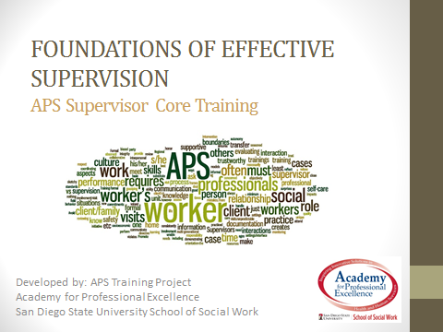

****TRAINER’S MANUAL

**Foundations of Effective Supervision**

 archstone foundation 

**This training was developed by the Academy for Professional Excellence, San Diego State University School of Social Work which is funded by California Department of Social Services, Adult Services Branch.**

**Curriculum Developer**

Carol Kubota, LCSW

© 2013. San Diego State University School of Social Work, Academy for Professional Excellence. Please acknowledge this copyright in all non-commercial uses and attribute credit to the developer and those organizations that sponsored the development of these materials. No commercial reproduction allowed.

**INTRODUCTION**

**THE ACADEMY FOR PROFESSIONAL EXCELLENCE**

We are pleased to welcome you to Understanding Self as Supervisor developed by the Adult Protective Services (APS) Training Project, a project of Academy for Professional Excellence, San Diego State University School of Social Work.

The Academy for Professional Excellence was established in 1996 and provides training, technical assistance, organizational development, research, and evaluation to public and private health and human service agencies and professionals.

The Academy is a project of San Diego State University School of Social Work (founded in 1963), which offers both a bachelor’s and master’s degree in Social Work. The School of Social Work at San Diego State University was founded in 1963 and has been continuously accredited by the Council of Social Work Education since 1966.

The Academy has extensive experience in providing specialized services, including:

* multi-disciplinary competency-based trainings
* curriculum development
* needs assessment
* research
* evaluation
* meeting facilitation
* organizational development consultation services

The APS Training Project is a CDSS funded project of Academy for Professional Excellence and has the overarching goal to develop standardized core curricula for new APS social workers and supervisors and to share these trainings on a national scale. Professional training opportunities are a critical step toward ensuring APS social workers have the appropriate tools to serve their clients. The APS Training Project has worked extensively with state and national partner agencies in the development of this curriculum.

Our partners include:

* National Adult Protective Services Association Education Committee (NAPSA)
* California Department of Social Services, Adult Services Branch
* California State University Sacramento IHSS Training Project
* Protective Services Operations Committee of the California Welfare Director's Association (PSOC)
* California Social Work Education Center Aging Initiative (CalSWEC)
* California Association of Public Administrators, Public Guardians and Public Conservators

**PARTNER ORGANIZATIONS**

|  |  |
| --- | --- |
| **Lori Delagrammatikas**, Program Coordinator for MASTER  Academy for Professional Excellence  6505 Alvarado Road, Suite 107  San Diego, California 92120  (909) 213-6059  [ldelagra@projects.sdsu.edu](mailto:ldelagra@projects.sdsu.edu)  <http://theacademy.sdsu.edu/programs/> | **Krista Brown**, Project Coordinator APS Training Project  Academy for Professional Excellence  6505 Alvarado Road, Suite 107  San Diego, California 92120 (510) 459-0731 [krbrown@projects.sdsu.edu](mailto:krbrown@projects.sdsu.edu)  <http://theacademy.sdsu.edu/programs/> |
| **Kathleen Quinn**, Executive Director  National Adult Protective Services Association  920 South Spring Street, Suite 1200  Springfield, IL 62704  (217) 523-4431 / (271) 522-6650  [kathleen.quinn@napsa-now.org](mailto:kathleen.quinn@napsa-now.org) | **Paul Needham**, Chair  NAPSA Education Committee  Oklahoma Dept of Human Services APS/FSSD Training Unit  ([405) 823-4900](tel:405-823-4900) [paul.needham@okdhs.org](mailto:paul.needham@okdhs.org) |
| **Angela Struckmann, Chair**  Protective Services Operations Committee  of the County Welfare Director’s Association  415.473.2743 [astruckmann@marincounty.org](mailto:astruckmann@marincounty.org) | |

**Academy for Professional Excellence**- 6505 Alvarado Road, Suite 107

Tel. (619) 594-3546 – Fax: (619) 594-1118 – <http://theacademy.sdsu.edu/programs/>

**ACKNOWLEDGMENTS**

This training is the result of a collaborative effort between Adult Protective Services administrators, supervisors, staff development officers and workers across the state and the nation; professional educators; and the Academy for Professional Excellence staff members. APS Training Project would like to thank the following individuals and agencies:

**Agencies & Committees**

California Department of Social Services, Adult Services Branch

California State University Sacramento IHSS Training Project

California Social Work Education Center Aging Initiative

Protective Services Operations Committee of the California Welfare Directors’

Association

National Adult Protective Services Association Education Committee

**Evaluation Consultant**

Carrie Gibson

**TABLE OF CONTENTS**

|  |  |
| --- | --- |
| **General Information** |  |
| **Introduction**…………………………………………………………………………… | 3 |
| **Partner Agencies**…………………………………………………………………….. | 4 |
| **Acknowledgements**…………………………………………………………………. | 5 |
| **Table of Contents**……………………………………………………………………. | 6 |
| **Executive Summary**………………………………………………………………….. | 8 |
| **How to Utilize this manual**……………………………..…………………………… | 10 |
| **Course Outline**………………………………………………………………………… | 11 |
| **Training Goals and Objectives**…………………………………………………… | 13 |
| **Trainer Guidelines**…………………………………………………………………… | 14 |
| **Presentation** |  |
| **Welcome and Introductions**…………………………………………………………   * Participant Letter of Consent……….………………………………………… * Developing an ID Code……………………………………………………….. | 16  18  22 |
| **APS Cultural Framework………….…………………………………………………** | 26 |
| **Educational Role: Case Consultation Factors & Elements……………………**   * Evidence-Based Practices…………………………………………………… * NAPSA Code of Ethics & Guidelines………………….……………………. * Case Consultation Scenarios………………………………………………… | 35  41  51   54 |
| **Supportive Role……………………..….…………………………………………….**   * Supportive Consultation Role Play………………………………………….. | 60  68 |
| **Administrative Role: Case Review & QA..……………………………………….**   * QA Case Review………………………………………………………………. * Case Review/QA Form……………………………………………………….. | 71  80  90 |
| **Administrative Role: Evaluating Performance & Managing Meetings………**   * Fishbowl Exercise…………………………………………………………….. * Common Meeting Purposes…………………………………………………. * The Life Cycle of a Meeting: The Core Meeting Process………………… | 92  99  106  110 |
| **L.I.F.E. Partner Exchanges………………..…………………………………………**   * L.I.F.E. Reports………………..………………………………………………. | 116  117 |
| **Closing/Evaluation…………………………………………………………………..** | 119 |
| **References……………………………………………………………………………..** | 121 |

**EXECUTIVE SUMMARY**

**Course Title: *Foundations of Effective Supervision***

**Curriculum Development:** Carol Kubota, LCSW, in collaboration with the Protective Services Operations Committee, NAPSA Education Committee and the APS Training Project/Academy for Professional Excellence.

**Target Audience:** APS Supervisors

**Training Description:**

APS supervisors are tasked with many different roles (educational, supportive and administrative) and among these roles are a multitude of foundational elements that once acquired are the building blocks for an effective supervisor. In this training, participants will explore each supervisory role and its elements in-depth and practice using tools to manage case consultations, professional boundaries, case review/QA, performance evaluations, and other topics.   
  
This training utilizes lecture, PowerPoint, and large and small group activities. Opportunities for participants to explore out-of-class partnerships with peers will be introduced.

**Learning Objectives:**Upon completion of this training, APS frontline supervisors will be able to:

1. Recognize the components of APS culture and how they impact the APS supervisor’s role.
2. Identify three key roles for the APS supervisor and practice elements from these roles, including:
   * Establishing rapport;
   * Determining professional boundaries;
   * Utilizing clinical skills and strength-based practice concepts in case consultations;
   * Applying a formal case review process;
   * Providing effective feedback.
3. Describe the key elements for quality assurance via the case review process.
4. Identify ways to effectively structure and utilize unit meetings.

**Transfer of Learning:** *Ways supervisors can prepare for the training and then utilize knowledge and skills acquired during the training on the job.*

**BEFORE the training**

Supervisors can work with their managers to:

* Identify their strengths as APS Supervisor in the key roles - Educational, Supportive, and Administrative
* Identify their challenges as APS Supervisor in the key roles - Educational, Supportive, and Administrative
* Review learning objectives and identify goals for this training

**AFTER the training**

Supervisors can practice the following activities:

* Revisit goals established prior to taking the training
* Identify the elements from the key roles that are missing from their supervision with workers and create an action plan (goal(s) + action steps) for how to incorporate those elements into their practice
* Identify three Supervisory Best Practices that they can incorporate into their job in the next three months.
* At the three month mark, ask for feedback from their manager as to their development regarding the strengths and challenges identified prior to the training.

**HOW TO UTILIZE THIS TRAINING MANUAL**

The course outline, provided in the next section of this manual, is the class schedule used during the piloting of this training. It can be used to help you determine how much time you might need to present each section. However, times will vary based on the experience and engagement of your audience.

Customizing the Power Point:

Once you decided on how you want to divide up your time in presenting this material, you may want to customize your Power Point. The Microsoft Office Power Point software allows you to hide any slides you don’t want to use.

|  |
| --- |
| Hide a slide instructions   1. On the **Slides** tab in normal [view (view: A way of displaying the contents of a presentation and providing the user with the means to interact with it.)](javascript:AppendPopup(this,'ppdefView_1')), select the slide you want to hide. 2. On the **Slide Show** menu, click **Hide Slide**.   The hidden slide icon Icon imageappears with the slide number inside, next to the slide you have hidden.  **Note**: The slide remains in your file, even though it is hidden when you run the presentation. |

Please note that this manual is set up so that the trainer script/ background material is on the same page as the accompanying Power Point slide making it easy to also customize your manual to match the slides you have decided to use, Just remove the unneeded pages.

**COURSE OUTLINE**

|  |  |  |  |
| --- | --- | --- | --- |
| **Content** | **Total Time** | **Activities** | **Slides/pages** |
| **Welcome, Introductions,**  **Learning Objectives** | 20 min | Housekeeping  Introductions | Slides: 2-7  Handouts: Letter to Participants, ID Assignment |
| **APS Cultural Framework** | 15 min | Lecture | Slides: 8-11 |
| **Educational Role: Case Consultation Factors & Elements** | 45 min | Lecture, large & small group activities | Slides: 12-23  Handouts: 1-3 |
| **Break** | 15min |  |  |
| **Educational Role: Case Consultation Factors & Elements (cont.)** | 35 min | Lecture, large & small group activities | Slides: 12-23  Handouts: 1-3 |
| **Supportive Role:**  **Supportive Consultation Role Play** | 50 min | Lecture, small group activity, writing activity | Slides: 24-32  Handout: 4 |
| **LUNCH** | 60 min |  |  |
| **Administrative Role: Case Review & QA** | 60 min | Lecture, large & small group activities, writing activity | Slides: 33-52  Handouts: 5-9 |
| **BREAK** | 15 min |  |  |
| **Administrative Role: Evaluating Performance & Managing Meetings** | 75 min | Lecture, large & small group activities, writing activity | Slides: 33-52  Handout: 5-9 |
| **L.I.F.E Partner Exchanges**  **3:35-3:45** | 15 min | Lecture, optional small group activity | Slide:53  Handout: L.I.F.E. Reports |
| **Closing/**  **Evaluation 3:45-4:00** | 15 min | Review/Q&A  Evaluation | Slide:54-55  Handout & Evaluation Materials |
| **Total Time (including lunch)** | **7 hrs.** |  |  |

TRAINING GOALS AND OBJECTIVES



Upon completion of this training, APS frontline supervisors will be able to:

1. Recognize the components of APS culture and how they impact the APS supervisor’s role.
2. Identify three key roles for the APS supervisor and practice elements from these roles, including:
   * Establishing rapport;
   * Determining professional boundaries;
   * Utilizing clinical skills and strength-based practice concepts in case consultations;
   * Applying a formal case review process;
   * Providing effective feedback.
3. Describe the key elements for quality assurance via the case review process.
4. Identify ways to effectively structure and utilize unit meetings.

TRAINER GUIDELINES

|  |  |
| --- | --- |
| **Teaching Strategies** | **The following instructional strategies are used:**   * Lecture segments * Video clips (embedded into PowerPoint or accessed via YouTube) * Interactive exercises (e.g. Table Top Activities, experiential exercises, role plays ) * Question/answer periods * Slides * Participant guide (encourages self-questioning and interaction with the content information) * Evaluation materials |
| **Materials and Equipment** | **The following materials are provided and/or recommended:**   * Computer with LCD (digital projector) * CD-ROM or other storage device with the slide presentations * Easel/paper/markers * Trainer’s Guide: This guide includes the course overview, introductory and instructional activities, and an appendix with reference materials. * Participant Guides: This guide includes a table of contents, course introduction, all training activities/handouts, and transfer of learning materials. * Evaluation Guide: This guide includes all in-class and out-of-class transfer of learning evaluation tools. * Name tags/names tents. * Water access/snacks/restroom access/lunch plans |
| **NOTE:** This training does not answer agency specific questions. If indicated, you will need to collect agency specific information before delivering this training. | |



**PRESENTATION**

**WELCOME AND INTRODUCTIONS**

**TIME ALLOTTED: 20 minutes**



**_______________________________________________________**

Slide #2: Facilitator Introduction & Housekeeping



**WELCOME** the participants and introduce yourself by name, job title, organization, and qualifications as Trainer.

**Review Housekeeping Items**

* There will be two 15-minute breaks and an hour for lunch today
* Use the restrooms whenever you need to do so. The restrooms are located at….
* Please turn off your cell phones for the duration of the training. If you must make or receive a call, please leave the training room and return as quickly as possible. Check the course outline to see what you have missed.
* Brief introduction to participant packet and materials.
* Participants should complete name tags/tents

Slide #3: Evaluation Process

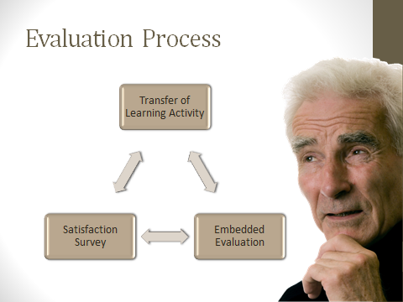

**Direct the participants to the *Letter to Participants* and the *ID Assignment* Handouts embedded in their participant manuals.**

For this training, you will be completing a training satisfaction survey, a pre-post Assessment of Learning and a post training transfer of learning exercise. All of these measures are intended to allow you to practice what you have learned and measure whether the training was effective. We want APS training to become an evidenced based practice that truly provides the knowledge and skills we believe it provides. The purpose of the evaluation process is more fully explained in your “Letter to Participants”.

**HANDOUT: Participant Letter of Consent**

* Academy for Professional Excellence at San Diego State University School of Social Work, MASTER (Multi-disciplinary Adult Services Training & Evaluation for Results) begun a process of evaluating training delivered to Adult Protective Service staff.
* At certain points during this training series, in addition to the usual workshop evaluation forms, you will be asked to complete various training evaluation activities.
* These training evaluation activities aim to: (1) improve trainings’ effectiveness and relevance to your needs, and help you better serve adults and their families; and (2) see if the training has been effective in getting its points across.
* If you agree to participate, you will fill out a questionnaire administered before and after the training.
* The questionnaires will be coded with a unique identifier system and all responses will be confidential



Dear Training Participant,

As a training program for the Academy for Professional Excellence at San Diego State University School of Social Work, MASTER (*Multi-disciplinary Adult Services Training & Evaluation for Results*) has begun a process of evaluating training delivered to Adult Protective Service workers. As part of this evaluation, we need your help.

At certain points during this training series, in addition to the usual workshop evaluation forms, you will be asked to complete various training evaluation activities.

These training evaluation activities have two main purposes:

1. To improve trainings’ effectiveness and relevance to your needs, and help you better serve adults and their families; and
2. To see if the training has been effective in getting its points across.

**Our goal is to evaluate training, NOT the individuals participating in the training.**

In order to evaluate how well the training is working, we need to link each person’s assessment data using a code. You will generate the code number using the first three letters of your mother’s maiden name, the first three letters of your mother’s first name, and the numerals for the day you were born. **Please put this 8-digit ID code on each of your assessment forms, exactly the same way each time**. ID code information will only be used to link demographic data to test data to ensure that the training is working equally well for all participants. Once this linking is done, we will only be looking at class aggregate scores, rather than individual scores.

Only you will know your ID code refers to you. All individual responses to evaluation exercises are confidential and will only be seen by the Academy’s training program and evaluation staff. Only group averages and percentages will be reported. Individual results will not be reported to your employer. Aggregate data may be used for future research to improve training for Adult Protective Service workers.

Continued

If you agree to participate, you will fill out a questionnaires administered before and after the training. The questionnaire will be coded with a unique identifier system and all responses will be confidential.

There are no foreseeable risks to you from participating. There is also no direct benefit to you. Your responses will contribute to the development of a series of evaluation tools that will be able to accurately assess the effectiveness of adult protective service training. It is hoped that these tools will assist the Academy for Professional Excellence in improving training for adult protective service workers and therefore improve services to adults and families.

Your participation is voluntary and you may withdraw your consent and participation at any time. Participation or non-participation will have no effect on your completion of this training series.

By completing and submitting the questionnaire, you agree to participate. You further agree to permit us to use your anonymous responses in written reports about the questionnaires.

Your help with this evaluation process is greatly appreciated. Your feedback will be instrumental in helping to improve adult protective service training for future participants. If you have any questions about the evaluation or how the data you provide will be used, please contact:

James Coloma, MSW

Training & Evaluation Specialist

Academy for Professional Excellence

San Diego State University – School of Social Work

6505 Alvarado Road, Suite 107

San Diego, CA 92120

(619) 594-3219

[jcoloma@projects.sdsu.edu](mailto:jcoloma@projects.sdsu.edu)

Slide #4: Developing an ID Code

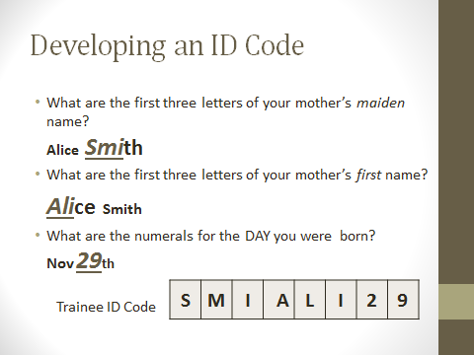

We are NOT evaluating you and no one from your agency will see your individual responses. To keep your responses confidential, we are going to develop your personal ID code. Follow along with your ID Assignment Handout and write in your ID code on the Handout:

**Your Identification Code:**

In order for us to track your evaluation responses while maintaining your anonymity, we need to assign you an *identification code*. We would like you to create your own *identification code* by answering the following questions:

1. What are the first three letters of your mother’s *maiden* name?

Example: If your mother’s maiden name was Alice Smith, the first three letters would be:   
**S** **M** **I**. If the name has less than three letters, fill in the letters from the left and add 0 (zero) in the remaining space(s) on the right.

1. What are the first three letters of your mother’s *First* name? Example:

Example: If your mother’s maiden name was Alice Smith, the first three letters would be:   
**A** **L** **I**. If the name has less than three letters, fill in the letters from the left and add 0 (zero) in the remaining space(s) on the right.

1. What are the numerals for the DAY you were born?

Continued

**HANDOUT: MASTER Identification Code Assignment**

* In order to track each of your evaluation responses while maintaining your anonymity, we need to assign you an identification code.
* You will generate the code number using the first three letters of your mother’s maiden name, the first three letters of your mother’s first name, and the numerals for the day you were born.
* Please put this 8-digit ID code on each of your assessment forms, exactly the same way each time. ID code information will only be used to link demographic data to test data to ensure that the training is working equally well for all participants.
* The questionnaires will be coded with a unique identifier system and all responses will be confidential. Only you will know your ID code refers to you.
* Aggregate data may be used for future research to improve training for Adult Protective Service workers.

|  |  |  |  |  |  |  |  |  |
| --- | --- | --- | --- | --- | --- | --- | --- | --- |
| Trainee ID Code |  |  |  |  |  |  |  |  |
|  |  |  |  |  |  |  |  |  |
| Date |  |  | / |  |  | / |  |  |
|  | M | M |  | D | D |  | Y | Y |

**Your Identification Code:**

In order for us to track your evaluation responses while maintaining your anonymity, we need to assign you an *identification code*. We would like you to create your own *identification code* by answering the following questions:

1. What are the first three letters of your mother’s *maiden* name?

Example: If your mother’s maiden name was Alice Smith, the first three letters would be: **S** **M** **I**. If the name has less than three letters, fill in the letters from the left and add 0 (zero) in the remaining space(s) on the right.

___ ___ ___

1. What are the first three letters of your mother’s *First* name?

Example: If your mother’s maiden name was Alice Smith, the first three letters would be: **A** **L** **I**. If the name has less than three letters, fill in the letters from the left and add 0 (zero) in the remaining space(s) on the right.

___ ___ ___

1. What are the numerals for the DAY you were born?

Example: If you were born on November 29, 1970, the numerals would be **2** **9**. If your birth date is the 1st through the 9th, please put 0 (zero) in front of the numeral (example **0** **9**).

___ ___

Combine these parts to create your own identification code (example: **S** **M** **I** **A** **L** **I** **2** **9**). Please write your identification code in the space at the top right corner of all evaluation materials you receive.

***Remember your identification code and write it at the top of every evaluation form provided to you throughout this training*.**

Slide #5: APS Supervisor Core Roadmap

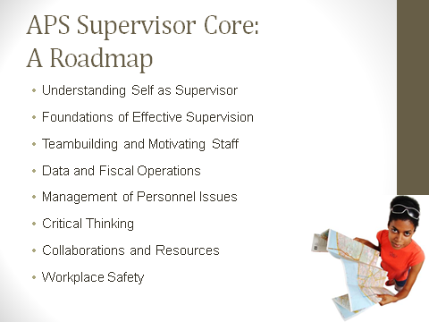

Welcome participants to APS Supervisor Core Series; provide brief description of the overall series of courses stressing the need for participants to commit to completing the entire series.

Emphasize that the courses are designed to increase their capacity and skills as a supervisor and also to facilitate capacity-building and skill development within the APS staff that they supervise. Ultimately, the skills that they learn should make their job easier!

Stress that the classes are all highly interactive and participants will reap the most benefit from active engagement with the curriculum.

Slide #6: Introductions/Suggestion Box Activity

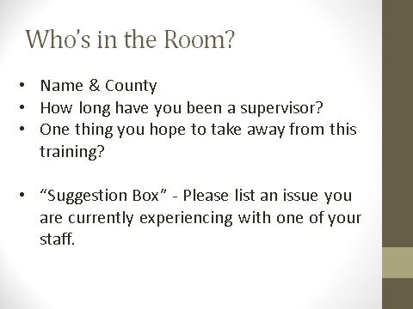

Trainer Note: This slide allows the facilitator to assess who is in the room and tailor what is said. It also initiates the interactive learning process. If there are more experienced APS supervisors, some of the preliminary information can be more rapidly covered so that more time can be spent in practice sessions in latter part of the day.

Go around the room and ask participants to share the following information and chart answers to refer back to throughout the training.

* Name and County
* How many years as a supervisor and whether promoted within APS or promoted from another area/discipline.
* One thing you hope to take away from this training?

After participant introductions, direct participants to the index cards placed in the center of the table. Have each participant list an issue they are currently experiencing with one of their staff. Have them put it aside and explain that later in the training these cards will be used in an activity.

Facilitator to end introductions by reminding participants that this is a safe environment and what is shared in the training will not be shared outside of training (aka Las Vegas Rules).

Slide #7: Learning Objectives

|  |  |
| --- | --- |
|  |  |

Review learning objectives.

**APS Cultural Framework**

**TIME ALLOTTED: 15 minutes**



**_______________________________________________________**

Slide #8: APS Cultural Framework

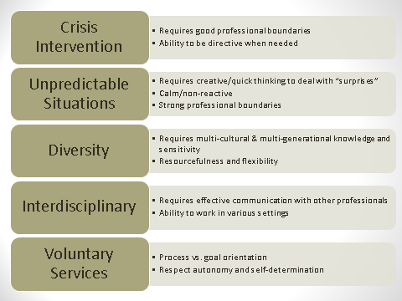

We know that culture impacts all aspects of life. Let’s just review some the unique aspects of APS social work culture which impact the supervisory role.

* APS becomes involved when the client is experiencing some problem that the client/family is apparently unable to handle on their own.
* APS initial involvement/visit is not always welcomed by the client/family, especially when we make unannounced visits.
* APS social workers walk into completely unexpected situations, as the information in the report is often sketchy or biased by the reporting party. They visit every type of culture/ethnic group and socioeconomic class. They see ages 18 through 100 + years old.
* They also perform visits in homes, health care centers, hospitals, coffee shops, Regional Center facilities, etc. and must necessarily be able to communicate effectively with both the client/family and the professionals who support the client in these settings.

Continued

* APS workers need to be flexible with their time and resources, to meet immediate/emergency response times and know how to prioritize to meet all mandated time frames for all their cases.
* Last but not least, APS is a voluntary service-and often the APS worker must close a case when the worker remains concerned about the client’s welfare.

***Ask -*** Why is it important for supervisors to understand the APS cultural framework and how it affects their role with workers?

Answer: Given that APS work is so challenging - effective/experienced APS workers will generally be independent/quick thinkers, verbal, strong advocates for their clients and for themselves, have a broad knowledge base regarding health/aging, developmental disabilities, mental health & cultural diversity.

Slide #9: Promoted From Inside APS

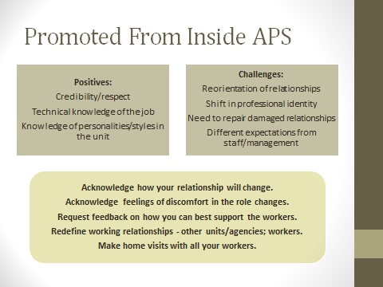

Trainer Note: Tailor this portion of the training to your audience (i.e. “Who’s in the Room” slide). This information also builds on content presented in “Understanding Self as Supervisor”. You may be able to review quickly if participants completed that training.

There are two types of APS supervisors - those who promoted from being an APS investigating social worker and those who come to APS from outside the APS culture.

For the supervisor who promoted from inside APS, the positive aspects of being a supervisor are:

* You probably have the respect of the workers, since you were a good APS worker.
* You have an intimate knowledge of the actual work of investigating and managing a case load, which makes you well suited to helping new staff learn the ropes and also guiding experienced staff.
* You also already know the personalities and strengths of many, if not all, of the workers in APS. This will allow you to be flexible in your communication with them and help with assigning cases.

The not so positive aspects are:

* You will need to reorient your relationships with your former co-workers.
* You are now the “boss” and your responsibilities require that you have a different type of interaction with workers.
* You may also be required to repair relationships with people you had formerly avoided, because of your position.
* Lastly, just because you were an exceptional APS social worker does not necessarily mean you will be an excellent supervisor because the skill sets are different.

Yet, you may have higher performance expectations both by your workers and your managers. And, you, yourself may be placing inordinately high expectations on yourself…

By virtue of your position, you now model leadership and are consequently held to a higher standard of conduct. You are same person you were, but the responsibilities you now have require you to behave differently. So you won’t be able to gossip about the managers, stroll in late, and be casual about time frames. You also may or may not be available to cover your worker’s cases (depending on your other job responsibilities and policies of your agency).

**Acknowledge changes**: APS workers, in many ways, are like first-responders. They share a common, sometimes cynical sense of humor and often bond very closely with their coworkers as a result. When one promotes, the relationship with former co-workers will/must change. The newly promoted supervisor will need to establish new professional boundaries. A supervisor has more power and authority than the social work staff. You will not be able to share everything you’re doing, but you will share what you can. You can still value their friendships, and you may choose to have social contact with your workers (lunches, after hours), but both parties need to acknowledge that your friendship cannot interfere with one’s role as a supervisor. Some agencies discourage supervisors from socializing with workers for this reason-it can be seen as a sign of favoritism and has the potential to interfere with professional judgment.

**Acknowledge feelings**: Change is uncomfortable for most of us. Both you and your workers will lose a certain amount of intimacy once you promote-and there may be grief/irritation/hurt associated with that loss. It is common for new supervisors to doubt their abilities as supervisors, because this emotional passage is not always addressed openly. Assure your staff that you will do what you can to make the transition as smooth as possible for all of you. Also, it is important that you convey that you are learning how to function as a supervisor, and that you will need your workers help in this process.

**Request feedback on how you can best support your workers**: You probably know the kind of supervisor you would like to be-open, honest, fair, respected, a person of integrity, a leader who people want to follow. Your workers, those independent thinkers/advocates will likely give you feedback if you are sincere about requesting it and consider applying/actually apply their suggestions.

**Redefine working relationships**: It may be as a worker, you had difficult relationships with co-workers/other professionals. If you’ve had some difficult relationship with others, now is the time to work on redefining those relationships.

**Make home visits with all your workers**: Even if you’ve made joint visits with your workers, as a new supervisor, you need to re-define your relationship with your staff-as a supervisor and the things you focus on. Making home visits allow you to actually oversee the work that your staff perform.

Slide #10: Promoted From Outside APS

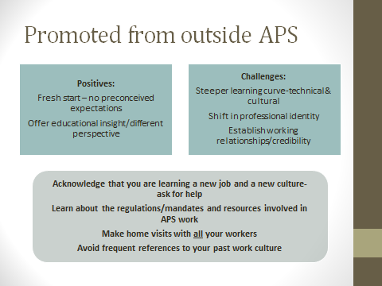

Trainer Note: Tailor this portion of the training to your audience (i.e. “Who’s in the Room” slide). This information also builds on content presented in “Understanding Self as Supervisor”. You may be able to review quickly if participants completed that training.

The APS Supervisor from outside APS: is like a “tabula rasa”- one is able to create the image one always wanted to have. This supervisor also has a fresh perspective on problem solving and sees APS culture with unbiased eyes; consequently can offer insight for resolving systems issues and may address personnel issues differently.

The challenges for this supervisor include: Not only learning a new job, but a new culture. The time it will take for this supervisor to feel competent/comfortable in the job will be longer-so it’s important that this supervisor have patience with himself/herself. It is said that it takes 18-24 months to feel competent in a job, but it may be longer for a supervisor coming from outside APS.

**Acknowledge that you are learning:** You don’t need to know all the answers, just know to ask the questions. This is humility-humility is knowing and accepting your place in the world. APS workers like to empower people, so if you ask them to teach you about the job, they will.

**Make a point to actually read the laws/mandates of APS-and** to learn about the agencies which work collaboratively with APS-including Regional Center, law enforcement, geriatric resources, area agencies on aging, and local senior centers.

**Make home visit with all your workers:** this allows you to learn not only about how APS work gets done, but to actually learn the different styles/strengths and values of your individual workers. This is a time to develop trust and establish positive working relationship. “I’m here to learn from you.”

**Avoid frequent references to your past work culture**: While your past experience is valuable, by frequently referring to it, you are unintentionally devaluing the experience of the present situation, that of APS culture. (eg. “Well, in my last job we did it this way, not that way”)

Slide #11: Professional Boundaries for Supervisors

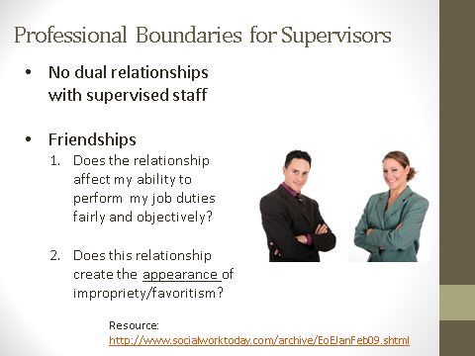

Trainer Note: This information builds on content presented in “Understanding Self as Supervisor”. You may be able to review quickly if participants completed that training.

As a supervisor, one applies the same ethical standards to which all social workers are held.

**Dual/multiple relationships**: It is particularly important that the supervisor avoid dual/multiple relationships with supervised staff. These relationships impede the supervisor’s ability to fairly and objectively perform critical supervisor duties such as performance evaluations and distribution of work.

***ASK*** *for examples on unacceptable dual relationships.*

Some examples include: Sexual relations between parties, business relations/ventures between parties, or family relationships by marriage or birth.

These are clearly unacceptable. Others may not be so clear.

**Friendships:** What about friendships? The Supervisor has to ask:

1) Does this relationship affect my ability to perform my supervisory tasks fairly and objectively?

2) Does this relationship create the appearance of impropriety or favoritism?

Supervisors are held to a higher level of scrutiny, so the appearance of favoritism or impropriety will damage trust and morale in the unit.

The answer to both questions should be “NO,” otherwise, the worker should be supervised by another. The supervisor should also consult his/her manager to receive objective guidance regarding this question.

Trainer Note: Included on the slide is web resource which reviews guidelines for professional boundaries for supervisors.

<http://www.socialworktoday.com/archive/EoEJanFeb09.shtml>

**Educational Role: Case Consultation Factors & Elements**

**TIME ALLOTTED: 80 minutes**



**_______________________________________________________**

Slide #12: Supervisory Roles

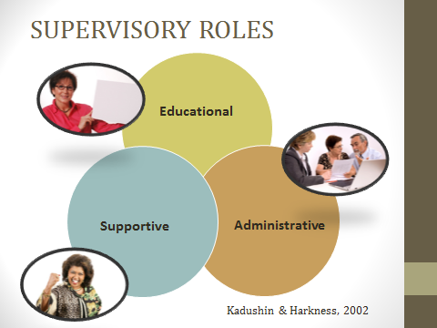

For those who attended the “Understanding Self as Supervisor” training, there were four supervisory roles identified; for the purposes of this training, the Managerial Role has been incorporated into the Administrative Role.

Kadushin & Harkness (2002) identify three primary supervisory roles – Educational, Supportive & Administrative. Each role requires different skills, knowledge and attributes.

References: Kadushin, A., & Harkness, D. (2002). *Supervision in social work*. (4th ed.). New York, NY: Columbia University Press.

National Association of Social Workers. 2012. *Best Practice Standards in Social Work Supervision: Taskforce on Supervision Standards – Draft.*

Slide #13: Educational Role

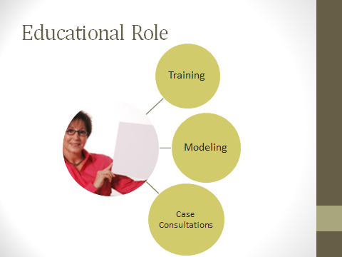

As an APS Supervisor, you are responsible for coordinating and providing training for new and seasoned workers.

* **Training** - Formal vs. informal. In the educational role, supervisors arrange workers to attend formal trainings. Formal trainings often provide basic information and the opportunity to practice skills; however, it is the supervisor’s relationship with worker which ensures that knowledge and skills acquired in formal training are practiced in the real world-this is known as “transfer of learning”.

When your worker attends a training/class/seminar-be sure to ask about what s/he learned (not just if s/he liked it). Also, ask if s/he would be willing to share this info at a unit meeting (nothing makes a person learn more than by teaching about the subject)

* **Modeling** - Consistently demonstrating through behavior and interactions with others the values and behaviors you wish others to develop
* **Case consultations** - the time set aside for skill development and transfer of learning.

Slide #14: Case Consultations

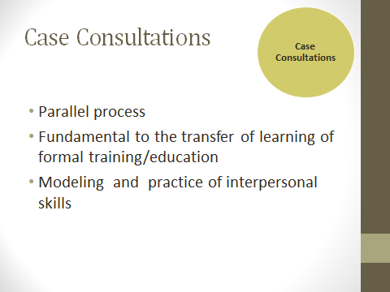

Individual case consultations are the most common way in which supervisors offer education and training to staff.

Note: Case conferences are distinctly different from performance consultations. Case consultations are specifically designed to discuss cases; performance consultations are to discuss work habits & performance expectations. Be sure to keep these separate.

**The concept of parallel process**: The dynamics of one relationship mirrors the dynamics of other relationships-in other words, the way the worker interacts with the supervisor may reflect the way in which the client relates to the worker.

**Transfer of Learning**: Most workers receive formal education and training. They attempt to apply what they’ve learned in their work with clients. Case consultation allows both the worker and the supervisor to assess if skills learned in formal trainings are applied in actual case situations.

**The supervisor needs to consistently model the interpersonal communication skills** (e.g. empathy, active listening, and motivational interviewing skills) to reinforce a supportive learning relationship with the worker and help them develop strategic problem-solving skills.

Slide #15: Case Consultation: Factors

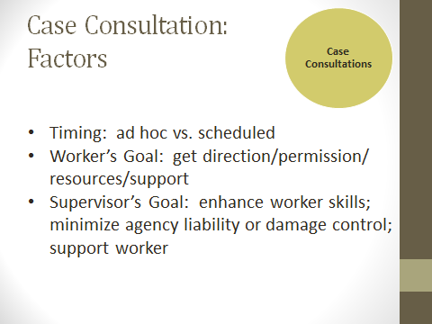

Several factors influence the way a supervisor will structure case consultations

**Scheduling:** Individual case consultations can be scheduled regularly or on ad hoc basis (the drop in meeting) or both. When working with new APS staff, supervisor should schedule case consultations at least once per week to ensure that the new worker is gaining the skills and to address learning deficits as they arise. However, it is recommended that the supervisor have regularly scheduled case consultations even with experienced workers (which can later support your Performance Evaluations, help experienced workers adapt to changes in practices, etc.

Who initiates the meeting will impact the goals of the meeting for the worker and the supervisor.

**Social worker goals**: If the worker initiates the meeting, s/he has run out of ideas on how to manage a case-this is more common with new workers. The experienced worker often has an idea what actions to take and needs either permission and/or resources to proceed.

**Supervisor goals:** If it is initiated by another (client complaint, client case is featured in the media), these conferences tend to be focus on “damage control” or reduction of liability and also support of the worker.

Slide #16: Case Consultation: Elements

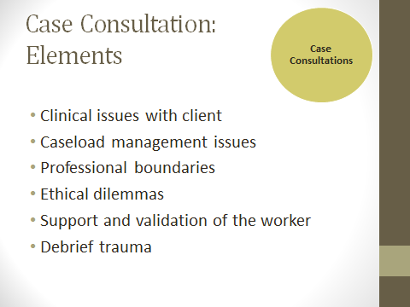

Essentially, the elements are the reason for the case consultation - why do you need to meet with the worker and discuss the case? The elements include:

**Clinical issues with client**: e.g. mental illness, hoarding, substance abuse

**Caseload management issues**: e.g. when to close the case; opening cases on significant others

**Professional boundaries**: Worker overly involved. Over-identification with the client-characterized by strong feelings of dislike, need to protect, requesting services outside the norm; also by judgmental statements/comments about client, lack of empathy);

**Ethical dilemmas**: Most common - the balance between self-determination and safety. What action really is in the best interest of the client? How do you select the least harm?

**Support and validation of worker**: This element is important after media exposure, law suits/subpoenas and client complaints have created anxiety and fear for the worker. Remember, you are not the worker’s therapist, if there are some deep issues-refer worker for outside help.

**Debrief trauma**: Goes beyond regular support and validation, supervisor need to allow worker to vent, be silent, cry, etc, following exposure traumatic events. Common events are: physical threats/assault to the worker and exposure to extreme abuse/neglect client situations. Trauma is personal - the degree to which we experience things as disturbing is based on our life experiences and internal coping mechanisms.

Slide #17: Case Consultation: Evidence-Based Practices

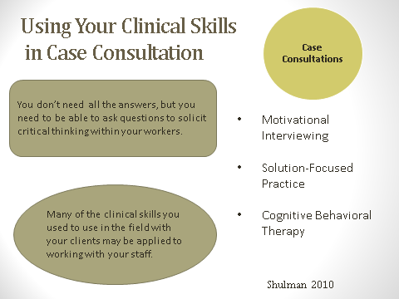

In your case consultation with staff, you don’t need all the answers, but you need to be able to ask questions to solicit critical thinking within your workers.

Many of the clinical skills you used to use in the field with your clients may be applied to working with your staff.

Briefly review **Handout 1 – Evidence-Based Practices** with participants.

**Handout 1 – Evidence-Based Practices**

**Motivational Interviewing**

* **Basic Tenets**
  + To assist the client to resolve about ambivalence regarding change
  + Change only occurs when client is motivated
    - Ready (is prepared to change now)
    - Willing (desires to change)
    - Able (has confidence that s/he can change)
* **Four Principles**
* **Express empathy**: Acceptance facilitates change. Skillful reflective listening is fundamental to expressing empathy. The worker will acknowledge that ambivalence is normal when considering any change.
* **Develop discrepancy**: The client, rather than the worker, should present the arguments for, and against, making the change. Change is motivated by a perceived discrepancy between present behavior and important personal goals or values.
* **Roll with resistance**: Avoid arguing for change. Resistance is not directly opposed. Resistance is a signal to respond differently. New perspectives are invited by not imposed.
* **Support self-efficacy**: The client is the primary resource for finding answers and solutions.
* **OARS**
* **Open-ended questions:** invite the listener to do most of the talking and to come up with the solutions.
* **Affirm:** expressions of appreciation or understanding or compliments about aspects of what the person says, strengths identified.
* **Reflective listening:** Listening to the content and the meaning of the statement. So, if someone says “I wish I was more sociable”, might mean “I feel lonely, and I want more friends;’ or “I’d like to be popular” or “I get nervous when I have to speak with strangers.” As the worker, you would make a statement which corresponds do what you believe the client is saying.
* **Summarize:** Periodically summarizing links together concepts discussed and reinforces what has been said

**Solution-Focused Therapy**

**Basic Tenets**

* If ain’t broke, don’t fix it
* If it works, do more of it
* If it doesn’t work, do something different
* The solution is not necessarily related to “the problem”
* The language of solution is hopeful and positive; problem language is negative and past-oriented
* The future is created and negotiable

**Strategies**

* **Asks client to envision what s/he would like to see different.** The miracle question - If you went to sleep tonight and overnight, a miracle occurred. The problem is now resolved - how would you know that the miracle had occurred? How would things be different? What would the world look like?”
* **Scaling questions**: Asking the client to rate the severity of the problem or the emotional pain on a scale of 1-10, useful in helping client identify changes/progress.
* **Exception Questions**: No problem exists continuously at the same intensity. By asking the client, has there ever been a time when the “problem” did not exist, or was less severe, the worker/therapist can explore what the client did differently- can focus on past incremental successes and coping strategies.
* **Coping questions**: by exploring what the client has done successfully, and validating those strengths, the worker allows the client to acknowledge his/strengths and inspire the confidence that s/he can resolve the current situation.

**Cognitive Behavioral Therapy (CBT)**

**Basic Tenets**

* How we think affects how we act
* Cognitive distortions lead to maladaptive behavior, which then strengthens the distortions
* The goal of intervention is discover these distortions and explore their validity – are these beliefs true?
* Therapy is also structured to teach clients how to identify and reframe cognitive distortions

**Strategies**

* **Open ended questions** to solicit important information from the client.
* **Ask alternative interpretations** to what is observed/perceived (reframing), particularly perceived negative events.
* **Assigning “homework”** helps the client and the worker to identify incremental actions which the client can master and to serve as material for further exploration.

References:

Beck, J. & Beck, A. (2011) *Cognitive behavior therapy: Basics and beyond. (*2nd ed.*) .*NYC, NY: Guilford Press.

de Shazer, S., & Dolan, Y. (2007). *More than miracles: The state of the art of solution-focused brief therapy.* Binghamton, NY: Haworth Press.

Miller , W., & Rollnick, S. (2002). *Motivational interviewing: preparing people for change*. (2nd ed.). New York, NY: Guilford Press.

Slide #18: Activity

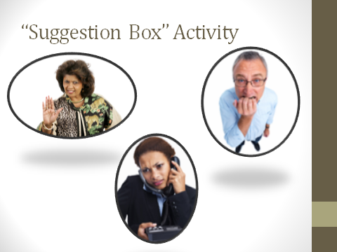 Activity time: 20 minutes

**Small Group Activity:**

Refer participants to the index cards they filled out during introductions. In table groups have participants discuss which technique(s) they could use with this worker? Why?

Role play and practice using the technique(s) should be encouraged if a participant has a particularly difficult issue.

Bring table groups back together to process activity as a large group – have volunteers share examples issues and solutions.

Slide #19: Caseload Management

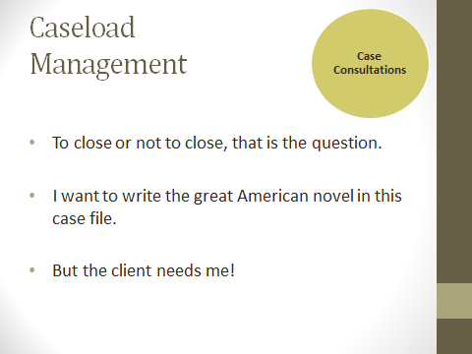

Caseloads can sometimes take on a life of their own. The supervisor controls the number of cases the worker receives, but it is up to the worker to close cases in a timely manner.

Slide #20: Professional Boundaries

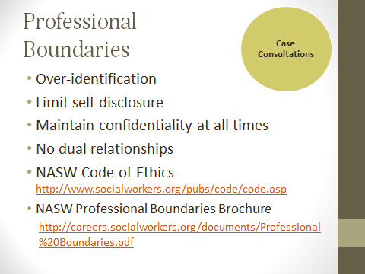

**Over-identification:** Over-identification or countertransference is common to new social workers, who have are still developing a professional persona. You can detect over identification from excessive negative/judgmental comments about the client; lack of empathy; worker interprets resistance as a personal insult-or alternatively, where workers makes over-complimentary remarks -”She’s so sweet, she reminds me of my grandmother” and asks for services beyond the normal scope of practice. etc.

**Limit self-disclosure**: In an effort to establish rapport, new social workers may self-disclose personal information about themselves. The difficulty is once one self-discloses, it becomes difficult to stop answering those personal questions. Remind workers they can be friendly to clients, but they are not the clients’ friend. Workers should only self-disclose in a very general way and then refocus the discussion on the client’s current situation.

**Maintain confidentiality:** It cannot be stressed enough that workers must maintain confidentiality, both at work and in their personal lives. That means the worker should not be mentioning names or other personally identifying information when discussing work at the dinner table or on their Facebook page. In this day of immediate access to information, the Internet/Facebook/You-tube etc. have become venues for finding everything about everyone. Remind staff not to post any personally identifying information on their social websites. Also, remind workers not to give client’s access to cell phones or social network accounts. If you read the papers you will see that the number of law suits related to breach of confidentiality will continue to increase.

**Dual relationships**: A dual relationship is when a social worker establishes a working relationship with a client and then has an additional relationship/connection with that client outside of the working relationship. Examples might be: client attends the same church as the worker; client wants to rent a room to the social worker, social worker wants to buy a car from the client, social worker dating a client’s family member.

If the worker or the supervisor becomes aware of a dual relationship, the supervisor should ensure that the worker takes necessary steps to terminate one relationship, if not both.

To deal with professional boundaries, guide the worker in reflecting on the client’s best interest. Also reviewing the NASW Codes of Ethics should reinforce professional conduct. Reflect to the worker areas in which the worker may be over identifying with the client and how this may be affecting his/her ability to serve the client’s best interest.

Trainer Note:

NASW Code of Ethics can be found at <http://www.socialworkers.org/pubs/code/code.asp>

NASW Professional Boundaries Brochure can be found at:  
<http://careers.socialworkers.org/documents/Professional%20Boundaries.pdf>

Slide #21: Values & Ethics

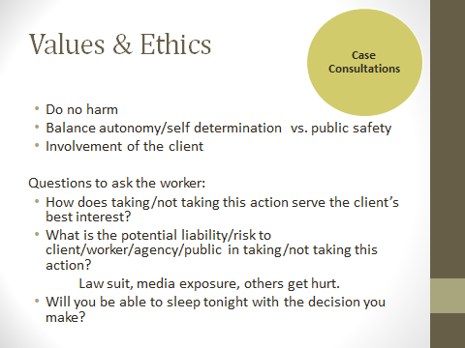

Refer participants to **Handout 2** **– NAPSA Code of Ethics and Guidelines** in their manuals.

The Code of Ethics and Practice Guidelines for APS was developed by the National Adult Protective Services Association (NAPSA). APS workers frequently encounter ethical dilemmas in their work. As a supervisor, you will need to assist them in the process of thinking of these situations in as objective a manner as possible.

**Do no harm**: Inadequate or inappropriate intervention may be worse than no intervention at all.

**Balance autonomy with public safety**: Examples: The dementia client who drives, the person who smokes on oxygen, the client who abuses substances and drives; the client with human hoarding syndrome who’s vermin infested home is infesting the neighbors’ homes.

**Involvement of the client:** To the best of your abilities and given the client’s ability to form choices. This is often very murky, as we deal with clients with dementia or substance abuse problems whose cognitive abilities may ebb and flow.

When discussing such dilemmas, ask these three questions:

* **How does taking this action/not taking this action serve the client’s best interest?** If the worker is capable of stating how his/her intervention will benefit the client, the supervisor will be in a better position to support him/her – regardless of the case outcome.
* **What is the potential liability/risk to client/worker/agency/public?** Need to evaluate all potential risks, not only the risk to the client. Workers are now getting sued, along with their agencies for failure to perform. While you cannot stop anyone from suing you, you can be prepared to again, demonstrate how you and the worker arrived at the decision to act/not act.
* **Will you be able to sleep tonight?** Almost every social worker can tell the story of at least one case that kept him/her up at night. Because social workers are generally conscientious-the ability to sleep at night is one way to demonstrate a social worker has reconciled that his/her decision was the best possible alternative, given the circumstances.

Slide #22: Values & Ethics: Mandated Actions

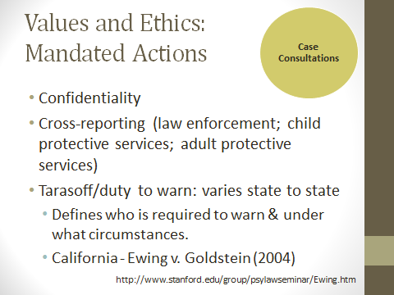

**Confidentiality:** Maintaining confidentiality of both the client and the reporting party cannot be emphasized enough, particularly with new workers.

**Cross-reporting**: Breaching confidentiality is required for mandated reporting. Cross-reporting parameters are typically outlined in statute.

**Tarasoff/duty to warn:** Laws vary from state to state. It is important to be familiar with the mandates and APS practice in your state.

* Defines who is required to warn and under what circumstances.
* California – Ewing v. Goldstein (2004) - This court case expanded the duty to warn in situations where a family member or other interested party lets the professional know that an individual has made a threat.

In the actual court case, a young man’s father told the young man’s therapist (Goldstein) that his son had made a threat against his ex-girlfriend’s new boyfriend (Ewing).  The therapist had the young man held on a mental health hold but when the young man was released (against the therapist’s wishes), the young man murdered the new boyfriend.  The court found that the therapist had a duty to warn the new boyfriend about the threat made against him.

Source: http://www.stanford.edu/group/psylawseminar/Ewing.htm

**Handout 2**

**NAPSA (or APS) Code of Ethics**

Adult Protective Services programs and staff promote safety, independence, and quality-of-life for older persons and persons with disabilities who are being mistreated or in danger of being mistreated, and who are unable to protect themselves.

***Guiding Value***

Every action taken by Adult Protective Services must balance the duty to protect the safety of the vulnerable adult with the adult’s right to self-determination.

***Secondary Value***

Older persons and persons with disabilities who are victims of mistreatment should be treated with honesty, caring, and respect.

***Principles***

* Adults have the right to be safe.
* Adults retain all their civil and constitutional rights, i.e., the right to live their lives as they wish, manage their own finances, enter into contracts, marry, etc. unless a court adjudicates otherwise.
* Adults have the right to make decisions that do not conform with societal norms as long as these decisions do not harm others.
* Adults have the right to accept or refuse services.

Learn about the APS practice guidelines developed from these principles.

**NAPSA (or APS) Practice Guidelines**

APS worker practice responsibilities include:

* Recognize that the interests of the adult are the first concern of any intervention.
* Avoid imposing personal values on others.
* Seek informed consent from the adult before providing services.
* Respect the adult’s right to keep personal information confidential.
* Recognize individual differences such as cultural, historical and personal values.
* Honor the right of adults to receive information about their choices and options in a form or manner that they can understand.
* To the best of one’s ability, involve the adult as much as possible in developing the service plan.
* Focus on case planning that maximizes the vulnerable adult’s independence and choice to the extent possible based on the adult’s capacity.
* Use the least restrictive services first whenever possible—community-based services rather than institutionally-based services.
* Use family and informal support systems first as long as this is in the best interest of the adult.
* Maintain clear and appropriate professional boundaries.
* In the absence of an adult’s expressed wishes, support casework actions that are in the adult’s best interest.
* Use substituted judgment in case planning when historical knowledge of the adult’s values is available.
* Do no harm. Inadequate or inappropriate intervention may be worse than no intervention.

Source: <http://www.napsa-now.org/about-napsa/code-of-ethics/>

Slide #23: Case Consultation Exercise

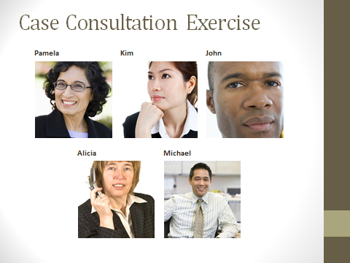 Activity time: 20 min

**Small Group Activity/Large Group Debrief**

Divide participants into 5 table groups.

Refer them to the **Handout 3 - Case Consultation Scenarios** in their manuals.

Assign 1 scenario per table group.

As a table group, have participants read their scenario and discuss the following questions:

1. What element(s) of APS practice need(s) to be addressed (e.g. Mandated actions/reporting; Values and ethics; Best interest of the client; Professional boundaries; Skill practice/role play; Affirmation and support of worker; Debrief trauma with worker)
2. What might you say/information would you provide to assist the worker to learn from this case?

After about 10 minutes, bring everyone back together to debrief scenarios answers as a large group.

**Handout 3 – Case Consultation Scenarios - Trainer Version**

**Case Consultation 1: Experienced Worker- Pamela Hernandez**

An experienced worker, Pamela Hernandez, comes to discuss a client, Anne Price. Ms. Price is a 70 year old Caucasian woman who has insulin-dependent diabetes and arthritis, walks with a walker and requires assistance with personal care, medication management, shopping, and transportation. She has been allotted 39 hours/month from IHSS. She does not appear to have any memory problems.

Her only child is her daughter, Danielle Price, who was early-released from jail 3 months ago for possessionof methamphetamines. She is in an out-patient drug treatment program & has lived with Anne her entire life. Danielle is also Mrs. Price’s IHSS provider. Recently, Danielle grabbed Anne and pushed her against the wall, when Danielle demanded money for cigarettes and Anne refused. Both Anne & Danielle admitted that this occurred, but said it was an isolated incident and would not happen again. Pamela confirmed physical abuse allegation.

The confirmation of the abuse violates the conditions of Danielle’s parole, but both Anne & Danielle have begged the Pamela not to report it to Danielle’s parole officer because Danielle would need to serve out her jail term (one year) and there is no other person who Anne wants to take care of her.

Pamela believes she shouldn’t report this to the police-even though it is mandated. By Danielle being jailed, client will be harmed and this is contrary to the APS code of ethics.

**Answers:**

**What elements of APS practice does this address?**

**Mandated reporting** (confirmed physical abuse is reported to law enforcement) and **best interest of the client**. Client wants her daughter as caregiver, but her daughter’s presence is a threat to client’s well-being. Worker is mandated to report and should inform client/daughter that she is required to do so.

**What you might say/info you might provide:** Pamela is compelled to report the confirmed physical abuse to law enforcement - this is not an option, but something she must do in order to fulfill her obligations as a social worker. Although the result may be that Danielle goes to jail, it also serves the interest of the client, by minimizing the potential for another incident. Although this is will be a difficult position, the worker needs support in recognizing that she (Pamela) is not responsible for the outcome of her mandated actions.

**Case Consultation 2: New Worker-Kim Park**  
Your new worker, Kim Park, comes to you, concerned about what she should do. Kim is second-generation Korean-American and her client, Mr. Thomas Austin is 74 year old Caucasian man with mild memory impairments, who lives alone in a dilapidated small home. He has no living family. He has both Social Security and a pension and manages his own finances-he is not eligible for public benefits. Mr. Austin is a “frequent flyer” client, who has multiple allegations for self-neglect and nutrition. He has a history of accepting services and then stopping them. Mr. Austin is familiar with Korean culture, his deceased wife was Korean and he speaks some Korean. He has asked Kim about her personal life and Kim, believing it was important to establish rapport, disclosed to Mr. Austin that she is a widow herself, has two young sons and is a devout Christian. Mr. Austin is also a devout Christian and asked Kim to pray with him, which Kim did, expressing it was her Christian duty. In the last visit, Mr. Austin told Kim he wants to provide for Kim and her children and would like to leave her his house for her and her sons in his will. Kim recognizes she can’t accept his gift, but doesn’t know what to say to him, “I’m the only family he has.”

Kim asks you what she should do.

**Answers:**

**Case elements:** **Professional boundaries; values and ethics.**  Kim is a new worker and has not yet learned how to establish and maintain professional boundaries. In her eagerness to connect with the client, she has revealed too much personal information. She may be flattered that Mr. Austin relates to her and that he wishes to provide for her.

**What you would say/info you would provide:** It is good that Kim recognizes that she can’t accept his gift. However, her comment “I’m the only family he has” demonstrates that she is not seeing him as a client but as someone more intimate. Because she has lost her objectivity, she will find it hard to serve Mr. Austin’s best interest.

It’s OK to be friendly, but she is not a friend, nor family, to Mr. Austin-she is his social worker, and must maintain a professional, not personal, relationship with him. You need to help Kim to explore why she felt that she needed to disclose so much personal information to Mr. Austin (does he remind Kim of someone in her past-countertransference) as well as why he became so willing to rescue her (does Kim remind him of his lost wife-transference). To disclose, as she did the fact that she had young children and that she was a Christian was unnecessary. Refer her to articles related to self-disclosure and working with clients; remind her to minimize self-disclosure and only if such self-disclosure will serve the client’s interests. Refer her to resources for understanding transference & countertransference.

**Case Consultation 3: New Worker - John Matthews**  
A new worker, John Matthews, has recently gone to see a client, Rose Nuncio. Ms. Nuncio is in her late 70’s, lives alone and is reportedly thin and disheveled when seen by the reporting part. The allegation is self-neglect for nutrition, health and safety, made by an anonymous neighbor.

When John made an unannounced home visit, he saw that there were numerous boxes, broken appliances and trash surrounding her home. None of this could be seen from the street, because the property is surrounded by a 6 foot high hedge. When Rose came to the door, she wore a thin cotton nightgown and was barefoot, despite the weather being close to freezing. John noted that she appeared quite thin, her hair was unwashed and John could detect the smell urine and alcohol from her person. She would not allow John into the house, but from what John could view from the door, Rose is a “hoarder” with stacks of boxes, newspapers & magazines stacked floor to ceiling. John reports that he was cordial, identified that he was APS and asked how she was doing, her how she got food, and if she had any health concerns. She refused to answer most of his questions, becoming more irritable with each minute and so, after trying to speak with her about 10 minutes, he gave her his card and left.

John asks you what else he should have done to engage her. He tells you he was shocked to see that someone could live like that.

**Answers:**

**Case elements**: **Skill building: establishing rapport**-John’s approach with Ms. Nuncio may have been too “goal-oriented” trying to determine if the allegations were true. **Values and ethics**: As a new social worker, John is just learning how to balance the values of client self-determination vs. safety. He is also just learning how to suspend judgment about clients and alternative lifestyles. His “shocked” comment indicates he may have limited experience making home visits

**What would you say/info you would provide:** John may feel uncomfortable not being “in control” as one would be in an office setting. As a supervisor, you will need to guide him in how to “ease into” the discussion with clients. Ask him about how he establishes rapport with anyone-asking neutral questions, or making comments which invite the person to reveal more about him/herself. It would be a good idea to role play with John about how to engage with clients, so he has an opportunity to practice these skills. Refer him to resources such as Code of ethics for APS, resources for establishing rapport; resources for working with those with human hoarding disorder; possible resources for substance abuse disorders.

**Case Consultation 4: Experienced Worker - Alicia Gordon**  
An experienced worker, Alicia Gordon, comes to discuss a “frequent flyer” client, Donna Brown, age 40. Alicia has seen Ms. Brown several times in the past several years. The allegations are always for self-neglect and findings for self-neglect have been inconclusive-she has always had food in the house, is oriented to person place and time and her home, although very sparsely furnished, does not present any safety hazards.

When Alicia made an unannounced visit yesterday, Ms. Brown came to the door without a top/bra on, exposing her breasts. She appeared to recognize Alicia but would not allow her in the home. Ms. Brown accused Alicia of having reported her to the FBI and stated she had to protect herself from mind melding. Tin foil now covered all the windows, which had been applied since Alicia’s last visit 2 months ago. Alicia thought she smelled a sour, decaying odor coming from inside the house. Alicia terminated the visit, called the emergency mental health team for an evaluation. When the mental health worker, Sally Hampton, arrived, Alicia and Sally went to the door again and when Ms. Brown answered, she still had no top on. Ms. Brown became openly hostile toward Sally and accused Sally of being an FBI agent and slammed the door before Sally could say a word to her. Sally told Alicia that she couldn’t smell anything because of her allergies and just because Ms. Brown chose not to wear a top/bra was not sufficient criteria for “gravely disabled.” Alicia explained that Ms. Brown appears to have decompensated (tin foil on the windows, inappropriate dress); however, Sally told Alicia there was nothing further that could be done and that she had to go pick up her daughter at soccer.

Alicia is angry, because she feels Ms. Brown should be have been hospitalized. She believes the only reason this didn’t happen is because Sally didn’t want to 5150 the client so Sally wouldn’t have work the overtime which would have been required.

**Answers:**

**Case Elements**: **Best interest of the client**; **professional boundaries/relationships.** Since Alicia is not charged with the ability to 5150 (involuntarily hospitalize) the client, she must defer to other professionals to perform this task. It is unclear, based on the evidence presented, if the client meets the criteria for “gravely disabled”; the mental health worker didn’t believe this to be the case. The fact that Alicia disagrees with the mental health’s worker’s assessment of the situation and the fact that the mental health worker disregarded Alicia’s assessment could affect their future working relationship.

**What would you say/information you would offer:** Validate Alicia’s feelings of being frustrated. Ask Alicia how an involuntary hospitalization would serve the best interest of the client. Focus Alicia on the process, vs. the outcome, of building a case for an involuntary hospitalization.

**Case Consultation 5: New Worker - Michael Edmundson**A new worker, Michael Edmundson, comes to discuss his new client, Muhammad Shirazi. Mr. Shirazi, who is 84 year old man from Iran, lives with his daughter, Roya & son-in-law, David Smith. Mr. Shirazi made the report himself, and alleges that his family is withholding medication from him.

Michael made an unannounced visit and interviewed Mr. Shirazi alone in Roya’s home. The home was clean and nicely furnished; there were no apparent safety hazards. Mr. Shirazi appeared as well-nourished, well-groomed man with no noticeable memory or cognitive deficits. He stated that his daughter and son-in-law were withholding his pain medications which he needs for his rheumatoid arthritis and gout. He walked with a cane, but he stated he is able to manage his own personal care. He would like to move out of their house and live on his own, but he stated because he does not have an income, Roya & David must support him. Mr. Shirazi was a high ranking official in Iran prior to the revolution, and he proudly showed Michael a photograph of himself standing behind the former Shah of Iran.

Roya called Michael the next day. She admitted that she and David hide Mr. Shirazi’s medications and “dole it out” as prescribed (every 6-8 hours) She stated that her father is addicted to prescription pain killers, Vicodin & Oxycontin and demands them every two-three hours. Mr. Shirazi has been hospitalized twice in the past 3 years for overdosing. Her father’s physician is an old friend from Iran and writes out the prescriptions however Mr. Shirazi demands.

Michael is not sure if he should confirm or find the allegation of abuse inconclusive.

**Answers:**

**Case elements:** **Best interest of the client; findings for the allegation**: The allegation of neglect by others is based on the assumption that client’s family is withholding necessary medications from the client. While this is true, the family actually is acting in the client’s best interest by monitoring client’s intake and issuing them as prescribed-not as the client wishes.

**What you would ask/what information would you provide**: Explore worker’s familiarity with Persian/Iranian culture. Explore worker’s familiarity with in working with prescription drug abuse.

**Supportive Role**

**TIME ALLOTTED: 50 minutes**



**_______________________________________________________**

Slide #24: Supervisory Roles



Let’s move onto the Supportive Supervisory Role. The supportive role of supervision creates the working “culture” for the APS unit.

Reference: Kadushin, A., & Harkness, D. (2002). *Supervision in social work*. (4th ed.). New York, NY: Columbia University Press.  
National Association of Social Workers. (2012). *Best Practice Standards in Social Work Supervision: Taskforce on Supervision Standards – Draft.*

Slide #25: Supportive Role

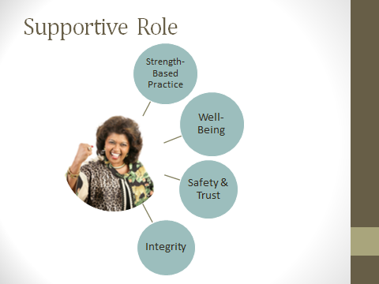

The supportive role of supervision draws from and expands the scope of **strength-based social work practice**. The relationship the supervisor creates with staff models the relationship characteristics which the social worker ideally would like to create with his/her client (parallel process).

Other elements of the supportive supervisory role include:

**Promoting physical/emotional well-being:** including safety in the field, self-care; valuing the worker as a person.

**Environment of safety and trust**: Communication is collaborative; this requires the supervisor to consistently express confidence in the worker, to be trustworthy with communication (e.g. Avoid gossiping about anyone, hold confidences unless to do so violates agency policy/professional ethics).

**Integrity:** What does integrity mean? It means to be whole, consistent and trustworthy. Integrity means you honor your commitments and take responsibility for your mistakes.

Slide #26: Model Strength-Based Practice

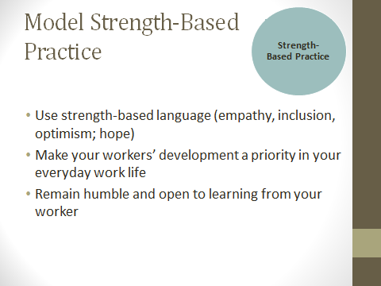

Along with parallel process, strength-based practice also includes:

* Using strength-based language (empathy, inclusion, optimism; hope)
* Making your workers’ development a priority in your everyday work life
* Remaining humble and open to learning from your worker

Slide #27: Promote Well-Being

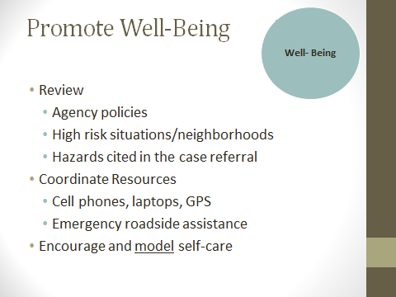

In the promotion of well-being within your workers, consider these factors:

**Agency policies**: Including completing field itineraries and “sign off for the day” procedures.

**High risk situations/neighborhoods**: Including gang areas, high crime apartment complexes - make sure that your workers have a way to alert their coworkers to these areas/situations. Encourage team visits if there is concern for safety with co-workers, other agencies or law enforcement

**Hazards in the referral**: Large aggressive dogs; vermin-infested home; strong odors in the home-as a supervisor, recommend strategies for dealing with these issues (shout out?)

**Coordinate resources**: Make sure your workers have access to working cell phones and or laptops. Emergency roadside assistance plans are also important for field workers.

**Encourage and model self-care –** As you are reminded every time you fly, “please fasten your oxygen mask securely before tending to others” – this is helpful in reminding you that as a supervisor you have the obligation to yourself and your workers to address your own self-care needs. In other words, practice what you preach!

Slide #28: Promote Safety and Trust

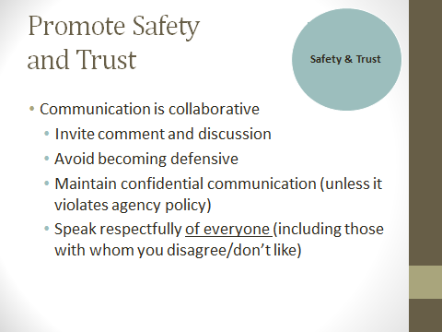

Encourage your workers to provide feedback about their work culture and about your performance. However, remember to avoid getting defensive of yourself, or of your managers, when workers are honest with you!

Confidentiality is critical-do not share anything that a worker shares with you unless you have his/her permission or you need to share it because failure to do so would violate your agency policies. If you must share information for this reason, apprise your worker why you need to do so.

Speak respectfully of everyone-we all believe we do this, but it is often easy to slip in snide remarks or body language (rolling eyes, shaking your head) when referring to someone we don’t respect, or don’t like. Our words communicate about us, not about the other. So if someone who you don’t like is the topic of discussion-change the subject or at the minimum, withhold any comments which could be perceived as negative.

Slide #29: Signs of Trauma Impact

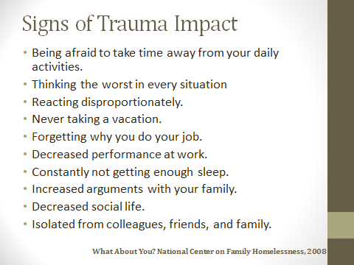

Trauma is associated with physical/psychological threats. Exposure to trauma is an occupational hazard for APS workers.

It is good to be aware of the signs that your workers may be negatively impacted by trauma. These signs include:

* Being afraid to take time away from your daily activities.
* Thinking the worst in every situation
* Reacting disproportionately.
* Never taking a vacation.
* Forgetting why you do your job.
* Decreased performance at work.
* Constantly not getting enough sleep.
* Increased arguments with your family.
* Decreased social life.
* Isolated from colleagues, friends, and family.

Reference: What About You? National Center on Family Homelessness, 2008

Slide #30: Debriefing Trauma

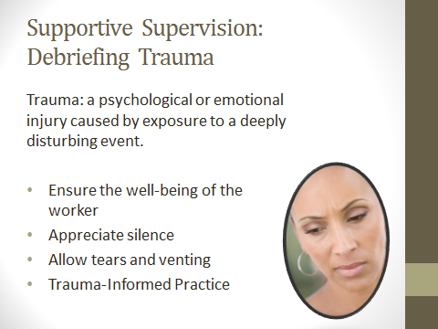

Supervisors must assist workers in identifying when they have been exposed to trauma and be available to assist with debriefing it.

Always ensure the well-being of the worker

Appreciate silence

Allow tears and venting

Become familiar with Trauma-Informed Practice concepts, research and resources.

Slide #31: Supportive Consultation Role Play

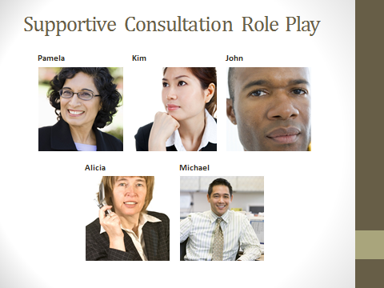 Activity time: 20min

Trainer Note: The intention of this activity is to offer the supervisor the opportunity to practice allowing the worker to "vent" without having to "problem-solve". It allows the supervisor the opportunity to practice using silence and to offer authentic support without resorting to clichés.

**Partner Activity/Large Group Debrief**

Have participants divide into pairs.

Refer them to the **Handout 4 - Supportive Consultation Role Plays** in their manuals.

Assign a follow-up scenario per pair (e.g. If pair reviewed Scenario 1 last activity, then the pair would be assigned Role Play 1)

Have participants read their role play and select a person to be the supervisor and another person to be the worker.

For those in the supervisor role – have them consider:

1. How to promote the well-being of the worker
2. How to use silences

After about 10 minutes, bring everyone back together to debrief role play experience as a large group.

**Handout 4 – Supportive Consultation Role Plays**

**Role Play 1: Experienced Worker-Pamela Hernandez**Pamela reported that she confirmed physical abuse to local law enforcement. The police then contacted Danielle’s parole officer. Danielle was arrested and it was determined she would have to spend the next year in jail. Mrs. Price was very angry and demanded her case be closed. Two weeks after her daughter was arrested, Mrs. Price was found unconscious in her front yard by a neighbor, and was hospitalized for complications related to her diabetes. She was placed in a nursing home following her hospitalization. Pamela closed the case; however, she learned from the nursing home social worker that the Mrs. Price has significantly deteriorated and has become very despondent.

Pamela comes to you and confesses she feels very guilty about what happened. How will you provide support to her?

**Role Play 2: New Worker-Kim Park**  
In her next meeting with Mr. Austin, Kim thanked Mr. Austin for his kind thoughts, but indicated she would not be able to accept his home, that it would get her into trouble with her employer. She explored with him the possibility of leaving his home to a church or a charity. He seemed to accept that, and asked Kim to pray with him again, which she did. He politely refused other services/referrals Kim offered to him.

A week later, Mr. Austin was found dead in his home. Kim comes to you, very upset, because she believes that he “gave up” after she told him she couldn’t accept his gift. How will you support Kim?

**Role Play 3: New Worker-John Matthews**  
Three days after John Matthews closed the case, you receive a call from Mayor Bigwig. After John left, Ms. Nuncio called the mayor (who is her nephew) to complain about her treatment by John. Mayor Bigwig, phoned John and demanded that John write an apology to his aunt. Mayor Bigwig told John, “This is just another example of how social services intrude on the privacy of citizens,” and he refused to listen to John’s side of the story.

John is visibly upset when he comes to talk with you. How will you support him?

**Role Play 4: Experienced Worker- Alicia Gordon**Mrs. Brown is 5150’d a few days later by the police. She had gone to a store to purchase canned whipping cream-without a bra or top on. Your social worker, Alicia, was contacted by the responding police officer, who found her APS card at Mrs. Brown’s door. The officer said the conditions of Mrs. Brown’s house were truly weird-Mrs. Brown had apparently believed that canned whipping cream could diffuse the electro-magnetic currents, and so she had sprayed whipping cream in the electrical sockets and along the seals of windows and doors (which had caused the “sour” odor that Alicia had smelled on the earlier visits) The officer commented “Aren’t you social workers supposed to keep these old folks safe-looks like you really screwed up on this one.” Alicia became very defensive and told the officer that she had tried to get Mrs. Brown 5150’d but mental health wouldn’t do it. The officer replied “Yea, yea, and the check is in the mail.”

Alicia was furious and comes to your office to vent. How will you support her?

**Role Play 5: New Worker-Michael Edmundson**  
Michael visited Mr. Shirazi the following week and tries to explore the nature of Mr. Shirazi’s drug use. Mr. Shirazi denied he had a problem with medication and stated that since Michael’s last visit, he and Roya have come to an understanding. Roya now administers his medications as the doctor prescribed. Michael leaves some written materials about prescription medication abuse and closes the case.

The next day, Michael is contacted by Roya. Mr. Shirazi was furious that Michael had talked to him about his drugs and he struck Roya several times with his cane for “humiliating me to strangers.” Roya is very angry, saying, “I thought what I told you was confidential, and now my father will never forgive me!”

Michael is very upset, and feels responsible for what occurred-that he hadn’t handled the substance abuse issue well. How will you support him?

Slide #32: Learning Journal

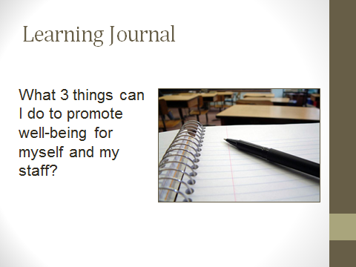 Activity time: 5-7 min

Provide participants with 5-7 minutes to write out a response to the posted question.

* What 3 things can I do to promote well-being for myself and my staff?

Participants should be encouraged to write out at least 3 changes that they can make for themselves and their staff.

Facilitator may ask for volunteers to share their learning journal entries.

**Administrative Role: Case Review and QA**

**TIME ALLOTTED: 60 minutes**



**_______________________________________________________**

Slide #33: Supervisory Roles



So far, we have covered elements from the Educational and Supportive Supervisory Roles. Let’s move into our third and final role, the Administrative Role.

Reference: Kadushin, A., & Harkness, D. (2002). *Supervision in social work*. (4th ed.). New York, NY: Columbia University Press.  
National Association of Social Workers. (2012). *Best Practice Standards in Social Work Supervision: Taskforce on Supervision Standards – Draft.*

Slide #34: Administrative Role

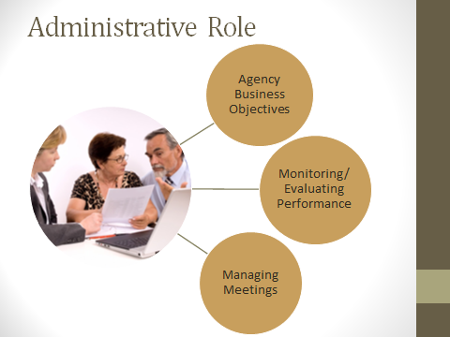

The administrative role of supervision encompasses three areas:

* Agency Business Objectives
* Monitoring and Evaluating Staff Performance
* Managing Meetings

Slide #35: Administrative Role

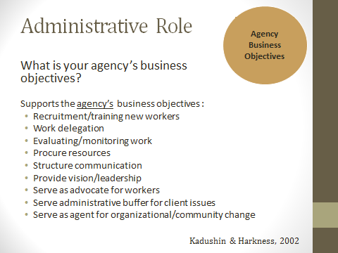

**Shout out**: *What are your agency’s business objectives?*

*Possible answers: Get funding; provide services to community; reduce costs; ensure staffing levels; reduce liability/lawsuits; improve community perception of the agency.*

The administrative role for the supervisor is designed to support the achievement of these objectives. Ultimately, the business objectives reflect the best interest of the community/clients served by the agency, although sometimes that’s hard to see.

Kadushin (1973) in a survey of social work supervisors noted that 71% of the respondents identified the “administrative housekeeping tasks” such as caseload audits, time sheets, statistical reports as being the strongest source of job dissatisfaction.

Reference: Kadushin, A., & Harkness, D. (2002). *Supervision in social work*. (4th ed.). New York, NY: Columbia University Press.

Slide #36: Authority and Power

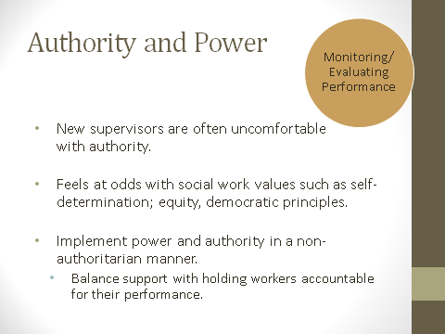

As a supervisor, one is granted both power and authority. Authority is the right to exercise power; and power is the ability to make things happen.

The tasks involved in the administrative role - such evaluating performance and applying rewards or sanctions based on that job performance make clear that the supervisor is no longer a peer with social workers*.*

New supervisors are often uncomfortable with authority - it feels at odds with social work values such as self-determination; equity, democratic principles.

APS supervisors are challenged to implement power and authority in a non-authoritarian manner; balancing support with holding workers accountable for their performance.

Remember, YOU DON”T HAVE TO DO IT PERFECTLY!

Slide #37: Monitoring/Evaluating Performance

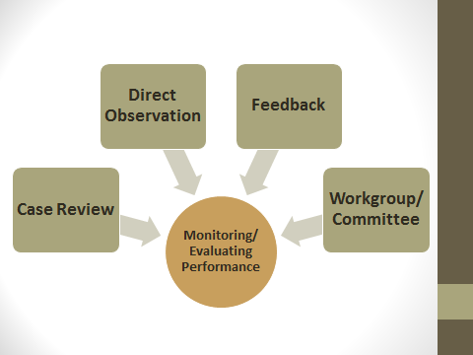

There are 4 primary ways of monitoring and evaluating the worker performance.

The first and most frequently used are **case reviews**. Supervisors must sign off on worker’s cases, so they are already reviewing the documentation of cases.

**Direct observation** of the worker’s interaction with clients/co-workers/other professionals is crucial for evaluating the quality of social work practice. No one can objectively assess his/her own performance and even the best documentation of case interaction cannot substitute for what can be observed and experienced. Supervisors should make at least two home visits with each worker per evaluation period. In addition to home visits, the supervisor can observe the worker’s interactions in meetings, in work groups, etc.

**Feedback from clients and from other professionals** often reflects the satisfaction others have with the worker’s interpersonal and team skills.

Additionally, **involvement in work groups/committees** reflects the worker’s initiative, creativity, commitment-traits that generally exceed the minimum performance standards.

Slide #38: Case Reviews: Individual vs. Group

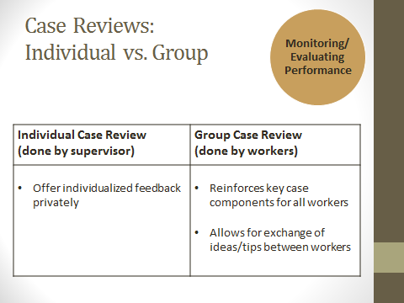

Many supervisors, in the interest of time, perform individual case reviews as they sign- off on cases. However, a recommended practice is to incorporate group case reviews on a regular basis, with a suggested minimum of quarterly (four times per year).

Workers evaluate the case elements of their colleagues and in doing so, reinforce learning for one another; group case review also allows documentation strategies and tips to be shared and discussed. There is also the element of “peer pressure” in conforming to the documentation standards and mandates.

Slide #39: Case Review: Compliance

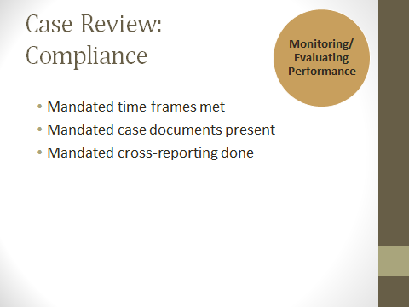

A supervisor is responsible for ensuring compliance with mandates and policies. Mandated elements include the time frames, signatures and case elements which are required by law.

Mandated elements are the minimum performance standard for workers’ documentation. Make sure, as the supervisor, you are signing off in the mandated time frames as well!

Slide #40: Case Review: Quality Assurance

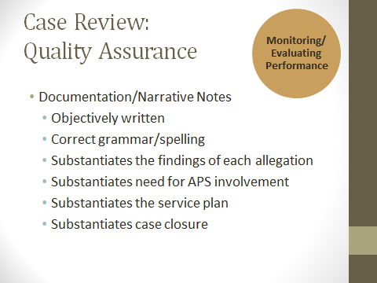

The assessment of the narrative notes is more time consuming than addressing the mandated components, yet it is vital that as a supervisor, you assist your workers in learning appropriate documentation.

In a time of increasing litigation, APS records will also be increasing subpoenaed and the documentation must reflect the professionalism of the worker. By practicing good documentation, hopefully the worker can avoid mandatory appearances in legal proceedings.

And of course, good documentation helps to jog the memory months or even years after a case is closed.

Slide #41: QA Case Review Exercise

 Activity time: 25min

Trainer Note: The Case Review/Quality Assurance Form was derived from common elements from QA forms shared by Florida, Texas, Oregon, Los Angeles County and San Diego County.

For states outside California, you may need to adapt the Case Review/Quality Assurance Form to your jurisdictions regulations (e.g. response times, service planning, etc.)

**Individual Activity**

Refer participants to **Handout 5 – QA Case Review** and **Handout 6 - Case Review/Quality Assurance Form** in their manuals.

Assign participants a case. There are 5 cases and participants can work on the case review related to previous activities (e.g. If they were in Group 1 and worked with Case 1, they may want to continue to work on Case 1 for the QA exercise).

Have participants review the narrative documentation provided by their worker and use the Case Review/Quality Assurance Form to identify items for correction.

Have them provide comments to assist the worker in correcting the deficiencies

After about 10-12 minutes, bring everyone back together to review answers as a large group.

**Handout 5 – QA Case Review - Trainer Version**

**Case 1**

|  |  |  |
| --- | --- | --- |
| **Client Name:** Anne Price | | **Date Referral Received:** March 13, 2012 |
| **Reporting Party:** Dr. Henry Bryant | | **Assigned APS Worker:** Pamela Hernandez |
| **Allegations:** Physical abuse by daughter | | **Findings for Allegations**: Confirmed |
| **10 Day Response:**  **Emergency Response:**  **No Face-to Face Required:** | | |
| **Date** | **Narrative** | |
| 3/14/12 | Received referral from supervisor. | |
| 3/26/12 | Home visit  Client came to the door and gave permission for undersigned to enter. Interviewed client alone in her living room. Home is neatly maintained and no obvious safety hazards were observed. Client stated that Danielle has been her government paid caregiver for the past 10 months and that she receives 39 hours/month for assistance with household chores, personal care and medical appointments. When undersigned asked how client and daughter were getting along, client stated “Fine, I so grateful she’s getting clean”’ Per client, daughter attends outpatient drug rehab 3 times per week and she has been “clean-tested” several times by her parole officer. Client admitted that her daughter had become agitated with her a couple of weeks ago and had pushed into the wall. “She wanted cigarettes, and I wouldn’t give her the money.” Client stated she hadn’t hit her head, but had been bruised on her back. Client denied that Danielle had ever hurt her before.  Danielle arrived home about 30 minutes after undersigned arrived. Danielle spoke rapidly and seemed to have difficulty concentrating on the topic of discussion, frequently commenting on unrelated things (eg. asking her mother if they could get a dog, saying “Look, it’s getting sunny, so maybe the roses will grow”). Danielle demanded to know why I was there and who had reported her mother to APS. Undersigned informed her that due to confidentiality, this information could not be disclosed. Danielle stated, “Look, my mom & I just want to be left alone.” Undersigned asked about the alleged incident a couple of weeks ago. Danielle looked at her mother and then began saying that she accidentally pushed her mom, “Actually, I just put my hands on her shoulders and she fell backwards, I didn’t push her, no way.” Undersigned reviewed with daughter the elder abuse penal code and apprised her that physical abuse of an elder was considered a crime. Danielle said, “You’re not going to call my P.O., are you?” Client also stated that she didn’t want this incident reported to Danielle’s P.O. Undersigned stated that she would need to consult with her supervisor.  Client stated that she does not have any other needs. Daughter assists with medical appointments, household chores and personal care. Client manages to pay her own bills, medications and meal prep. Client insists that she only wants her daughter as her paid provider. | |
| 3/27/12 | Consultation with supervisor. Undersigned does not agree with the recommendations of the supervisor, but will comply.  T/C to Riverton Police Department-apprised Detective Aaron Adams of the confirmation of physical abuse of client by daughter. He will contact Danielle’s P.O. and will arrange for her to be detained. | |
| 3/29/12 | T/C from client, very angry and upset. Danielle arrested by P.O. yesterday. She cannot appeal her jail time and will be in jail for the next 12 months. Undersigned attempted to refer her to the Public Authority agency to hire a care provider, but client said, “I never want to see you again”, and hung up.  Mailed client a brochure for the Public Authority to locate an alternate care provider. | |
| 3/30/12 | Case closure: Case closed at client’s request to no longer have contact with APS. Allegation of physical abuse by daughter was confirmed. Daughter taken into custody for violation of her parole. Client without a care provider at the time of case closure; resources to locate care provider mailed to client. | |

**Answers:**

Strengths: Well written; good use of quotes.

QA issues: Initial HV made 12 days after referral date; no explanation for delay in case notes. On 3/27 consultation with supervisor, worker notes that she does not agree with supervisor, but will comply. It is unnecessary to note disagreement with supervisor-might introduce increased liability into the case.

**Case 2**

|  |  |  |
| --- | --- | --- |
| **Client Name:** Thomas Austin | | **Date Referral Received:** March 12, 2012 |
| **Reporting Party:** Martha Reed (neighbor) | | **Assigned APS Worker**: Kim Park |
| **Allegations:** Self neglect-Health and safety; nutrition | | **Findings for Allegations**: Inconclusive for health and safety; unfounded for nutrition |
| **10 day response:  Immediate Response:  No Face to Face Required:** | | |
| **Date** | **Narrative** | |
| 3/12/12 | I received this referral. I read the previous 4 referrals on Mr. Austin. He accepts help and then he stops the help | |
| 3/13/12 | I went for a home visit this afternoon. Mr. Austin let me into his house, which was very dark inside. He was very polite and asked me how long I had worked in my job. I told him that wasn’t important, but that I wanted to make sure he was safe. He asked me if I was Christian, and I told him I was. He told me I reminded him of his wife, and then he said you are pretty in Korean. He said that he had spent time in Korea working for a food import company and had met his wife there. They had been married for 30 years. She died 4 years ago from cancer. They had not had any children. I asked if he has enough food to eat, he said he does, and he showed me his refrigerator that has lots of frozen foods. I asked him if he feels safe in his home, he said he does. He said he has everything he needs. He said he had enough money-that he gets Social Security and a pension and that he is able to pay his bills. He says he does not go to the doctor, because he only goes when he is sick, and he says he has not been sick for a long time. I asked him what else I could do for him, and he asked me to pray with him that his wife be at peace. I prayed with him and we said the Lord’s Prayer together and then I left. | |
| 3/20/12 | I went to visit Mr. Austin again this week. He asked me to have tea with him and I did. He spoke about his wife and how much he missed her. He started to cry. I told him, I was a widow but I know God intended good for me and my two sons. He told me he had always wanted children, but that the Good Lord had not blessed him with children, that his wife had been infertile. He said he had no relatives and did not want his estate to go to the state. He told me because I was Korean and Christian, he wanted to leave his money to me and my sons. I told him I couldn’t accept that –but he insisted. We prayed together and I left. | |
| 3/21/12 | I talked with my supervisor about Mr. Austin. I should tell him not to leave me anything in his will. I should tell him to leave it to a church or a charity. I should give him referrals for help, like the Senior Center, Friendly Visitor Program. I should close his case because he does not have any protective needs.  I called Mr. Austin. I told him since he was OK , I needed to close his case. He asked me to visit again, but I said I could not. I gave him the numbers for the Senior Center and Friendly Visitor program. | |

**Answers:**

Strengths: Worker captures client’s history very well. Grammatically correct.

QA issues: the allegations are for self-neglect for health and safety and nutrition. Worker documents asking client about these issues, but does not document objective observations.

Most of the documentation is about the interaction between worker and client, but not about worker’s observations or conclusions. Worker’s self-disclosure about being a widow, having two sons, about God intending “good” for her and her sons was not relevant to the client’s situation/investigation.

Definitely issues with professional boundaries are indicated in worker’s documentation.

**Case 3**

|  |  |  |
| --- | --- | --- |
| **Client Name:** Rose Nuncio | | **Date Referral Received:** 3/12/12 |
| **Reporting Party: Anonymous** | | **Assigned APS Worker: John Matthew** |
| **Allegations:** Self neglect-health/safety  Self-neglect-nutrition | | **Findings for Allegations**: Inconclusive for self-neglect for health and safety; inconclusive for self-neglect for nutrition |
| **10 day response:  Immediate Response:  No Face to Face Required:** | | |
| **Date** | **Narrative** | |
| 3/12/12 | Received referral on client. No prior referrals on this client. | |
| 3/15/12 | Home Visit to client’s home at 2233 Maple Street. Home is surrounded by a large ivy hedge, and worker had a hard time opening the gate into the property. Front yard was cluttered with lot of useless appearing items, like broken furniture and appliances; porch had many boxes and bags filled with old newspapers and magazines piled up. Worker knocked several times loudly on the front door. After several attempts, client opened the door . She wore a thin cotton nightgown that had stains on the front and she was barefooted. She appeared thin. Her hair was thin and greasy, I could see a lot of dandruff. She smelled strongly of urine, and I think I smelled alcohol coming from her as well. I could see little past her in the doorway; I saw a lot more magazines, newspapers and clothing piled up, but couldn’t see much beyond the hallway because it was very dark in her house. She demanded to know who I was and why I was there.  I explained that I was with APS and was there to check on her welfare and make sure she was safe. She told me she was fine and told me to go away and leave her alone. I said I’d leave, but I just want to make sure that she has enough to eat, I asked if I could come in and check her kitchen. She said, “Absolutely not.” I told her I couldn’t leave until I made sure she had enough food. She said, I’ve plenty to eat-you don’t have to worry about that.” I asked her what she had eaten that morning, she said she had made Quaker Oatmeal and prunes. I asked her what she planned to have for lunch, she said, none of your business, now go away, and she slammed the door in my face. I called through the door and said I was going to leave my card in case she had any other needs. Left my business card in the door jam.  As I was getting into my car, an elderly man approached me. He told me that he was the one who had made the APS report and wanted to know what I was going to do to help “crazy Mrs. Nuncio.” I told him I didn’t think I would be back, because she didn’t want any help. | |
| 3/16/12 | Meeting with supervisor regarding this case. Will close the case as APS services are voluntary. | |
| 3/16/12 | Received telephone call from Mayor Bigwig; he was very angry; it turns out that Mrs. Nuncio is his aunt and she called him right after I left to complain about me. Mayor Bigwig accused me of violating his aunt’s right to privacy and said this is another example of how social workers intrude on the lives of private citizens. He demanded I write a formal letter of apology to his aunt. | |

**Answers:**

Strengths: Recorded the discussion with client-using quotes-clear how the conversation went.

QA Issues: Misspelled words throughout the narration (usless; abbsolutly; rapore)

Worker’s documentation is not objective “usless junk,” “looked dirty” “smelled terrible” are judgments without supporting objective observations (usless junk-maybe useful to client-so what was the “junk” that worker observed “looked dirty”-did she have stained clothing, did she have greasy hair visible dandruff; did she have mud on her hands. “Smelled terrible” did she smell like a skunk, did she smell of urine, or of alcohol).

Worker quotes the client and Mayor Bigwig, but fails to put the quotes in quotation marks.

**Case 4**

|  |  |
| --- | --- |
| **Client Name:** Donna Brown | **Date Referral Received:** March 12, 2012 |
| **Reporting Party:** Anonymous | **Assigned APS Worker:** Alicia Gordon |
| **Allegations:** Self neglect-health and safety; self-neglect-nutrition | **Findings for Allegations**: Confirmed for health and safety; inconclusive for nutrition |
| **10 day response:  Immediate Response:  No Face to Face Required:** | |

|  |  |
| --- | --- |
| **Date** | **Narrative** |
| 3/16/12 | Home visit-arrived at the home at 2:45PM. Undersigned noted all windows have been covered with tin-foil; previously, client had kept shades down, so this is new for her. Undersigned called out and identified herself several times at the door. After several minutes, client opened the door a few inches. Undersigned noted client wore several hats but was topless, without a bra or shirt. Undersigned detected a sour, moldy odor when the door opened; however, was unable to view inside the house or determine the source of the odor. Undersigned asked client if she would like to put on a top; client stated that there was no need for that, because her hats protected her. Client indicated she recognized undersigned from prior visit last month. She stated she has taken measure to stop the FBI from reading her thoughts. Undersigned asked her how she was able to accomplish that; client replied that she has disconnected all electrical appliances and has used the foil to deflect the mind rays that the FBI attempts to beam at her home. She indicated that she needed to close the door, to prevent any potential spy bots from entering her home.  T/C to the Psychiatric Evaluation Team, requested an immediate evaluation for a 5150. Explained client’s deterioration based on dress, pronounced paranoia and the weird odors which undersigned suspects may be dangerous to client’s wellbeing. PET to send out worker to evaluate the situation. |
| 3/16/12 | 4:30PM Team visit with Sally Brown, psychiatric social worker from PET. Undersigned knocked on the door and client opened the door a few inches. She remained without a top and when she saw Ms. Brown, she screamed, “FBI agent” and slammed the door. Undersigned detected the same odor previously detected; however, Ms. Brown stated she was not able to detect it due to allergies. Undersigned attempted to re-engage the client, but she refused to open the door. After several minutes, Ms. Brown and undersigned conferred. Ms. Brown stated that she didn’t see any evidence that client was a threat to herself or others. She stated that just because she chose to answer the door topless, was not sufficient grounds for gravely disabled. |
| 3/19/12 | Consultation with supervisor. Will make another attempt to visit client later this week. |
| 3/24/12 | T/C from Officer David Edinger. He and his partner 5150’d client to Riverton Psychiatric Hospital last night. Client had gone to ABC Grocery store without a bra or top and had tried to purchase several cans of whipped cream, but apparently had no money. Officer Edinger had gone to the client’s home to secure it and had found the undersigned’s business card in her door jam. He stated “You really blew this one, aren’t you supposed to keep this folks safe?” I explained that it was due to the PET team’s laziness that client had not been hospitalized last week. He also had found she had filled all the electric sockets and all crevices with whipped cream; apparently she believed that the whipped cream had properties which could protect her from electromagnetic rays. |
| 3/24/12 | T/C to Riverton Psychiatric Hospital. Social worker Christine Murray would not confirm client’s presence in the facility and consequently would not discuss any discharge plans with undersigned. |
| 3/24/12 | T/C to Sally Brown (555-1212). Apprised her that client had been 5150’d to Riverton Psychiatric Hospital. Also told her what Officer Edinger said, she denied she was responsible-I told her that she was unprofessional and she hung up on me. |
| 3/25/12 | Case closed |

**Answers:**

Strengths: Worker writes notes differences she observes between last visit and this visit-sets context for how she views client as having deteriorated. Well written, good objective descriptions.

QA Issues: this was assigned as an immediate response, but worker saw client 4 days after the referral-with no explanation of the delay. In the 3/24 notes: documenting that another professional is “lazy’ is an irrelevant judgment, which slips in when worker gets frustrated with being blamed by the officer. This comment is unprofessional, as is recording worker’s comment to Sally Brown.

Case closure - disposition of client’s release from facility is unclear. There is insufficient documentation to justify the case closure.

**Case 5**

|  |  |
| --- | --- |
| **Client Name:** Muhammad Shirazi | **Date Referral Received:** March 12, 2012 |
| **Reporting Party**: Self | **Assigned APS Worker:** Michael Edmundson |
| **Allegations:** neglect by others (dau/son-in-law) | **Findings for Allegations**: Unfounded |
| **10 day response:  Immediate Response:  No Face to Face Required:** | |

|  |  |
| --- | --- |
| **Date** | **Narrative** |
| 3/12/12 | Received the referral. |
| 3/13/12 | Made home visit. Met Mohammed at his home, which is in a very high-priced neighborhood. He was at home alone. He let me into the home, which was very large and expensively furnished, there was a pool in the backyard and there were a lot of Middle Eastern antiques throughout the house. Clt looks to be a man in good health, he walks slowly with a cane, but I didn’t see any balance problems-it looks like he uses the cane for effect, rather than he actually needs it. Mohammed was very polite and well spoken. He told me he was a government official in Iran, and showed me a picture of him standing behind the Shah of Iran. He stated he has lived in America since 1982, after having lived in England for a short time after the Shah was deposed.  When asked about the report he made yesterday, he said that Roya and her American husband, David, refuse to give him his pain medications. I asked what medications he takes; he said he takes Vicodin & Oxycontin. I asked him what he takes them for, he said he has rheumatoid arthritis and gout, which cause him a lot of pain. He stated he was unable to show me his medications, because Roya hides them from him. I asked why she would do that, and clt says he suspects that David is addicted to the medications and Roya is keeping them for David to use. I asked him about any other health conditions, he stated that he has high blood pressure, and takes Dyazide for that. Other than withholding his medication, Mohammed likes living with his daughter, who is his only child.  Clt stated that he is able to manage his own personal care. Roya, does all the housework and cooking and son-in-law, David, manages the household finances. Mohammed is a typical Middle-Eastern man, he doesn’t do any housework at all. I got the impression that clt does not like his son-in-law, his tone changed whenever he mentioned David’s name.  He asked me what I was going to do, would I make Roya give him his medications. I asked his permission to speak with his daughter and son-in-law and he said it was OK. He refused to sign a release to speak with his doctor-“no need to get my physician involved in a family matter.” I left my card and asked him to have his daughter call me. |
| 3/14/12 | T/C from Roya. She said her father asked her to call me but she didn’t know why. I explained her dad had filed a report saying that she and her husband were abusing him by withholding needed medications. I did tell her that Mohammed alluded to the possibility that David taking her father’s medication. She was very quiet and then asked “Did my father tell you that?” She said, “Of course he did.” She then stated that her father is addicted to Oxycontin and Vicodin. She stated that he has been hospitalized twice in the past 3 years for overdosing and that she and her husband have to hide his medications and dole them out every 6-8 hours as prescribed, but that her father demands them every 2-3 hours. I asked her why she didn’t ask the doctor to restrict his prescriptions; she said her father’s physician is an old friend from Iran, who will do whatever her father demands. She has tried to get her father to get treatment for his addiction, but he refuses. David, who is a psychotherapist, has spoken with clt several times, but clt becomes so agitated that David has given up trying. David got on the other line and confirmed what Roya had said. He said I should call a psychiatrist Dr. Allen, who treated clt both times he was hospitalized. |
| 3/14/12 | Case consultation with supervisor. Findings for neglect appear inconclusive, daughter/son-in-law appear to be keeping client safer by managing his medications. |
| 3/20/12 | Home visit to drop off some resources for client. Clt looks the same. I told him I had spoken with Roya, and that she seemed to believe that he had a problem with prescription drugs. He adamantly and loudly denied he had a problem with medications, that it was David “is the addict.” He said, “It doesn’t matter, Roya & I have come to an understanding about all this.” He thanked me for my time. I left some brochures about treatment programs for drug addiction. |
| 3/20/12 | Closed the case. Allegations of neglect by others inconclusive. |

**Answers:**

Strengths: Good detail, clear what the issues are within the family.

QA Issues: Worker uses confusing grammar; sometimes referring the client as “clt” and other times as “Mohammed”, still other times as “her father”.

Worker documents unnecessary/prejudiced bias “Mohammed is a typical Middle-Eastern man” “It looks like he uses his cane for effect”

Worker breached confidentiality by telling Roya that her father made the report of abuse.

**Handout 6 - Case Review/Quality Assurance Form**

**Case assigned as:**

Emergency Response  Client seen within 24 hours

10 day response  Client seen within 10 days

No Face to Face Indicated  Client/significant other contacted within 10 days

If client/significant other not contacted within mandated time frame- adequate documentation explaining the reason why (including attempts to contact)

**Initial Assessment Documentation & Time Frames**

Initial Assessment documentation reflects:

1. Client/family gave permission for APS to enter the home
2. Client was interviewed alone **or** reason why client was not interviewed alone
3. Full names of those interviewed and their relationship(s) to the client
4. Objective observations (including quotes), that support findings for allegations
5. Assessment of client’s strengths and needs
6. Worker obtained signed release(s) of information form to speak with other involved parties
7. Client consented to additional APS involvement

If client refuses further APS involvement-referrals offered to client

1. Assessment completed and signed by worker within 21 calendar days of referral date

Comments for unchecked items: ________________________________________________________________________________________________________________________________________________________________________________________________________________________________________________________________________________________________________________

**Service Plan Documentation & Time Frame**

Service Plan documentation reflects:

1. Client was involved in the development of the Service Plan
2. Client consented to the Service Plan
3. The desired outcomes/goals of APS involvement
4. Strategies and resources to be used to achieve desired outcomes/goals
5. Anticipated length of APS involvement
6. Service Plan completed and signed by worker within 30 calendar days of referral date
7. Additional services offered and refused/ unavailable

Comments for unchecked items: ________________________________________________________________________________________________________________________________________________________________________________________________________________________________________________________________________________________________________________

**Narrative Case Notes**

Case Notes reflect:

1. Objective documentation
2. APS social work activities outlined in the Service Plan
3. Monitoring of providers/resources to promote desired outcomes of Service Plan
4. If applicable, home visit made at required intervals for duration of the case **or** alternative visitation plandocumented and approved

Not applicable-case closed before additional visits required

1. If applicable, changes in client’s situation which require amendment to the Service Plan

Not applicable-no changes in client’s situation which required Service Plan amendment

1. If applicable, mandated cross reporting

Not applicable-no mandated cross reporting indicated in case

Comments on unchecked items: ________________________________________________________________________________________________________________________________________________________________________________________________________________________________________________________________________________________________________________

**Case Closure**

Case Closure notes reflect:

1. Each allegation and the findings for each allegation
2. The reason that the case is being closed
3. The extent to which the Service Plan goals were achieved
4. Services in place at the time of case closure
5. The services provided by APS

Comments on unchecked items: ________________________________________________________________________________________________________________________________________________________________________________________________________________________________________________________________________________________________________________  
Source: The Case Review/Quality Assurance Form was derived from common elements from QA forms shared by Florida, Texas, Oregon, Los Angeles County and San Diego County.

**Administrative Role: Evaluating Performance & Managing Meetings**

**TIME ALLOTTED: 75 minutes**



**_______________________________________________________**

Slide #42 & 43: Evaluating Performance

|  |  |
| --- | --- |
|  |  |

Case reviews demonstrate the workers ability to meet the mandatory deadlines and document activities; however, observing the worker interacting with the client will yield additional & critical information about his/her interpersonal and clinical skills. As an APS supervisor, you must observe firsthand what the worker is actually doing in the field.

There are those social workers who are great documenters and terrible practitioners, and there are those who are terrible documenters who have excellent social work skills.

In evaluating a social worker performance Kadushin & Harkness identify 8 performance criteria. Let’s use the criteria in an activity.

Continued

**Small Group Activity**

Divide participants into table groups; provide each group with charting paper and a marker.

Assign each group 2 performance criteria. Have each group identify ways to measure each criterion using concrete examples.

Bring groups back together and process answers as a large group.

Note: Trainer can add to participants’ answers or provide clarification from list below if needed.

**Ability to establish/maintain effective meaningful relationships** with clients -including the ability to establish rapport, convey respect, empathetic understanding, non-judgmental acceptance warmth and concern. Can empathize without over identifying with client. Adheres to professional values and ethics in client relationship-respects and maintains confidentiality.

**Social work process-knowledge and skills** - including ability to gather data from client and other sources; to grasp information to relevance with client’s psychosocial situation; to apply knowledge of human behavior, culture and communication; can tailor treatment/care plans to the individual needs of the client; can document actions in an organized manner and objective manner.

**Orientation to the agency administration objectives, policies and procedures -**does the worker follow the agency’s policies and procedures

**Relationship to and use of supervision** - comes prepared, not overly dependent on supervisor; accepts guidance without being subservient; acknowledges authority and participates actively in the supervision process; recognizes when to come to supervisor for assistance.

**Staff & community relationships -** contributes to harmonious relationships at all levels of the agency and within the community; is knowledgeable of key community resources and personnel.

**Workload management -** Covers assignments consistently; maintains case load comparable to others in similar positions. Submits needed records on time and absences/lateness is infrequent.

**Professional attributes/attitudes -** Self-aware of limitations without undue anxiety, flexible and cooperative; upholds values of the profession; participates in training/professional development activities.

**Evaluating cultural competence -** Aware of own personal culture-based values and biases; understands and accepts the values, attitudes and behaviors of different ethnic/cultural groups; can apply strategies/techniques that are culturally appropriate to the needs of culturally diverse clients.

**Reference:** Kadushin, A., & Harkness, D. (2002). *Supervision in social work*. (4th ed.). New York, NY: Columbia University Press.

Slide #44: Effective Feedback

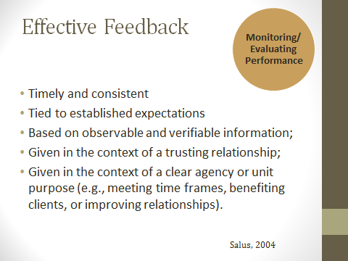

Salus (2004) noted that effective feedback for performance improvement must be:

* Timely and consistent
* Tied to established expectations: including mandated time frames, job expectations/descriptions.
* Based on observable and verifiable information: this is why making home visits and observations by the supervisor is so important, also documentation of feedback from others
* Given in the context of a trusting relationship
* Given in the context of clear agency/unit purpose: How does this performance issue impact the purpose of the overall agency?

Reference: Salus, M. US Department of Health and Human Services, Administration for Children and Families. (2004).*Supervising child protective services caseworkers*. Retrieved on 11/1/12 from US Department of Health and Human Services website: <http://www.childwelfare.gov/pubs/usermanuals/supercps/supercps.pdf>

Slide # 45: Fishbowl Exercise

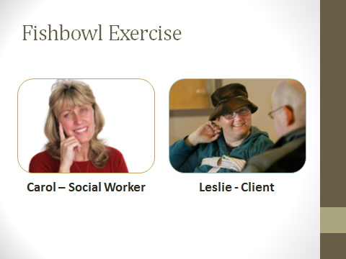 Activity time: 10min

Trainer Note: Optional Activity. In the Fishbowl Exercise participants view a social worker with limited skills. Purpose of the exercise is practice offering developmental feedback to help worker to improve skills.

**Optional Large Group Activity:**

Refer participants to **Handout #7 – Fishbowl Exercise** in their manuals

The trainer plays the role of the new social worker – Carol Carson and recruits a participant to play the client – Leslie Chambers.

Divide participants into 5 table groups - each table is assigned to observe for one skill:

* developing rapport/trust
* cultural sensitivity
* interviewing skills/obtaining information
* professional boundaries
* ethical issues

Read scenario aloud as a group and use the interview script to role play for 3-5 minutes.

Slide # 46 – Small Group Activity

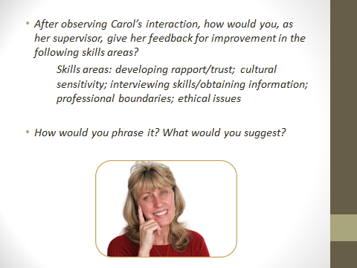 Activity time:10min

**Optional Small Group Activity:**

After observing the Fishbowl as a large group, have table groups discuss the following:

* After observing Carol’s interaction, how would you, as her supervisor, give her feedback for improvement in the following skills areas?
* Skills areas: developing rapport/trust; cultural sensitivity; interviewing skills/obtaining information; professional boundaries; ethical issues
* How would you phrase it? What would you suggest?

After table groups have processed, ask for examples and use the following information to elaborate on what is missing:

Best to offer both direct feedback and ask guiding questions.

Give direct feedback to worker on specific ways to improve: e.g. Next time, ask some preliminary questions to assess what your client can/cannot understand. Offer the same respect to persons with developmental disabilities (asking permission, ensuring client’s comfort) you would give to any other client.

Ask guiding questions so that workers can come to develop their own insights to correct deficiencies

* What are some important things to keep in mind when working with any client?
* start where the client is
* respect autonomy
* counselor expresses unconditionally warmth and safety;
* have training and experience with the population you serve (scope of practice)
* serve the best interest of the client
* How do you think you conveyed these things in your interview
* What’s your understanding of working with persons with developmental disabilities?
* assess ability to understand concepts related to interview
* need to use developmentally appropriate language
* need for comfort and familiarity are crucial
* What is you understanding of how to work with victims of sexual abuse/trauma?
* worker needs to promote feeling of safety and support
* shame, embarrassment, guilt, confusion are common themes for victims (for developmentally disabled, confusion is exacerbated)
* worker needs to be patient/comfortable with silence

**Handout 7 - Fishbowl Exercise – Trainer Version**

**Scenario:**

A 25 year old woman, Leslie Chambers is a Regional Center consumer, who attends a sheltered workshop 3 days/week. The reporting party is her job coach, Donna. Per reporting party, Leslie functions at the level of a 7-8 year old child. Her mother, Linda Armstrong, is the probate conservator of person and finances for Leslie. A few weeks ago, Leslie met Pete (last name unknown) at the local convenience store. Pete is approximately 50 years old, and has tried to visit Leslie at the sheltered workshop several times-Donna has always told him he was not allowed on the property. Today, Leslie left the premises at lunchtime without permission. When she returned, she said that she had gone to lunch with Pete. Leslie’s shirt was inside out and she did not want to answer any questions of her job coach, saying “Pete told me not to tell.” Reporting party suspects Pete sexually abused Leslie.

This is assigned as an immediate response visit. The social worker, Carol Carson has just started with APS. She has a background in clinical psychology and substance abuse counseling, but has never worked with sexual abuse or developmental disabilities.

**Script for Interview – Trainer Version**

Leslie (client) is seated in a chair, she plays nervously with her hair, twirling it, or pulling on it.

Carol (social worker) comes in and sits across from her and immediately starts into the interview.

|  |  |  |
| --- | --- | --- |
|  | **Script** | **Areas for Improvement** |
| **Carol:** | Leslie, my name is Carol and I am a social worker. I need to talk with you about what happened today. | Lack of empathy/rapport  No expression of concern for the client, no effort to comfort the nervous client. Does not ask permission to speak with her.  Does Leslie know what a social worker does? |
| ***Leslie:*** | *Where’s Donna?* |  |
| **Carol:** | Donna’s in the next room and she said it was OK that we talked about what happened today. | Carol could ask if Leslie would like Donna to be there for reassurance. Again, even if Donna gave permission for them to talk, Carol has not asked Leslie’s permission. |
| ***Leslie*** | *I want Donna.* |  |
| **Carol** | Well, I need to talk with you alone right now. We can talk with Donna later, OK? (Carol reaches over and pats Leslie’s shoulder/hand) | This isn’t true, client has requested Donna-it is not necessary to interview her alone. |
| ***Leslie:*** | *OK. (pause, looks down) Am I in trouble?* |  |
| **Carol** | What makes you think you’re in trouble? | Carol is responding to Leslie as if she is an insightful, self-reflective adult client. Leslie is developmentally delayed, and likely lacks the ability to self-reflect or to say what she is thinking. |
| ***Leslie*** | *I don’t know.* |  |
| **Carol** | (pause)Let’s talk about where you went today, shall we? Donna said you left the workshop today. | Carol has not asked preliminary questions to assess Leslie’s ability to comprehend basic concepts (such as right and wrong, truth and not true, time of day, etc) |
| ***Leslie*** | *I don’t know.* |  |
| **Carol** | You don’t know? (Pause). Leslie, you’re not in trouble, you know | Carol does something right, by assuring Leslie she is not in trouble. |
| ***Leslie*** | *Pete said if I told, I’d get in trouble.* |  |
| **Carol** | Well, you’re not in trouble. Can you tell me who Pete is? |  |
| ***Leslie*** | *He’s my friend.* |  |
| **Carol** | How long have you known Pete? | Is this a relevant question? Carol doesn’t know if Leslie has a concept of time. |
| ***Leslie*** | *I don’t know.* |  |
| **Carol** | Is he your boyfriend? | Is this relevant? Do we know if Leslie understands the concepts of dating; heterosexual relationships of boyfriend/girlfriend? |
| ***Leslie*** | *I don’t know.* |  |
| **Carol** | Did you see Pete today? |  |
| ***Leslie*** | *I don’t know.* | *Leslie’s responses of “I don’t know” are a typical answer which covers a range of meaning-including “I don’t want to tell you,” “I can’t remember” “I can’t say because I don’t have the vocabulary.” “I can’t say because I don’t have a concept of time.”* |
| **Carol** | Well, Donna said you told her went to lunch with Pete. Did you go to lunch with Pete? | Normally, we don’t ask ‘yes-no” questions, but in this case, it’s probably appropriate. |
| ***Leslie*** | *I don’t know.* |  |
| **Carol** | Leslie, I need for you to tell me the truth. I am trying to help you. | Carol probably needed to say this before she started the interview. |
| ***Leslie*** | *I don’t want to get in trouble.* |  |
| **Carol** | (somewhat exasperated tone) You’re not in trouble. But I can’t help you unless you tell me the truth. Can you tell me, did you see Pete today? | Carol’s own lack of experience is causing her to get frustrated and not retain her focus on the client’s needs. Leslie needs reassurance and comfort. |
| ***Leslie*** | *Yes.* |  |
| **Carol** | And did he touch you in an inappropriate way? | Leading question, Carol jumped into the question too quickly; use of the word “inappropriate” would not have meaning to a person whose cognitive ability is 7-8 years old. |
| ***Leslie*** | *I don’t know.* | *Again, “I don’t know” here may mean “I don’t know what inappropriate means” or “I don’t want to get into trouble if I tell you Pete touched me.” Or “I don’t want to get Pete in trouble if I tell you he touched me….”* |

Slide #47: Making the Most of Meetings



An essential skill for all supervisors is managing meetings.

Meetings are a great opportunity for a supervisor to carry out a variety of tasks including training, coaching, team building, or just providing opportunities for the exchange of ideas or to discuss challenging cases that workers are confronting. But the truth is that running an effective meeting can be a very difficult skill.

**Large Group Shout Out**

***Ask:*** What is it that can make a meeting a really great experience? Ask participants to think about some really excellent meetings that you have attended.

***Ask -*** What is it that can make a meeting a really negative experience?

Chart answers.

Slide #48 – Common Meeting Problems

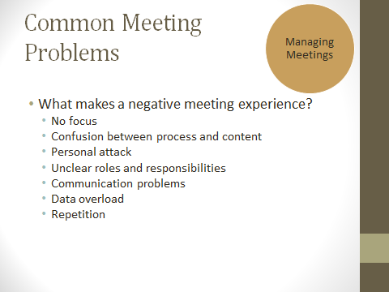

It is likely very easy to think about what goes into making a meeting a negative meeting experience.

One or more of these elements can contribute to make a meeting very ineffectual.

**No Focus** - Team members may feel that their time is simply wasted by being there.

**Confusion between process and content** - Without effective facilitation and planning, it may not be clear to those in attendance if the discussion is centering around the feelings of those who are discussing the issue or the actual issue.

**Personal Attack** - If team members are not respectful or there are conflicts that are not managed properly, a meeting can be a very negative experience for all.

**Unclear roles and responsibilities** - It should be clear exactly what the roles and responsibilities of all members of the group are. This will increase team unity and enhance the effectiveness of the meeting.

**Communication Problems** - A facilitator must model and ensure that everyone has the opportunity to share and be heard.

**Data overload** - Statistics and information can be helpful but it should not overwhelm the meeting or the issues at hand.

**Repetition** - Has the topic already been successfully addressed? If so, make a plan and move on. Repetition is a sure fire way to ensure that team members will not return to future meetings.

Slide #49 – Exercise

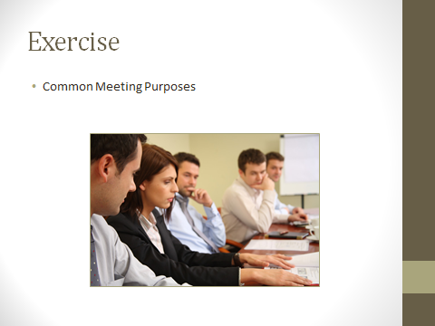 Activity Time: 10min

Refer participants to **Handout #8 - Common Meeting Purposes**

**Individual Activity**

Provide individuals with 5 minutes to read through the handout and provide a few examples from one of their own meeting experiences. They should note when they have engaged in a particular meeting purpose - either at a meeting that they have attended or facilitated.

**Large Group Activity**

***Ask*** for any examples from the group after the completion of the exercise.

To close explain that this exercise points out there are different meeting purposes and as supervisors you need to adapt your facilitation to match the meeting purpose.

**Handout #8 - Common Meeting Purposes**

|  |  |  |
| --- | --- | --- |
| **Purpose** | **Description** | **Example** |
| Affiliating | Providing an experience belonging to the Organization or Unit or Team |  |
| Analyzing | Determining the causes of a situation or the relationship between things |  |
| Celebrating | Recognizing and honoring achievements and life passages |  |
| Conciliating | Bringing conflicting parties together to acknowledge the legitimacy of other’s point of view |  |
| Decision-Making | Reaching conclusion about what action to take |  |
| Enrolling | Requesting participation or partnership in achieving outcomes |  |
| Evaluating | Assessing relative success in achieving planned objectives |  |
| Informing | Providing or receiving data or clarifying information, usually for use at a later time |  |
| Mediating | Facilitating the resolution of conflict among people |  |
| Planning | Setting goals and establishing a schedule of activities |  |
| Problem-Solving | Working in a team to resolve issues or take advantage of an opportunity |  |
| Socializing | Creating opportunity for people to relax with each other |  |
| Team-Building | Creating feelings of trust and establishing common norms among members |  |
| Tracking | Monitoring progress toward goals (usually for work that is done independently) |  |

Source: Garrison, M and Dahlin, P. (2009). *Team development* – Foundations of Supervision Series, Participant Manual. (p. 27).

Slide #50 – Meeting Life Cycle

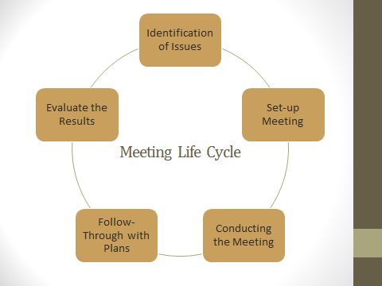

Refer participantsto **Handout #9 - The Life Cycle of a Meeting: The Core Meeting Process** and walk through the different stages of the life cycle using the handout as a guide.

**Identification of the Issues & Making Sure the Meeting is Necessary -** Sometimes, meetings become a part of a cultural expectation when information could be conveyed in e-mail notifications. Meetings are necessary when there is a need for discussion/feedback or when you want to ensure that everyone gets exactly the same information regarding a controversial issue. Some examples of when a meeting is needed:

1. A policy/procedural change that needs to be discussed. Not all P & Ps changes require discussion, but if the change requires a significant change in work practices, then you should have a meeting to address concerns, anticipated problems with the change.
2. Pending reorganization/personnel changes
3. Debrief media exposure/traumatic events/reorganization or personnel changes

**Setting up the Meeting** is a very important planning stage. It is essential that supervisors dedicate time to planning out a meeting in order to produce effective results. Setting up and distributing an agenda is a key part of this planning process. Providing staff with the opportunity to participate with the agenda setting is a best practice that supervisors should follow.

**Conducting the meeting** - The supervisor should talk to those in attendance about the purpose of the meeting as well as the decision-making style that will occur. Discussion about logistics - timeframe, housekeeping issues, etc. is also very important. Make sure to start and end the meeting on time even if it means tabling an issue for a future meeting.

**Following Through with the Plans from the Meeting and Evaluating the Results** are both stages that occur once the meeting is adjourned but they are key steps that are often neglected by meeting facilitators.  Supervisors often neglect this stage and this makes their meetings less effective. It is essential that supervisors follow through if they make a commitment during a meeting. "I will look into it" is too commonly used and the issue appears to be forgotten to staff. The underlying message is then that team issues are not as important as the agenda that the supervisor has drawn up.

**Handout #9 - The Life Cycle of a Meeting: The Core Meeting Process**

**Step 1: Identification of the Issues**

* What are the issues?
* What are the barriers to solutions?
* Who are the stakeholders?
* What is already in writing about this?
* Why is this important?

**Step 2: Setting Up the Meeting**

* Who should be there?
* What will the goal be?
* What are the likely roles that participants will play?
* Where am I on the issue?
* Where am I in my relationships with the participants?
* Where should the meeting be?
* How long should the meeting be?

**Step 3: Conducting the Meeting**

* Roles of participants
* Agenda review
* Agreement on type of meeting
* Agreement on decision-making method
* Agreement on structure and timeframes
* Review of meeting results
* Plus/delta (evaluation)
* Next steps

**Tools for Conducting Meetings**

|  |  |
| --- | --- |
| 1. **Brainstorming**   *No judgments*  *Free-flowing*  *No defending*  *No rationales*  *Everything goes*  *Possibly add-on, if initiator agrees*  *Scrunching words* | 1. **Clarification**   *Illustrating so each person has an idea of the concept*  *Freedom to combine, if initiator agrees*  *No need to try to combine*  *Not a time to defend or justify*  *Not a time to attack or lobby* |
| 1. **Prioritization**   *n/3, n=number of IDEAS*  *Each participant chooses their top concerns and votes on top n/3*  *Facilitator highlights group’s scores* | 1. **Agreement**   *Facilitator asks each individual to agree on top n/3 to work on*  *Disagreeing person(s) asked what could be changed so that they are 80% satisfied* |

**Step 4: Follow Through**

**Check-In for Actions Plans – Example**

|  |  |  |  |  |  |  |  |
| --- | --- | --- | --- | --- | --- | --- | --- |
| **Objective** | **Who** | **Start Date** | **IPR**  **(In-Progress Report)** | **Stop Date** | **Additional Resources Needed** | **Additional Action Plans** | **Remarks** |
| Case review standards | Sue | 1/1/13 | Policy never completed but was drafted and forwarded to Program Managers for decision on implementation | N/A | Program Managers need to meet with Supervisors to determine implementation process | Program Managers to meet with Supervisors to get feedback | Meeting scheduled for 5/1/13. Program Managers to get back to Sue by 4/15/13. Sue to then present updated IPR. |

**Meeting Results – Example**

* Summary of what happened (content)
* Summary of the meeting process (how)
* The following agreements were made:
* The following decisions were made:
* The evaluation of the meeting was:

|  |  |  |
| --- | --- | --- |
|  | **+** | **Δ** |
| 1 |  |  |
| 2 |  |  |
| 3 |  |  |
| 4 |  |  |

* Next actions are:

Note Taker & Date: _______________________________

**Step 5: Seeing the Results**

* Outcomes
* Celebration
* Implementation
* Acknowledgment
* Termination of any special committees
* Finalization of policies and procedures

Source: Garrison, M and Dahlin, P. (2009). *Team development* – Foundations of Supervision Series, Participant Manual. (p. 29, 31, 32, 33 & 34).

Slide #51

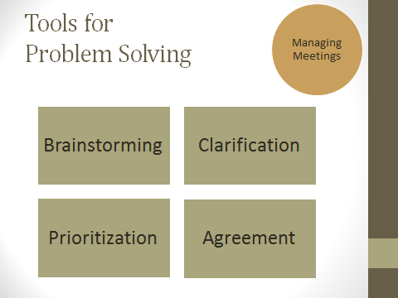

Supervisors can rely on the Core Meeting Process when they are trying to reach consensus around a difficult topic.

Let’s refer back to **Step 3 on Handout #9 – Tools for Conducting Meetings: Brainstorming, Clarification, Prioritization and Agreement**

**Brainstorming** allows all team members the opportunity to provide input. A supervisor might use a flipchart during this process.

**Clarification** happens around the ideas that have been brought up during the brainstorming process.

**Prioritization** can actually happen via a process of voting among the shared ideas. This process can be challenging but it is an important step for the facilitator to actually help the group make a decision.

**Agreement** does not mean that all members will be 100% on board with the decision. In order to bring other members on board, the supervisor can ask those in disagreement what can be changed in order to help them to at least be 80% satisfied with the selection.

Slide #52: Learning Journal

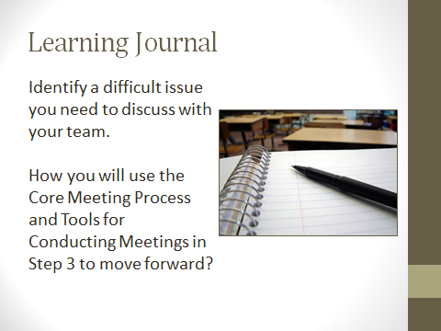 Activity time: 5-7 min

Provide participants with 5-7 minutes to write out a response to the posted question.

* Identify a difficult issue you need to discuss with your team. How you will use the Core Meeting Process and Tools for Conducting Meetings in Step 3 to move forward?

Facilitators may ask if anyone wants to share what they wrote with the group.

**L.I.F.E. Partner Exchanges**

**TIME ALLOTTED: 10 minutes**



**_______________________________________________________**

Slide #53: L.I.F.E. Reports

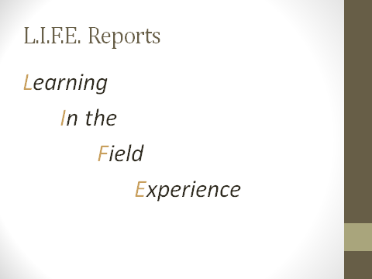

**Optional Activity:**

We learn best when we do. We also learn best when we teach. The Learning in the Field Experience is the opportunity for participants to learn from and teach one another. Recognizing the expertise and diversity in the room, the participants will pair into learning dyads and make arrangements to visit one another’s office. Each will prepare a learning log and will present the finding of their respective visits at the next session of the Supervisor (Foundations of Supervision) class.

Refer participants to ***Handout: Learning In The Field Experience*** ***(L.I.F.E.) REPORTS*** in their participant manual. Review handout with participants.

Reference: Garrison, M and Dahlin, P. (2009). *Understanding self as supervisor* – Foundations of Supervision Series, Participant Manual. (p. 9).

***Handout: Learning In The Field Experience*** (***L.I.F.E.) REPORTS***

**Purpose:**

The Learning In The Field Experience (L.I.F.E.) provides supervisors with the following learning opportunities:

* To apply concepts and methods learned in training.
* To practice providing feedback to other supervisors.
* To expand awareness of supervisory practices specific to APS work.
* To apply collaborative learning techniques.
* To receive feedback on professional development.
* To develop professional, supportive relationships with colleagues in neighboring counties or programs.

**Rationale:**

APS Supervisors work with complex issues and situations in similar settings. The scope and nature of supervision varies according to local or state practice, departmental procedures, administrative focus and organizational climate. Given the lack of federal oversight for APS programs, supervisors are often faced with the challenge of having limited direction in order to determine best practices. Additionally, new supervisors face the daunting challenge of learning skills that pertain to supervision while stretching or modifying casework behavior that worked for them when they were APS field workers.

Providing field experience for APS Supervisors provides an opportunity for collaborative learning while simultaneously developing professional relationships and connections that could prove to be useful long after the end of the project. Working with a learning partner from another agency, supervisors will be able to provide and receive feedback on their development or refinement of supervisory skills. Working on their goals, both supervisors will be able to compare the progress of their learning. Through a dialogue with professional support, supervisors can candidly examine their strengths and developmental needs.

**Guidelines for the Supervisor's Field Experience (L.I.F.E.):**

1. When choosing a learning partner, consider the following:

-Does this partner work in a jurisdiction or office that is reasonably close in proximity?

-Does this partner have a similar role within her/his department?

-Does this partner work within a similar type of state, county, parish or local office? (i.e., rural vs. areas of high urban density; APS staffing ratios similar).

-Partnerships will be finalized by the end of the second session.

2. Schedule two days for collaborative learning

Supervisors will schedule a full day for visiting and learning in another agency and a full day when their learning partners will visit their agency. It is critical that supervisors schedule this time in advance. Your APS Supervisor CORE facilitator will give you parameters for these dates.

1. Focus on your own learning goals:

The field experience provides an opportunity for structured observation and feedback related to personal learning goals. The material that is being covered in the APS Supervisor CORE series will help you to determine these goals.

As you complete the APS Supervisor CORE classes, consider and take note of potential areas that may be appropriate for you to address as learning goals.

1. Between APS Supervisor CORE sessions, consider the following:

- How do the components of APS culture impact your role as supervisor?

- Are there elements from the key roles (Educational, Supportive and Administrative) that are missing from your supervision with workers? How can you incorporate missing elements into your practice?

- How do you currently evaluate and monitor staff performance? How can you incorporate elements presented in this training to your practice?

- Identify three Supervisory Best Practices and explain how you use them/will use them on the job.

1. After completing the two day visit to your partner's program (between sessions 6 and 7), you will complete a L.I.F.E. Report and then present your findings to the whole class.

**Closing/Evaluation**

**TIME ALLOTTED: 15 minutes**



Slide #54: Best Practices

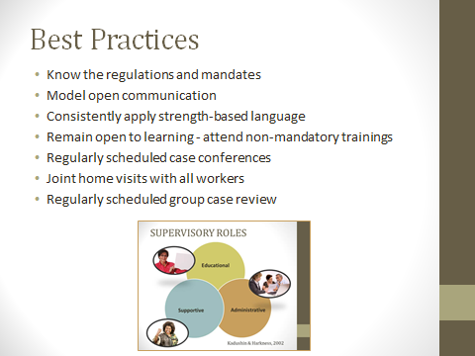

We have covered a lot of ground today, so let’s review some supervisory best practices.

Supervisor best practice review:

* Know the regulations and mandates
* Model open communication
* Consistently apply strength-based language
* Remain open to learning - attend non-mandatory trainings
* Regularly scheduled case conferences
* Joint home visits with all workers
* Regularly scheduled group case review

Slide #55: Closing

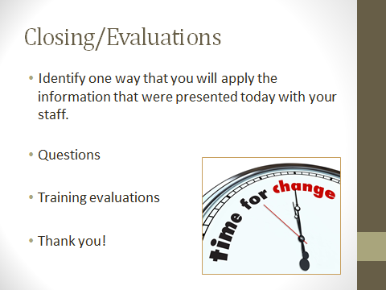

***ASK***for volunteers to share with the group one way that they apply the information that were learned today with your staff.

Facilitator to answer remaining questions, thank participants for their energy and participation, and encourage them to complete their training evaluations.

Brief explanation of Transfer of Learning activity.

|  |
| --- |
| Trainer Note: All in-class and out-of-class evaluation activities are located in the Evaluation Manual for your convenience. |

**References**

Beck, J. & Beck, A. (2011) *Cognitive behavior therapy: Basics and beyond. (*2nd ed.*) .*NYC, NY: Guilford Press

de Shazer, S., & Dolan, Y. (2007). *More than miracles: The state of the art of solution-focused brief therapy.* Binghamton, NY: Haworth Press.

Ewing v. Goldstein (2004). Cal.App.4th. Retrieved on January 22, 2013 from <http://www.stanford.edu/group/psylawseminar/Ewing.htm>

Garrison, M and Dahlin, P. (2009). *Understanding self as supervisor* – Foundations of Supervision Series, Participant Manual. (p. 9).

Garrison, M and Dahlin, P. (2009). *Team development* – Foundations of Supervision Series, Trainer and Participant Manual.

Greenleaf, R. K. (1977/2002*). Servant-leadership: A journey into the nature of legitimate power and greatness*. Mahwah, NJ: Paulist Press.

Kadushin, A., & Harkness, D. (2002). *Supervision in social work*. (4th ed.). New York, NY: Columbia University Press.

Miller , W., & Rollnick, S. (2002). *Motivational interviewing: preparing people for change*. (2nd ed.). New York, NY: Guilford Press.

National Adult Protective Services Association. (n.d.). *NAPSA (or APS) Code of Ethics and Practice Guidelines*. Retrieved on December 14, 2012 from <http://www.napsa-now.org/about-napsa/code-of-ethics/>

National Association of Social Workers-Legal Defense Fund, (2008). *Social workers and duty to warn*. Retrieved on 11/1/12 from http://www.socialworkers.org/ldf/legal_issue/2008/200802.asp?back=yes

National Association of Social Workers. (2012). *Best Practice Standards in Social Work Supervision: Taskforce on Supervision Standards – Draft.* Retrieved on 11/1/12 from <http://www.socialworkers.org/practice/naswstandards/socialworksupervision/SUPERVISION%20STANDARDS2%20Public%20Comment%20Draft%20August%2016.pdf>

National Center on Family Homelessness. (2008). What About You?

Nelson, T. S., & Thomas, F. N. (2007). *Handbook of solution-focused brief therapy: Clinical applications*. Binghamton, NY: Haworth Press.

Saleebey, D. (Ed.). (2006). *The Strengths Perspective in social work practice* (4th ed.). Boston: Allyn & Bacon.

Salus, M. US Department of Health and Human Services, Administration for Children and Families. (2004).*Supervising child protective services caseworkers*. Retrieved on 11/1/12 from US Department of Health and Human Services website: <http://www.childwelfare.gov/pubs/usermanuals/supercps/supercps.pdf>

SAMHSA National Registry of Evidence-Based Programs and Practices. Retrieved on 11/1/12 from <http://www.nrepp.samhsa.gov/>

Shulman, L. (2010). *Interactional supervision*. (3rd ed.). Washington, DC: National Association of Social Workers Press.

Spears, L.C. (2005). *The understanding and practice of servant leadership-retrieved.* Retrieved on 11/1/12 from <http://www.regent.edu/acad/global/publications/sl_proceedings/2005/spears_practice.pdf>